SEA Vocational-Technical High School/College Network
4th Meeting Report
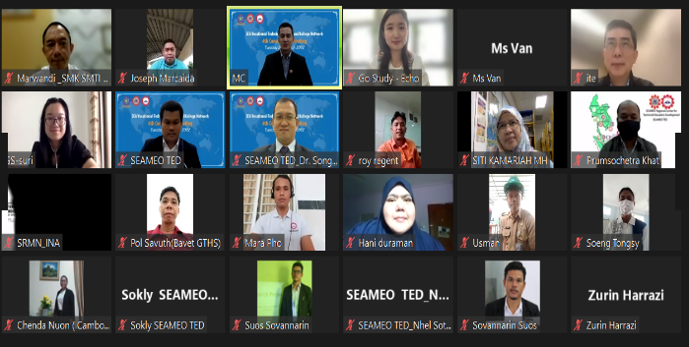
March 22, 2022 (10:00-12:00am, Cambodia Local Time +7)

SEAMEO TED organized a consultation meeting on March 22, 2022 virtually. The meeting was participated by 30 SEA Vocational-Technical High School/College Network members
Dr. Songheang Ai, Director of SEAMEO TED, delivered his welcome remarks by encouraging all schools to share initiatives and raise inputs for Draft Work Plan 2022. He stressed three main objectives of today’s meeting: (1) to make work plan 2022; (2) to introduce new initiatives/activities from our strategic partners Go Study Global Education China; and (3) to inform our members about the regional workshop on Awareness-Raising on Labor Market Needs in IR 4.0 Era between the Private Sector and Technical Education Teachers in the ASEAN Region (Face-to-Face) in Preach Sihanouk Province, Cambodia to celebrate Cambodia ASEAN Chairmanship 2022.
Ms. Qin Ziyan, director of International Relations of Go Study Global Education China presented her proposed activities planned to support the network members including (1) Scholarship for International Master’s Degree Program for SEA VoT Network Teachers in the field of Technical Education at Southwest Jiao Tong University, China; (2) Scholarship for Diploma Program for SEA Students; and (3) Plan to establish Joint TVET regional centre in SEAMEO countries, especially the network members.
SEAMEO TED also updated the network progress and proposed exchange learning and teaching program off-line and online to the network for their considerations.
Dr. Songheang also discussed the proposed plan for Awareness-Raising Workshop on the Labor Market Needs in IR 4.0 Era between the Private Sector and Technical Education Teachers in the ASEAN Region (Face-to-Face) in Cambodia in July 2022. Some of the network members as technical education teachers will be invited to join this face-to-face workshop.
Key Results of Consultation Meeting as follows:
- Go Study Global Education China will provide specific information on Scholarship Programs for Master Degree’s and Diploma for teachers and students studying at Southwest Jiao Tong University and Guangxi,
- Go Study Global Education China will establish the Joint Regional TVET centres in each of the 11 SEAMEO member countries, especially at the schools of our network members
- SEAMEO TED proposed an exchange program for technical education teachers/students off-line or online that will be conducted upcoming months
- SEAMEO TED will organize an Awareness-Raising workshop on the Labor Market Needs in IR 4.0 Era between the Private Sector and Technical Education Teachers in the ASEAN Region (Face-to-Face). Some of our network members will be invited to join the workshop. The expenses of invited participants will be covered by SEAMEO TED. The expenses consist of round trips of air fares, accommodation, local transportation, and meals during the workshop. The workshop will be held in Preah Sihanouk Province, Cambodia. The total participants will be 60 participated by technical education teachers, industrial experts/technicians and TVET policy makers regionally. The objectives of the workshop are (1) to create the best-practice sharing forum from the perspectives of industries, schools and policy makers; (2) to strengthen the close relationship between schools and industries in terms of skill supplies and demands; (3) to pave the way for better future cooperation between schools and industries regarding student internship programs, apprenticeship, job openings; (4) to raise the awareness and significance of technical education at vocational-technical high schools in the region to the public interests; and (5) to enhance hand-on skills of technical education teachers by exposing them to interact, communicate and observe and reality by visiting industrial factories/enterprises. The workshop will be tentatively held on July 14-15, 2022.
SEAMEO TED will follow up with all network members for the involvement of the above-activities and stay updating on the upcoming events.

