Report on
2024 International Youth Talk: Analysis of Intelligent Technological Innovation and Social Progress from the Youth Perspective

On the afternoon of August 16, 2024, the "International Youth Talk： My Perspective on Intelligent Technology Innovation and Social Advancement" event was successfully held. The event was hosted by the China-ASEAN Technical Education Cooperation Platform (CATECP) and the SEAMEO TED, and co-organized by Go Study Global Education.

The event invited keynote speakers from top universities in Cambodia, Malaysia, Thailand, Indonesia, Brunei and Vietnam to share and discuss the theme of "My Perspective on Intelligent Technology Innovation and Social Advancement", delving into the impact of intelligent technology on social development. The lecture attracted more than 140 scholars from different countries in related fields, who contributed multi-layered and diverse perspectives on the topic.
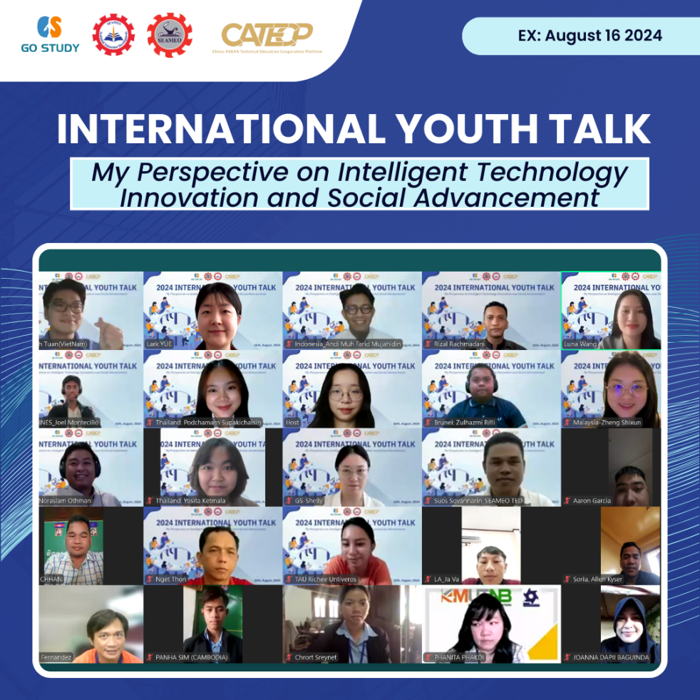

- 【Opening Remark】
The opening remarks were delivered by Mr. Khat, Deputy Director of SEAMEO TED. In his speech, he profoundly expounded on the key role of youth in scientific and technological innovation and social progress. He emphasized that today’s young people are in a period of unprecedented scientific and technological change, shouldering the important mission of leading the future and promoting social development. He encouraged young scholars and professionals to actively participate in scientific and technological innovation, respond to global challenges with wisdom and courage, and promote more inclusive and sustainable social progress.
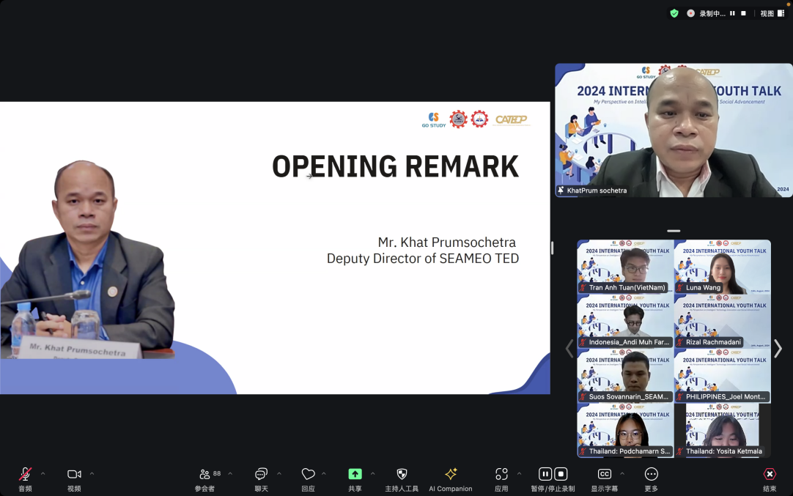

- 【Sharing Session】
- Shared by student from Saigon Univerity, Vietnam:
The student representative from Vietnam noted that intelligent technology innovation is profoundly shaping human life and civilization, especially in the medical and economic fields. In the medical field, AI enhances diagnostic accuracy and optimizes workflows by analyzing data such as symptoms, images, emotions, and language. In the economic sphere, AI and robots can automate repetitive tasks, reducing labor costs and increasing productivity and efficiency. However, it also comes with challenges, such as the risk of imperfect technology, easy exploitation by criminals, and job losses for workers. Despite this, intelligent technology will still have a positive impact on various fields and advance the development of human civilization.
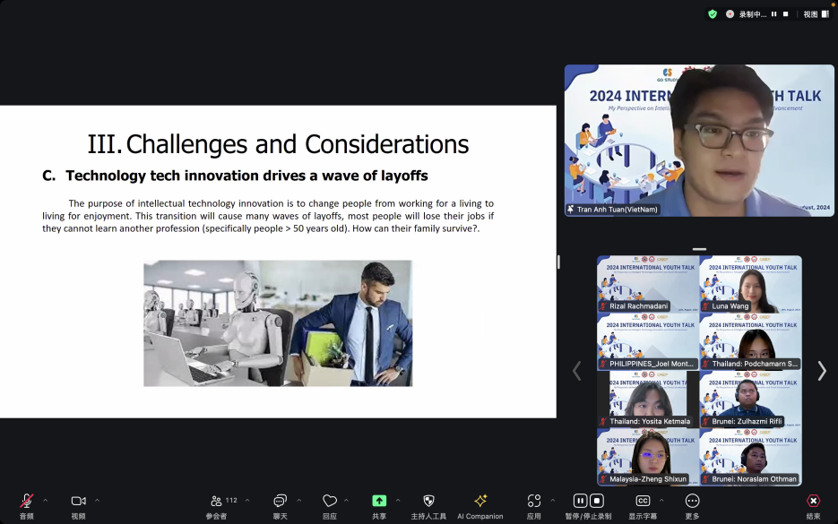

- Shared by student from University Malaya, Malaysia:
The student representative from Malaysia discussed how intelligent technologies, especially electromyography (EMG) technology and intelligent insoles, can contribute to social progress. First, the definition of intelligent technology, AI and wearable devices are introduced. This is followed by the EMG technique, which measures muscle activity and helps diagnose neuromuscular diseases and assess muscle function. This is followed by the introduction of intelligent insoles, which can not only provide personalized support and comfort by integrating EMG data and artificial intelligence technology, but also monitor foot health in real time to prevent sports injuries. These innovations are expected to improve quality of life and enhance athlete performance while reducing costs and improving healthcare accessibility. In addition, with the application of sustainable materials, this technology is also able to reduce environmental impact.
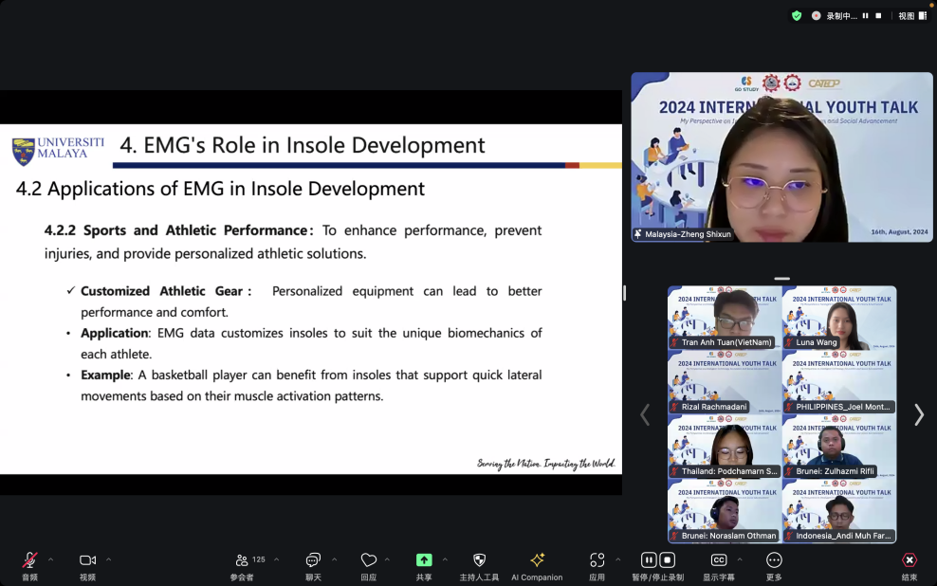
- Shared by student from Khon Kaen University, Thailand:
The student representative from Thailand analyzed the impact of intelligent technology and objectively cited its advantages: it optimizes healthcare, education, transportation and economic growth, while providing personalized services and data-driven decision-making. And using the tourism industry as an entry point, to illustrate the challenges posed by intelligent technology, such as workers face to loss job, traveler privacy leaks, and reduced interpersonal interactions. It is said that intelligent technology innovation and social advancements are reshaping the tourism industry in profound ways, from enhancing customer experience to improving operational efficiency and supporting sustainability. The integration of technology is creating a more dynamic, responsive, and responsible travel landscape.
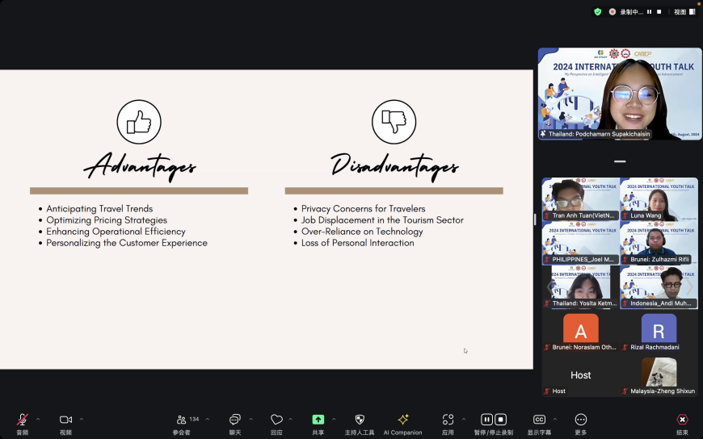

- Shared by student from Hasanuddin University, Indonesia:
The student representative from Indonesia explored the role of intelligent technology in social progress, highlighting how advanced technologies like artificial intelligence, the Internet of Things and renewable energy can drive social change by addressing issues such as poverty, education, healthcare and environmental sustainability. Intelligent technology can provide communities with the tools and knowledge to improve living conditions, promote economic self-sufficiency, and ensure the ethical application of technology to avoid exacerbating inequalities. Additionally, the "AQU4LORONG" project implemented by the Renewable Energy Association of Hasanuddin University (SRE Unhas) is used as an example to illustrate the potential of intelligent technologies as catalysts for social change by using intelligent technologies to address food security caused by economic disparities, greenhouse gas emissions and limited agricultural land, thereby positively impacting society, the economy, and the environment through the use of IoT technology and solar-powered hydroponic systems.
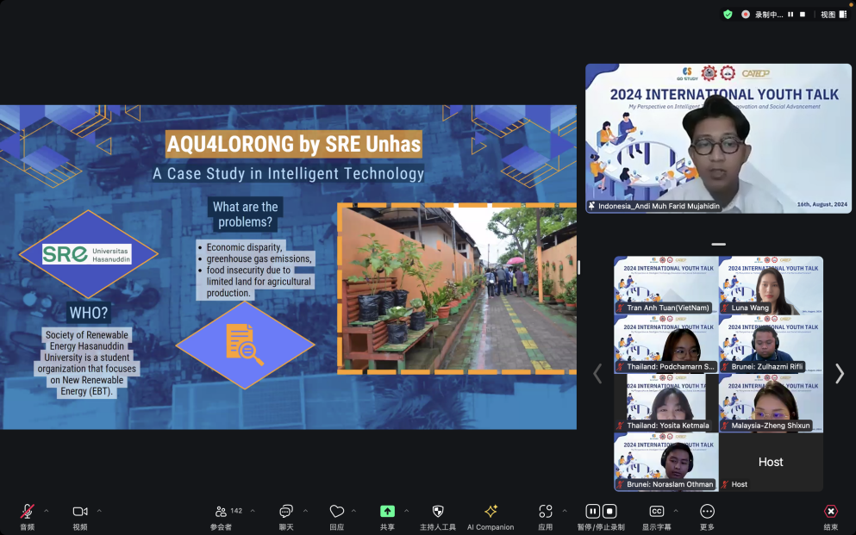

- Shared by students from Universiti Teknologi Brunei:
Focusing on the key role of intelligent technology in promoting sustainable social development, improving quality of life and promoting inclusive progress, student representatives from Brunei Darussalam showcased the application of renewable energy technology, environmental technology, electric vehicles, artificial intelligence (AI), Internet of Things (IoT) and other technologies, and introduced concepts such as intelligent transportation, assistive technology, digital education, telemedicine and smart city. At the same time, they pointed out the gap and challenges between ethics and technology brought about by intelligent technology, and called for measures such as AI ethics, human-centered design, collaborative innovation, and lifelong learning to achieve the mutual prosperity of technology and society.
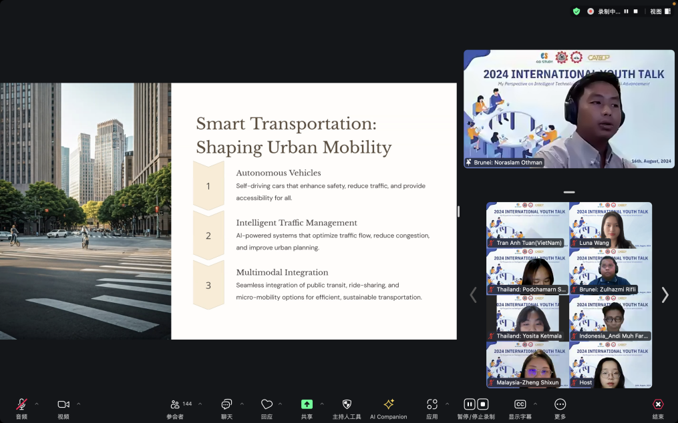

- Shared by student from King Mongkut's University of Technology North Bangkok, Thailand:
The student representative from Thailand discussed intelligent technology innovation and its impact on social progress. Intelligent technologies have shown great potential in increase efficiency and productivity, innovate problem-solving, and improve quality of life. The use of technology facilitates job transformation and skills development, and contributes to achieving the Sustainable Development Goals. However, challenges such as privacy security, equitable accessibility, and AI ethics must not be overlooked. Therefore, when promoting technological innovation, it is necessary to carefully consider its positive contribution to society and ensure that the fruits of technological development can benefit and reach the public.
