Policy Dialogue

“Empowering TVET for the Digital Transformation: Strategies for a Future-Ready Workforce”
8 August 2024, Phnom Penh, Cambodia
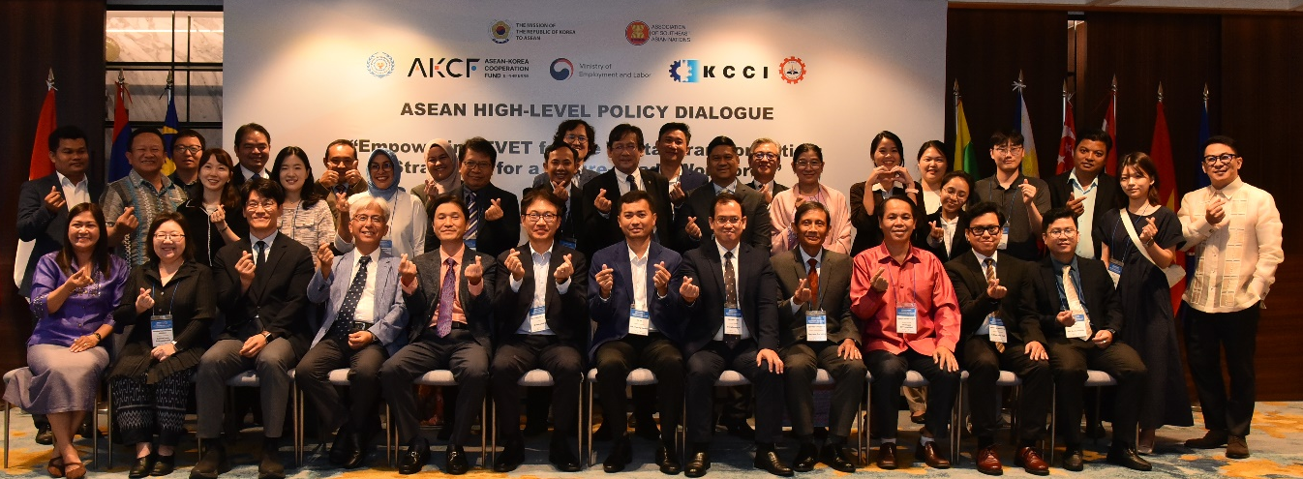

On 8th August 2024, the Policy Dialogue on Empowering TVET for the Digital Transformation: Strategies for a Future-Ready Workforce is mainly co-organized by the Korea Chamber of Commerce and Industry, ASEAN Secretariat, SEAMEO TED, and Cambodia's Ministry of Labour and Vocational Training. 45 participants who are high-level officials, researchers, and experts in TVET from ASEAN Member countries and South Korea attended the event in the Hyatt Regency Hotel in Phnom Penh, Cambodia. The workshop aims to explore strategies for empowering TVET systems across the region to meet the challenges and opportunities in the digital era. The opening session, “Empowering TVET for the Digital Transformation: Strategies for a Future-Ready Workforce,” proceeded with congratulatory remarks by Dr. Suthep Kaengsanthia (SOM-ED Chair), Mr. Jang Keun Lee (Ambassador of the Republic of Korea to ASEAN), and Mr. Myounghee Cho (Executive Director
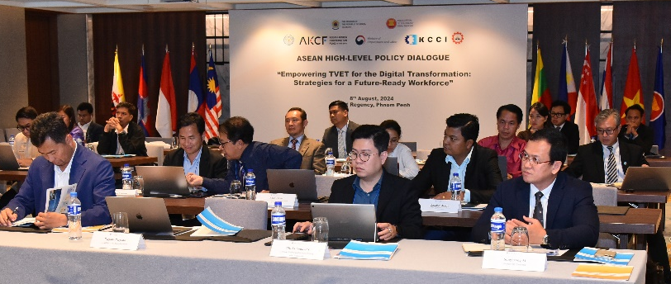
of HRD Division, KCCI).

The session also highlighted the refreshing role of new technology in business, the job market, and strategy for education and vocational training while the Fourth Industrial Revolution, led by digital transformation, is rapidly changing the world of work, demanding new skill sets from workers as automation and technological advancements reshape industries. The session emphasized the importance of adopting TVET systems to prepare for well-equipped labor with skills and knowledge for the future. The speakers also emphasized the importance of collaboration and shared learning for the TVET transformation success and the development of applicable strategies among ASEAN member states and stakeholders in empowering TVET systems to better prepare our labor force for the digital age and drive sustainable economic growth. In addition, the session also highlighted that more support for new training methods has been done through the active improvement of e-learning systems through digital convergence training platforms to be established and available to workers, job seekers, and small business owners. The session stressed the importance of the ASEAN Korea Dialog Partnership, which has lasted for 35 years with remarkable progress in the respective political, economic, and cultural fields supporting and collaborating.

The speakers also shared the successful implementation of the ASEAN TVET Mobility Program, a flagship project between ASEAN and Korea in employment and labor fields, with the support of the ASEAN Korea Cooperation Fund (AKCF) in 2020 in joint efforts to improve Technical and Vocational Education and Training (TVET) in the ASEAN region, especially as we face rapid technological changes brought by the Fourth Industrial Revolution. The session also introduced how the investment in TVET has contributed to the country's economic development in Korea with innovation, growth policies of the government, and the presence of vocational skills development. The session finally stressed the current priorities by focusing on the capacities trainers need in the digital transformation and how training institutions can respond to labor market needs.

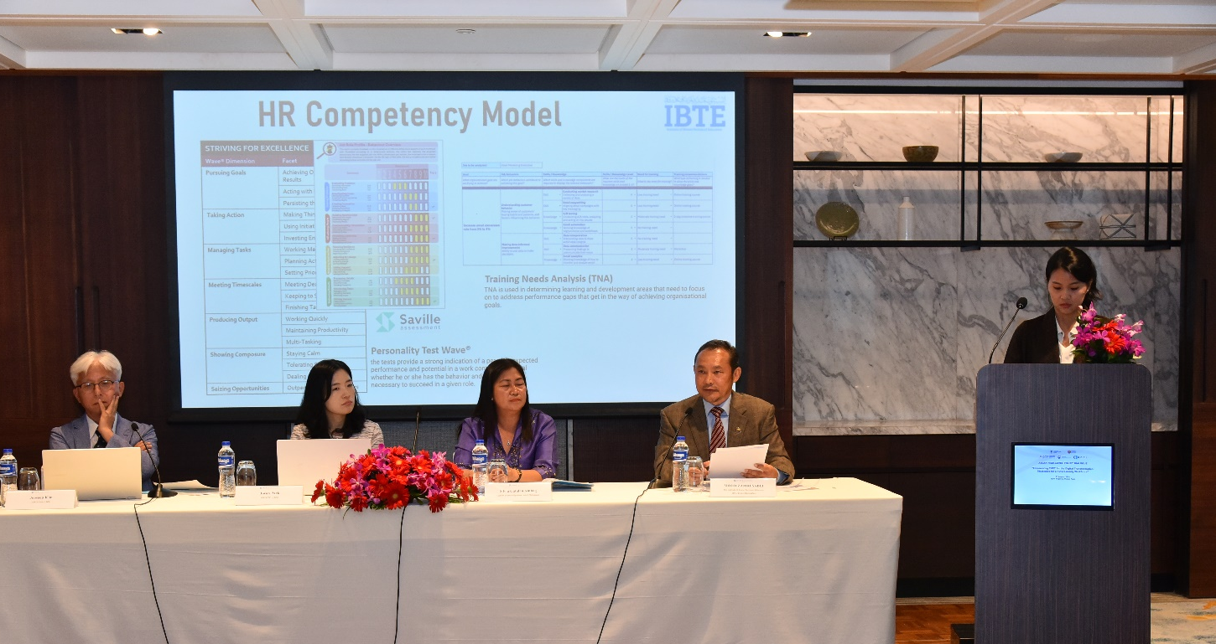
- [Session1] Policy Strategies for Upskilling TVET Trainers in Emerging Technologies
In this session, a keynote presentation on “Equipping Educators with Emerging Technologies was made by Ms. Ayu Pratiwi, Programme Officer, ASEAN Foundation, Indonesia. The keynote presenter covered mainly some key points, including the Education & Digital Transformation Strategy in ASEAN, the ASEAN Foundation’s Programs in 2024, Enhancing Education in ASEAN through an AI TEACH for ASEAN, developing AI Tools, conducting training of trainers on AI in education, teaching and learning, Cascading Training, ASEAN Digital Literacy Programs, and so on. In the panel discussion, there were three panelists: Dr. Jiwon Park, Professor of the Department of Human Resources Development, KOREATECH, ROK; Prof. Silvia Ambag, Professor of the Lyceum of the Philippines University; and Dr. Haji Mohd Zamri bin Haji Sabli (Director of Technical Education, Institute of Brunei Technical Education, Brunei). The speakers in this session mainly captured some key areas, including emerging cooperative learning trends with the development of generative AI, the ASK of “AI Literacy” attitude, skills, and knowledge that talent needs, the generative AIs impact on freelance professionals’ performance, and training + LLM AI Boosts performance significantly, developing competency applicable for TVET trainers. They also shared six strategic pillars for upskilling TVET trainers in emerging technologies in the Philippines: the key training capacity enhancement, policy support for choosing effective training programs aligned with the goals of trainees, trainers, and training institutions, and policies for enhancing the capacity of TVET educators at regional and international levels. Finally, in the sessions, the last panelist also shared IBTE’s 5 Key Performance Indicators, the Tripartite Eco-System (training of workers), and Transforming the TVET program and IBTE identification on the HR competency model and TVET academy.
This session was facilitated by Dr. Jooseop Kim (professor at Korea University, ROK) as the moderator.
- [Session2] Strengthening TVET Institutions for the Digital Age: Regional Policy Strategies
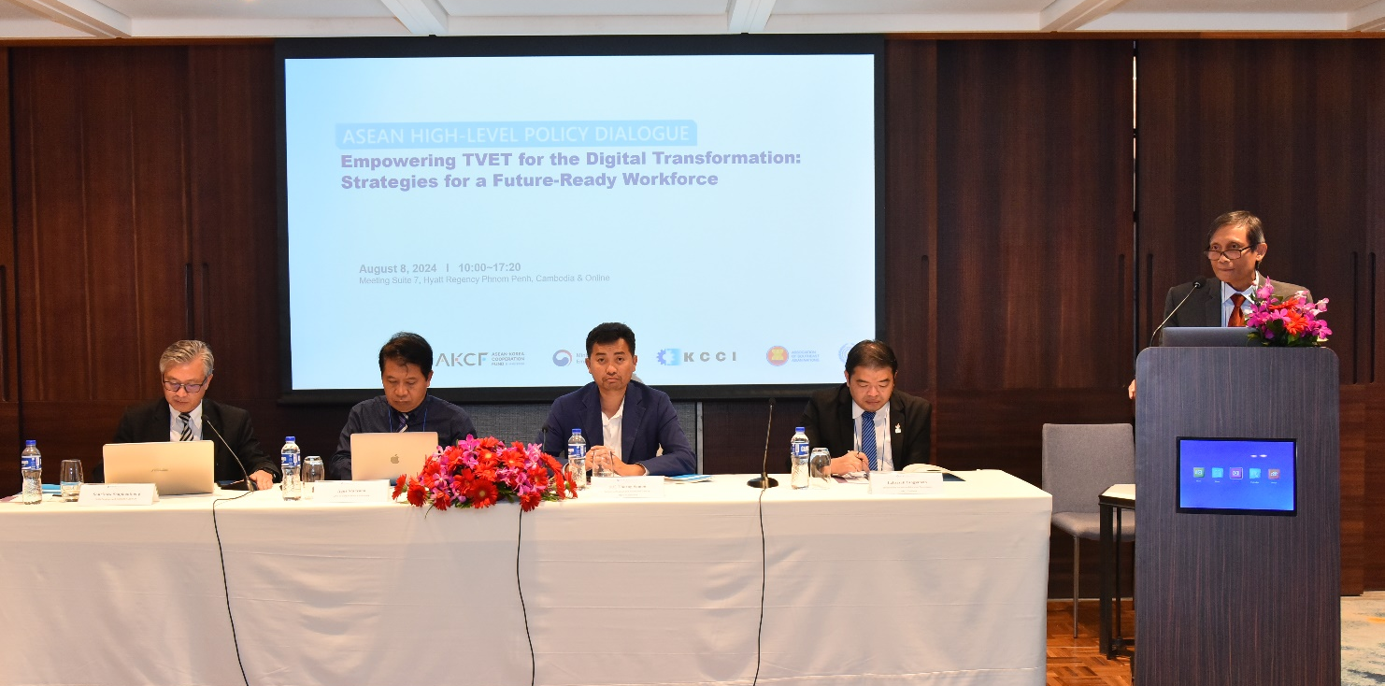
In this session, a keynote presentation on the 4.0 IR readiness of TVET institutions in Southeast Asia was shared by Dr. Paryono (Deputy Director for Professional Affairs and Research Manager/specialist, SEAMEO VOCTECH, Brunei). The keynote speaker mainly covered the primary study on the Smart Education Readiness Index (SERI) Framework, covering three main blocs (process, technology, and organization), highlighting that the overall index of the readiness of TVET institutions for IR 4.0 in Southeast Asia using the SERI framework is 2.03, while the worldwide IR readiness index for industry using the Smart Industry Readiness Index (SIRI) is 1.55. The speaker stressed attention to the TVET institutions’ strong needs for integration, policies and guidelines, support and investment in infrastructure and human resources, as well as innovation in teaching and learning. Dr. Paryono also noted that certain issues should be addressed, including a mismatch between graduates' skills and industry demands and gender gaps and inequalities in access to IR 4.0 education and employment opportunities.
The keynote speaker also emphasized that some countries in ASEAN are better prepared to cope with artificial intelligence (AI) than the world average and the Asia Pacific (Singapore, Malaysia, the Philippines, and Thailand). However, there were big gaps between the potential and the implementation, adoption, and practices related to digitalization and IR 4.0. Paryono advised that TVET institutions and industry should share and exchange experiences to synergize the effort for digitalization and narrow the mismatches. Subsequently, an action or enhancement plan, outlined in conjunction with the roadmap, ought to be devised, complete with a timeline and precise activities aimed at elevating the status to the succeeding tier.
The panel discussion was made by three speakers, namely Mr. Sourisack, Dr.-Ing. Ir Agus Maryono, Dean of SEKOLAH VOKASI, University of Gadjah Mada, Indonesia, Mr. H.E. Thorng Samon, Deputy Director General of TVET, Cambodia, and Mr. Laksasak Yangsama, Director of International Strategy and External Relations Division, Office of Vocational Education Commission, Thailand.
Dr. Agus mainly highlighted Implementing Innovation in TVET to solve problems using the concept of systemic thinking approach, Implementing Innovation in TVET to solve the problem of Climate Change and Water Scarcity, and Development of Science, Technology, Innovation, and Vocational Training Processes to Harvest Rainwater. Dr. Agus briefly elaborated on 7 processes of development of science, technology, innovation, and vocational training processes to harvest rainwater: (1) Problem of Climate Change, (2) Concerns and Research of Rainwater Quantity and Quality, (3) Innovation and Development of Technology Gama Rain Filter, (4) Development of Conception, Standard, Operational, and Procedure for Technical and Vocational Training, (5) Development of Technical and Vocational Training Movement in Rain Harvesting (GMHI), (6) Development of Teaching Factory (TeFa) for Technical and Vocational Training, and (7) Positive Impacts of Science, Technology, and Vocational Training of Rainwater Harvesting and Sustainability. Dr. Agus concluded his presentation that technical and vocational education training must be supported by innovation science technology.
Mr. H.E. Thorng Samon (Deputy Director General, General Department of TVET, MLVT, Cambodia) briefly shared how to prioritize strengthening TVET in Cambodia. To address the skill mismatching, Mr. Samon mainly highlighted some key points in strengthening TVET in Cambodia, which are the top priorities of the government in this mandate. These are investments to modernize the equipment and infrastructure to be up-to-date and aligned with the industrial current needs. This needs more financing from the government and support from development partners on various projects to share the IR4.0 development in TVET Cambodia. Secondly, he talked about the leadership and management of TVET institutions, which is very crucial in Cambodia. The other priorities are the enhancement of TVET leadership and curriculum improvement. Which is very important to get updates relevant to the IR.4.0, trainer’s capacity, engagement of industries, which is very crucial that we can do something to respond to their need.
Mr. Laksasak mainly stressed the importance of OVEC's collaboration with the private sector to update and develop the curriculum to be aligned with industrial needs and internationalization. He also highlighted other focused points of OVEC attention on TVET, including encouraging the creation of social innovation toolkits to develop the social skills of students learning, the focus on teacher training to get ready with updated skills curriculum, and concern for students’ readiness through hands-on development. Mr. Laksasa also highlighted that the infrastructure is also one of the challenging factors in vocation and education in Thailand due to budget constraints. The rapid change of technology is also a challenge.
Mr. Sourisack Souphanthong, Deputy Director of Skills Development Institute, Lao PDR, was a moderator of session 2.

- [Session3] Shaping the Future of TVET: Policy Directions for Advancing Digital Skills Development

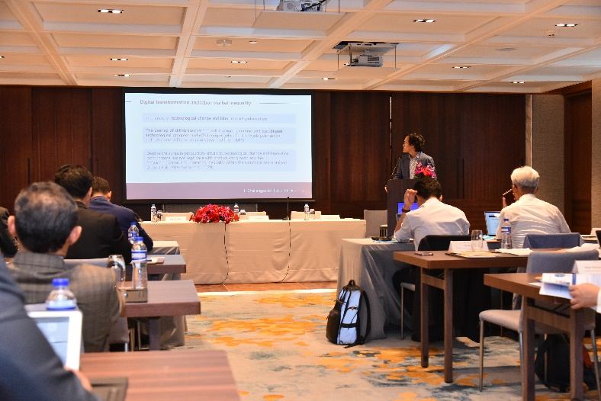
A keynote presentation on “Future of Work: Skills Policies for 4IR and Digital Transformation” was given by Dr. Kirak Ryu (Korea Research Institute for Vocational Education and Training, KRIVET, ROK). She mainly highlighted the key challenges for skills policy in the digital transformation, digital concepts of transformation, two main approaches to digital transformation, and how digitalization is impacting job configurations through automation, tasks, and the use of ICT. In addition, Dr. Kirak discussed key challenges and policy initiatives by capturing on addressing skills mismatch, upskilling, and reskilling issues and advice that addressing skills mismatching should focus on enhancing comprehensive competencies that enable an individual to perform tasks within the context of work and organization, whereas upskilling and reskilling should focus on the enhancement of general skills at a broad level rather than detailed-job-specific competence standards. Finally, the keynote speaker shared the policy initiatives for aligning the TVET programs with the demands of the digital economy and an introduction to the policy framework to ensure the success of digital skills initiatives.
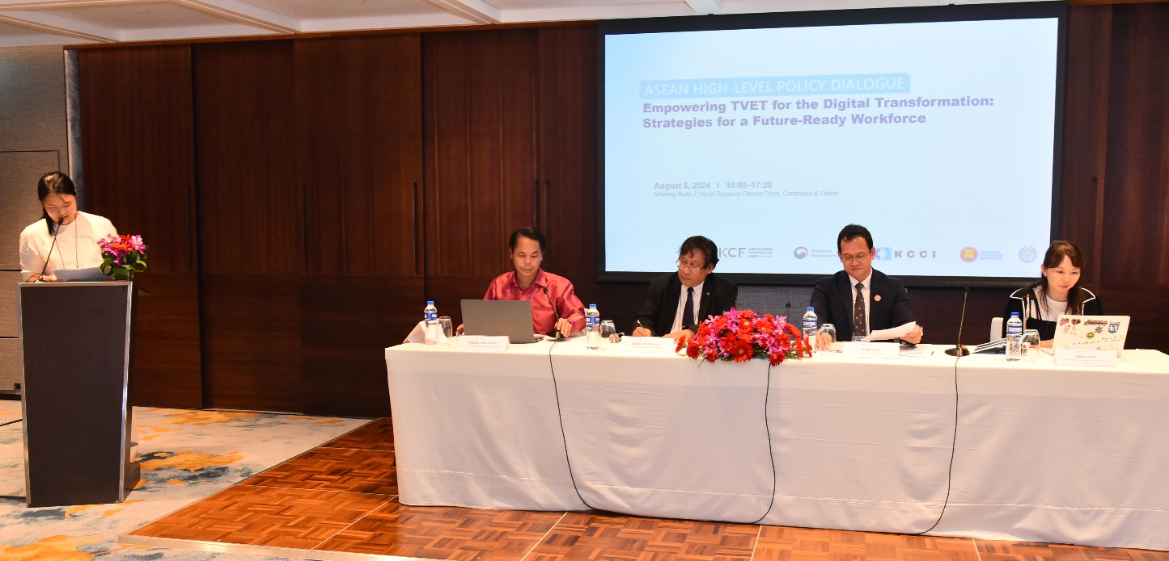
The first panelist, Dr. Ramlee Mustapha, a professor at University Pendidikan Sultan Idris, Malaysia, shared on the Competency of TVET Students in the Field of Artificial Intelligence: A Case Study in a Public University. He highlighted AI in human work and industries in the future: AI, Green Economy, Digital Finance, Digital Marketing, High-Tech Manufacturing, Digital Games, Agri-tech and advanced food engineering, Space, and METAVERSE. He also stressed the competencies and challenges of dealing with AI. He finally recommended that the TVET curriculum should be revised and the AI-based TVET curriculum be introduced.
The second panelist, Dr. Hanna Moon, Director of the Center, Korea Research Institute for Vocational Education and Training, KRIVET, ROK, presented on Policy Operation: Lifelong Learning Card, introducing the decision to introduce lifelong learning cards, which was made by the Job Council, headed by the President, and introduced in January 2020. Dr. Hanna also highlighted the challenges and weaknesses. Primarily, the increasing number of platform workers in a gray area in terms of lifelong learning has not been properly addressed. Employment status will continue to change from working full-time at a company to working as a freelancer repeatedly. In addition, Dr. Hanna discussed the main target of the lifelong learning card, the redesign of co-payment, and the contents of the lifelong learning card. Dr. Hann mainly addressed policy implications and how to contribute to bridging the training divide between employment types by providing vocational training services as a safety net. He also shared another policy implication of Training investment can be designed with long-term perspectives by increasing the period and amount of support, allowing for more tailored training designs, and contributing to the accumulation of human capital by allowing them to take desired training courses. Dr. Hanna also discussed policy effectiveness: lifelong learning cards are increasingly required for activating the participation of vulnerable people. Finally, she suggested that steering support, including financial support to training groups, reduces losses for individual-led training and prevents low-income groups from using the system less than others, and revitalizing individual training will require ongoing financial support.
The third panelist, Dr. Songheang Ai, a Center Director at SEAMEO TED, shared on Shaping the Future of TVET: Policy Directions for Advancing Digital Skills Development, highlighting the increasing role of AI in replacing the roles of traditional jobs. He stressed the innovation of TVET in the digital era. He also highlighted the digital economy scale in ASEAN member states. Dr. Songheang Ai also shared trends shaping the future of TVET, including digital transformation, a green economy for sustainable development, lifelong learning, and work-based learning with partnerships between schools and industries. Dr. Songheang Ai raised the emerging challenges that will affect the future TVET policies and programs on IR4.0 and digital transformation, which are mainly arising with skills gaps with the rapid pace of technological change, infrastructure disparity, teacher capacity, and employer engagement. Dr. Ai concluded his talk by stressing how to address these challenges, for which we should draw more attention to the flexible and modular curriculum, work-based learning, digital platforms, life-long learning eco-system, and public-private partnership for IR4.0 and digital transformation that will be achieved in the future with more active and reliable roles of government in coordinating both sectors (private and public).
The moderator for session 3 was Dr. Rangsan Thepmondhri, Director of the Policy and Strategy Division, Bureau of Policy and Planning, Office of the Vocational Education Commission, Ministry of Education, Thailand.

- Reflection and Recommendations

- Dr. Paryono (Deputy Director for Professional Affairs and Research Manager/Specialist, SEAMEO VOCTECH, Brunei) presented the reflection and key recommendations of the whole-day sessions as follows:

- Session 1: [Session1] Policy Strategies for Upskilling TVET Trainers in Emerging Technologies
  - Every country has a policy in place about digital transformation. At the regional level. Need to have a mapping of innovative digital transformation programs and capacity building (partners, duration, selection): regional and national level + partners
  - How can we move forward?
  - Specific: Address on security and enrolment

- Session 2: [Session2] Strengthening TVET Institutions for the Digital Age: Regional Policy Strategies
  - Adopting more learner-centered approaches: problem-based and project-based TL methodologies.
  - Complexity due to many line ministries running TVET. Some challenging issues: financing, leadership and management, curriculum contents, the capacity of trainers, and industry engagement.” To strengthen, not to expand more.”
  - Finding creative ideas to leapfrog the next level of digital transformation.
  - For using SERI, it is advisable to have wider usage and a validator team to validate the score/index from the institutional assessment (Dr. KIM).
- Session 3: Shaping the Future of TVET: Policy Directions for Advancing Digital Skills Development
- Digital Transformation: shared various frameworks, at the national level, and findings from OECD and other countries. The impact of digitalization on job configuration.
- Skills mismatch, upskilling and reskilling issues (skills in the future are different than now), People science
- LMIS of Scotland (country level). Do you think regional direction is preferable or not possible?
- Policy initiatives in aligning TVET programs with the demand in the digital economy. PI1: Transition maps on the impact of complex transitions; PI2: Transforming the National Tomorrow Learning Card into a Personal Training Account; PI3: K-Digital Training.
- Policy implications: customized training format for business
- Introducing- Stock-flow-buffer functions that can be considered in ASEAN
- How we can work together to address the common issues in preparing our workforce for a digital and sustainable future.

- Closing Speech by Cambodia Government Representative
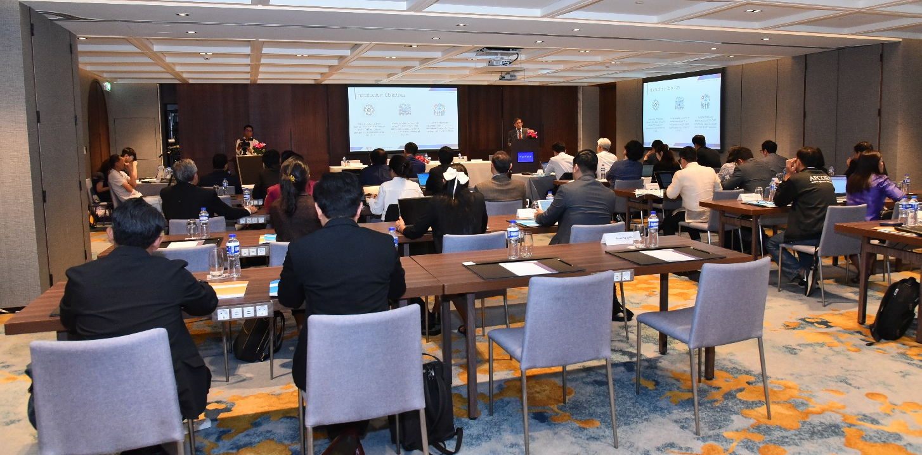
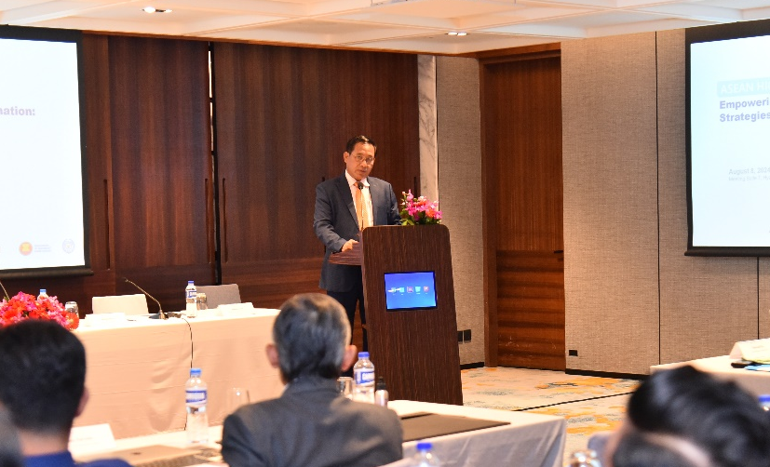
The closing speech was given by H.E. Dr. Hing Sideth, delegate of the Royal Government of Cambodia in charge as the Director General of the Directorate General of MoLVT of Cambodia. He commented that the workshop has brought many useful and important key takeaways from the workshop through the keynote presentations, panel discussion, and inputs from the participants, especially all the suggested recommendations at the end of the dialogue shared during the two-day workshop. Dr. Sideth agreed that the rapid technological innovations and the advent of UR4.0 have brought significant challenges and opportunities for the TVET development of ASEAN Member States. He addressed that the ASEAN countries should strategize on enhancing their quality TVET programs and policies in order they can adapt to the emerging technologies, especially the need to improve TVET trainers and institutions and enhance collaboration between TVET institutions and industries. He commented that the policy dialogue has brought together government officials on education, labor, and TVET and experts from relevant sectors across the ASEAN and TVET research institutions in Korea to discuss policies and strategies for addressing the challenges and opportunities brought about by technological innovation and changes in the labor market within the TVET sector.

