5th International Experts Sharing
Topic: The Scope and Future of Intelligent Technology Applications
On September 20, 2024, SEAMEO TED, Go Study Global Education, CATECP, and the International Youth Culture and Education (KEMG) once again teamed up to host the 5th "International Experts Sharing" meeting. themed "The Scope and Future of Intelligent Technology Application" brought together experts from Thailand, Cambodia, Indonesia, Vietnam, and the Philippines to delved into the topic from various perspectives. The meeting attracted 300 learners from related fields across different countries as a platform for sharing and exchanging ideas.
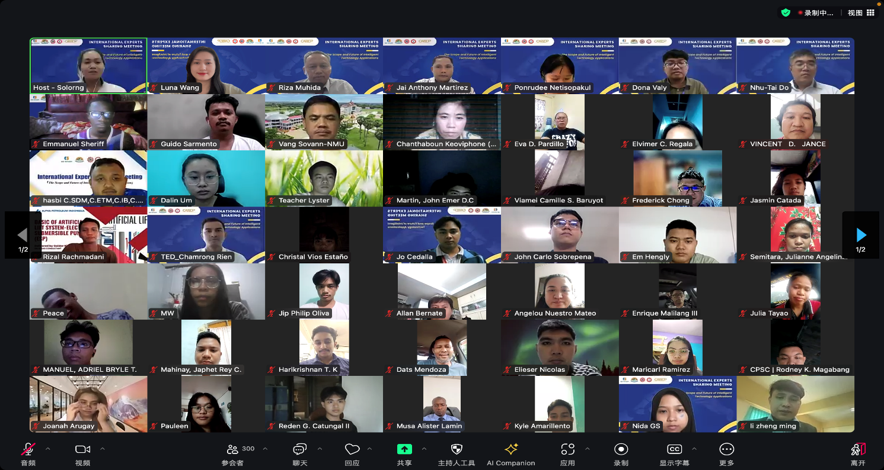

(Group Photo of the webinar)
The opening remarks were delivered by Mr. Pho Mara from SEAMEO TED, he noted that we are standing at a crossroads filled with both opportunities and challenges. As technologies like artificial intelligence, machine learning, and big data continue to evolve rapidly, they are reshaping our lives, work, and even our ways of thinking at an unprecedented pace. He expressed hope that this event would not only inspire new ideas and reflections but also help develop more responsible and forward-looking guidelines for the application of intelligent technologies, contributing to a future shaped by the power of AI.
Sharing Session
Topic:ApplicationofArtificialIntelligenceinTransportation
Dr. Riza Muhida, Director of the Center for Mechatronics and Automation Research at Universitas Bandar Lampung, Indonesia explored the application of artificial intelligence (AI) in transportation and urban planning. He began by introducing AI's role in the transportation sector, including autonomous vehicles, traffic management, and optimization in railways and aviation. He then discussed the concept of "smart cities," which use innovative, integrated, and sustainable solutions to manage city resources and improve citizens' quality of life. AI can address challenges such as population density and traffic congestion in future megacities through traffic management and autonomous driving technologies. Additionally, Dr. Muhida highlighted the potential of drones in aerial transportation and their impact on urban planning, noting that drones could be used for logistics, agricultural spraying, and mapping in the future. Lastly, he discussed Indonesia’s legal framework for drone usage and the wide application of drones in agriculture, logistics, and emergency transportation. He emphasized that AI and drone technologies could effectively solve transportation problems and profoundly impact the spatial planning of future cities.
Topic: Digitalization: A New Phase of Energy Efficiency
Mr. Jai Anthony F. Martirez, Professional Mechanical Engineer from the Philippines focused on how energy audits and Digital Manufacturing Operations (DMO) improve energy efficiency. He explained that an energy audit is an inspection and analysis of energy use aimed at identifying opportunities for energy savings and reducing energy input. He then introduced three standards for energy audits. Moving on to DMO, he explained how technology integrates various functional areas to monitor energy use in manufacturing processes in real time, helping managers make better decisions. Mr. Martirez emphasized the importance of digitalization in driving factory energy efficiency, reducing costs, and achieving zero-carbon goals. Through automated data collection, DMO can analyze equipment performance, energy consumption, and improve efficiency, enabling factories to achieve real-time energy monitoring, equipment optimization, and predictive maintenance. He concluded by discussing the possibilities of improving factory energy efficiency through energy audits and digitalization, offering specific steps for energy-saving implementation and expected outcomes.
Topic: Traditional Natural Language Processing (NLP) Applications vs. Large Language Model (LLM) Applications
Prof. Pornrudee Netisopakul, Associate Professor from the Faculty of Information Technology, King Mongkut’s University of Technology North Bangkok, Thailand compared traditional Natural Language Processing (NLP) applications with Large Language Model (LLM) applications. She explained that traditional NLP applications include theoretical analyses such as sociolinguistic analysis, historical linguistic research, and psycholinguistic studies, as well as practical technological applications like machine translation, speech recognition, and sentiment analysis. She then introduced LLM applications, which cover areas such as natural language reasoning, cognitive modeling, computational linguistics, and privacy protection, while emphasizing emerging fields like cross-cultural considerations, multimodality (the integration of vision and language), and knowledge graph integration.
Topic: AI for Khmer Text Analysis and Language Understanding
Dr. Dona Valy, Associate Professor at the Institute of Technology of Cambodia explored the application of artificial intelligence (AI) in Khmer text analysis and language understanding. He first described the complexity of the Khmer language, including its numerous characters, a wide variety of symbols, and multi-layered arrangements. Based on this, he discussed AI’s role in handling these complex texts, including using deep learning models for text recognition and character classification. He also addressed efforts to synthesize text images and digitize palm-leaf manuscripts for character, word, and text line recognition in Khmer. Dr. Valy showcased research results on character and word localization using the YOLO model for object detection and text localization, and introduced online handwriting recognition and teaching tools designed to help students and teachers verify the correctness of Khmer script writing. He emphasized the importance of computer vision and deep learning in document and text image analysis, particularly in automating document processing, information retrieval, and preserving historical manuscripts.
Topic: Context-Aware Approaches in Deep Learning Models
Dr. Do Nhu-Tai, Lecturer from the Department of Information Systems, Saigon University, Vietnam introduced various context-aware techniques in deep learning research, with a focus on areas such as emotion recognition, medical tumor detection, gesture recognition, and image colorization. He first explored the challenge of emotion recognition, analyzing seven basic emotions (such as anger, disgust, and fear) and demonstrating how context information improves recognition accuracy, especially in cases where facial expressions vary due to cultural, linguistic, or physiological factors. He then discussed research in the medical field, specifically knee tumor detection, using X-rays and MRI images to identify tumors. By developing a multi-level Seg-Unet model that combines global and local image information, tumor detection accuracy was enhanced. Additionally, Dr. Nhu-Tai briefly mentioned gesture recognition and image colorization, highlighting the effectiveness of these models in extracting gesture shape features and understanding the context of image colorization.
