The 7th SEAMEO TED’s Governing Board Meeting (GBM) 2024
17 – 18 October, 2024, Siem Reap, Cambodia

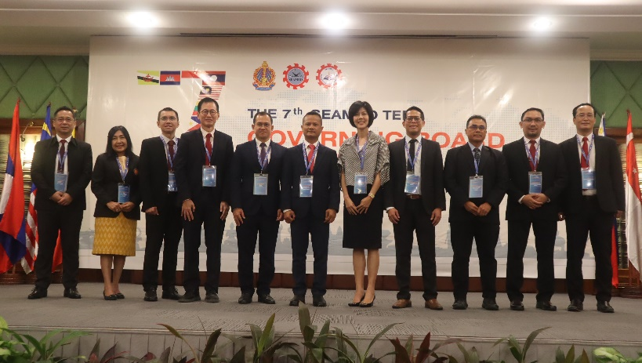
SEAMEO TED organized its 7th Governing Board Meeting (GBM) at Hotel Somadevi Angkor Resort, Siem Reap, Cambodia. The meeting was conducted in pursuit of seeking suggestions, advice, and approval from the Governing Board Members for some essential proposals, action plans, and achievements setting strategic directions for the way forward. The meeting was held in a blended format, with Governing Board Members and representatives from seven SEAMEO member countries—Brunei Darussalam, Indonesia, Malaysia, the Philippines, Singapore, Thailand, and Vietnam—attending in person while the representative from Cambodia participated via Zoom.

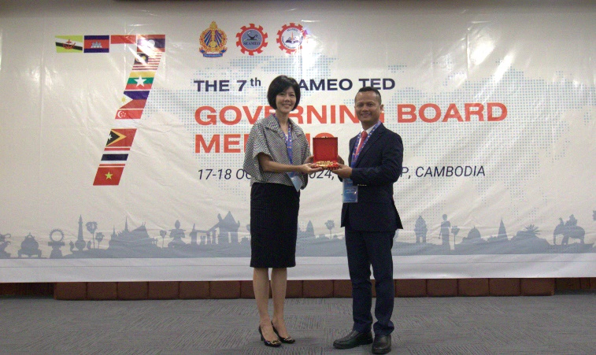
The Opening Ceremony was presided over by H.E. Dr. Kolpheng Vaddhana, Under-Secretary of State, representing H.E. Dr. Hang Chuon Naron, Deputy Prime Minister and Minister of Education, Youth and Sport (MoEYS) of the Kingdom of Cambodia. The ceremony was attended by distinguished guests, including high-ranking officials from MoEYS, delegates, and representatives from relevant departments of other ministries, as well as SEAMEO TED partners.

During the Opening Ceremony, Dr. Songheang Ai, Director of SEAMEO TED, delivered his welcome remarks, expressing deep appreciation and gratitude to the Ministry of Education, Youth, and Sport of Cambodia, the SEAMEO Secretariat, the Governing Board Members (GBMs) and representatives from 11 SEAMEO member countries, as well as all partners and networks for their support of SEAMEO TED. He emphasized the mission behind the establishment of SEAMEO TED in 2017 in Cambodia, which aligns with SEAMEO Priority 4—Promoting Technical and Vocational Education and Training (TVET)—among the seven SEAMEO priorities. Finally, he reiterated the primary objectives of the Governing Board Meeting: to discuss, evaluate, provide suggestions, and secure approval for the working papers.

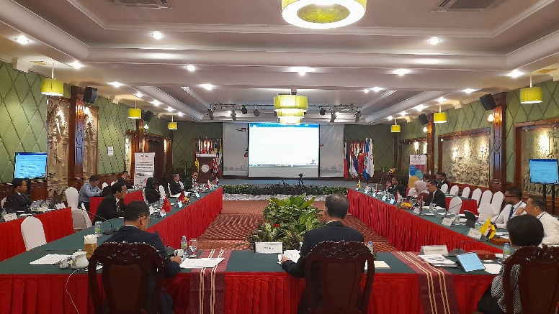
Ms. Pintip Iamnirath, Deputy Director of the SEAMEO Secretariat, was invited to deliver remarks focusing on the importance of the Governing Board Meeting for SEAMEO Centers to ensure that the proposed initiatives respond effectively to regional needs. Lastly, the SEAMEO Secretariat looks forward to the discussion and active participation of Governing Board members during the meeting. H.E. Dr. Kolpheng Vaddhana extended a warm welcome to all Governing Board members in Cambodia. He briefly highlighted the five strategic goals of the Cambodian government for the 7th parliamentary term. Additionally, he emphasized that Cambodia has prioritized the “Pentagonal Strategy Phase 1,” focusing on people, roads, water, electricity, and technology. He further stressed that the digital transformation of TVET has become increasingly crucial. Digital transformation leads to massive changes in the skill sets needed for work and life. Successful use of digital technologies is also a key factor in meeting the Sustainable Development Goals (SDGs). In the Session of Working Paper presentation. Dr. Goh Mong Song, a GB member from Singapore was elected as a chairperson while GB representatives from Brunei and Cambodia were elected as chief rapporteur of the meeting under coordination from the SEAMEO Secretariat. Fourteen working papers that were presented have been discussed, taken note of, and endorsed by all GB members. One working paper was presented by SEAMES namely Significant Points, Agreements, and Actions Taken on Key Agenda Items from SEAMEO Meetings in FY 2023/2024. The thirteen working papers were presented by SEAMEO TED as follows: (1) Matters of Acknowledgement: Endorsement of the List of Governing Board Members 2024/2025; (2) Annual Progress Report for FY 2023/2024; (3) Report on the China-SEA Partnership Workshop; (4) Report on the China-Southeast Asian Capacity Building Workshop on Transforming TVET and Adult Education for Rural Sustainable Development; (5) Report on the TVET Leadership and Management Benchmarking Program II 2024; (6) Report on the Policy Dialogue on Empowering TVET for Digital Transformation: Strategies for a Future-Ready Workforce; (7) Report on Regional Cooperation with TVET Institutions; (8) Proposed Activities for FY 2024/2025: Training Programs and Workshops; (9) Research Study on School Health Influences on Technical Education Students' Learning Outcomes in Cambodia; (10) Proposed International Conference on Applied Research in Education; (11) Proposal for the Annual Centre Operational Plan for 2025/2026; (12) Proposal for the Three-Year Operational Budget Plan for FY 2025/2026–2027/2028; and (13) Proposal on the venue and date for the 8th Governing Board Meeting in 2025. SEAMEO TED management delivered a presentation for each working paper, providing explanations in response to inquiries raised by the Governing Board members. All the working papers were adopted by the Governing Board members for further action. Additionally, the meeting tentatively scheduled the 8th Governing Board Meeting for October 2–3, 2024, in Siem Reap Province, Cambodia.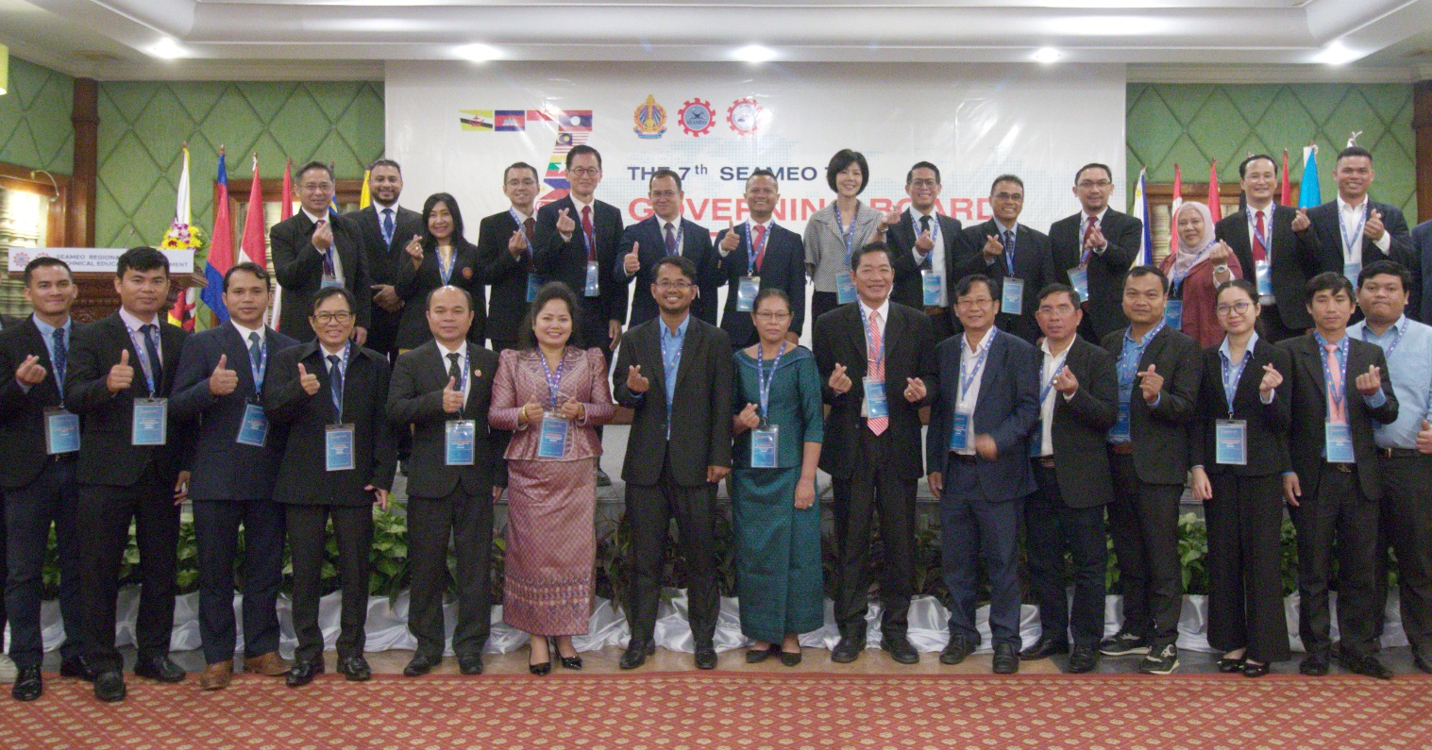(H.E. Dr. Kolpheng Vaddhana, Governing Board Members and SEAMEO TED Management)

