The 3rd International Youth Talk on “New Trends in Global Trade and What Youth Can Learn From”

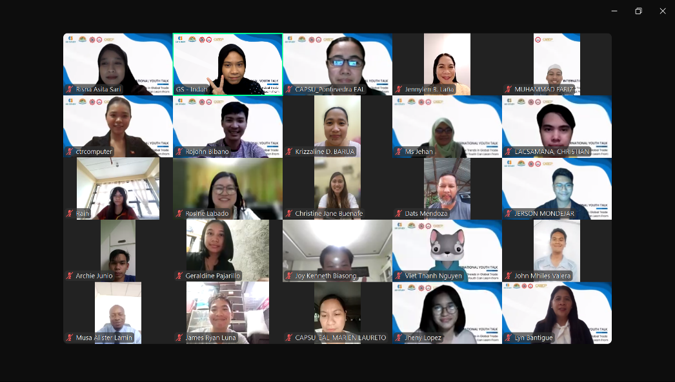
To increase the participation of the global youth community in building a sustainable world, SEAMEO TED, CATECP, and the International Youth Culture and Education (KEMG) co-hosted the 3rd International Youth Talk on “New Trends in Global Trade and What Youth Can Learn From” on October 25, 2024, virtually which participated by 83 participants from the region. This online forum has three main objectives: (1) to discuss emerging trends in global trade and the transformative impact of smart technology on social progress; (2) to explore how artificial intelligence, green technology, and smart transportation shape daily life and drive positive societal change; and (3) to share perspectives on how technology fosters inclusive development and addresses pressing global challenges among youth. Eight students from seven colleges and universities in five countries in the Southeast Asian region namely Cambodia, Indonesia, Malaysia the Philippines, and Thailand were invited to share and discuss their personal perspectives under the theme: “New Trends in Global Trade and What Youth Can Learn From”.
Mr. Voeun Ravy from SEAMEO TED delivered the opening remarks, emphasizing that youth are not only future leaders but also today's innovators and change-makers. He stressed the importance of young people staying informed on global trends, particularly in fields such as artificial intelligence (AI), green technologies, and smart transportation. As these innovations redefine global trends and reshape how we live, work, and connect with each other, he noted that today’s discussion provides a timely opportunity to examine how these transformative technologies can be leveraged to create a more inclusive and sustainable world.
Sharing Session
Teo Yeh Terng, a student from Sultan Haji Ahmad Shah Polytechnic, Malaysia, shared his presentation on "The I-Gen Vision." He focused on topics such as the introduction and core aspirations, the blueprint implementation, future pursuits, outcome catalysis, business development, transformation, impacts on economic growth and society, and the Sustainable Development Goals (SDGs).

Ryan Ferdinan Alvindo and Dennys Jonathan Putra Siagain, students from Tanjungpura University, Indonesia, presented on "Fast Charge with Perovskite." Their presentation covered the background of the problem, an introduction to its potential, reference data, the step-by-step charging process using Perovskite, mathematical calculations, and Perovskite’s energy power conversion system (PCS).

Miss Gisie Baul, a tourism student from Thai Global Business Administration Technological College, Thailand, presented "New Trends in Global Trade." She discussed e-commerce and digitalization through online platforms like Lazada, Shopee, and Shein, along with both the benefits and downsides of digitalization.

Lyn G. Bantigue, MRD, L.Agr., a student from Capiz State University-Burias Campus, the Philippines, presented "The Future of Global Trade." She covered the current landscape and key trends in global trade, case studies on AI in smart agriculture, including a Digital Farmers’ Program, and youth exchange programs.

Risna Asita, a student from PGRI Adi Buana University, Indonesia, presented "The Power of Canva: Boosting Sales in the Digital Age." She focused on understanding the digital landscape where visual content and social media dominate and a mobile-first world. She demonstrated Canva’s user-friendly interface, the creation of impactful social media content, tracking and measuring campaign performance, and concluded by unlocking Canva’s potential for driving sales.

Miss Ouk Sokundalis, a computer science student from Pannasastra University of Cambodia, presented on "New Trends in Global Trade." She discussed e-commerce and e-trade, the advantages and challenges of e-commerce, green technology, and sustainability. Her presentation included case studies on Cambodia’s agricultural trade, farming sites, crop plantations, and transportation, as well as ideas about startups and innovations in Cambodia.

Houie Milfred Durango, a student from Capiz State University-Pontevedra Campus, the Philippines, presented "The Positive Effect of Global Trade." He defined green technology and provided statistics on its usage in the Philippines. He emphasized the goal of achieving net zero emissions by 2050 and expressed his belief that youth hold the power to help realize green technology initiatives.
