One Health Awareness Raising Workshop
for the Project on “Developing Teachers to Raise One-Health Awareness at General and Technical High Schools in Cambodia”
28 October 2024, Kampong Thom Province, Cambodia
The Southeast Asian Ministers of Education Organization Regional Center for Technical Education Development (SEAMEO TED) and the Southeast Asia One Health University Network (SEAOHUN) co-organized One Health Awareness Raising Workshop with teachers and students for the Project on “Developing Teachers to Raise One-Health Awareness at General and Technical High Schools in Cambodia on October 28, 2024 at Kampong Chheuteal Demonstration General and Technical High School, Kampong Thom Province, Cambodia. This workshop was participated by 65 participants, including 9 national teacher trainees, and 1 teacher trainer from SEAOHUN, 10 teachers and 41 students of Kampong Chheuteal Demonstration General and Technical High School. The main objectives of this workshop are to strengthen the teacher trainee’s capacity on One Health, and to raise One Health awareness for teachers and students using One Health training module developed by this project.
During the opening ceremony, Dr. Songheang Ai, Centre Director of SEAMEO TED, stressed the importance of One Health for and particularly this workshop for teachers and students. He also briefly highlighted the project description, and the potential expansion of this project to other general and technical high schools nationwide. Dr. Songheang Ai also emphasized on the priorities of the Ministry of Education and Youth, and Sport and the Royal Government of Cambodia regarding school health.
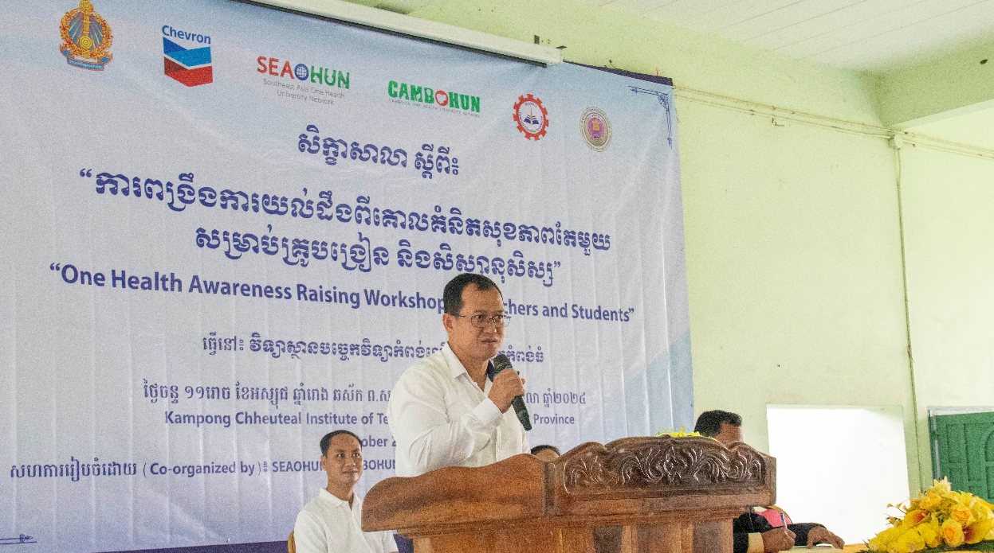

(Dr. Songheang Ai Delivering his Opening Remarks)
In his welcome remarks, Mr. Chan Phearum, Deputy Director of Kampong Chheuteal Institute of Technology, expressed his appreciation for SEAMEO TED and Dr. Songheang Ai, for always engaging Kampong Chheuteal Demonstration General and Technical High School in taking part in activities such as training and workshops and cooperating with Kampong Chheuteal Institute of Technology (KCIT) to host these events. He also stressed the importance of this workshop for his teachers and students at KCIT. Students and teachers need to be more aware of One Health as students are increasingly exposing to health risks from unhealthy diets and food consumption.
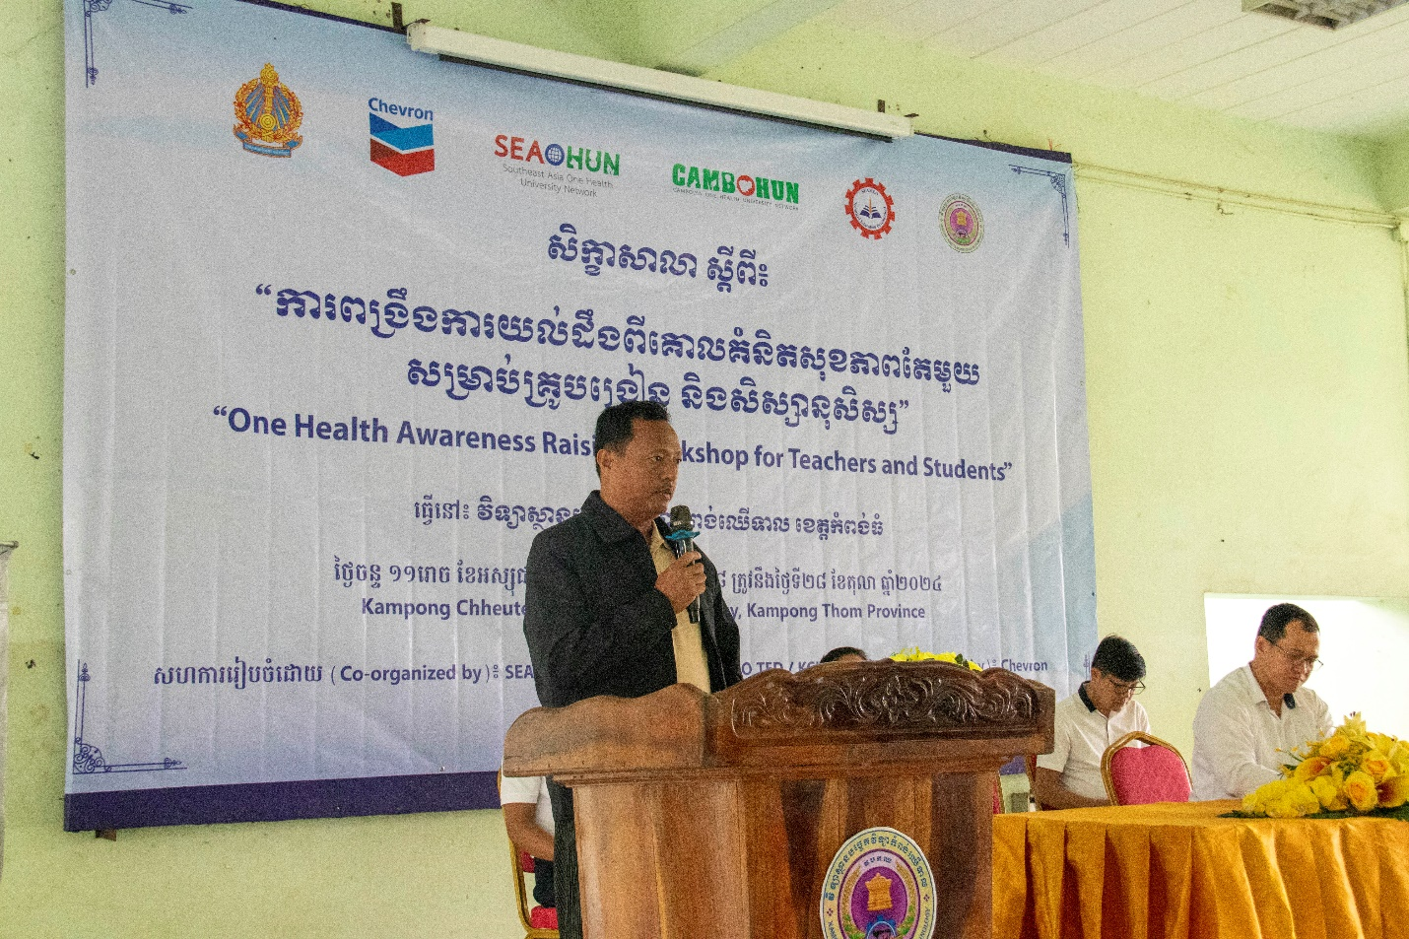
(Mr. Chan Phearum, Deputy Director of KCIT, delivered his Welcome Remarks)

In this workshop, 3 teacher trainees from Kampong Chheuteal Demonstration General and Technical High School, out of a pool of 9 teacher trainees, took the role as trainers to lead the workshop while 6 other national teacher trainees helped facilitate the workshop. The workshop covered five main topics regarding One Health such as definition of One Health, Stakeholders, One Health Competencies, One Health approach to zoonosis and One Health approach to food safety.
This workshop is a part of a joint initiative aimed at enhancing One Health awareness among students, teachers and community members in Cambodia. This project is fully funded by Chevron which strives to empower people around the world to improve their lives, achieve their ambitions and meet their full potential.
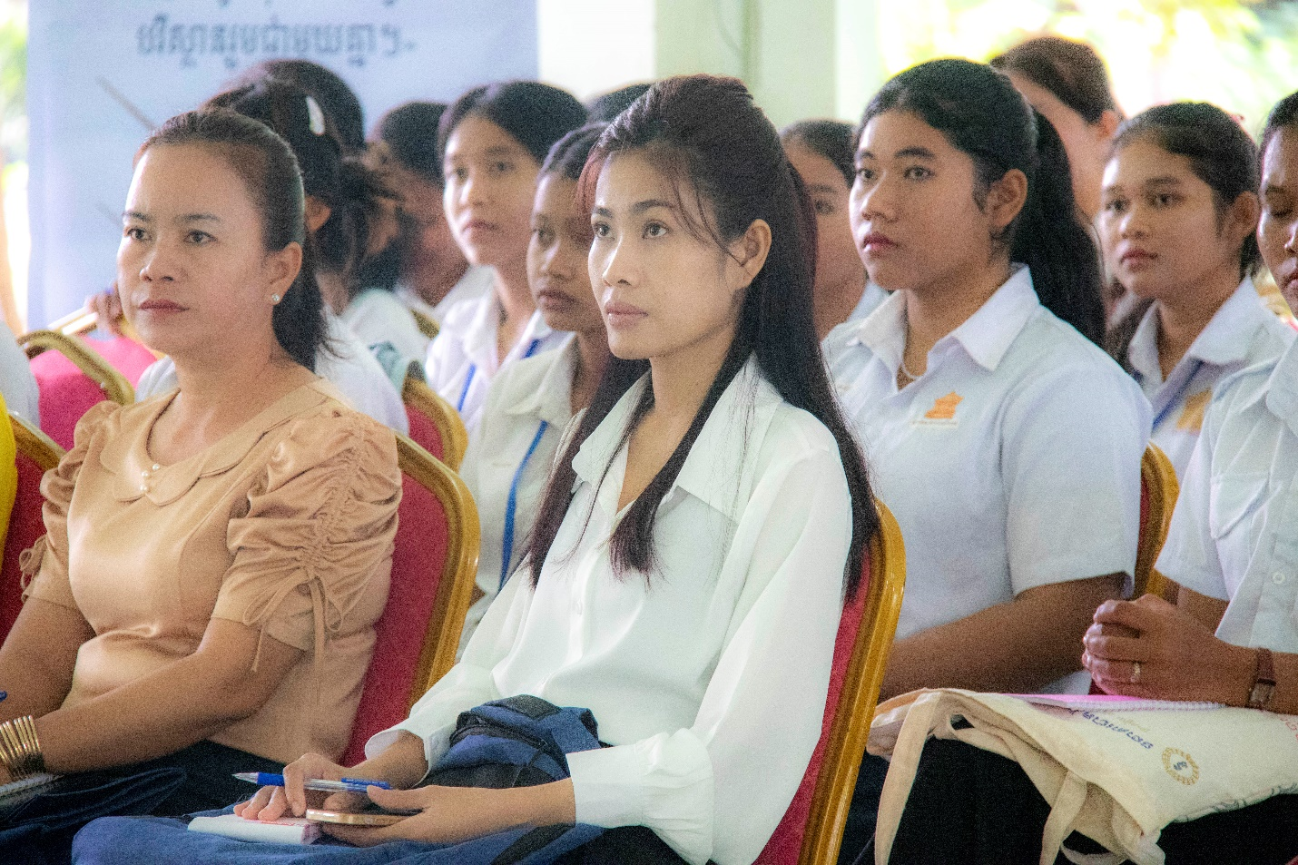
(Participants as Teachers and Students Listening to Lectures)
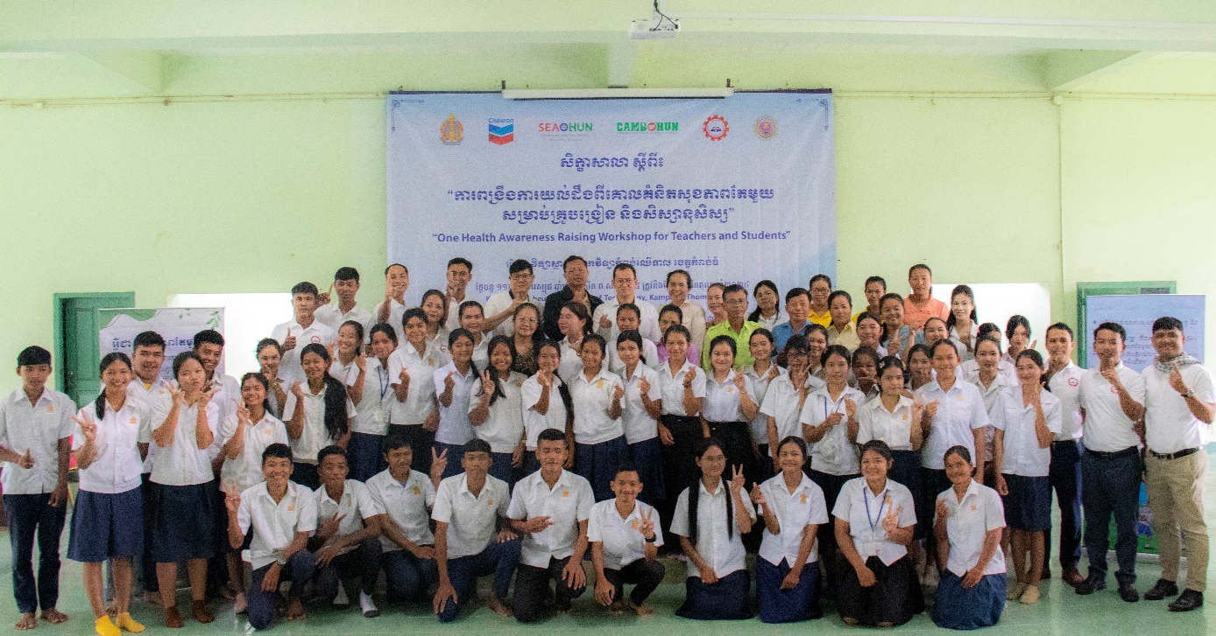

(Group Photo of all Participants)

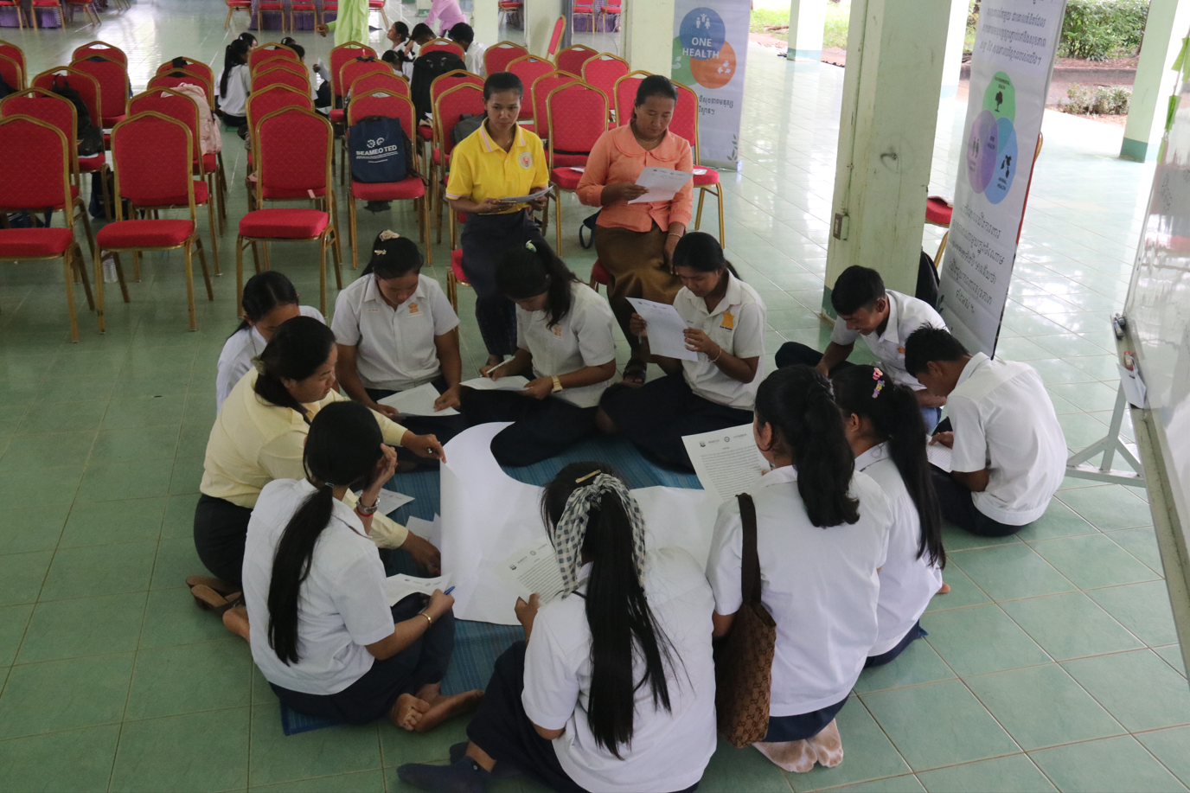
(Group Work of Participants)

