The 6th International Experts Sharing Meeting on "Digital Economy and Global Sustainable Development"
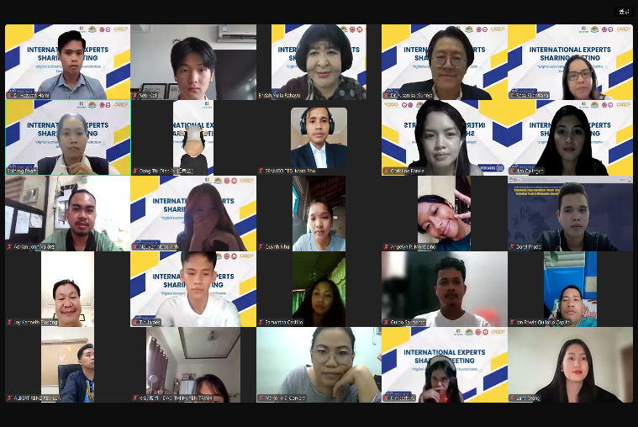
On October 11, 2024, SEAMEO TED, CATECP, and the International Youth Culture and Education (KEMG) co-host the 6th "International Experts Sharing" meeting under the theme: "Digital Economy and Global Sustainable Development". Four experts from Brunei Darussalam, Indonesia, and Thailand were invited to share the topics from various perspectives. The meeting accommodated 224 participants from related fields across different countries as a platform for sharing and exchanging ideas.
The opening remarks were delivered by Mr. Pho Mara from SEAMEO TED, he noted that technologies keep evolving and there are many opportunities and challenges. As technologies like artificial intelligence, machine learning, and big data continue to evolve rapidly, they are reshaping our lives, work, and even our ways of thinking at an unprecedented pace. He expressed his anticipation of the event and hope that our audience will be able to gain useful knowledge from all of our experts.
Sharing Session
Topic: Financial Technology Innovations for Seniors: Creating More Age-Friendly Banking Services
Presenter: Dr. Rosa Rilantiana, Lecturer of Department of Managemen, Universitas International Semen Indonesia
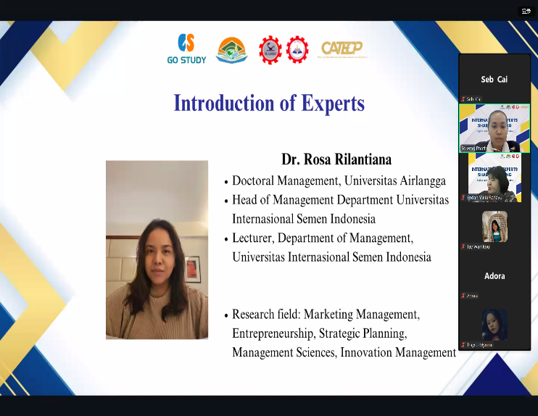
Dr. Rosa Rilantiana emphasizes the importance of making digital banking more accessible to the elderly, a demographic that holds significant wealth yet faces challenges with online services due to physical and cognitive changes. It highlights research conducted on elderly consumers in Indonesia, which identifies ease of use as a crucial factor in adopting digital banking while complexity is less impactful. The presentation calls for financial institutions to improve user interfaces and offers suggestions for enhancing financial literacy among seniors to ensure greater inclusion and usability of digital banking services.

Topic: Digital Economy in Thailand: Ethical Issues and Beyond
Presenter: Dr. Pusanisa Thechatakerng, Lecturer of School of Information, Associate Professor of Marketing, Shinawatra University, Thailand
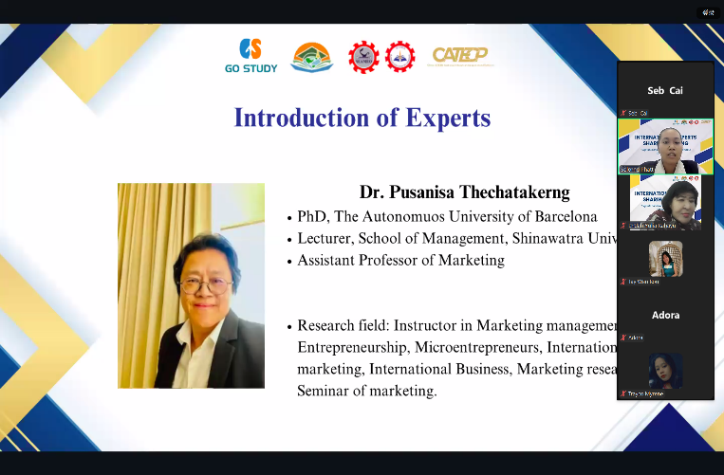
The presentation by Dr. Pusanisa Thechatakerng focuses on the digital economy in Thailand, discussing its development, contributions to GDP, potential growth, and ethical challenges. It also highlights the concept of the digital economy as a response to technological changes and competitive pressures. The presentation continues to outline the future trends like Big Data, AI, and cybersecurity threats, noting the global rise in cybercrime and the increasing need for strong cybersecurity measures. Market challenges include data privacy laws, AI regulation, and cross-border data flows, governed by frameworks such as the Personal Data Protection Act (PDPA) and AI sandbox initiatives. Thailand is also developing ethics guidelines for AI, focusing on transparency, security, fairness, and accountability. Finally, Dr. Pusanisa discussed the need for robust education in cybersecurity and legal frameworks is stressed to navigate the challenges posed by digital transformation.
Topic: Bridging the Digital Divide: A Catalyst for Sustainable Development
Presenter: Dr. Hazwan Haini, Researcher, Head of Economics and Finance Unit, Centre for Strategic and Policy Studies, Brunei
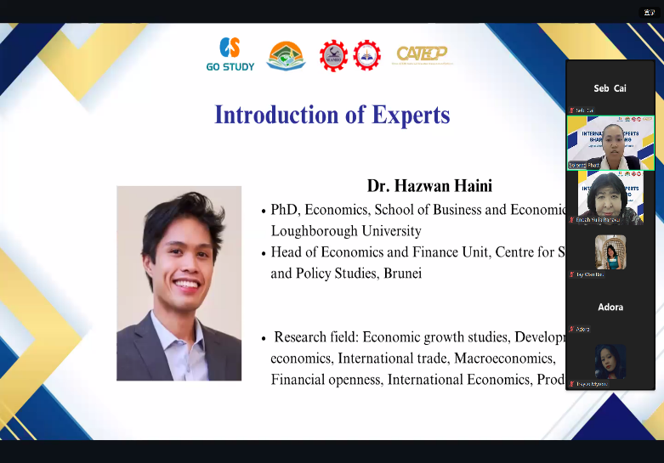
Dr. Hazwan Haini's presentation emphasizes the crucial role of public-private partnerships (PPPs) in addressing digital inequalities in Asia and the Pacific. It highlights the increasing concentration of income and wealth, which contributes to persistent inequalities, exacerbated by the digital divide. This divide, worsened by the COVID-19 pandemic, limits access to essential technologies, particularly in rural areas, hindering progress toward the Sustainable Development Goals (SDGs). The presentation stresses that digital infrastructure is foundational for sustainable development, yet government funding alone is insufficient due to fiscal constraints. Ultimately, Dr. Hazwan Haini concludes that public-private partnerships are essential to bridging the digital divide, balancing the risks associated with foreign investment, and addressing social and economic inequalities through strategic infrastructure development, although the transition to a digital economy may initially widen inequality before creating long-term benefits.
Topic: The Emotional Landscape of Digital Teaching: Exploring the Impact of Technology on Educators' Well-being
Presenter: Dr. Endah Yulia Rahayu, Lecturer of English Language Education Magister at Universitas PGRI Adi Buana Surabaya, Indonesia

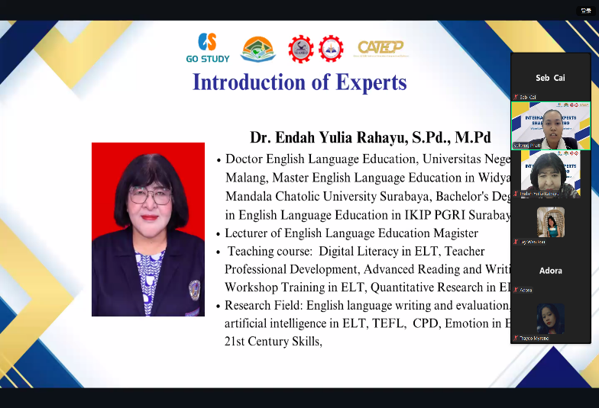
The presentation by Dr. Endah Yulia Rahayu explores the emotional impact of technology on educators' well-being in digital teaching environments. It showcases the complex relationship between teachers' internal factors (like self-efficacy and beliefs about technology) and external influences (such as institutional support and resources) in shaping their experiences. Positive emotions, such as joy and fulfillment, are associated with student engagement, while challenges like inadequate support and stress can hinder well-being. Dr. Endah suggests strategies for improving teachers' emotional experiences, including professional development, emotional regulation techniques, and cultivating supportive online classroom environments. It focuses on the importance of addressing both emotional well-being and technology integration to enhance teaching effectiveness.

