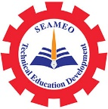

International Experts Sharing Forum on
Building a Brighter Future with Sustainable Tourism
8 November 2024, 14:00-15:30 pm (Phnom Penh Time)

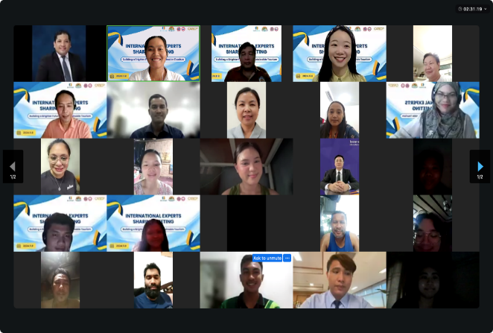
On November 8, 2024, SEAMEO TED, CATECP and International Youth Culture and Education (KEMG), and Go Study jointly hosted the 7th International Experts Sharing Meeting on "Building a Brighter Future with Sustainable Tourism" to explore multifaceted topics spanning education, technology, sustainability, social innovation, cultural exchange, and more. Four experts from the Maldives, Indonesia, Malaysia, and Laos were invited to share their unique perspectives and in-depth analyses related to the theme of the event. This important webinar accommodated 103 regional participants.

Opening Remarks
The Opening Remarks was delivered by Ms. Cheng Chantola, Head of the Administration and Finance Division of SEAMEO TED. She stated that we are living in an ever-changing world, and in the context of the continuous development of the global tourism industry, how to balance economic growth with environmental protection has become a core issue we must address. Sustainable tourism is not just an industry development issue, but also an essential path for us to collectively promote social progress and ecological conservation. She expressed the hope that through today’s discussions, new ideas would emerge for the future development of sustainable tourism, and that together, we could contribute to building a better world.

Presentation Topic: Towards Sustainability: Information Technology for Competitive Advantage of Tourism
Sneaker: Zeenath Solih, Dean of the Faculty of Hospitality and Tourism Studies, The Maldives National University
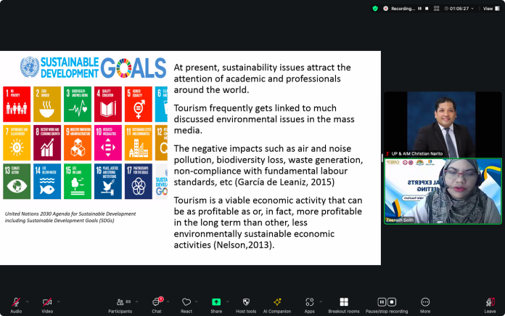
Dr. Zeenath Solih focused on how information technology can promote the sustainable development of the tourism industry. She began by introducing the concept of sustainability and its importance to the tourism sector, noting that tourism is closely linked to environmental issues, often causing negative impacts. However, she emphasized that, as an economic activity, tourism, in the long run, could be more profitable than other unsustainable economic activities. She then discussed the role of information technology in today’s world, highlighting the impact of information and communication technologies in improving market transparency and efficiency. Technology should be seen as a tool to assist efforts in sustainable tourism. By introducing new technologies, such as digital transformation, carbon offsetting, and cloud computing, the tourism industry can open new pathways to sustainability. These technologies not only help improve operational efficiency but also contribute to environmental protection. Finally, Dr. Solih emphasized the concept of digital convergence, which refers to the combination of various technologies leading to significant changes and opportunities. She stressed that businesses need to continuously invest in resources and capabilities to build core competencies, encourage a culture of learning, innovation, and risk-taking, and create new competitive advantages.

Presentation Topic: Marine Tourism and Conservation
Speaker: Mr. Jongky Kamagi, Lecturer at the Tourism Department, Manado State Polytechnic, Indonesia
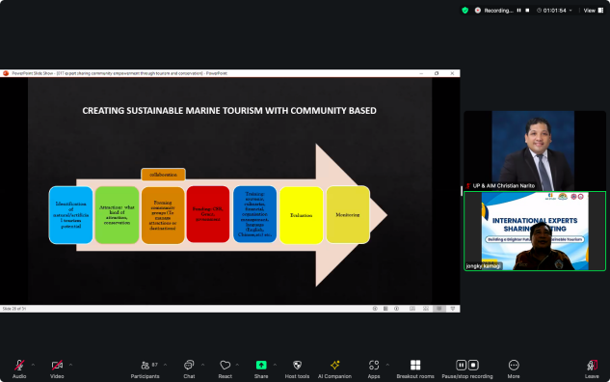
Mr. Jongky Kamagi explored how tourism attractions can drive community development, using the mangrove trail and coral reef projects in North Sulawesi as key examples. In Budo and Tiwoho villages, training programs supported by the UK Skills Prosperity Project, the International Labour Organization, and Indonesia Port Company’s Corporate Social Responsibility initiatives significantly enhanced villagers' entrepreneurial skills, particularly in homestays, financial management, and local products. These efforts resulted in increased income and strengthened community self-development. The Tiwoho village mangrove trail, managed by a local youth group, has become a major tourist attraction, raising environmental awareness. Meanwhile, the coral reef restoration project in Bahoi village is aimed at repairing damaged ecosystems and has received funding from the Ministry of Science, Research, and Higher Education. Mr. Kamagi explained the coral transplantation process, including site selection, module deployment, and the planting of coral seedlings. These projects not only restore marine ecosystems but also provide new income and employment opportunities for local communities. They exemplify the dual value of tourism and ecological conservation, contributing to both environmental sustainability and the diversification of the local economy, while promoting long-term community development.

Presentation Topic: The Challenges of Sabah’s Ecotourism for Local Communities
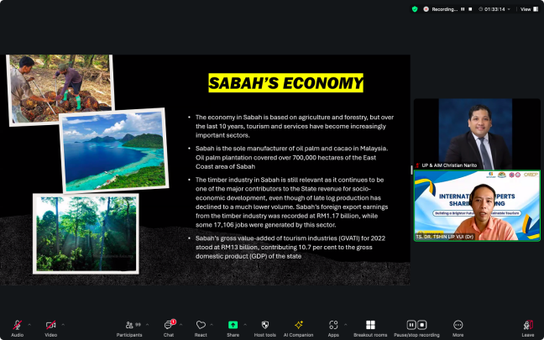
Speaker: Ts. Dr. Tshin Lip Vui, Head of the Department of Tourism and Hospitality, Politeknik Tawau Sabah
Ts. Dr. Tshin Lip Vui discussed the development of ecotourism in Sabah, Malaysia, and its impact on local communities. Located on the northern part of Borneo Island, Sabah has traditionally relied on agriculture and forestry. However, tourism has grown rapidly in recent years and now represents one of the region's key economic drivers. In 2019, Sabah welcomed 4.2 million visitors, nearly doubling the number from a decade ago, showcasing the region’s appeal as an ecotourism destination. Despite this growth, ecotourism in Sabah faces several challenges. Environmental concerns such as habitat degradation, pollution, and over-tourism are significant issues. There are also socio-cultural challenges, with tourism sometimes disrupting local traditions and cultures. Furthermore, local communities are often underrepresented in the tourism industry, limiting their ability to fully benefit from it. Management issues, including inadequate infrastructure and coordination, also hinder sustainable development. Security and safety remain critical concerns, particularly in more remote areas. To address these challenges, Ts. Dr. Tshin emphasized the importance of collaboration among stakeholders, enhancing local community involvement, and adopting responsible tourism practices. By fostering a sustainable and inclusive approach, Sabah can continue to thrive as an ecotourism destination while preserving its natural and cultural heritage for future generations.

Presentation Topic: Sustainable Tourism in the World Heritage Town of Luang Prabang, Lao PDR
Speaker: Dr. Vilayphone Somsamone, Vice Dean of the Faculty of Economics and Tourism, and Director of Souphanouvong University, Luang Prabang, Laos
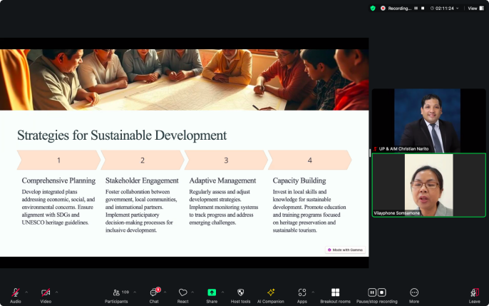
Dr. Vilayphone Somsamone discussed the challenges and initiatives for sustainable tourism in Luang Prabang, Laos, focusing on balancing economic development with cultural preservation. He began by introducing Luang Prabang, located in the mountainous northern region of Laos. With a population of about 630,000, including 76,000 in the urban area, and 12 ethnic groups, Luang Prabang’s economy is predominantly agricultural, with tourism accounting for 30% of its economic activity. Tourism is a key focus for the region’s socio-economic development. Dr. Somsamone then explored the relationship between tourism and the United Nations Sustainable Development Goals (SDGs) through a review of literature, interviews, and document analysis. He highlighted the environmental challenges facing Luang Prabang, such as waste management and water sanitation, and introduced several community-led environmental initiatives. The importance of balancing local needs with tourism development was emphasized. Finally, Dr. Somsamone discussed future opportunities for Luang Prabang, suggesting the development of the town as a regional economic hub in northern Laos. He recommended strategies such as comprehensive planning, stakeholder engagement, adaptive management, and capacity building to achieve sustainable development goals and ensure the long-term success of tourism in the region.

