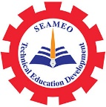

SEAMEO TED paid a Courtesy Visit to Office of the Vocational Education Commission (OVEC) in Bangkok, Thailand
25 November 2024

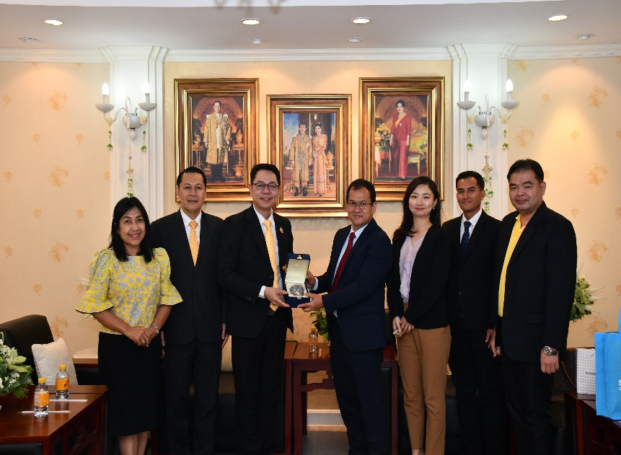
On November 25, 2024, Dr. Songheang Ai, Centre Director of SEAMEO TED and his colleague were warmly welcomed by Dr. Surapong Ermuthai, Director of Bureau of Personnel Competency and his colleagues at Office of the Vocational Education Commission (OVEC) during the courtesy visit in Bangkok, Thailand. This visit was aimed to further explore opportunities for closer collaborations between SEAMEO TED and OVEC in terms of Vocational Education. Both parties had a discussion on developing and resolving vocational education issues, guidelines for future cooperative activities, as well as exchange experiences of vocational education management.

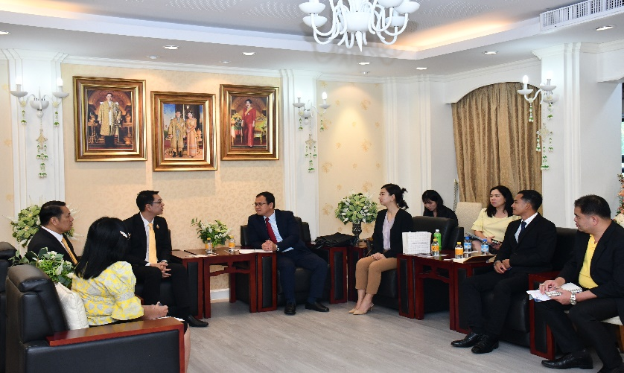
As the results of discussion, OVEC is happy to send its representatives to join and support future activities which are organized by SEAMEO TED such webinars, workshops and online trainings. SEAMEO TED is organizing the China-SEA Partnership Workshop in Phnom Penh next year and it is going to invite OVEC’s representatives to attend that workshop.

