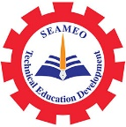

Southeast Asian Ministers of Education Organization Regional Centre for Technical Education Development (SEAMEO TED)

SEAMEO TED Delegation Visiting Cheju Halla University

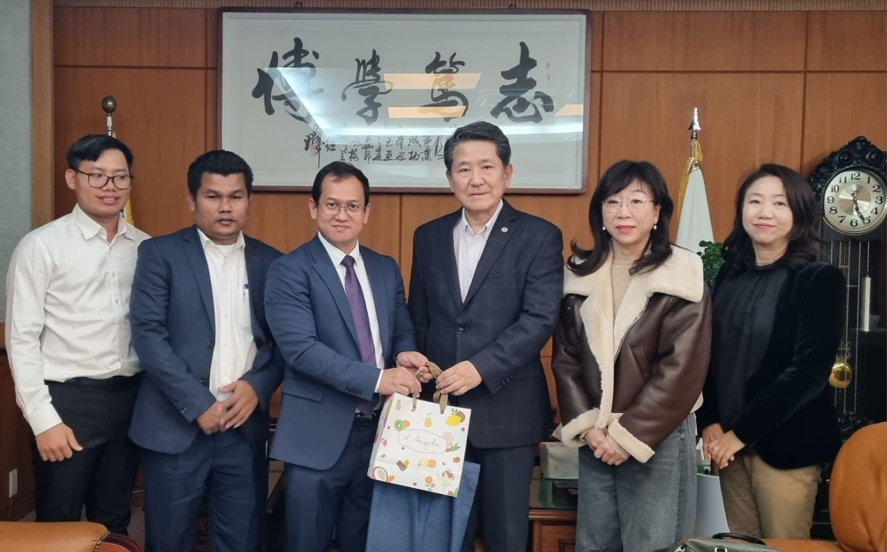
(Group Photo of Gift Exchange)

Jeju Island, South Korea: On December 06, 2024, the delegation of SEAMEO TED led by Dr. Songheang Ai, director of SEAMEO TED has paid an official visit to Cheju Halla University to seek cooperation and partnership among both organizations. The delegation was warmly welcomed by Dr. Sung-Hun Kim, President of Cheju Hall University, Professor Shin Wuikyung, Assistant Vice President, and Dr. Boyoun Lee, Vice Director of Office of International Affairs.

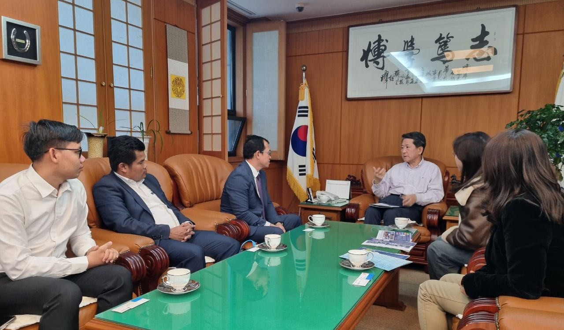
(Discussion on Cooperative Points)

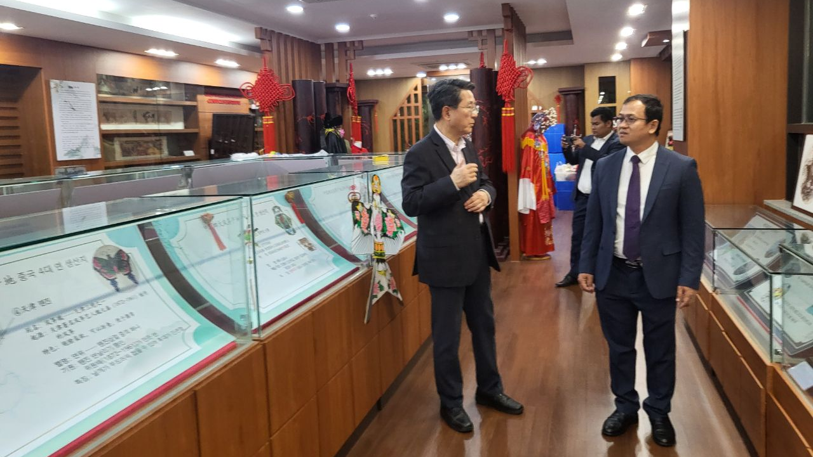
(Visiting Confusion Training Center)

Both parties discuss the cooperative points of actions consisting of co-hosting an international training program, research conferences, workshops, study visits, benchmarking programs, and exchange programs.

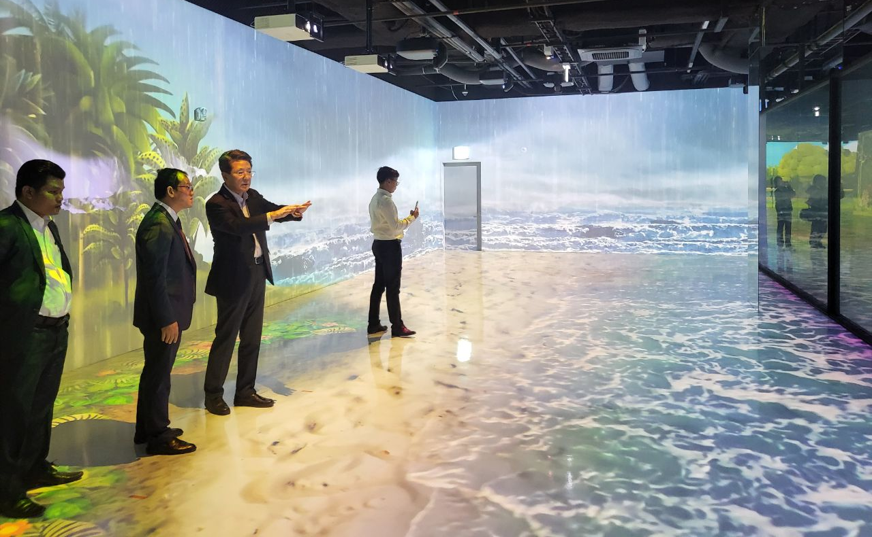
(President Kim Explaining the Graphic Design Assisted by AI)

Specifically, the cooperation might focus on the strength of the university comprising hospitality and tourism, graphic design assisted by artificial intelligence (AI), nursing, and information technology and architecture. Both parties promised to keep in touch working together following the proposed points of cooperation in the future after the visit by appointing the focal points from each party to work closer.
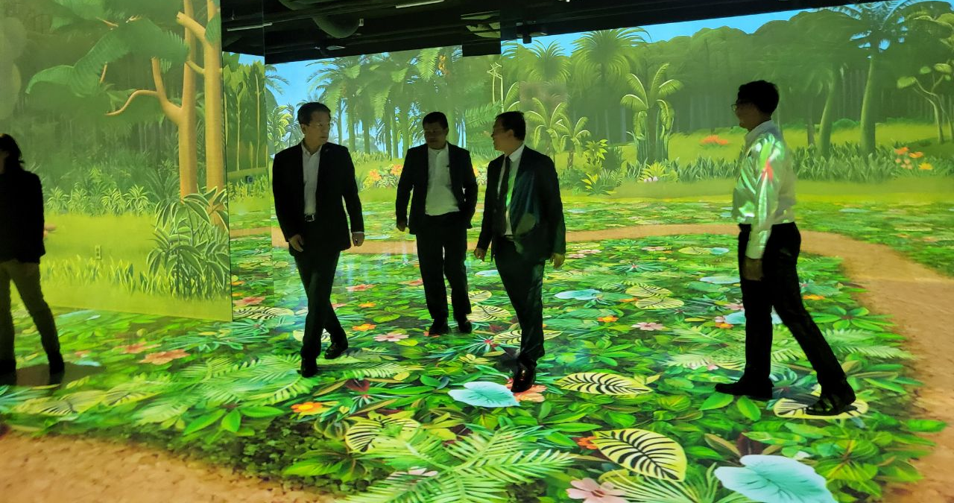
(Visiting Imaginary room Designed by AI)

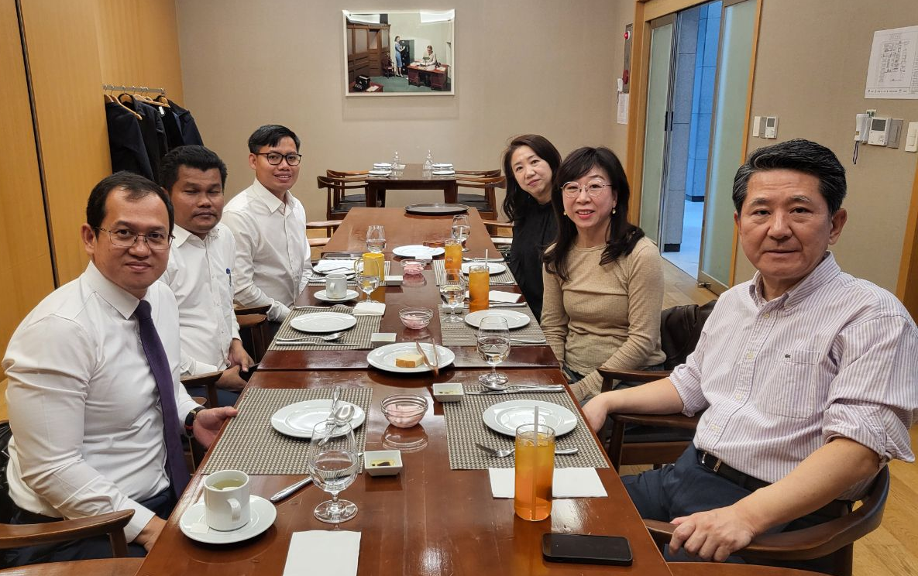

(Welcome Dinner at University Cafeteria)

Finally, the delegation was hospitalized by the welcome dinner at the university cafeteria, served by students of hospitality and tourism as part of on-the-job training programs.

