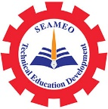

4th International Youth Talk on
Youth Perspectives on Current Trends in Sustainable Tourism: Insights and Innovations
22nd November 2024, 14:00-15:30 pm (Phnom Penh Time)
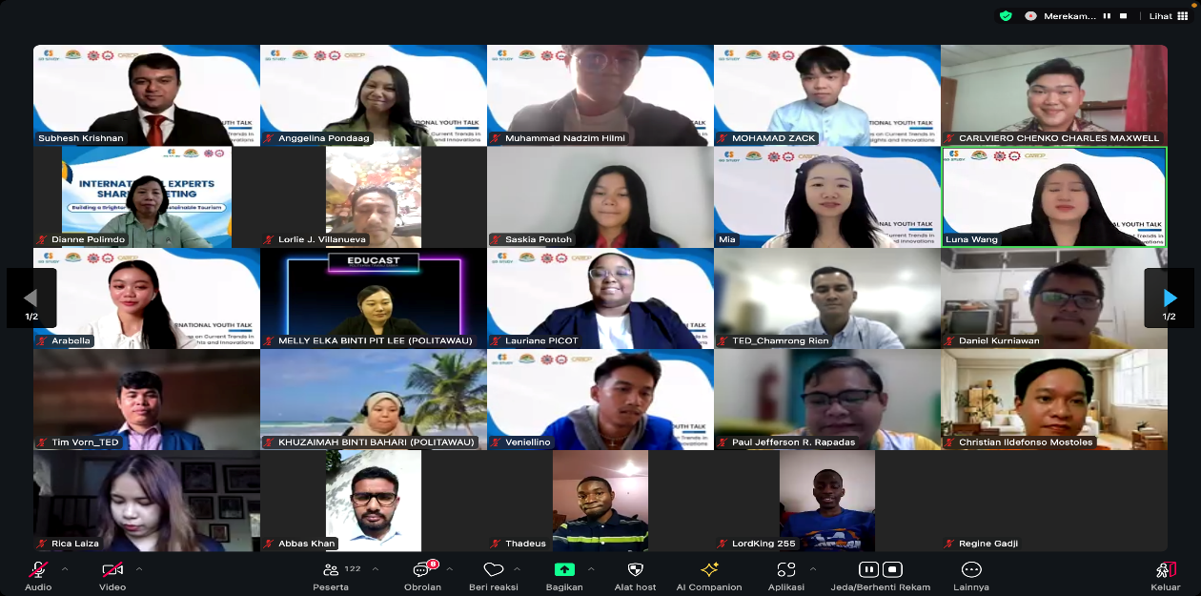
\

(Photo of Participants)
On 22 November 2024 SEAMEO TED, in cooperation with Go Study and International Youth Culture and Education (KEMG) co-hosted the 4th International Youth Talk on "Youth Perspectives on Current Trends in Sustainable Tourism: Insights and Innovations" to explore the concept of sustainable tourism and its current outlook and to examine how advancements in technology, innovation, and emerging economic trends are shaping the future of sustainable tourism. This talk accommodated 123 regional participants. Four groups of students (totally 11 students) from four different countries namely from Laos, Indonesia, Malaysia, and France were invited to share their insights on their topics.

The opening remark was delivered by Mr. Tim Vorn, Head of Research and Development Division of SEAMEO TED. He indicated that this gathering is not only to discuss but also to envision the transformative power of youth perspectives in shaping sustainable tourism. The synergy between innovation, emerging technologies, and sustainability offers us unprecedented opportunities to drive progress in ways that respect our environment and uplift communities.
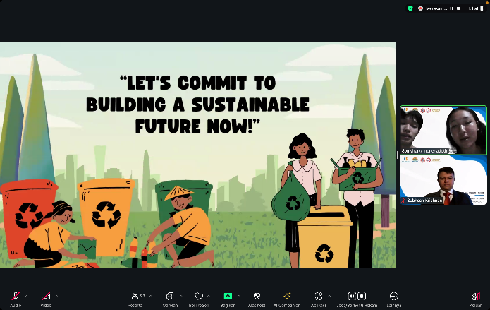
The first youth team from Souphanouvong University, Laos introduced their topic on Sustainable Tourism in Luangprabang. They focused on the definitions of Tourism Sustainability, Environmental Sustainability, and Culture Sustainability. In the conclusion, they pointed out that Luang Prabang can serve as a model for sustainable tourism by combing the practices of Tourism Sustainability, Environmental Sustainability, and Culture Sustainability.
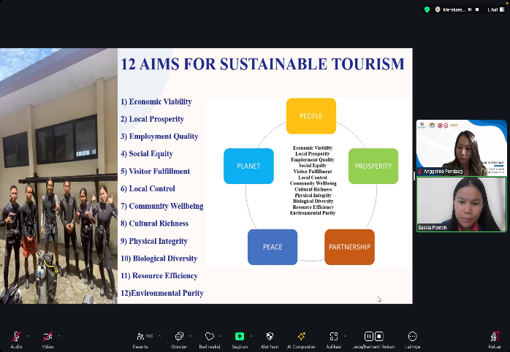
The second team from Manado State Polytechnic, Indonesia presented their topic on Sustainable Marine Tourism. They drew out the definition of sustainable tourism and some important principles in sustainable tourism such as Respecting Culture and environment, Empowering local communities, improving quality of life and ensuring economic sustainability. Their also shared the five pillars of sustainable tourism such as people, prosperity, partnership, peace, and planet. They also highlighted their projects of Innovation of Underwater ecotourism: mangrove restoration and coral transplantation.

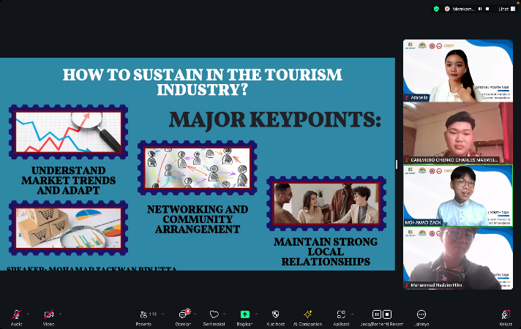
The third team from Politeknik Tawau Sabah, Malaysia focused on Minimizing negative impacts of tourism on the environment, economy and local culture, enhancing natural resources, and promoting cultural heritage for future generations. They also raised the importance of youth perspectives in which they are crucial in influence the travel industry towards greener solutions, shaping the future of tourism, and preferences, value, and innovative ideas for more sustainable practices. They pointed out major key points on how to sustain in the tourism industry such as understanding market trends and adapting to them, networking and community arrangement, and maintaining strong local relationships.
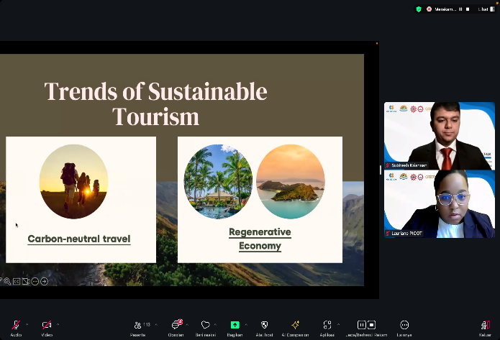
Last but not least, the team from ESSEC Business School, France shared and discussed trends of sustainable tourism: Carbon-neutral travel and regenerative economy. They shared the keys to Carbon-neutral travel such as calculating carbon footprint, offsetting emissions and choose greener options. They also raised up the challenges such as accurate measurement, effectiveness of initiatives and behavioral change

