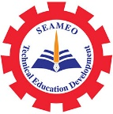

The 8th International Experts Sharing Forum on
Cultural Creativity from Educational Perspective
13 December 2024, 14:00-15:30 pm (Phnom Penh Time)
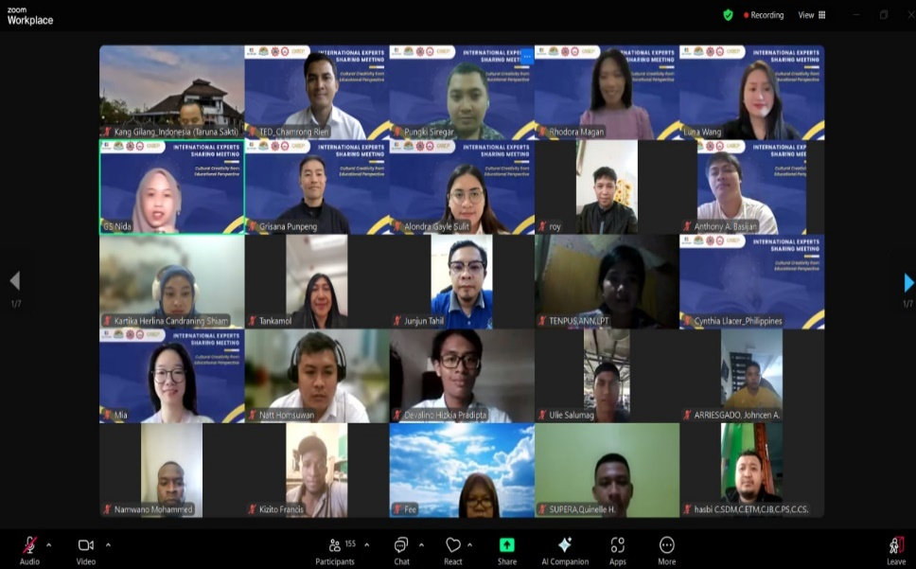
On December 13, 2024, SEAMEO TED, CATECP and International Youth Culture and Education (KEMG), and Go Study jointly hosted the 8th International Experts Sharing Meeting on " Cultural Creativity from Educational Perspective" to explore multifaceted topics spanning education, technology, sustainability, social innovation, cultural exchange, and more. Four experts from Indonesia, the Philippines, and Thailand were invited to share their perspectives and in-depth analyses related to the theme. This sharing meeting accommodated 154 regional participants.

Opening Remarks
The Opening Remarks was delivered by Mr Mara Pho, Head of Technical Education and Training Division of SEAMEO TED. He concluded that culture education in ASEAN is not just about preserving heritage; it’s about creating connections. By integrating cultural studies into our curricula, we empower the youth to appreciate both their own heritage and that of their neighbors. This knowledge fosters respect, empathy, and collaboration—key qualities in building a harmonious and prosperous ASEAN community.

Experts Sharing Session
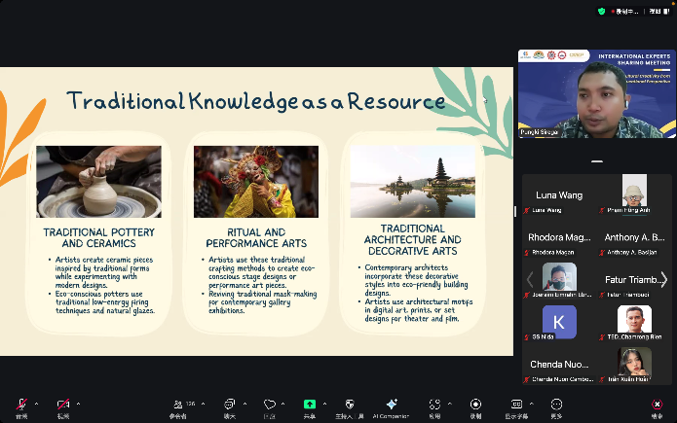
Mr. Pungki Siregar, Lecturer of Visual Art Education of Universitas Negeri Surabaya, Indonesia, presented his topic “Indonesia Traditional Drawing Culture Education”. In his presentation he deliberately shared sustainable creativities- our challenges such as cultural knowledge at risk, perception of obsolescence, Resource constraints. He emphasized the connection between local traditions and sustainability and Sustainable Practices Embedded in Traditions. He also focused on Traditional Knowledge as a Resource- traditional pottery and ceramics, ritual and performance arts, and traditional architecture and Decorative arts. Lastly, he shared Educational Applications: Teaching Sustainable Creativity and Benefits of teaching sustainable creativity- Environmental Awareness, Empathy and Cultural Appreciation and Practical Innovation Skills.

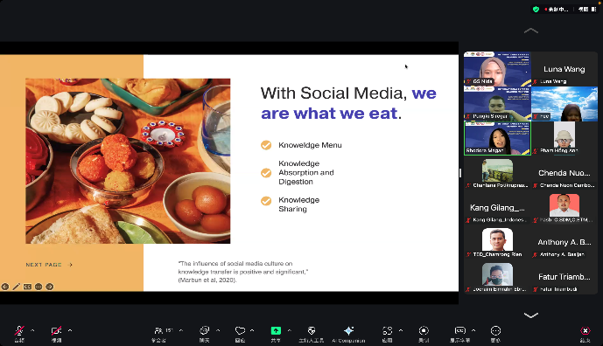
Dr. Rodara Magan, Associate Professor, College of Education, Arts and Sciences of Cebu Technological University, the Philippines, presented her topic “Beyond-class Interaction: Cultural Episteme Incubation through Social Media”. She precisely shared the beyond-class interactions Engagements outside the classroom setting such as mentorship, academic support, collaborative learning, and socialization. She stressed on Cultural Episteme/knowledge/understanding, Cultural Relativism, Social Construction of Knowledge, Cultural Practices and Power and Authority. She also emphasized on The Global Village- Technology, and Cultural Exchange,

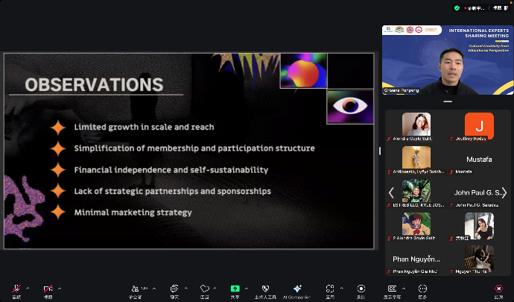
Dr. Grisana Punpeng, Assistant Professor, Faculty of Fine and Applied Arts of Thammasat University, Thailand, presented his topic “Bakhtinian Carnival and the Cultural Significance of the Bangkok Theatre Festival”. He illustrated the development and observations of BTF: Bangkok Theatre Festival. In his observations, he pointed out the limited growth in scale and reach, Simplification of membership and participation structure, financial independence and self-sustainability, Lack of strategic partnerships and sponsorships, and minimal marketing strategy of Theatre Festival. He also provided many recommendations and attempts to improvement. He also stressed on Mikhail Bakhtin's Carnival and its core concepts.

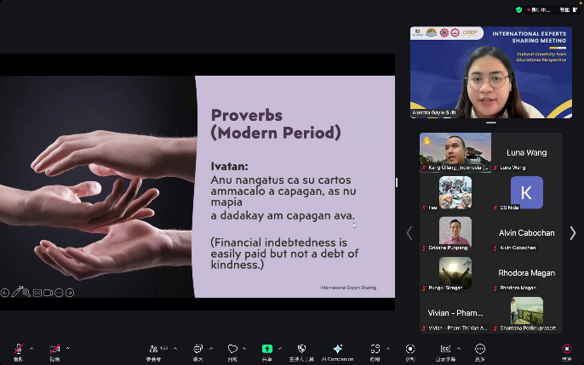
Ms Alondra Gayle Sulit, Asst. Prof, Department of Filipinology College of Arts and Letters, the Philippines, presented her topic “Philippine Short Poems: A Reflection of Filipino Culture and Identity”. She shared the Navigating Poetry in Philippine Literature-Forms and Commonality (Indigenous tradition, Spanish colonial tradition and American colonialism tradition and the contemporary tradition. She also pointed out “From Folk Poetry to Modern Poetry”.

