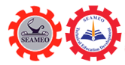

Courtesy Call with Mr. Hadi Tjahjono, Director of Education, Culture and Tourism Division, ASEAN-China Center (ACC)
Beijing, December 20, 2024

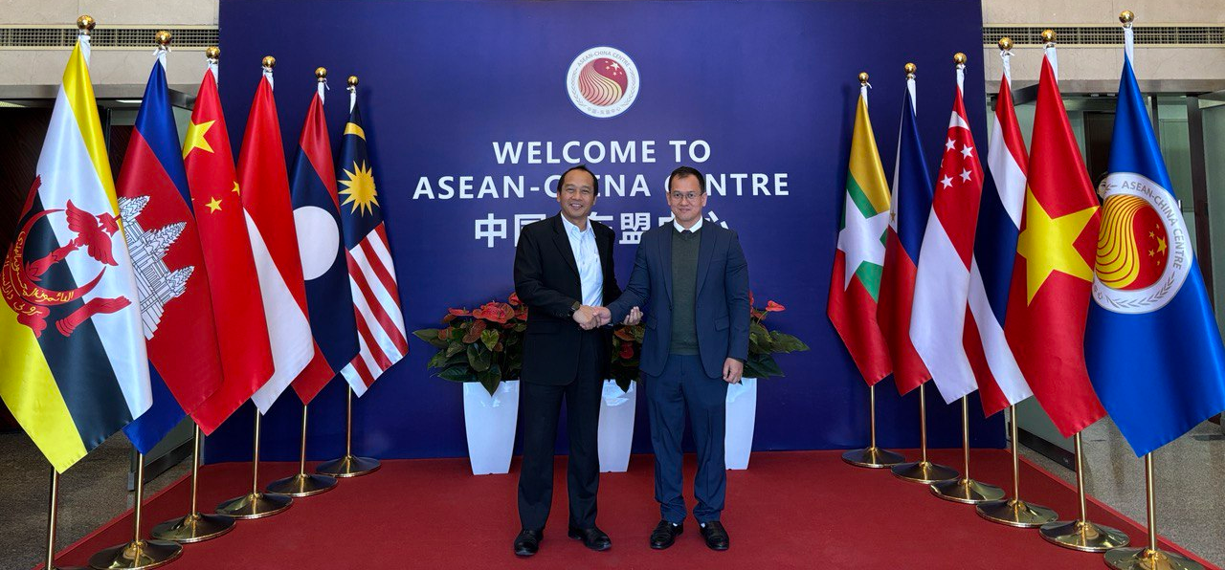
(Dr. Songheang Ai, and Mr. Hadi Tjahjono at ACC Headquarter)

Beijing City, China: On December 20, 2024, Dr. Songheang Ai, Director of SEAMEO TED had a courtesy call with Mr. Hadi Tjahjono, Director of Education, Culture and Tourism Division of ASEAN-China Center (ACC) for purposes to (1) strengthen cooperation and partnership between ACC and SEAMEO TED in terms of resource sharing for some upcoming events in 2025; (2) have deeper understanding of both organizations for shared visions and missions; and (3) seek opportunities to co-organize some events in 2025.

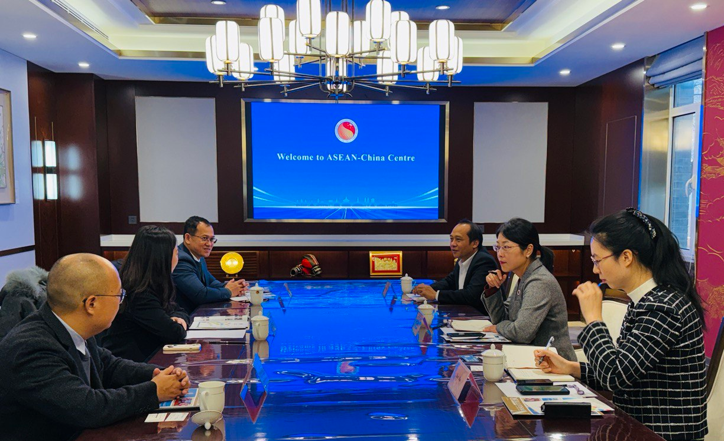
(Discussion between Dr. Ai and Mr. Hadi)

Mr. Hadi Tjahjono offered a warm welcome to Dr. Songheang Ai and his delegates take time to have a courtesy call at ASEAN-China Center (ACC) to highlight our commitments to enhance cooperation on technical and vocational education and training (TVET) between China and ASEAN. Dr. Songheang Ai highlighted some achievements that SEAMEO TED has done with its partnership in 2024 for consideration such as co-organizing TVET benchmarking programs for ASEAN TVET teachers to Beijing in 2023 and 2024, formulating SEA Vocational and Technical High School/College Network for 87 school members from the 11 SEAMEO country members, establishing SEA-TVET program that co-initiated by SEAMEO TED and Guangxi Education Department to support SEAMEO TED for capacity-building programs for teachers, students and administrators, and research and development, organizing some webinars and online learning platforms, online and offline training programs, etc. In response, Mr. Hadi Tjahjono offered high appreciation to SEAMEO TED that has done some ultimate achievements for the ASEAN region subsequently for TVET field. He also underlined some highlights that ACC has achieved with its partners consisting of faculty and students exchange programs between China and ASEAN, capacity-building programs for TVET teachers, co-organizing China-ASEAN Education Cooperation Week, etc. Dr. Songhean Ai gave high respect to the leadership and management of ACC for achieving some activities between ASEAN and China bridging the close relationship among the two regions. Dr. Ai also informed Mr. Hadi Tjahjono that SEAMEO TED is under progress in drafting its an annual work plan 2025 that if ACC has any cooperative events that we can organize together, SEAMEO TED will inject them into the draft plan. In response, Mr. Hadi Tjahjono will inform Dr. Ai later if ACC has any events that can be organized cooperatively in 2025.

Finally, both organizations were committed to working cooperatively for TVET development between China and ASEAN.

