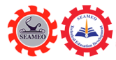

Co-Organizing the International Conference on Applied
Research in Education (ICARE 2025)
Nay Pyi Taw, January 09-10, 2025
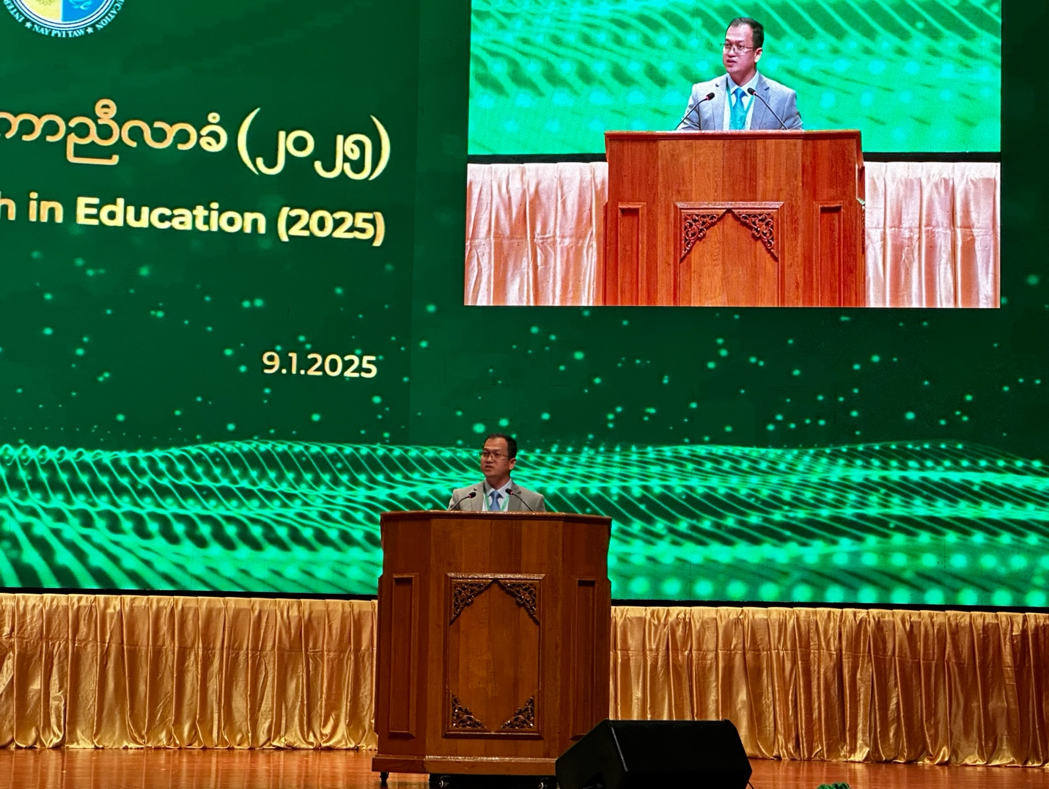
(Dr. Songheang Ai Delivered his Keynote Speeches)

Nay Pyi Taw, Myanmar: Dr. Songheang Ai, director of SEAMEO TED, has co-organized the International Conference on Applied Research in Education (ICARE 2025) to be held in Nay Pyi Taw on January 09-10, 2025 participated by over 2,000 participants from 14 countries consisting of Cambodia, Indonesia, Laos PDR, Malaysia, Myanmar, the Philippines, Thailand, Vietnam, Russia, Bangladesh, India, China, Japan, and South Korea. Some regional and international organization representatives also joined the conference. The theme focused on “Navigating the Future: Education, Science, and Technology for Brighter and More Prosperous Societies”. Its objectives are (1) disseminating research findings related to applied research in education; (2) identifying educational challenges and proposing solutions; and (3) promoting collaboration and partnership. During the conference, Dr. Songheang Ai, delivered the keynote addresses focusing on his past experiences in research and development, and motiving participants to actively engaging in Q and A session for learning and sharing as the members of community of practice (CoP). Dr. Ai highlighted that “Research is a critical factor to diagnose educational challenges and problems and propose recommendations as solutions to the challenges so that it needs to be scientific empirically”.

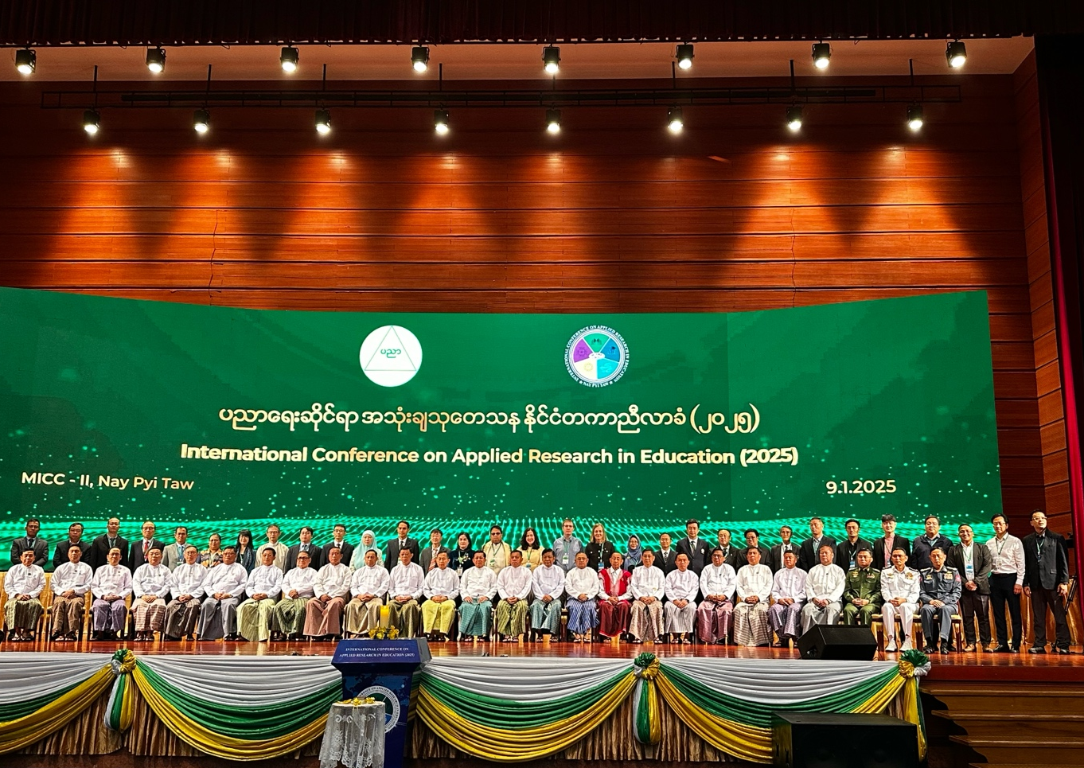
(Group Photo of VIP Participants)

He also raised four purposes of research and development (R&D) consisting of (1) for informed decision-making; (2) for policy formulation; (3) for publication and sharing; and (4) for knowledge acquisition. He shared his research writing experience that he applied to present his manuscript at the 2nd International Conference on Multidisciplinary Academic Research in Bali, Indonesia in 2019 that his paper titled “Teamwork Skills Boils Over in Cambodia”. After the presentation, his paper was awarded the No. 1 outstanding paper in education track, but if he reflects and compares its quality with the present status, his paper needs more improvement. Therefore, he encouraged all speakers to admit any constructive feedback from the audience and improve some points for more scientific before publication.
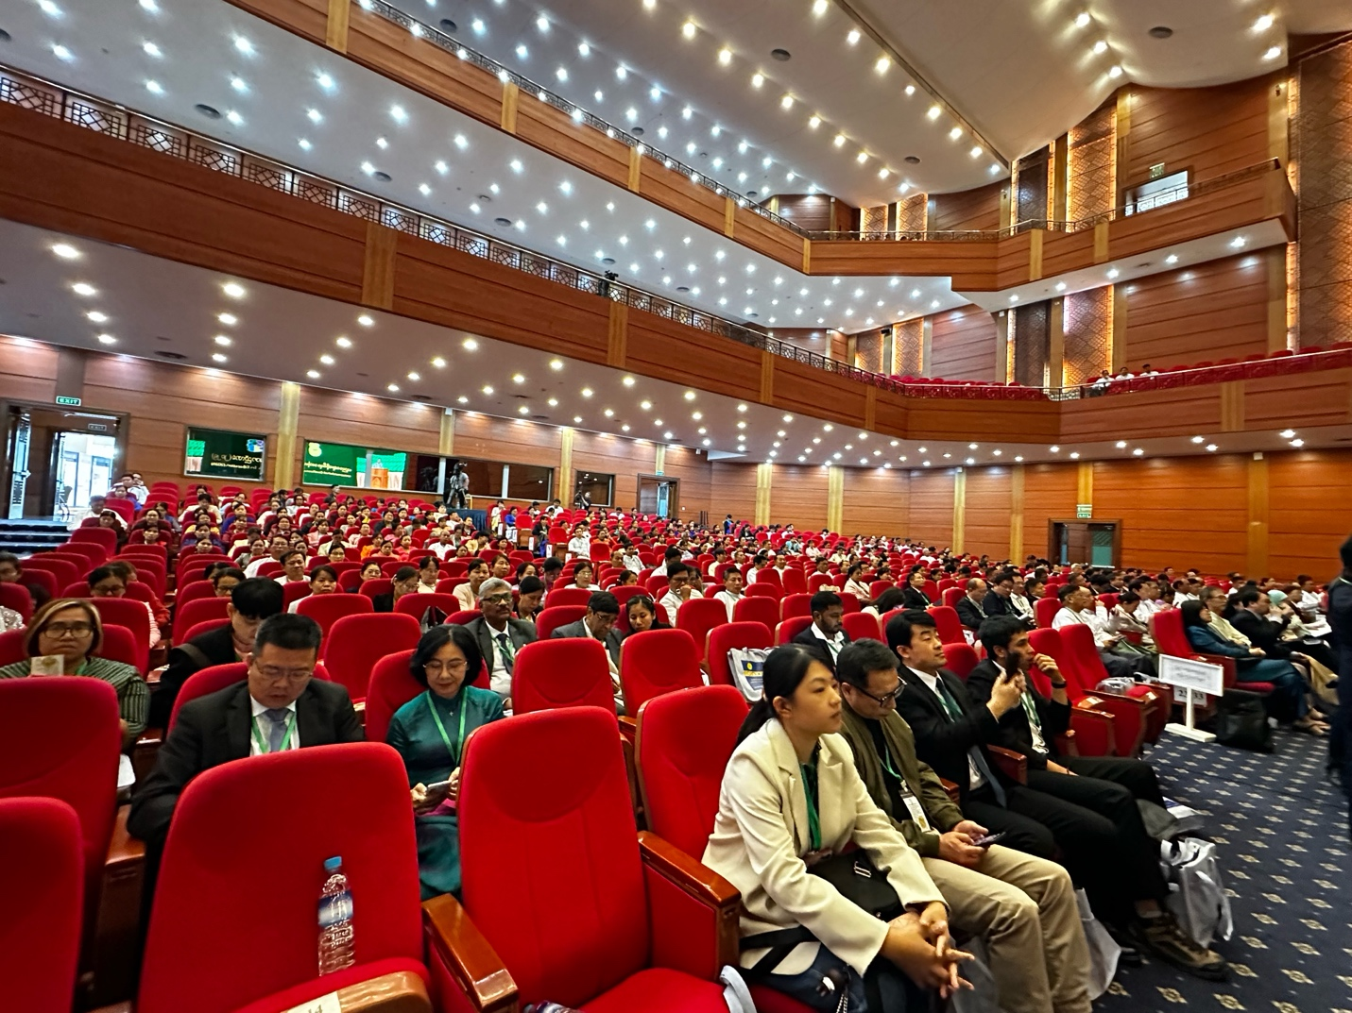

(Participants at the Conference)

Finally, as a co-organizer of ICARE 2025, Dr. Ai got a prestigous gift from deputy prime minister of Myanmar for his tremenous contribution and engegement in the conference as a representative of international organziation during a Gala Dinner on January 10, 2025.
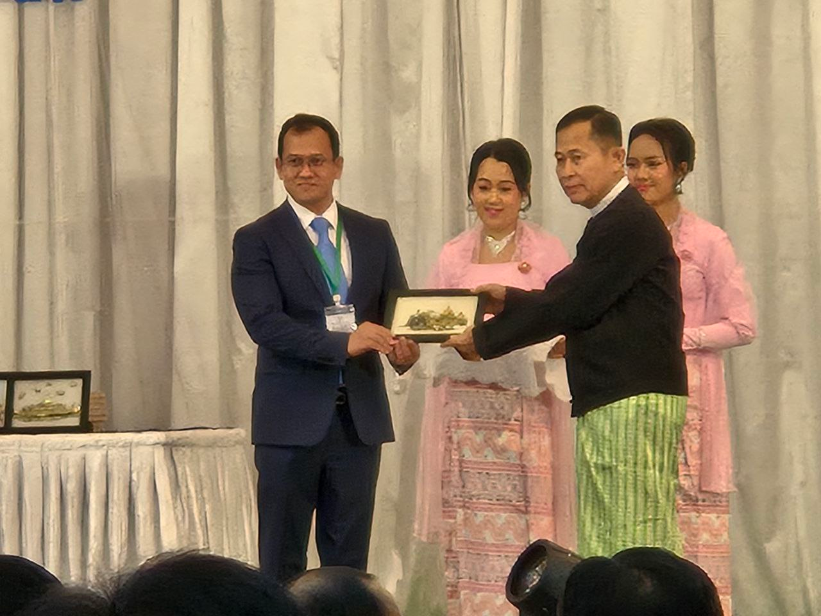

(Dr. Ai Got Prestigious Gift from Deputy Prime Minister of Myanmar)

