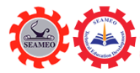
One Health Awareness Raising Activity in the community of Bavet General and Technical High School for the Project on “Developing Teachers to Raise One-Health Awareness at General and Technical High Schools in Cambodia”
Bavet City, January 19, 2025

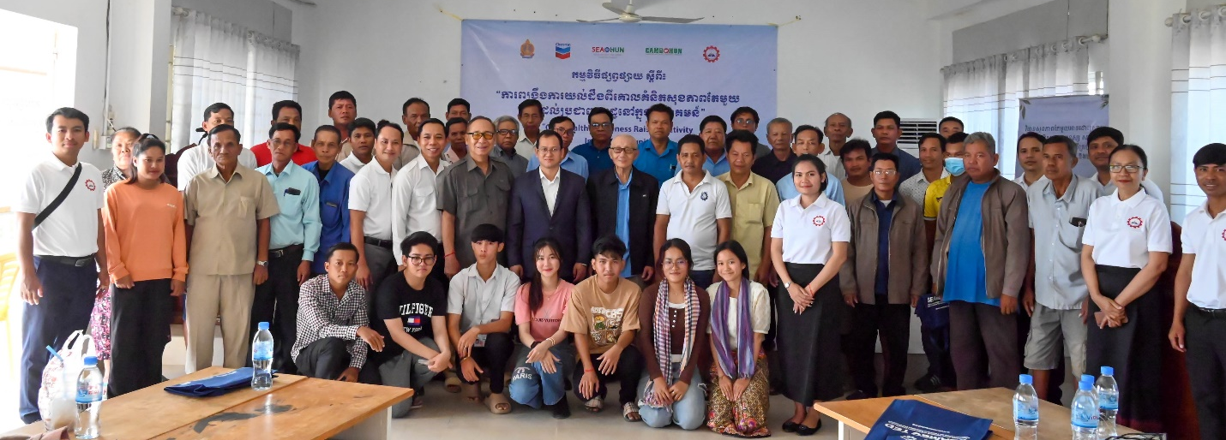
Group Photo during the Opening Ceremony
Bavet City, Svay Rieng Province: The Southeast Asian Ministers of Education Organization Regional Center for Technical Education Development (SEAMEO TED) and Southeast Asia One Health University Network (SEAOHUN) co-organized One Health Awareness Raising Activity in the community of Bavet General and Technical High School for the Project on “Developing Teachers to Raise One-Health Awareness at General and Technical High Schools in Cambodia on January 19, 2025. This event was carried out in Sangat Bavet, Bavet City, Svay Rieng Province, Cambodia, participated by over 59 people including 50 community members, 06 students, 03 national teacher trainees of Bavet General and Technical High School, 01 teacher trainer from CAMOHUN, 01 trainer from the Ministry of Education, Youth and Sport, and 05 representatives from SEAMEO TED. The main objectives of the activity are to raise One-Health Awareness for the community at the target school of Bavet General and Technical High School with an emphasis on One Health Measure to “Rabies” and to strengthen the teacher trainee’s capacity regarding the application of One-Health training module of the project.

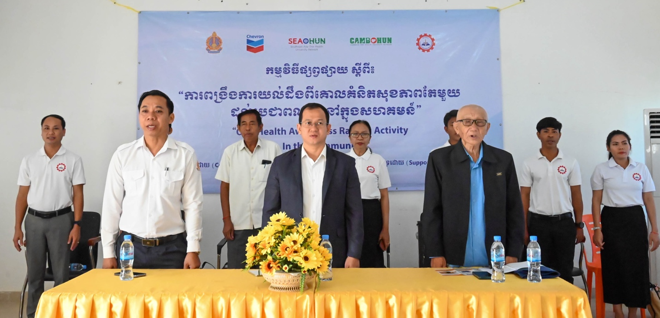
VIP Participants during the Opening Ceremony

In his opening remarks, Dr. Songheang Ai, Centre Director of SEAMEO TED and the project manager, welcomed all the participants to the event and explained the participants “what is One-Health?” He stated that it referred to an approach by which relevant stakeholders worked together to prevent and address health problems with consideration of the interconnectedness of the human, animals and environment. For human to have good health, the animals and the environment must be in good health as well. He also stressed the importance of One Health for students as it is an important factor in determining students’ health which is also a critical factor affecting students’ academic performance. He also highlighted food safety for the participants as our society is experiencing pressing health issues, such as unhealthy food and excessive sugar intake from energy-consumption drinks as well as other sugary drinks. Dr. Ai encouraged all the participants to lead an active and healthy life by doing physical exercises and stick to healthy diet.
In his concluding remarks, he appealed to all the participants to engaging in the event fully and actively to learn about One Health, and Rabies prevention, and share this information to other family and community members to raise One Health Awareness and to potential rabies cases in their communities.
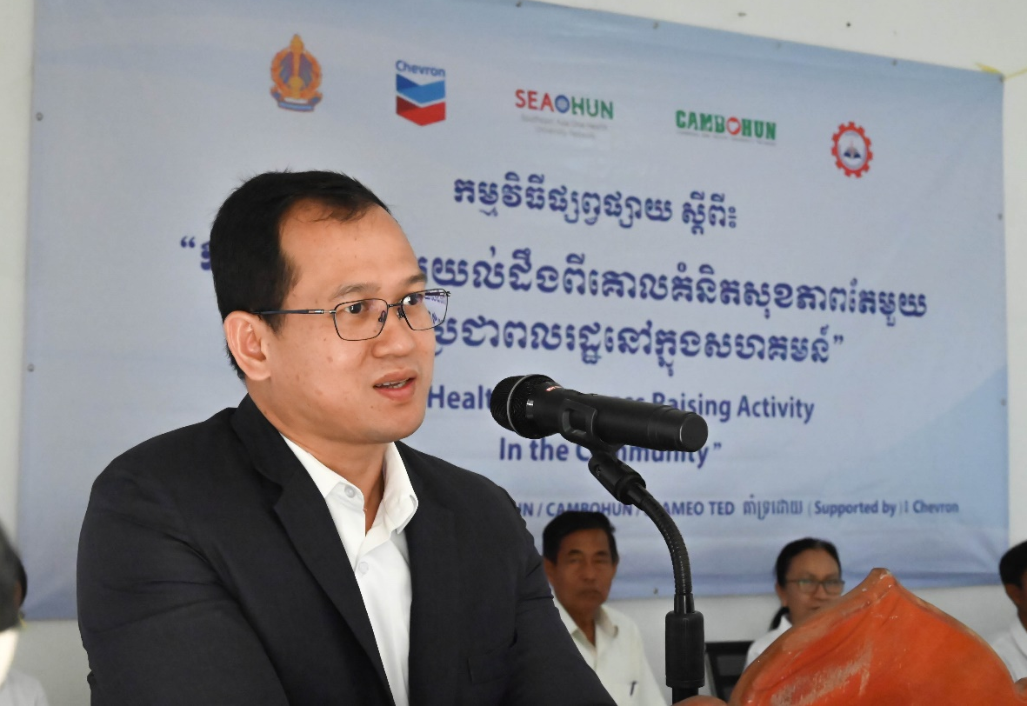
Dr. Songheang Ai, Centre Director of SEAMEO TED, Delivered his Opening Remarks

In his welcoming remarks, Mr. Kao Saran, Deputy Chief of Sangkat Bavet, on behalf of the Chief of Bavet commune, expressed his delight and welcomed distinguished guests and all the participants to this event. He expressed his appreciation for SEAMEO TED, its partner, SEAHOHUN and Bavet General and Technical High School for organizing such event for his communities of five villages namely Ta Pov, Tabeb, Chrak Leav, Bavet Leu, and Bavet Kandal Villages. In his concluding note, he wished everyone with four gems of Buddha blessing: Longevity, Nobility, Health, and Strength.
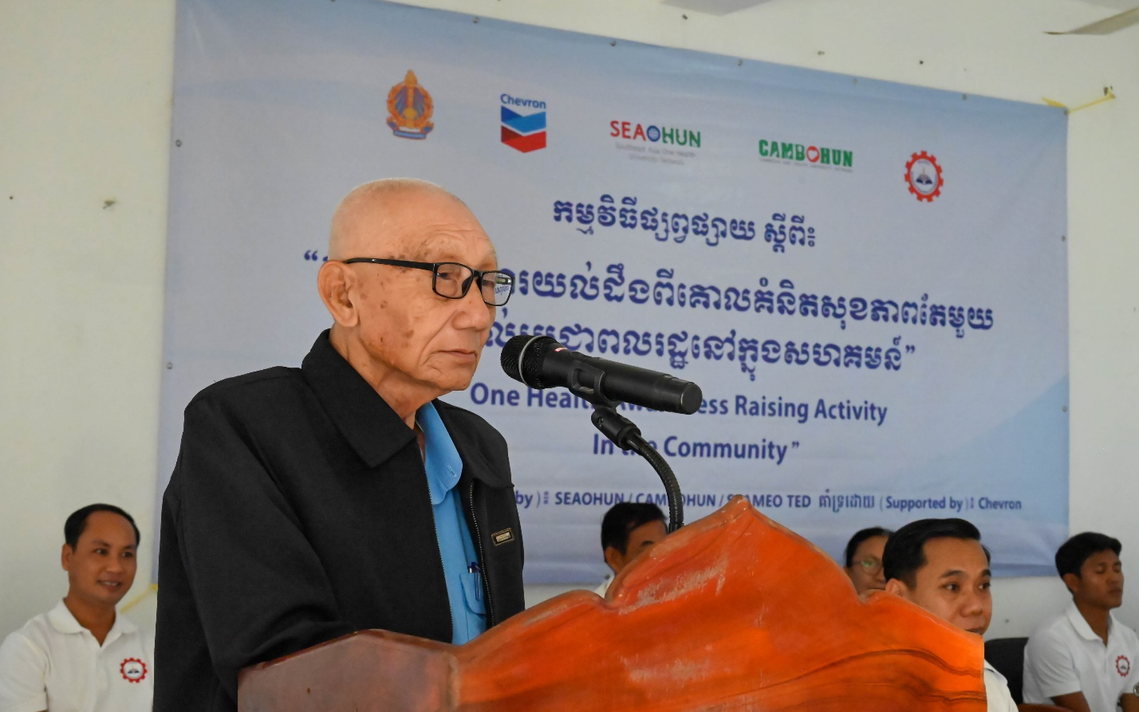
Mr. Kao Saran, Deputy Chief of Bavet commune, Delivered his Welcoming Remarks

In this event, 3 teacher trainees from Bavet General and Technical High School took the role as trainers to lead the activities with the assistance of 6 students of Bavet General and Technical High School who joined One Health Awareness Raising workshop organized on the 22nd of November 2024 at Bavet General and Technical High School. The event covered the introduction to One Health and One Health approach to zoonosis with an emphasis on One Health Measure to “Rabies”
This event consists of two parts—the workshop in the morning and the leaflet distribution campaign in the afternoon. In the morning, all the participants gathered in meeting hall of Bavet General and Technical High School to learn about the introduction to One Health Concepts and One Health approach to zoonosis with an emphasis on One Health Measure to “Rabies”. There was also a skit about rabies performed by the six students, which was a highlight of the morning. In the afternoon, the trainers covered information on the Rabie Fliers to all the participants and after that all the participants were divided into 3 groups. With the knowledge of about One Health, they obtained, and leaflet given, all the participants set out in different directions in Sangkat Bavet to distribute Rabies leaflet and educate the community members about One Health and how to tackle rabies. During the campaign there were about 550 leaflets were handed out to community members.

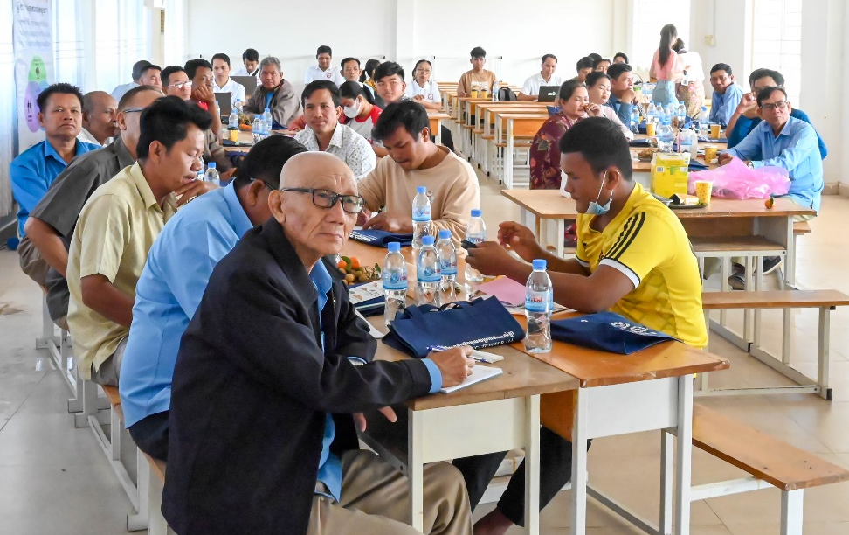
Participants during the Workshop
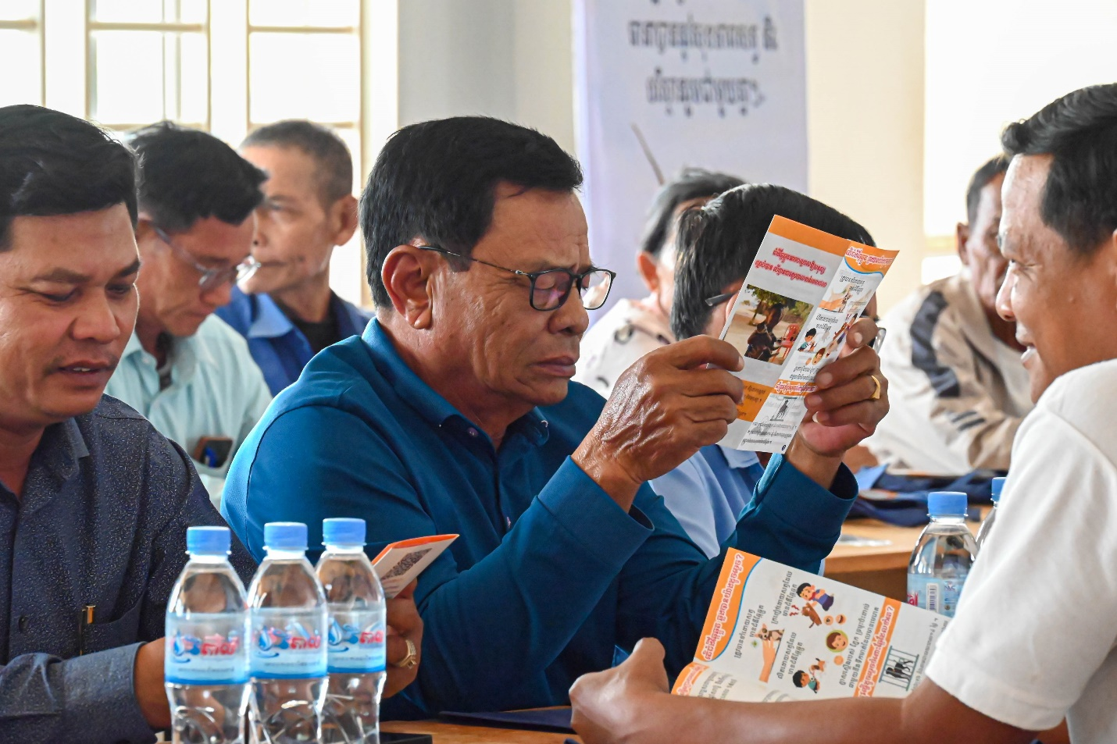
Participants learning about the Rabies Leaflets

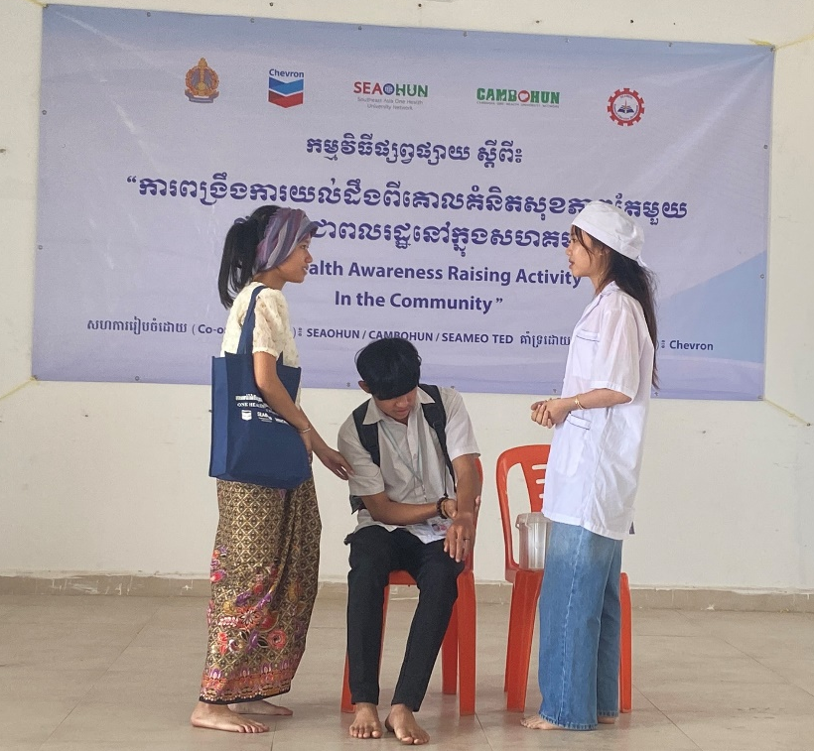
Students Performing a Rabies Skit

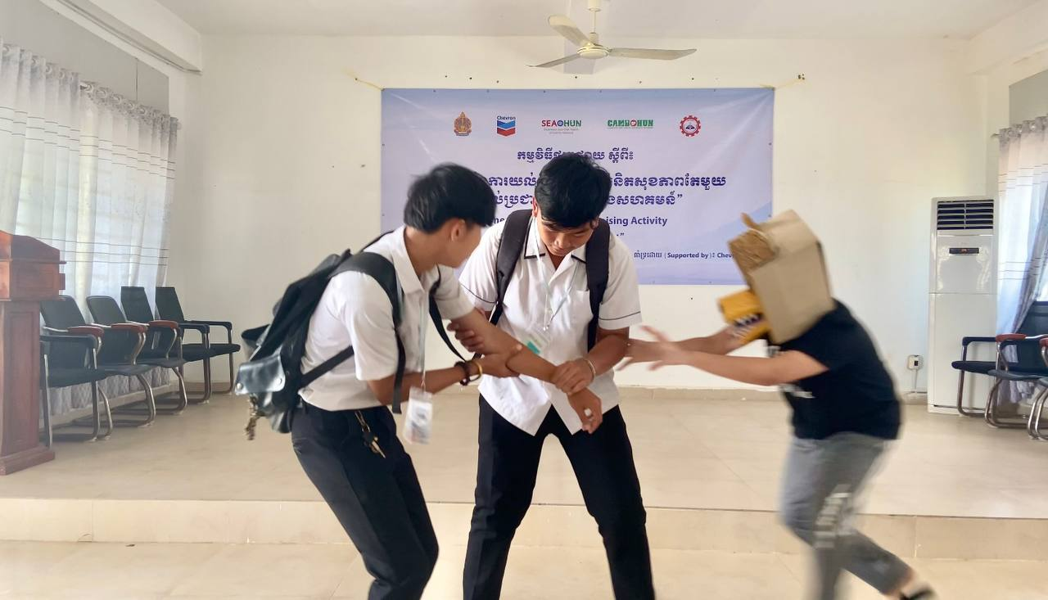
Students Performing a Rabies skit

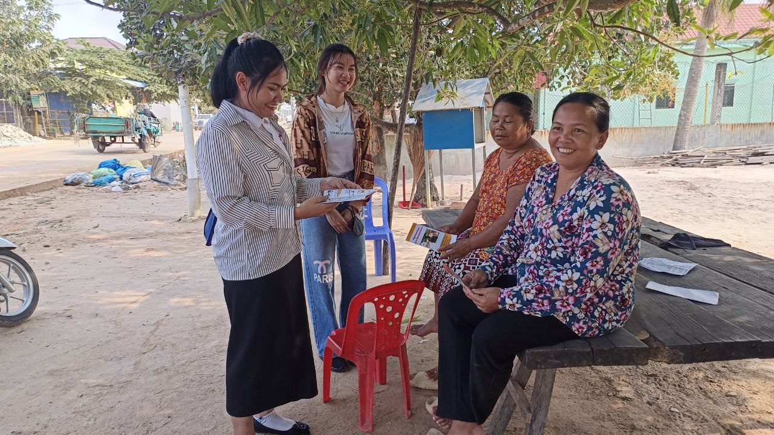
Ms. Sreypov Chhorn, one of the teacher trainees, explaining about rabies measure to the community members

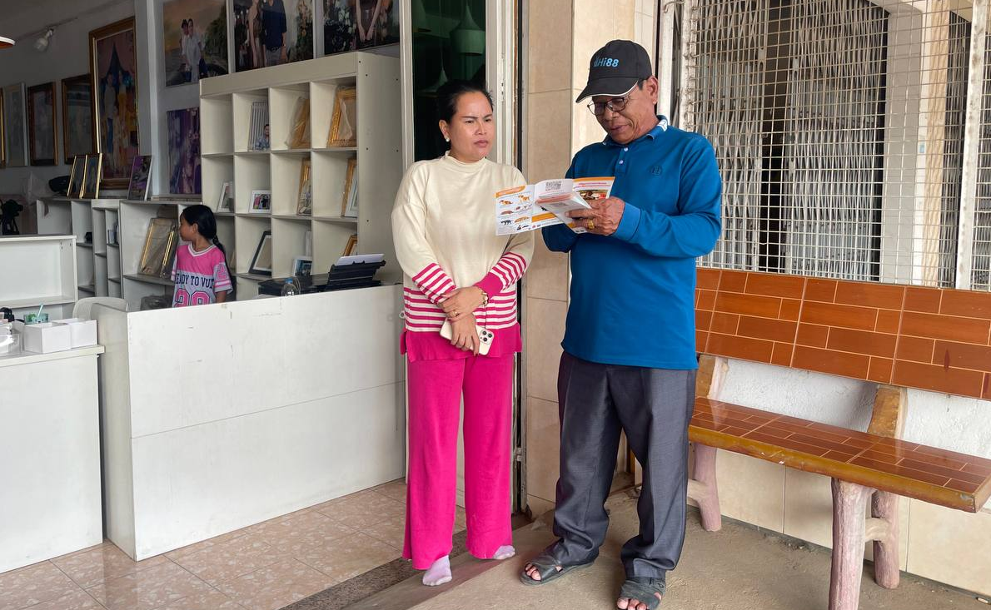
One of the participants explaining about rabies measure to a community member

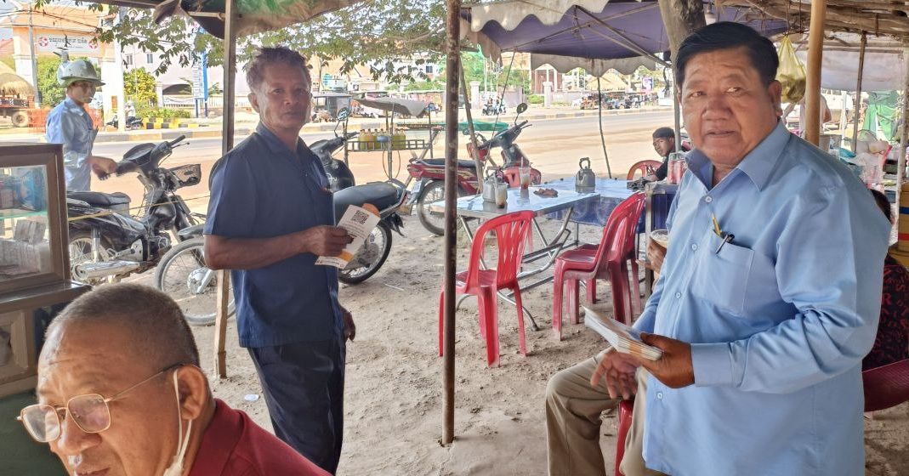
A participant explaining about rabies measure to a community member

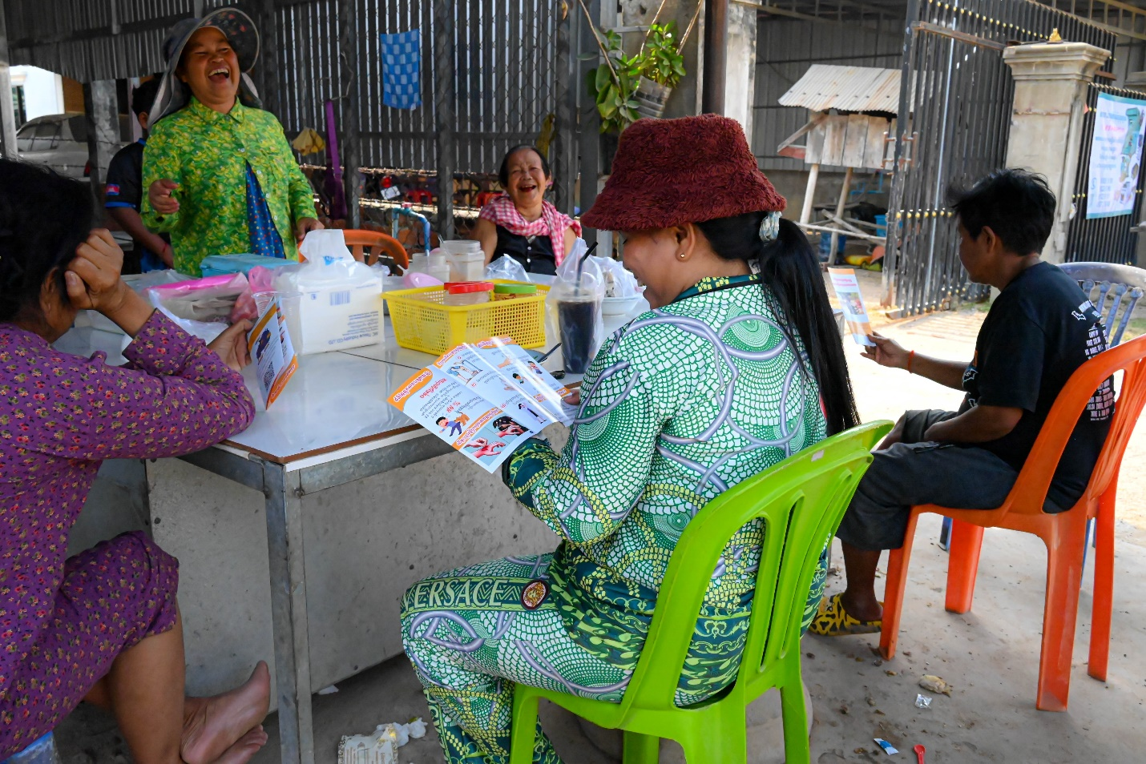
Community Members Read Rabies leaflets

This event is a part of a joint initiative aimed at enhancing One Health awareness among students, teachers and community members in Cambodia. This project is fully funded by Chevron which strives to empower people around the world to improve their lives, achieve their ambitions and meet their full potential.

