Report of
The 1st International Experts Sharing Meeting on
"Digital Literacy and Educational Innovation in Southeast Asia"
(14 February 2025)

SEAMEO TED, CATECP, and the International Youth Culture and Education (KEMG), virtually co-hosted an International Experts Sharing Meeting on "Digital Literacy and Educational Innovation in Southeast Asia" successfully on 14 February 2025 at 14:00 (GMT+7). The meeting focused on the opportunities and challenges that education in Southeast Asia faces in the digital era. Experts from the Philippines and Thailand were invited to share their valuable experiences and unique insights on fostering digital literacy and driving educational innovation. 300 participants from different parts of the world participated this event.

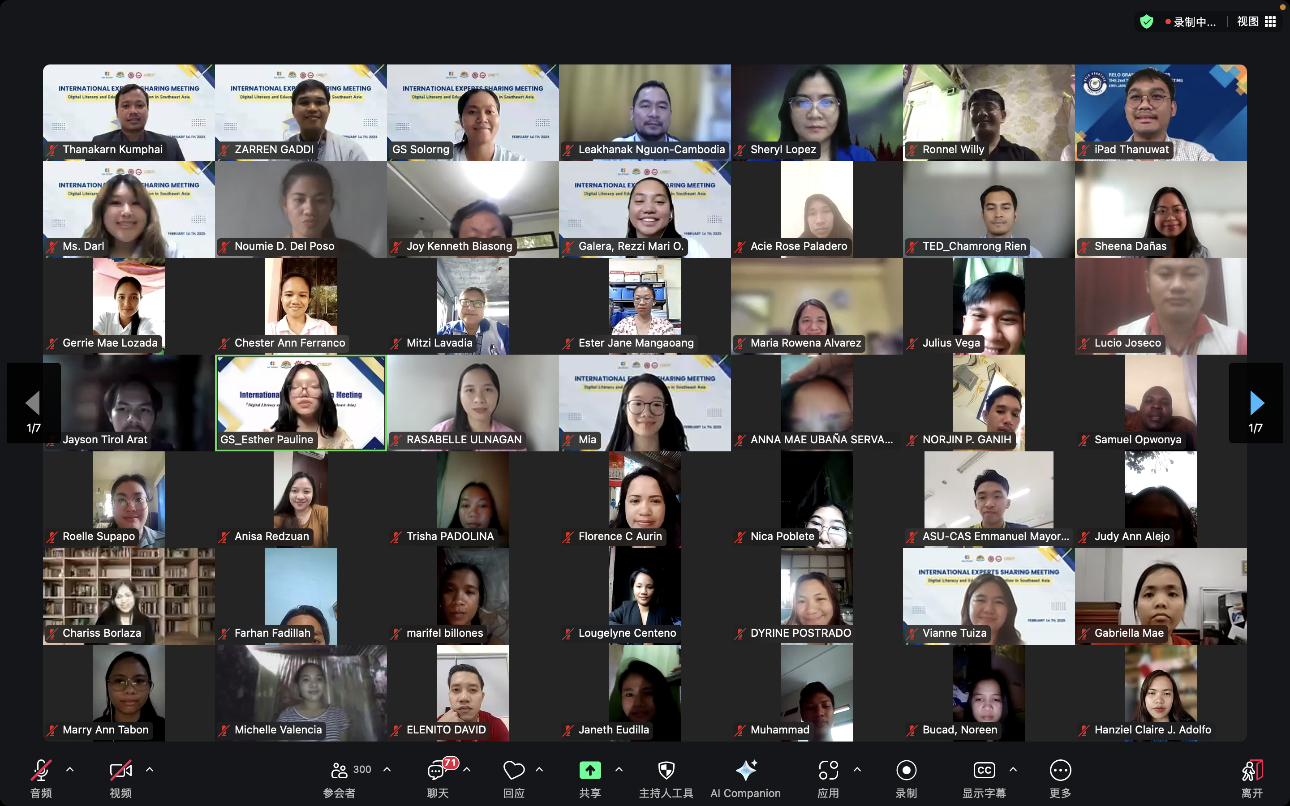

Ms. Cheng Chantola, Head of Administration and Finance Office of SEAMEO TED was invited to delivered her Opening remarks. She emphasized that in the wave of digital transformation, we are at the forefront of educational reform. Southeast Asia, a region full of vitality and diversity, is experiencing unprecedented opportunities and challenges in its education system. Ms. Cheng encouraged participants to embrace diverse perspectives and spark innovation through meaningful discussions.
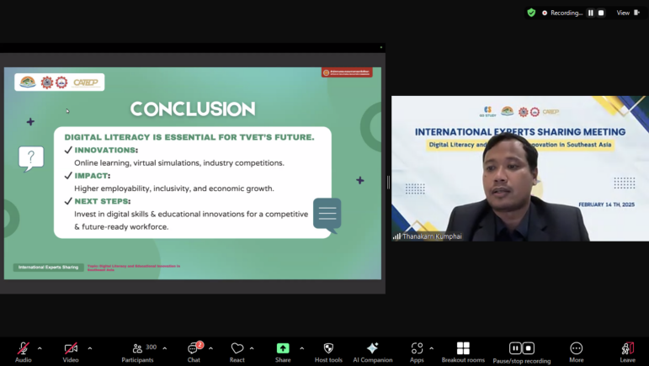
Mr. Thanakarn Khumphai, Lecturer at Chachoengsao Technical College, Thailand shared his topic on “Inclusive TVET for a Green and Digital Future in Thailand: Adapting TVET for Sustainable Development and Digital Transformation”. He focused on Thailand’s Industry 4.0 agenda and addressing employment challenges. He highlighted that green and digital skills are highly aligned with Thailand’s future economic development and the Thailand 4.0 vision. He also shared successful cases, such as the Dual Vocation (DVT) program, the China-Thailand vocational education cooperation, and “Smart Agriculture”.

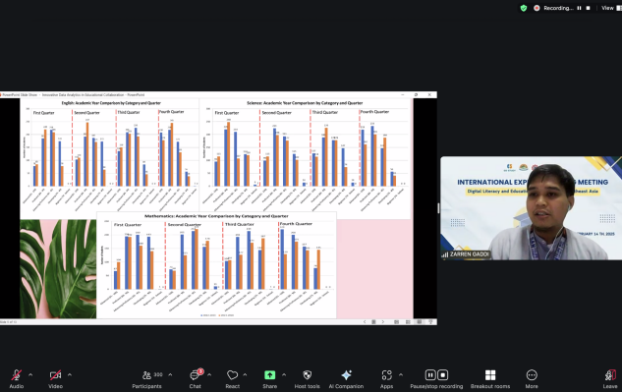
Dr. Zarren Aleta Gaddi, Lecturer at San Felipe Neri Catholic School and Jose Rizal University, The Philippines, presented her topic on “The Utilization of Data Analytics through Professional Learning Communities”. His presentation focused on Digital literacy, digital leadership, and data analytics literacy which are key drivers of educational development. He also introduced a case study from Cluster 3 schools under the Roman Catholic Archdiocese of Manila Education System, which established professional learning community activities through the “TAYO” project. He also addressed the challenges of educational reform such such as data ethics concerns and the need for educators with relevant skills.

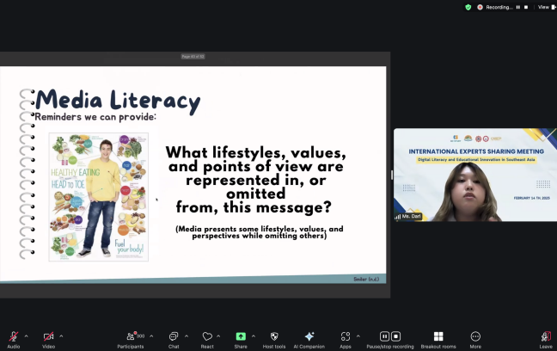
Ms. Darl Jacqueline M.Orillaza-Giray, Lecturer of Department of Educational Leadership and Management, De La Salle University,The Philippines, presented her topic on “Promoting Safe and Appropriate Technology Use for Young Children”. She focused on digital technological tools such as computers, tablets, cameras, software, and internet which offers numerous benefits to early childhood development, including facilitating high-quality interactions and supporting learning through digital tools, such as virtual field trips that expand children’s perspectives. She insisted that parents and educators establish household digital usage plans with clear rules, ensuring appropriate privacy settings, content filtering, and restrictions.

