Report on the 2nd International Youth Talk on
“How Digital Tools Are Changing the Way We Learn"
28 February 2025, 14:00-15:30(GMT+7)
On February 28, 2025, SEAMEO TED and Go Study co-hosted the 2nd International Youth Talk on “How Digital Tools Are Changing the Way We Learn" as one flagship program of China-ASEAN Technical Education Cooperation (CATECP). This event was aimed to delve into how digital tools and technologies are transforming the education landscape and to explore how these innovations reshape traditional learning methods. Four teams of youth representatives from Russia, Indonesia, Thailand, and the Philippines were invited to engage in insightful discussions and share their perspectives to 275 participants from the region.
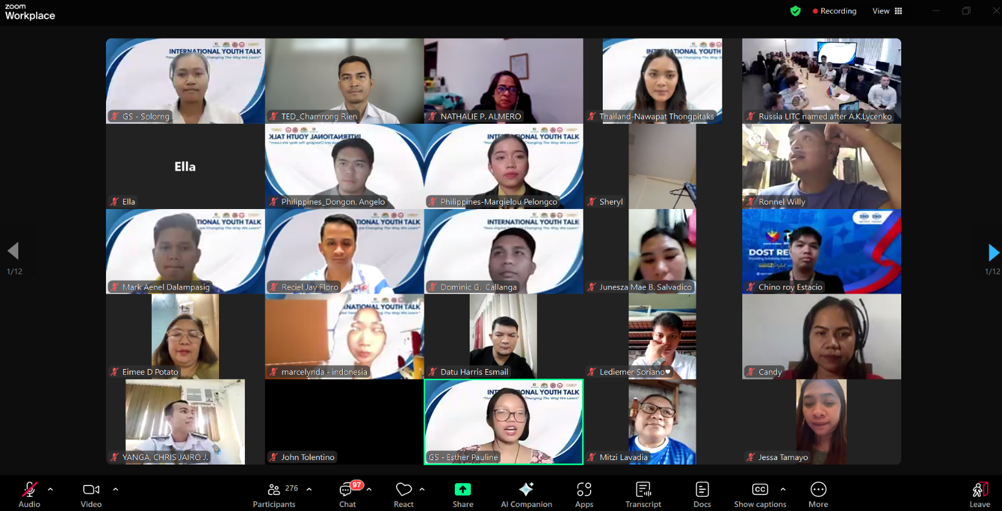

Mr. Sous Sovannarin, Vice Head of Public Relations and Partnership Division of SEAMEO TED, was invited to deliver the opening remarks. He emphasized that digital technology is transforming global education at an unprecedented pace, creating new opportunities for learning and innovation. He highlighted that youth are not only users of technology but also key drivers of educational progress, capable of leveraging digital tools to enhance learning experiences, promote knowledge sharing, and contribute to a more inclusive education system.

Sharing Session
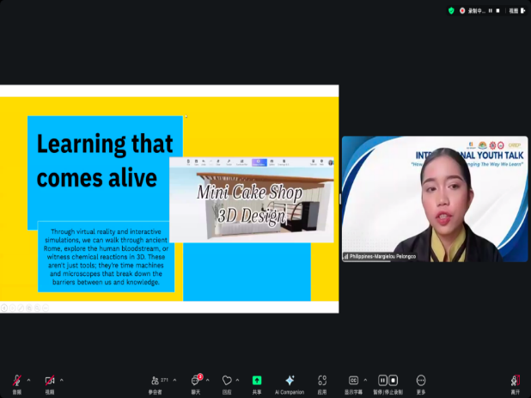
Youth team from Capiz State University, The Philippines, shared insights on the topic "Digital Tools and Modern Education: Beyond Textbooks." They emphasized that sustainable development relies on education, with information technology driving educational reform. Social media has become a valuable learning tool, breaking time and space limitations in information sharing while also creating opportunities for social interaction and employment. The shift to online learning during the pandemic highlighted the role of digital tools in enriching education, with teachers using feedback mechanisms for targeted guidance. Digital methods like PPT, videos, and online training are now widely applied.

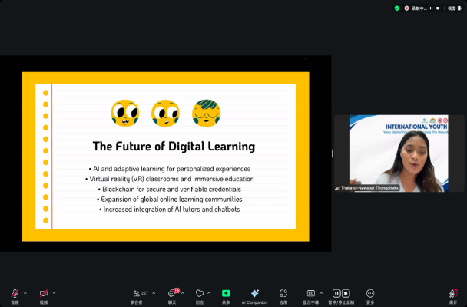
Youth team from King Mongkut’s University of Technology North Bangkok, Thailand, shared their views on how digital tools are shaping education today. They highlighted the benefits of digital learning, such as AI-powered personalized education and interactive learning platforms that break geographical barriers and allow flexible study schedules. Multimedia content enhances student engagement and provides valuable teaching data. However, challenges remain, including digital inequality due to limited internet access, screen fatigue from prolonged device use, reduced face-to-face interaction, and concerns over privacy and data security. Teachers also need to adapt to new tools while avoiding over-reliance on technology.

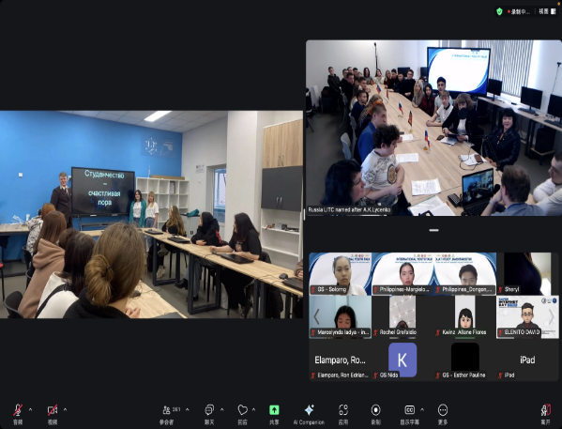
Youth students from Liskinsky Industrial and Transport Technical College, Russia, shared how digital tools are transforming education by offering personalized learning paths and promoting lifelong learning. The college's IT-Cube Center focuses on VR/AR education, training students in gaming and virtual learning through platforms like Varwin, Unity, and HTC Vive Pro. They also emphasize Java programming and robotics. While digital tools enhance learning through innovations like neural networks for note-taking and gamified teaching, challenges such as the digital divide remain. The speaker noted that digital tools can't replace teachers, and student interest and engagement are crucial for success. The college is using digital platforms to train versatile professionals for the future.

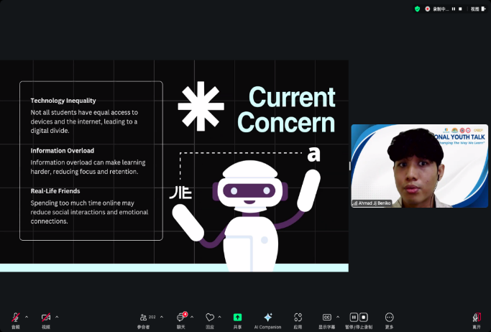
Youth students from University of Semarang, Indonesia, discussed the transformation digital tools bring to learning, along with the challenges and future developments. They emphasized that digital tools have changed traditional learning methods by increasing student interest, curiosity, and learning outcomes. These tools allow students to connect with others globally, fostering cultural understanding and broadening perspectives. Mastering digital skills is essential for lifelong learning. However, issues like the digital divide, lack of resources, and information overload still hinder online learning.

