Report on
International Webinar on Research Proposals, Tips for Writing Research Articles, Guidelines & Criteria for Research Article Publication

On March 7, 2025, the Southeast Asian Ministers of Education Organization Regional Centre for Technical Education Development (SEAMEO TED) hosted an international webinar on “Research Proposals and Tips for Writing Research Articles, Guidelines & Criteria for Research Article Publication.” This event brought together 155 participants from SEAMEO member countries and featured distinguished speakers sharing insights on grant proposal writing, academic research writing, and research article publishing.

This webinar was honoured to have Dr. Songheang Ai, Centre Director of SEAMEO TED, deliver the opening remarks, emphasizing the significance of well-structured research proposals and high-quality academic writing. He highlighted common challenges in publishing, the importance of ethical research standards, originality, and adherence to guidelines. Dr. Ai also underscored the necessity of collaboration and knowledge sharing to enhance research impact and publication success.

The first session of the webinar featured a presentation on “Grant Proposal Writing” by Dr. Siyan Yi, who provided a comprehensive guide to developing successful research grant proposals. He outlined the essential components of a grant proposal, including problem statements, goals, objectives, methodology, key personnel, and evaluation plans. The session stressed the importance of understanding funding calls, following guidelines meticulously, and demonstrating impact and sustainability. Dr. Yi also identified common pitfalls such as plagiarism, vague problem statements, and careless mistakes, encouraging participants to adopt a strategic and realistic approach to proposal writing.

Additionally, Dr. Viddi Mardiansyah further enriched the webinar with practical tips on writing high-quality research articles and getting published in reputable journals. He emphasized selecting the right journal, structuring articles using the IMRaD format, and ensuring clarity and coherence in writing. Key topics included crafting a compelling introduction, effectively presenting results, and meticulously addressing reviewer feedback. Ethical considerations, such as plagiarism and authorship integrity, were also highlighted. The session provided valuable insights into common pitfalls and best practices to enhance article writing as well as publication success.

Finally, Ms. Fatima Rahmah presented the guidelines for research article publication, offering a structured approach for authors to publish their work effectively. The guidelines covered journal article types, selection criteria, and strategies to avoid predatory journals. The peer review process was discussed in detail, emphasizing single-blind, double-blind, and open review types. Ms. Rahmah also provided strategies to improve acceptance rates, such as refining research design, enhancing writing quality, and constructively addressing reviewer feedback. She recommended tools like Scopus, Web of Science, and DOAJ for journal selection and research tracking.

Overall, the webinar provided a valuable platform for researchers to enhance their grant proposal writing and academic publishing skills. By addressing key challenges and offering expert insights, the event contributed to strengthening research capacities and fostering a collaborative academic environment across Southeast Asia.
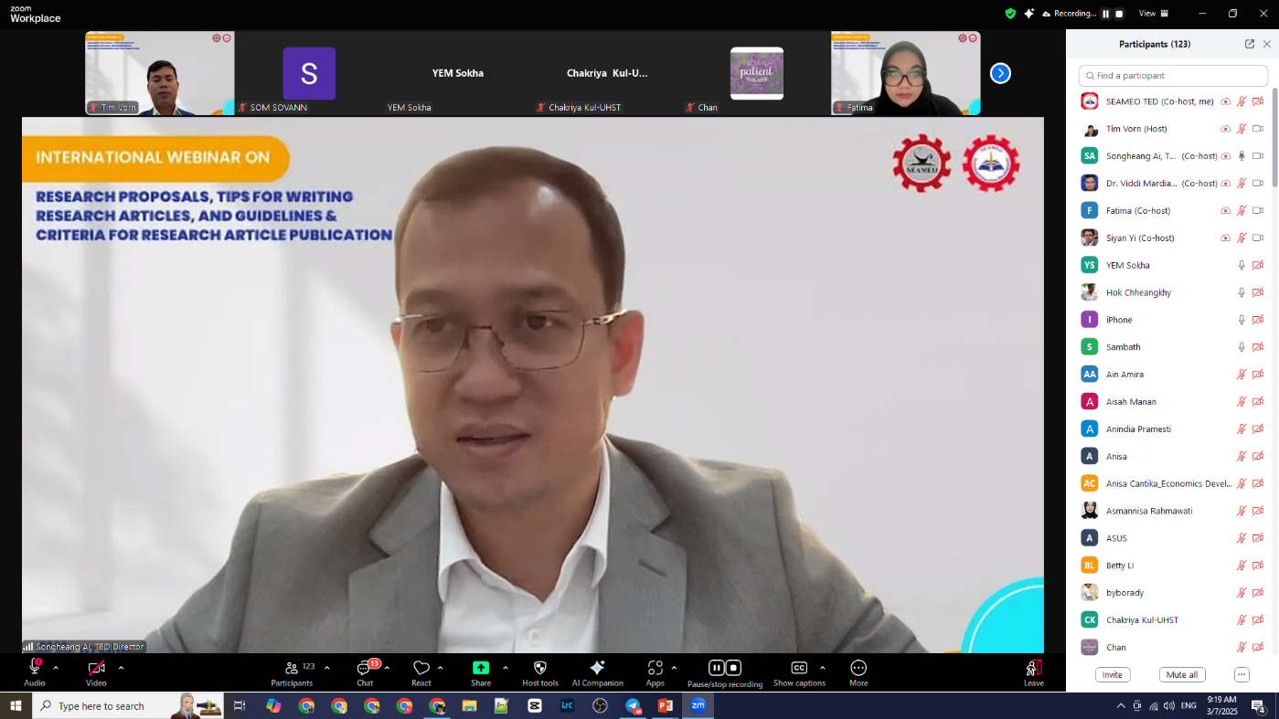
Dr. Songheang Ai, Centre Director of SEAMEO TED, delivered the opening remarks.
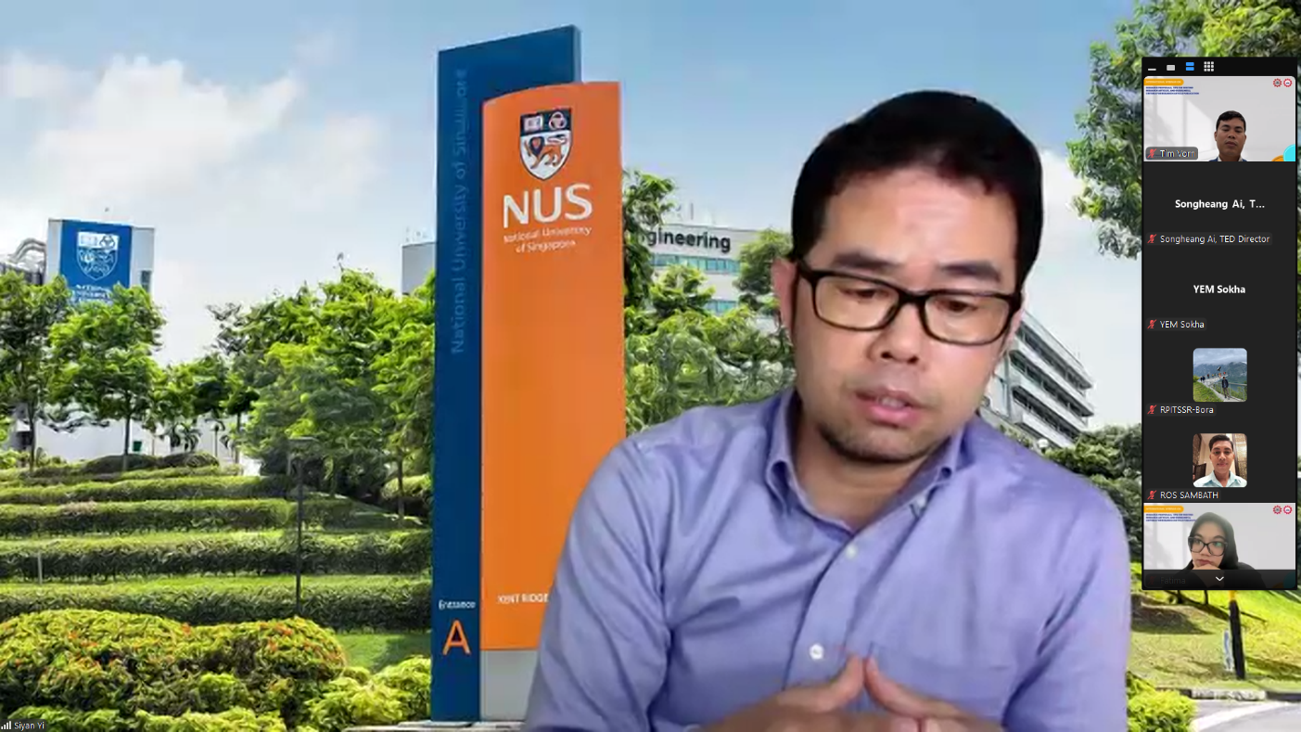
Siyan Yi, MD, MHSc, PhD – Associate Professor and Director of Integrated Research Program
Saw Swee Hock School of Public Health, National University of Singapore, shared his expertise on
Grant Proposal Writing.
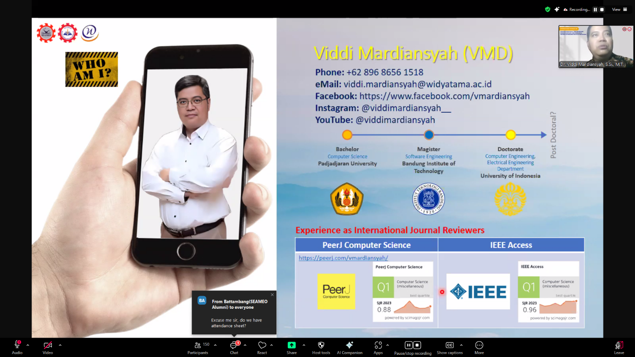
Dr. Viddi Mardiansyah, S.Si., M.T., SMIEEE, Senior Member of IEEE (Institute of Electrical and Electronics Engineers), Lecturer and Researcher at Widyatama University, Bandung, Indonesia shared his knowledge on Tips for Writing Research Articles.

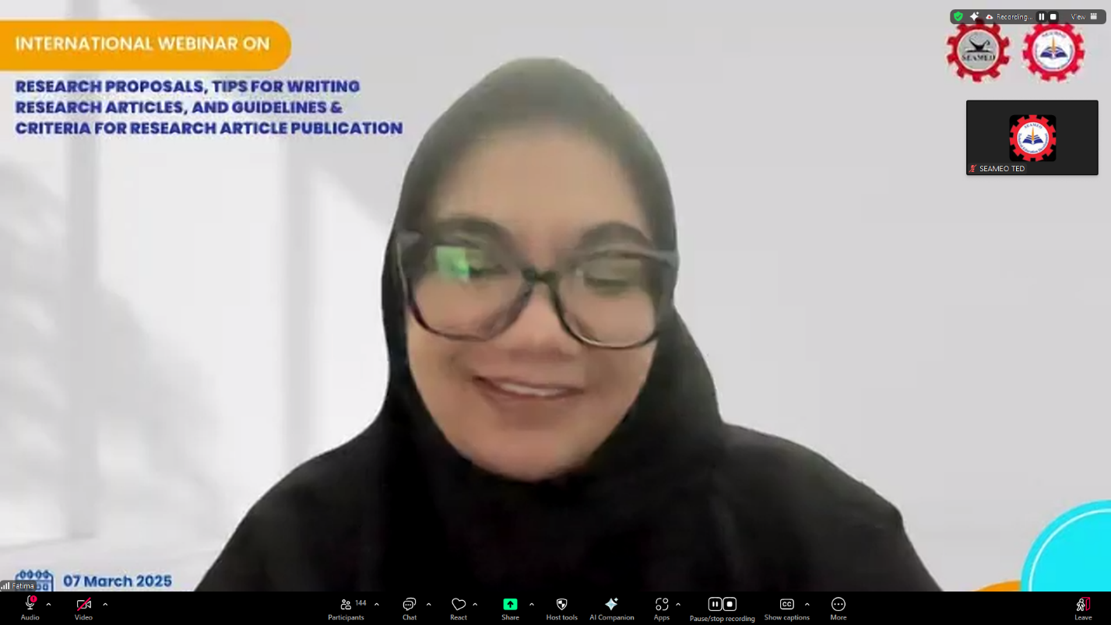
Ms. Fatima Rahmah – PhD Candidate of Psychology at Padjadjaran University, Indonesia, shared his expertise and knowledge on Guidelines and Criteria for Research Article Publications.

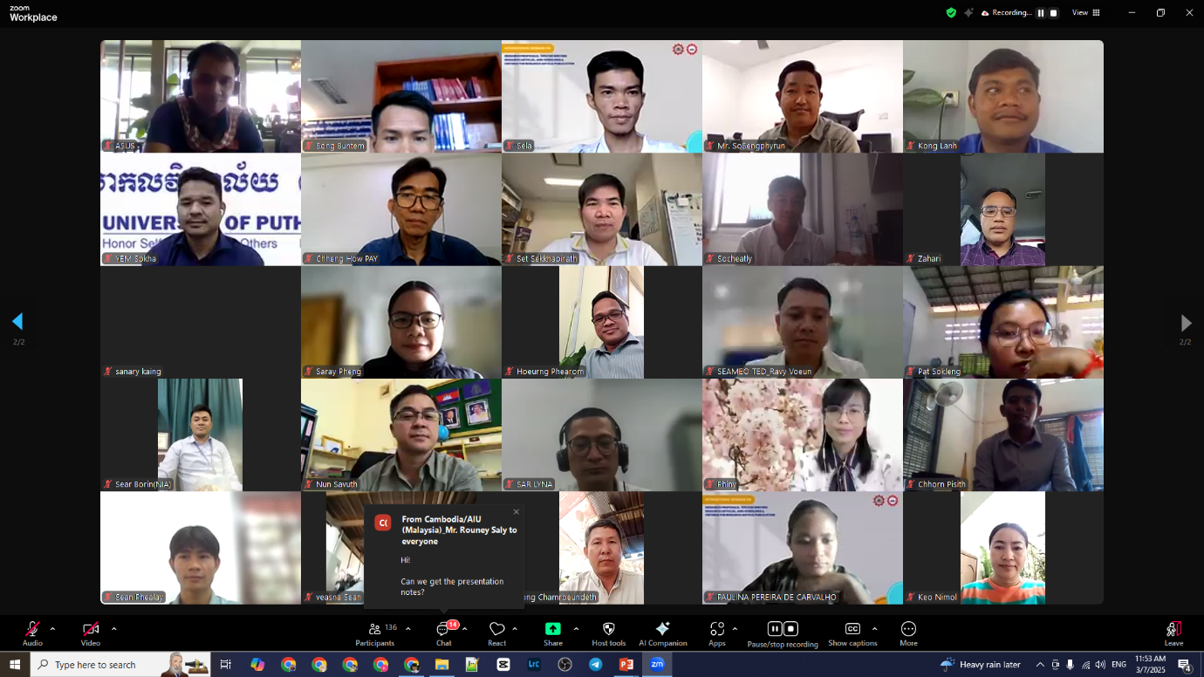
Photo Session of Honourable Speakers and Participants

