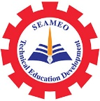

The 1st International Youth Talk on
A Cultural Tapestry: Music, Dance, and Art from Around the World
10 January 2025, 14:00-15:30 pm (Phnom Penh Time)
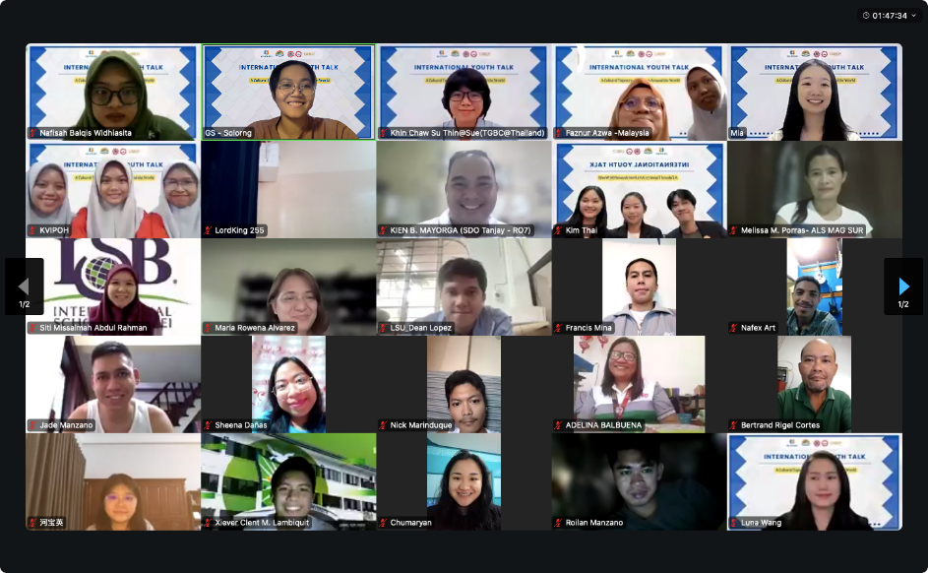
On January 10, 2025, SEAMEO TED, CATECP and International Youth Culture and Education (KEMG) and Go Study co-organized the 1st International Youth Talk on the theme: "A Cultural Tapestry: Music, Dance, and Art from Around the World" virtually. Speakers from Cambodia, Indonesia, Thailand, and Malaysia were invited to share and presents their country’s cultural tapestry. This event accommodated 109 regional participants.

Mr. Voeun Ravy, Vice-Head of the Research and Development Division of SEAMEO TED was invited to deliver the opening remarks. He emphasized the unifying power of arts, music, dance, and visual culture, highlighting their ability to convey both traditional and modern interpretations. He expressed his heartfelt gratitude to partners and participants, noting that their involvement would enhance the event and provide an opportunity to learn, share, and deepen our appreciation for the arts that enrich our lives.

Cambodia’s Youth Team from East Asia Management University
Speakers: Chea MeyJing, Sok Liza, Te Kimthai
Topic: Lahkon Khol
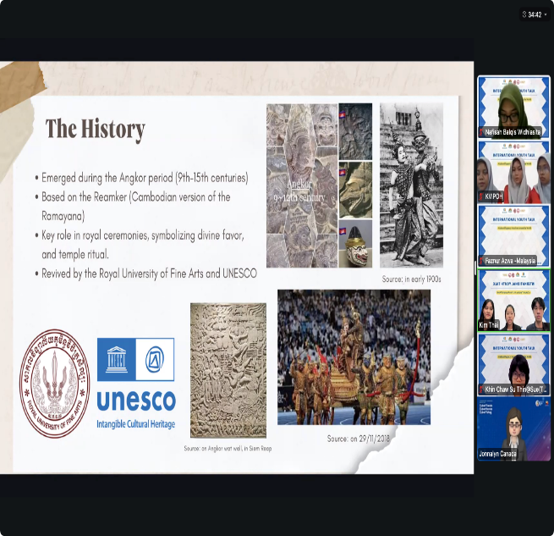
Cambodia’s team started by introducing the audience to one of Cambodia’s prominent traditional forms of theater performance called “Lakhon Khol.” During the performance, the team highlighted the history, the significance, and the different elements of this theater performance. Lakhon Khol is a traditional Cambodian masked dance-drama, rooted in the country's history since the Angkor period (9th–15th centuries) and inspired by the Reamker, Cambodia's version of the Ramayana. Originally performed in royal ceremonies and temple rituals, it features an all-male cast with handcrafted masks, vibrant costumes, and stylized gestures, accompanied by a Pinpeat orchestra. Lakhon Khol serves as a vital cultural expression, preserving Khmer identity, passing moral lessons through storytelling, and fostering social cohesion. It also plays a key role in education, community bonding, and tourism, with ongoing efforts by artists and organizations to preserve this treasured heritage.

Indonesia’s Youth Team from University of PGRI Adi Surabaya
Speakers: Nafisah Balqis Widhiasita
Topic: Unveiling the Beauty of Tari Jayandaru
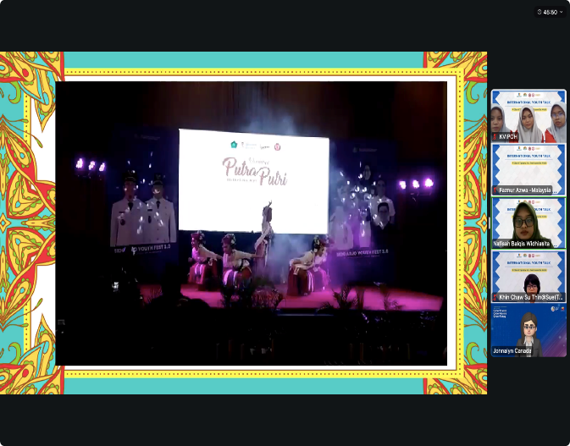
Tari Jayandaru is a traditional dance from Sidoarjo, East Java, created in 2021 by Muhammad Nur Muslimin and Hindar Krismalisa of the Jagad Pangestu Traditional Dance Studio. Inspired by the Jayandaru Monument, which symbolizes prosperity with its iconic shrimp and milkfish icons, the dance reflects the spirit of growth, harmony, and local aspirations for a peaceful life. It highlights the lives of farmers, fishermen, and entrepreneurs, serving as a welcoming dance that symbolizes progress, unity, and hospitality. With costumes symbolizing purity and bravery and movements representing cooperation, Tari Jayandaru celebrates Sidoarjo's identity, heritage, and the values of unity in diversity.

Malaysia’s Youth Team from Kolej Vokasional Ipoh
Speakers: Adriana Qaseh Binti Ehsal Jesrin, Insyirah Binti Jaimehatta, Amy Ariana Binti Abdul Syahid
Topic: Malaysian Traditional Dances
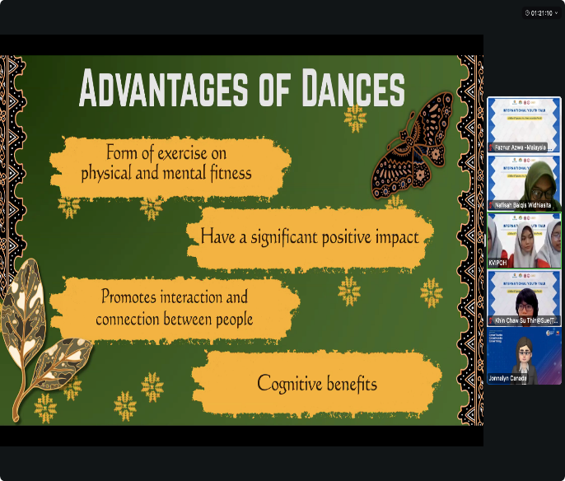
The presentation of the "Malaysia's Traditional Dance" highlights the rich cultural tapestry of Malaysia, shaped by its native Malays, indigenous peoples, and the influences of Chinese, Indian, and Portuguese settlers. Traditional dances, music, and visual arts reflect the nation's history, beliefs, and artistic expression, performed during festivals, rituals, and social events. Notable elements include music forms like Kompang and Gamelan, dances such as Zapin and Mak Yong, and visual arts like Batik and Songket. Region-specific traditions, such as Johor's Gambus and Zapin, Kelantan's Tarian Mak Yong, and Sabah's Sumazau, emphasize Malaysia's diversity. Dance also serves as a form of exercise, fostering social bonding, interaction, and cognitive benefits.

Thailand’s Youth from Thai Global Business Administration Technological College
Speaker: Khin Chaw Su Thin
Topic: Lacqerware in Mayanmar
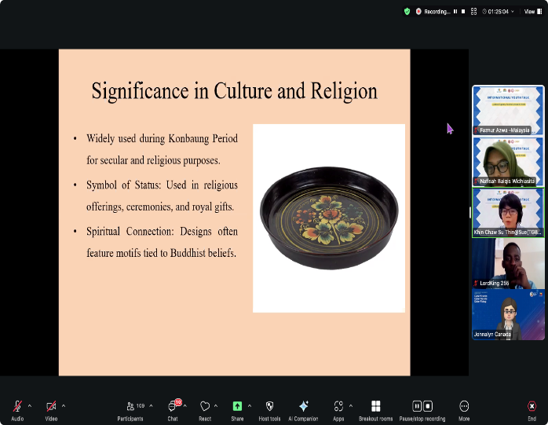
Lacquerware is one of Myanmar’s ten traditional arts. Historically significant during the Konbaung period, lacquerware held cultural and religious importance, often featuring Buddhist motifs and serving as symbols of status in religious ceremonies and royal gifts. Crafted from bamboo and wood coated with lacquer sap, its intricate production process involves weaving, multiple lacquer coatings, polishing, and detailed decoration, taking months to complete a single piece. While traditional techniques originated in Bagan and included luxurious embellishments like gold leaf, the art faces modern challenges from imported goods and resource scarcity. Despite these hurdles, efforts continue to preserve lacquerware as a valuable symbol of Myanmar’s artistic heritage.

