IT Purple Conference 2025
Moscow, Russian Federation
March 13-15, 2025

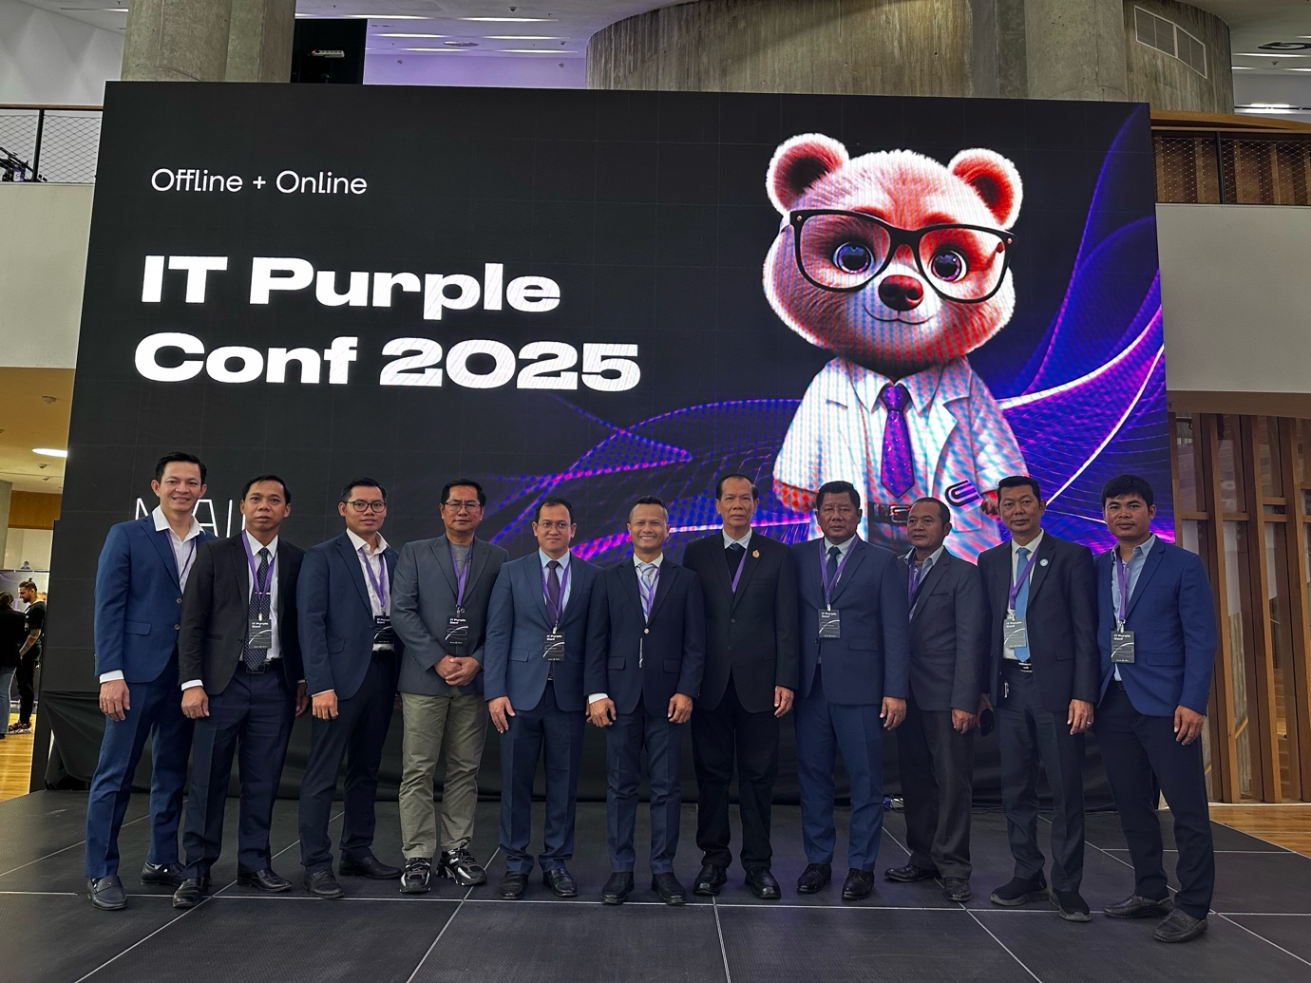
(Participants Joining the Conference)

Moscow: From March 13 to 15, 2025, Dr. Ai Songheang, Director of the SEAMEO Regional Centre for Technical Education Development, led the delegation of 18 ASEAN participants to participate in the IT Purple Conference 2025, held in Moscow City, Russian Federation. Organized by the Moscow Institute of Physics and Technology (MIPT), the conference brought together over 100 distinguished speakers and more than 3,000 participants, including senior leaders, researchers, educators, policymakers, technology professionals, and students.
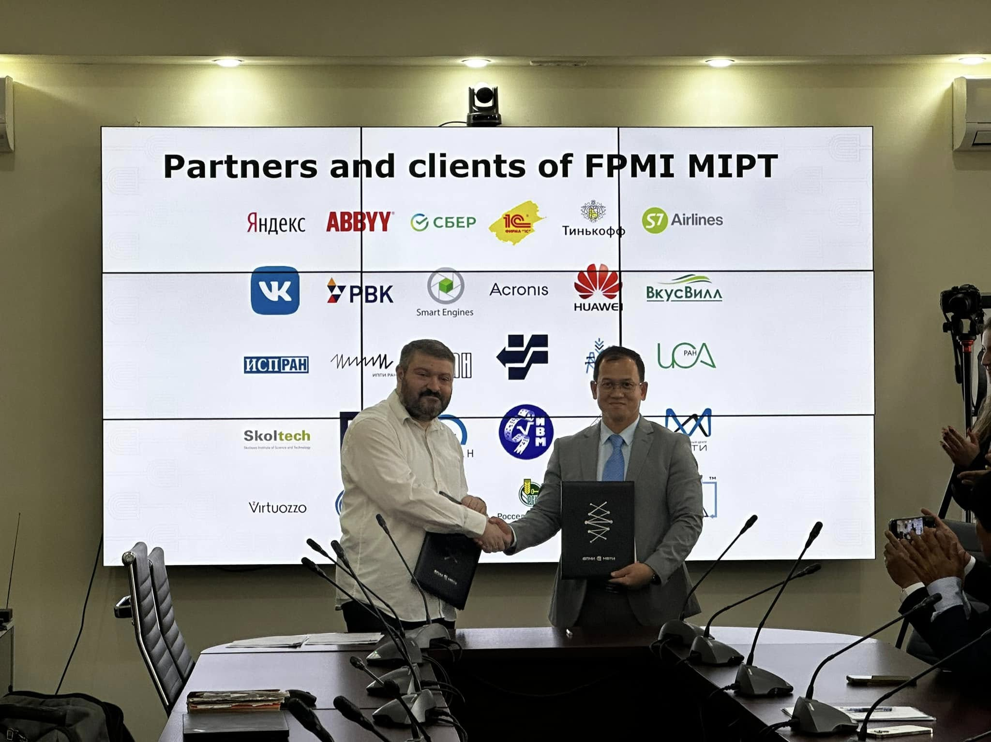
(Exchange of Signed MoU between both institutions)

This prestigious conference served as a platform for knowledge exchange, professional development, and networking with leading experts and technology companies. Discussions focused on seven key topics, namely: Mathematics, Machine Learning, Artificial Intelligence Development, Education, Research, and Career Opportunities.
During the event, Dr. Ai Songheang delivered a keynote presentation highlighting SEAMEO TED’s achievements and the role of education technology in ASEAN countries. His session emphasized the centre’s contributions and paved the way for establishing strategic collaborations. Dr. Ai focused on the critical role of education technology to support student learning according to the local contexts and needs.
As part of the conference, Dr. Ai signed a Memorandum of Understanding (MoU) between SEAMEO TED and Moscow Institute of Physics and Technology (MIPT), establishing a framework for cooperation in curriculum development, student and teacher exchange program, conference organization, and research studies. The memorandum also promotes participation in international competitions, faculty and leadership exchange programs, and technical and vocational education and training (TVET). Furthermore, it facilitates the organization and participation in online and in-person workshops, training programs, and study visits, fostering a dynamic and sustainable partnership between the two institutions.
This partnership between SEAMEO TED and Moscow Institute of Physics and Technology (MIPT) signifies a strategic commitment to advancing education, research, and innovation in technical and vocational fields. By leveraging shared expertise and fostering cross-border collaboration, both institutions aim to enhance knowledge exchange, empower educators and students, and drive technological advancements. This MoU not only strengthens ASEAN-Russia relations in education and technology but also paves the way for future initiatives that will contribute to global progress in technical education and workforce development.

