International Youth Talk: How Intercultural Dialogue Shapes Young Minds in the Age of Globalization
March 28, 2025

March 28, 2025: The online youth exchange event was jointly co-organized by the China-ASEAN Technical Education Cooperation Platform (CATECP), the Southeast Asian Ministers of Education Organization Regional Centre for Technical Education Development (SEAMEO TED), Go Study Global Education and other organizations focusing on the theme "How Intercultural Dialogue Shapes Young Minds in the Age of Globalization,". The event brought together college youth representatives from Russia, Cambodia, Indonesia, Thailand, and the Philippines. 300 participants from around the world engaged in in-depth discussions on the profound impact of intercultural exchange on young people's thinking, cognition, and actions in the context of globalization.
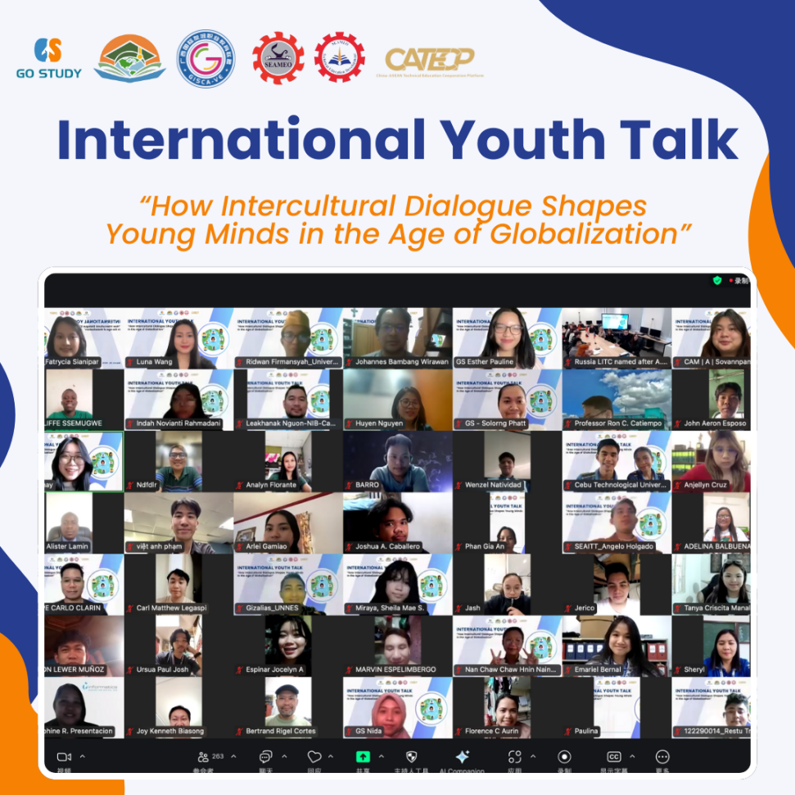

【Opening Remarks】
Mr. Pho Mara, Head of Technical Education and Training Division of SEAMEO TED, delivered the opening remarks. He emphasized that globalization brings both opportunities and challenges, making intercultural dialogue crucial for shaping young minds and fostering personal growth. He encouraged participants to share their experiences and insights, highlighting how intercultural exchange broadens perspectives and deepens understanding of diverse values. He expressed confidence that this event would inspire meaningful discussions, promote regional education and cultural exchange, and contribute to a more harmonious world.
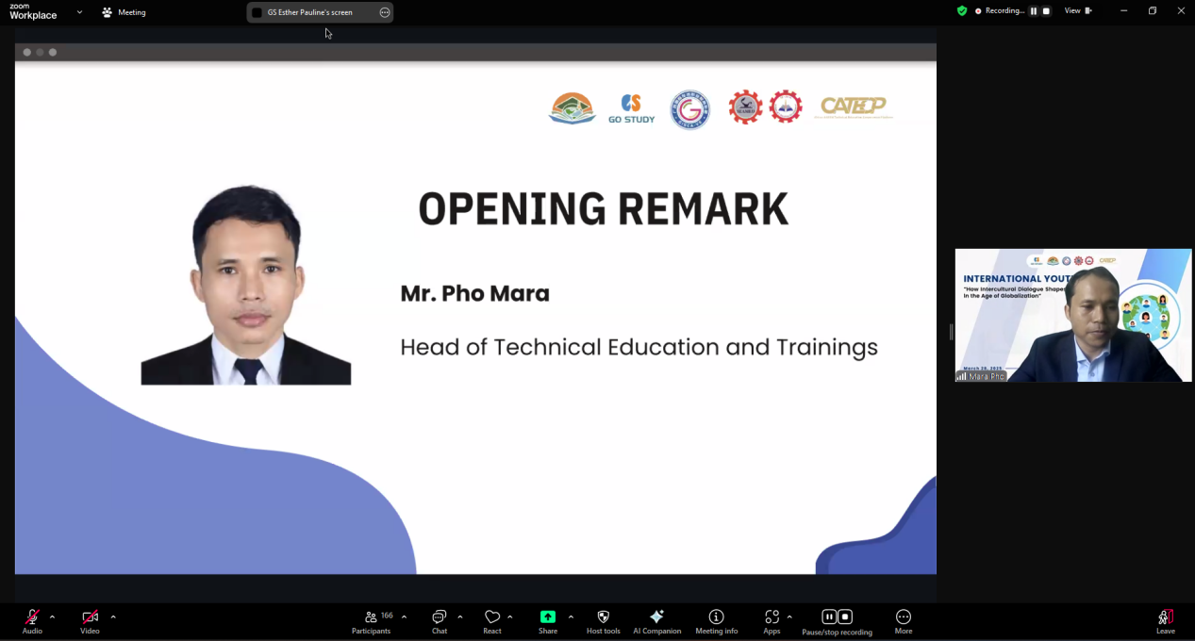

【Sharing Session】
Young students from Cebu Technological University, the Philippines shared:
Youth representatives from the Philippines shared that the modern world has become a closely connected "global village," where intercultural dialogue is crucial for seizing opportunities and personal growth. They highlighted various ways to foster intercultural understanding and personal development, such as academic exchanges, English as a second language, and debate activities. Digital tools like DISCORD and language exchange platforms also help expand global networks, breaking geographical barriers. They concluded, "The ‘global village’ is not just a village, but a global, interdependent society."
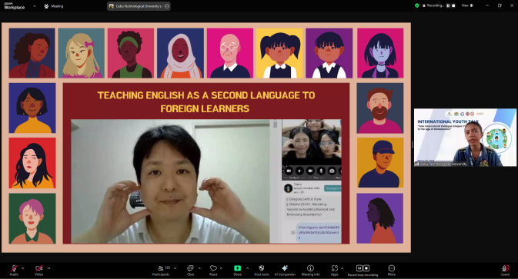

Young students from Guiyang University, China shared:
A Cambodian student from Guiyang University shared on "Empowering Intercultural Dialogue through Multilingualism." The speaker emphasized that language is not just a communication tool but a bridge to understanding different cultures. Reflecting on their own experience in China, they highlighted how multilingualism helped overcome cultural misunderstandings and build trust. They concluded, “Mastering multiple languages is to embrace the world and the future.”
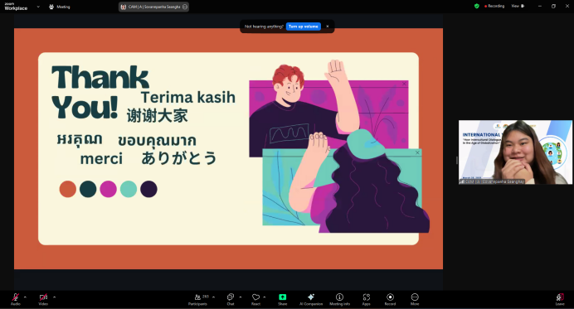

Young students from Universitas Negeri Semarang, Indonesia shared:：
Youth representatives from Indonesia discussed how intercultural communication shapes young people's thinking and actions, helping them connect with others globally. They highlighted the importance of intercultural dialogue in promoting personal growth and social awareness. Addressing challenges like language barriers, stereotypes, and cultural misunderstandings, they suggested improving language skills, cultural awareness, and active listening. The representative encouraged youth to engage in international exchanges, use social media, and join community projects to broaden their perspectives. They concluded that embracing cultural diversity creates opportunities for learning, collaboration, and making a global impact.
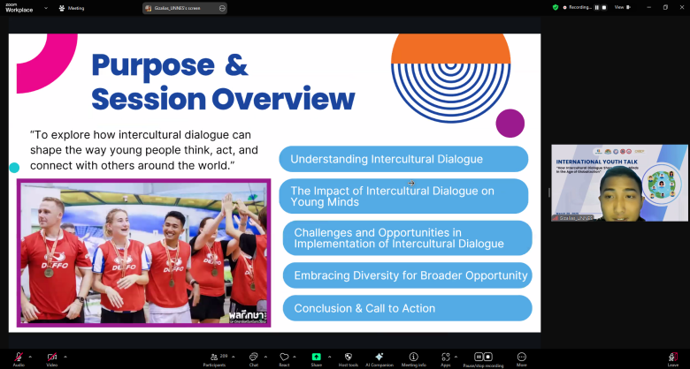

Young students from Liskinsky Industrial and Transport Technical College in Voronezh, Russia shared:：
Youth representatives from Russia shared thoughts on shaping the cultural worldview of contemporary youth. They emphasized that, in the age of globalization, young people deepen their understanding of different cultures, traditions, and customs through learning foreign languages and interacting with overseas friends. They also noted that culture evolves with time. The speaker highlighted that intercultural dialogue broadens perspectives and promotes a deeper understanding of global diversity, while another student stressed that it’s not only about language but also about understanding and respecting cultural differences. They concluded that breaking barriers and eliminating stereotypes is key to building a more harmonious and inclusive society.

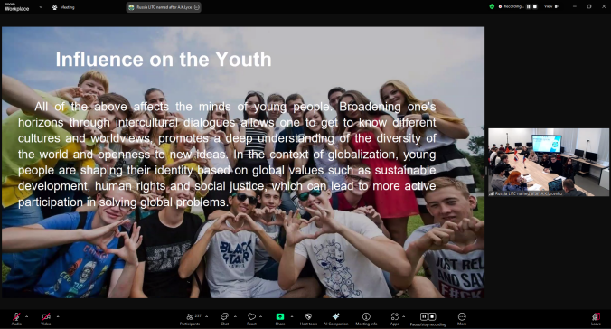

Young students from Universitas Sumatera Utara, Indonesia shared:：
Youth representatives from Indonesia shared about the "Medan Book Club: Fostering Multicultural Awareness and Embracing Cultural Differences." They introduced Medan, a multicultural city in North Sumatra, where different ethnic groups coexist harmoniously. The speaker highlighted how the government integrates respect for diversity into youth education and how the MBP Reading Community promotes inclusivity by discussing topics like prejudice, language differences, and minority integration. They emphasized that cultural diversity is an asset and urged youth to engage in intercultural dialogue to build a harmonious future.
