Report of
The 2st International Experts Sharing Meeting on
"Sustainability in International Education:
Challenges and Opportunities"
(14 March 2025)

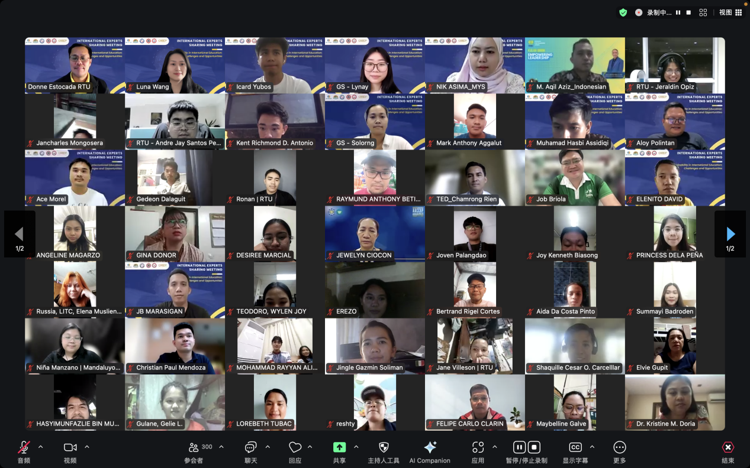
SEAMEO TED, CATECP, and the International Youth Culture and Education (KEMG), virtually co-hosted an International Experts Sharing Meeting on "Sustainability in International Education: Challenges and Opportunities" successfully on 14 March 2025 at 14:00 (GMT+7). This webinar was aimed to how to achieve sustainability in International Education and the challenges and opportunities that institutions in Southeast Asia faces in the digital era. Experts from the Philippines, Indonesia, and Malaysia gathered online to share their valuable experiences and unique insights on how their institute try to achieve sustainability the challenges and opportunities that each bring. The event provided participants with a thought-provoking intellectual exchange and attracted enthusiastic participation from over 300 attendees worldwide.

Mr. Pho Mara, Head of Technical Education and Training Division of SEAMEO TED was invited to deliver his Opening Remarks. He emphasized on the importance of equipping learners with the tools and knowledge to address pressing global challenges has never been more critical. Education for Sustainable Development not only empowers individuals to think critically about environmental, social, and economic issues but also fosters a sense of responsibility and agency that transcends borders.
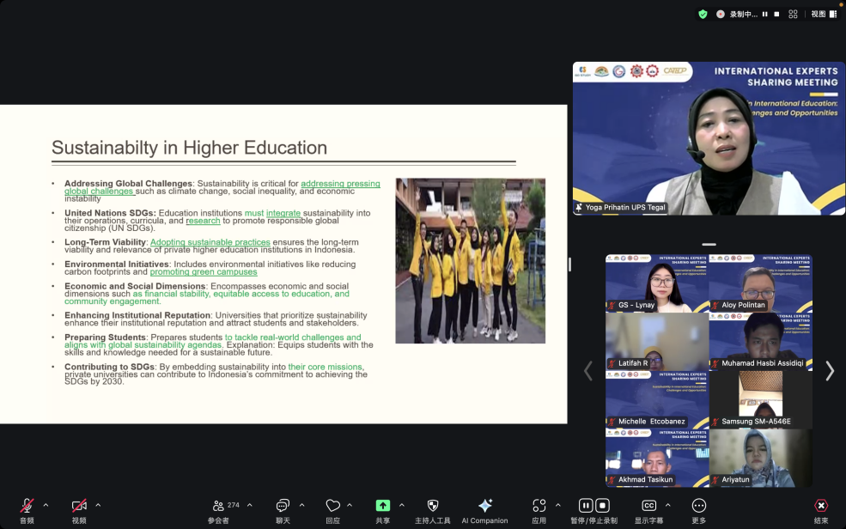
Dr. Yoga Prihatin, Dean of Teacher Training and Education Faculty, Universitas Pancasakti Tegal, Indonesia shared his topic on “Sustainability Strategies for Private Higher Education in Indonesia: Challenges and Opportunities”. Dr. Yoga emphasizes the importance of sustainability strategies for Private Higher Education Institutions (PHEIs) in Indonesia, focusing on financial, social, and environmental challenges. She noted that financial sustainability is critical, as most PHEIs rely heavily on tuition fees (70-80% of revenue). She stressed on the need for curriculum alignment with industry demands to enhance the chance of getting employed, as well as the importance of scholarship programs to support students from lower-income backgrounds.

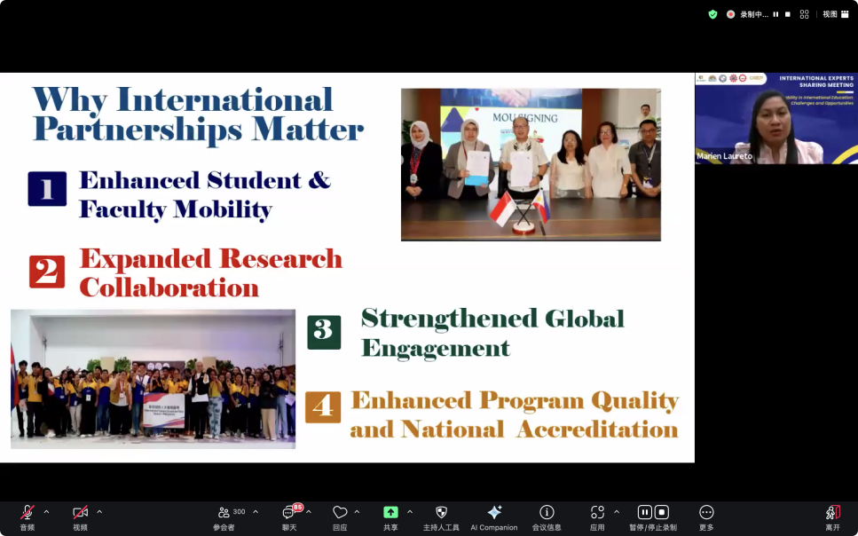
Dr. Marien Laureto, Associate Professor at Capiz State University, The Philippines, presented her topic on “Strengthening International Partnerships for Sustainable Education”. She emphasized the importance of internationalization and sustainability in higher education, particularly at Capiz State University (CapSU). She wants the audience to understand that international partnerships play a crucial role in enhancing academic quality, research opportunities, and global competitiveness. She highlighted key strategies for building sustainable partnerships, including establishing academic collaborations, enhancing student and faculty mobility programs, co-hosting international conferences, and integrating global perspectives into the curriculum.

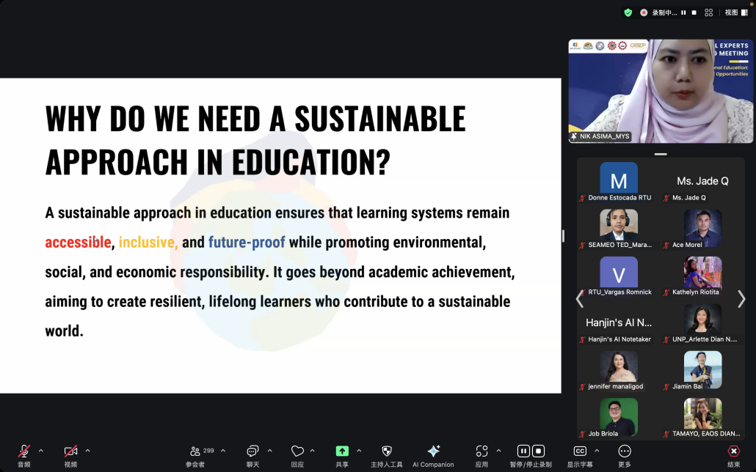
Mrs. Nik Nor Asima Ariffin, Senior Lecturer at the Department of Civil Engineering at Politeknik Sultan Haji Ahmad Shah, Malaysia, presented her topic on “Global Partnerships & Collaboration for Sustainable Education”. She focused on the importance of global partnerships and collaboration in sustaining international education. She also pointed out that a sustainable approach to education goes beyond academic excellence—it must ensure accessibility, inclusivity, and long-term relevance while promoting environmental, social, and economic responsibility. She stressed on the need for transnational education programs, student mobility and exchange programs, joint degree initiatives, and government-led policy efforts that encourage sustainability in education.

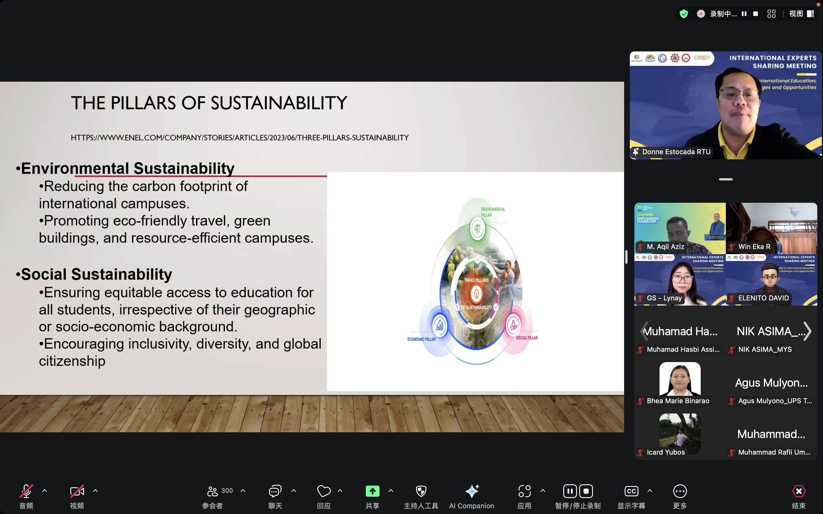
Dr. Donato Estocada, Director, International Affairs and Linkages Office at Rizal Technological University, The Philippines, presented his topic on “Exploring the path forward in a rapidly evolving global landscape”. He focused on the three pillars of sustainability—environmental, social, and economic. He insisted that policymakers play a key role in harmonizing visa policies, funding green initiatives, and ensuring equitable education policies. He believed that by integrating these strategies, the global education sector can become more inclusive, environmentally friendly, and financially sustainable.

