Capacity-Building Workshop on AI and Digital Transformation in TVET for ASEAN TVET Teachers
South Korea, March 23-25, 2025

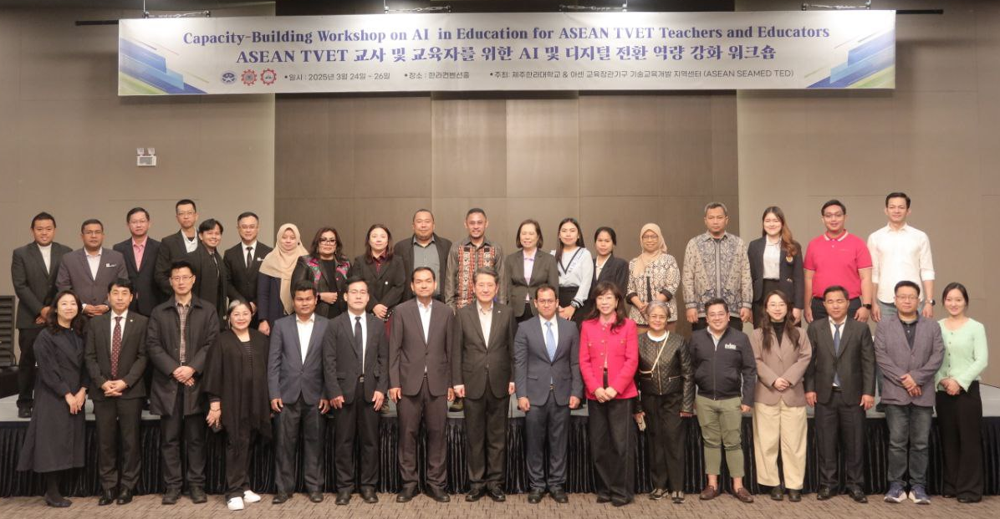
(Group Photo of Participants)

On March 23-25, 2025, Dr. Songheang Ai, director of SEAMEO TED has led 28 ASEAN TVET teachers and policy makers to join the capacity-building workshop on AI in education at Cheju Halla University, South Korea for purposes (1) to provide ASEAN TVET teachers with the comprehensive understanding of AI application and digital technologies; (2) to equip ASEAN TVET teachers with digital skills for incorporating AI tools and digital platforms into existing TVET curricula; (3) to explore innovative teaching methodologies using AI application and digital platforms that can improve students’ learning outcomes; (4) to enhance the teaching skills and methodologies of vocational education teachers using AI as an assisting teaching aid; (5) to build the foundational bridge between ASEAN TVET institutions and Korean institutions for future cooperation projects; and (6) to strengthen educational relationship between TVET institutions in ASEAN and Korean institutions in terms of best practice sharing. The workshop was participated by 28 ASEAN TVET teachers and policy makers from 7 ASEAN countries consisting of Brunei Darussalam, Cambodia, Indonesia, Malaysia, the Philippines, Thailand, and Vietnam including 2 participants from China.
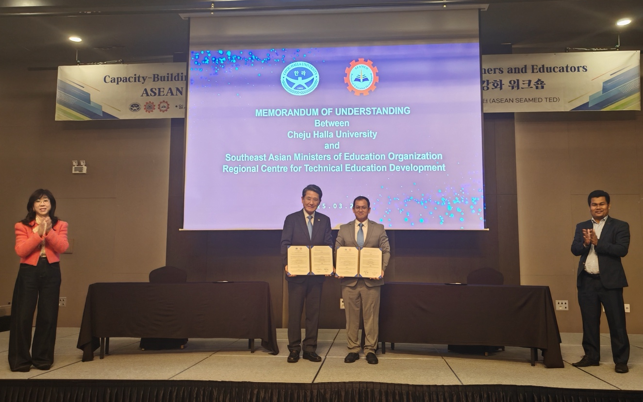
(MoU Signing between SEAMEO TED and CHU)

During the workshop, SEAMEO TED led by Dr. Songheang Ai and CHU led by Prof. Dr. Jonghwa Kim has signed MoU to start cooperation between South Korea and ASEAN for TVET development.

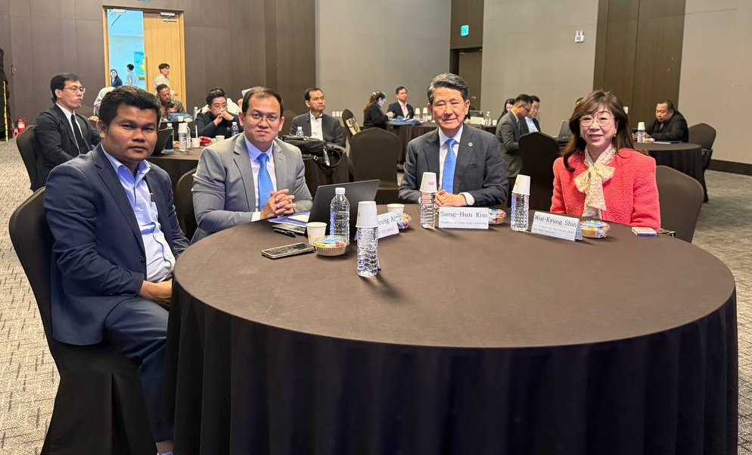
(Dr. Ai and Dr. Kim)
During the opening ceremony of the workshop, Dr. Boyoun Lee, vice director of office of international affairs, delivered her welcome remarks focusing on the importance of the workshop that focuses on AI in education during the AI era. She encouraged all participants learn from each other and share best practices with their colleagues upon going back to their home countries.
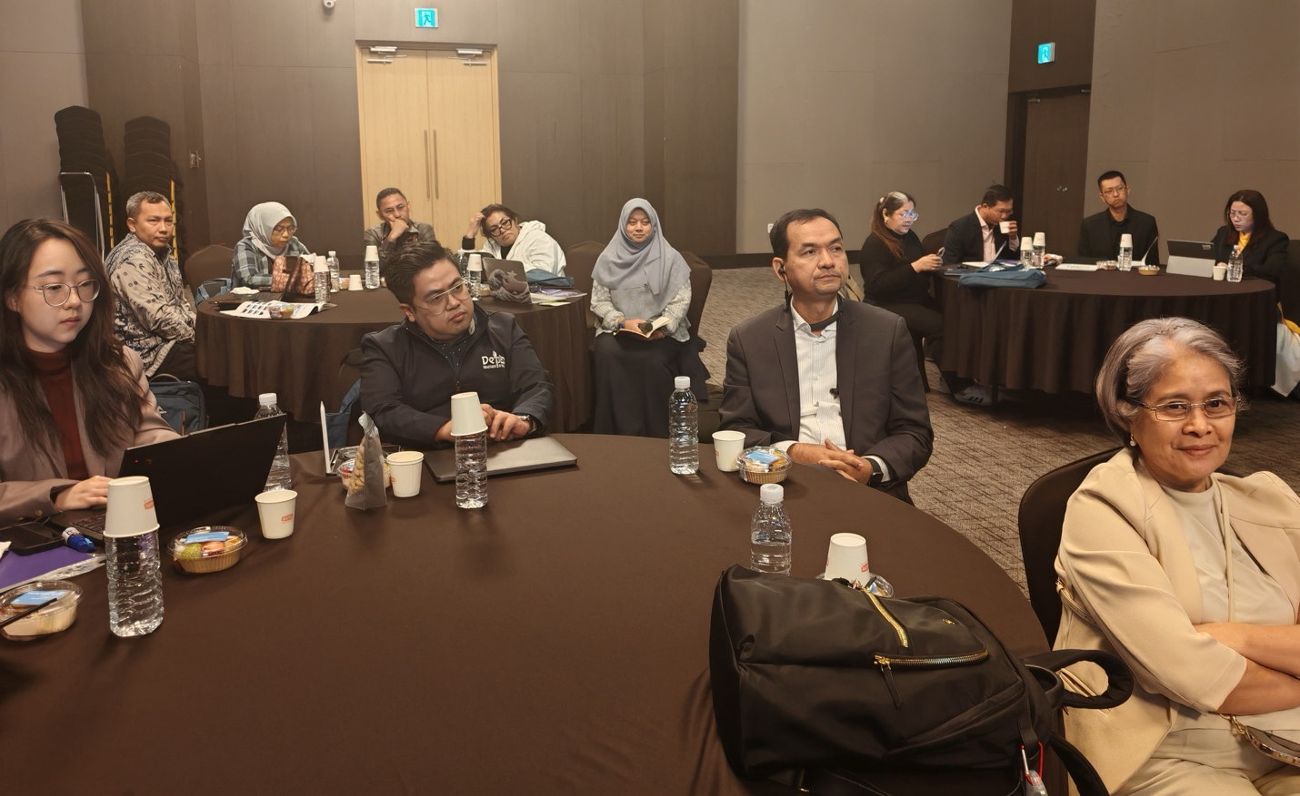
(Participants from China, Cambodia, Philippines, Indonesia, and Malaysia)

Dr. Songheang Ai, director of SEAMEO TED delivered his addressing remarks stressing the AI era requiring teachers to be upskilled and reskilled to catch up with the digital transformation. Globally, the percentage of internet users rose from 16% in 2005 to 66% in 2022. Technology has made a wide range of informal learning opportunities accessible. He mentioned that since 1990s, the number of education policies has increased by 13 times in high-income countries, 9 times in upper-middle income countries, and 5 times in low and lower-middle income countries. Dr. Ai encouraged all participants to be attentively learn AI tools and platforms from the Korean experts and make plans to implement them at their own work settings.

Prof. Dr. Jonghwa Kim, president of Cheju Halla University (CHU) delivered the opening remarks highlighting the cooperative points of action such as curriculum development, and AI tool design and development that the university can cooperate with ASEAN participants to co-develop the programs. Dr. Kim noted the importance of collaboration between South Korea and ASEAN for TVET development. He hoped that participants would learn and experience AI tools productively.

Some main modules that participant learned were AI/Digital Transformation in Education, Empowering Vocational Education Through Digital Tools and Analytics, Understanding the Natural Resources and Tourism Industry of Jeju.

During the workshop, the participants visited the CHU Horse Science Department’s Practice Ranch, and Marine Leisure Sports Center.

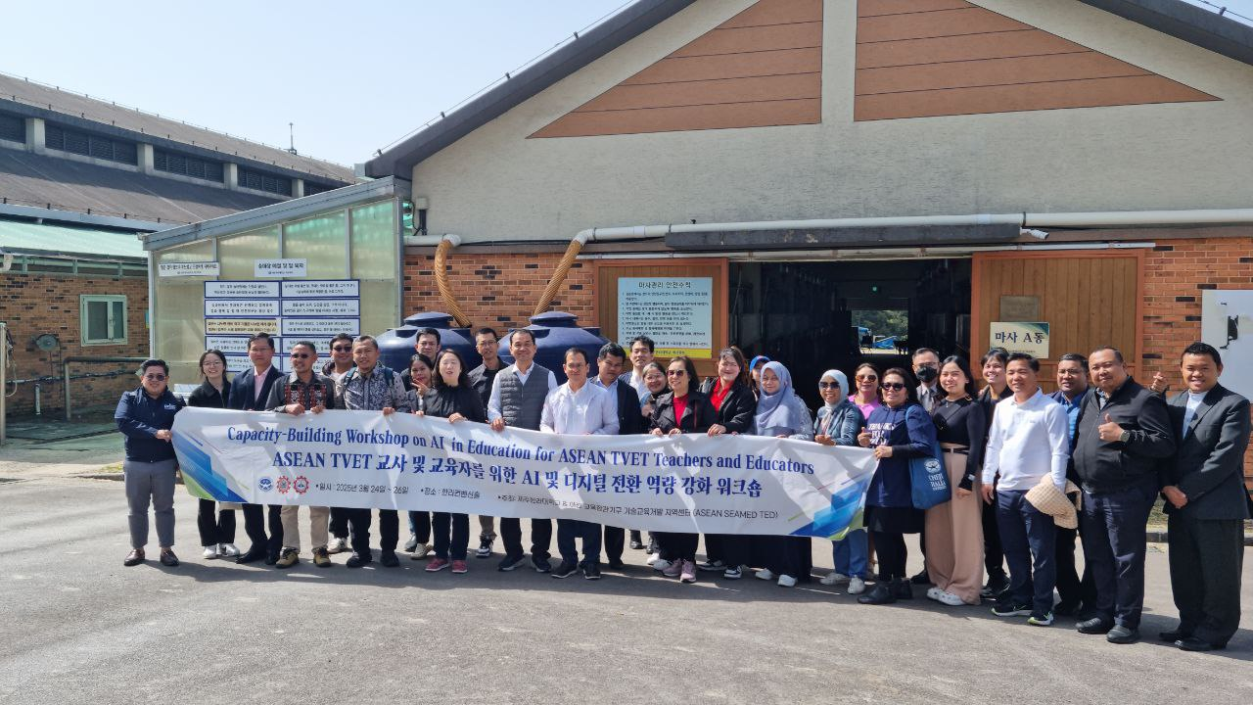
(Visiting the Horse Science Department’s Practice Ranch)

During his closing remarks, Dr. Kim raised some proposals for ASEAN participants’ consideration upon returning to their work settings consisting of joint development of AI-Based Metaverse university, joint development of Digital Twin Education Environment, Joint development of AI-Based Education Curriculum, joint development of Domain Database, and Online and offline Joint Education Programs.

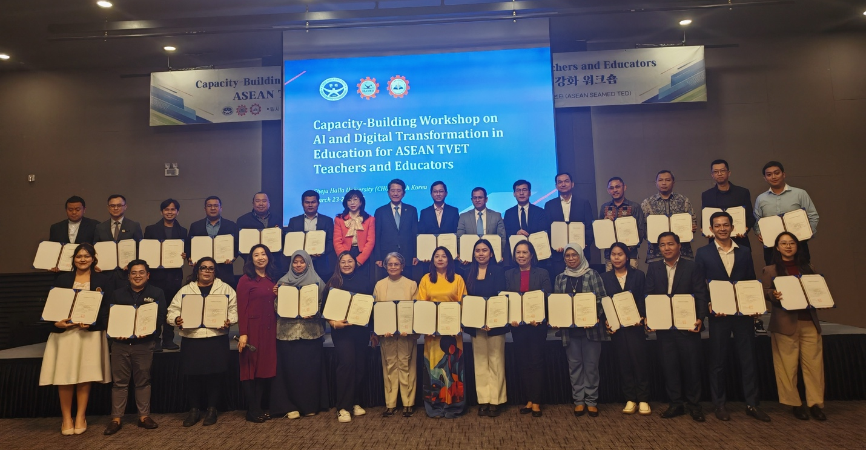
(Certificate Graduation for all Participants)

On March 26, 2025, Dr. Songheang Ai, has paid an official visit to Hangang Media High School and Korea Association of Secondary Vocational Education (KASVE) to seek cooperation and partnership for TVET development between South Korea and ASEAN.

Dr. Ai and the management of Hangang Media High School has come out with some common points of cooperation such as student and teacher exchange programs online and offline, cultural visits, student internship, skill competition, etc.

Dr. Ai and Mr. Kim Chong Kwan, president of Korea Association of Secondary Vocational Education (KASVE) has come out with some common points of cooperation such as applying project proposal for Mekong-ROK Cooperation Fund for project implementation between South Korea and ASEAN, MoU signing between SEAMEO TED and KASVE for resource sharing and cooperation, capacity-building programs for school management, TVET teachers, and policy makers, applying for ODA projects from KOICA, etc.

