Training Course on Technical Drawing for TVET Teachers
Siem Reap City, March 20-21, 2025

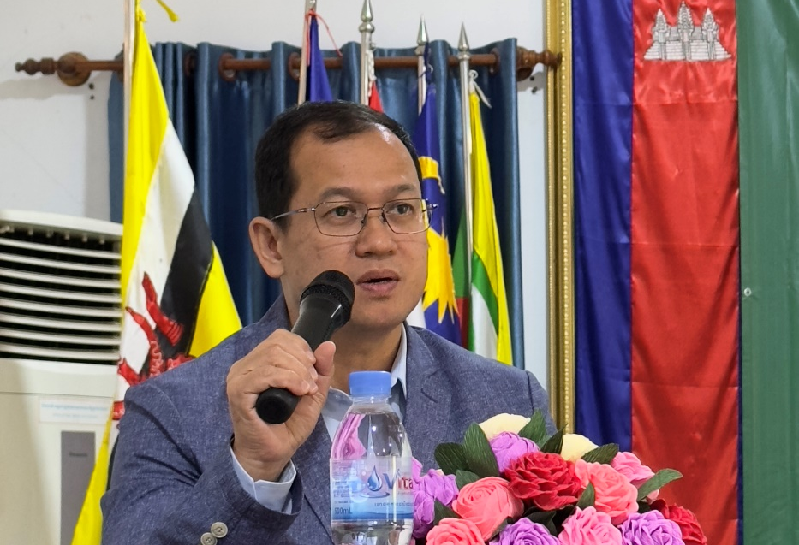
Siem Reap Province: Southeast Asian Ministers of Education Regional Centre for Technical Education Development (SEAMEO TED) of the Ministry of Education Youth and Sports organized a training course on “Technical Drawing″ at Puok General and Technical High School in Siem Reap Province, participated by 42 participants (2 Females) from 15 General and Technical High Schools and one New Generation School in Cambodia. The training course aimed at building capacity for the participants on Technical Drawing with an emphasis of using AUTOCAD program and strengthening the implementation of the Electricity and Electronics curriculum more effectively.
(Dr. Songheang Ai, Director of SEAMEO TED Opening the Course)

The Opening Ceremony of the training course on Technical Drawing was presided over by Dr. Songheang Ai, director of the SEAMEO TED. In his opening remarks, he congratulated Mr. Nhek Sokun, Deputy Director of Siem Reap Provincial Department of Education, Youth and Sport regarding some of its achievements that he highlighted, particularly the overwhelmingly remarkable passing rate of the high school and junior high school graduates in the preceding academic year accounting for over 86% and 90% respectively. He also thanked him for the insightful remarks for the participants during the opening ceremony.
Dr. Ai also stressed on the importance of TVET sector as indicated the government’s various policies. TVET is a school-to-work approach which provides youth a faster alternative path to enter the world of work and be productive in the labor market. He also noted that this training course is a response to the training need assessment to train technical education teacher on Technical Drawing subject as it is very important for the teachers of Electricity and Electronic trades to know this subject to be able to implement technical curriculum of these two trades successfully. In addition, he emphasized the importance of peer learning in enhancing skills development among teachers. He encouraged the teachers who participated this training or other capacity development training to share what they learned and best practices to their colleagues.

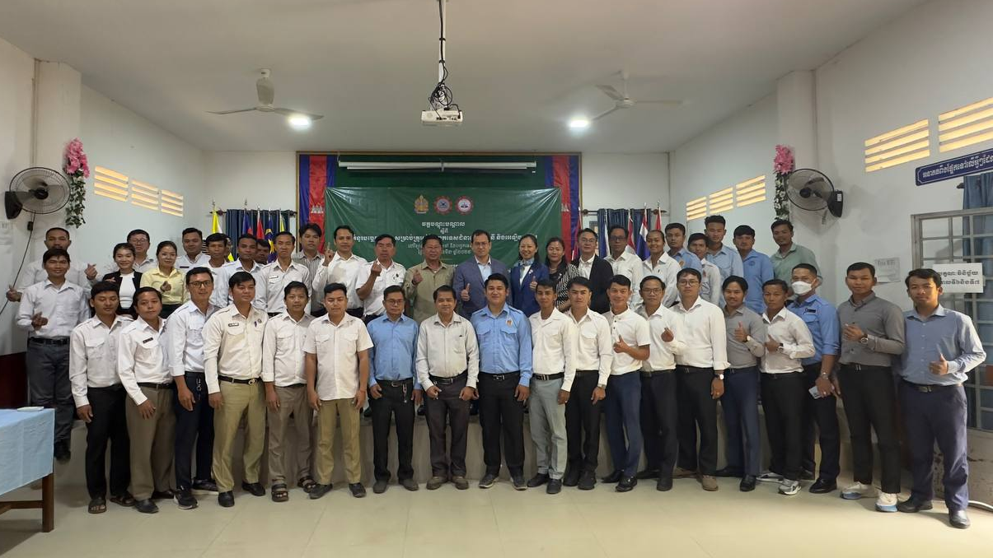
(Group Photo)

This training was taught by two Chinese experts of SEAMEO TED—Ms. Zhao Peili, Professor of Guangxi Polytechnic of Construction, as the core trainer, and Mr. Wei Qinghua, Senior Engineer of Guangxi Vocational College of Water Resources and Electric Power, as the assistant trainer. The training covered five topics with a balance of theory and practices: Basics of Technical Drawing, Development of Technical Drawing, Reading of Construction Engineering Drawings, and Introduction to AutoCAD Program and (5) Technical Drawing Practice.

Ms. Zhao Peili, the core trainer, was able to engage all the participants in the training. Overall, the training was really engaging and participants were really active. They were really eager to carry out tasks assigned by the core trainer, one of which is to draw floor plan of a building using AutoCAD. Almost all of the students were able to completed the tasks on their own with help from their follow participants.
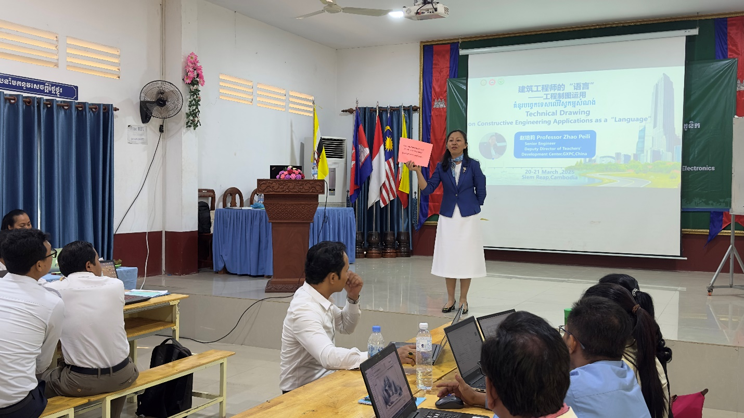
(Ms. Zhao Peili Lecturing)
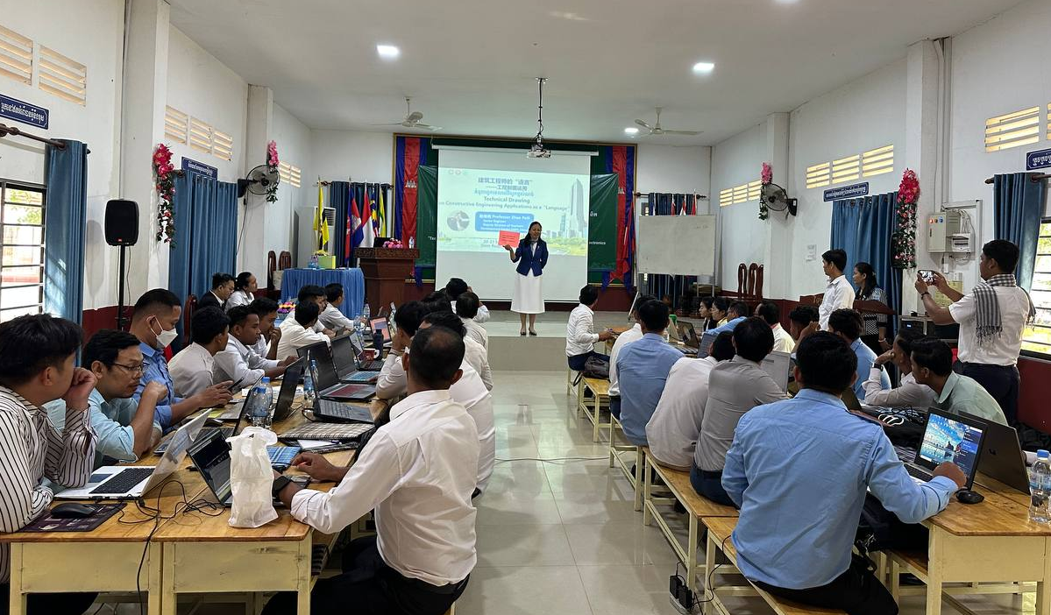
(Lecture in Progress)

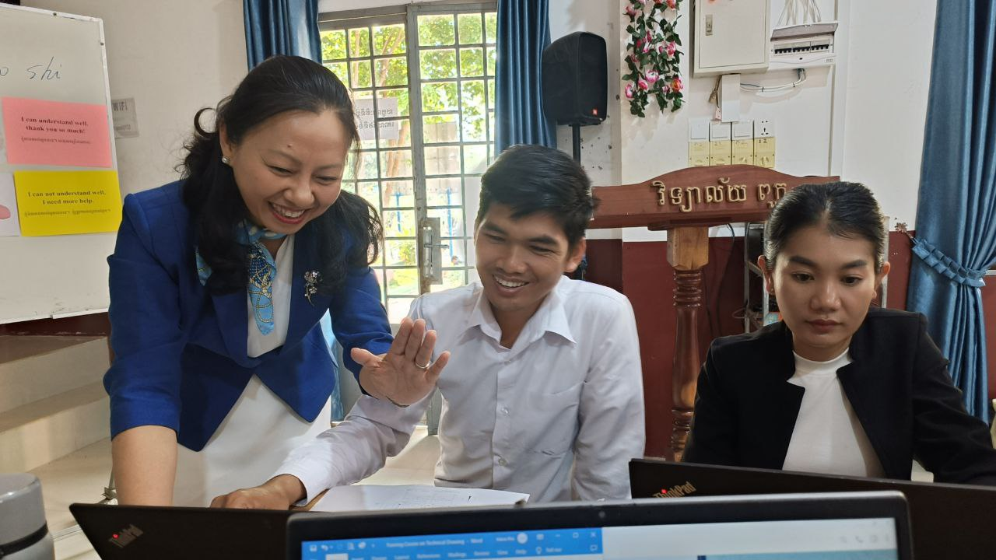
(Ms. Zhao Peili Explaining Participants)

