Capacity-Building Workshop on “Transformative Leadership, Modern Teaching Methodology, and Cutting-Edge Technology”
Phnom Penh, March 18, 2025

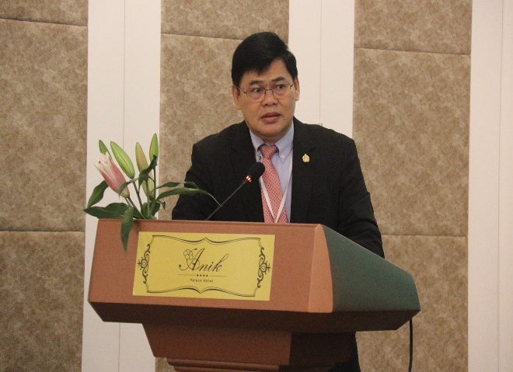
Phnom Penh: Southeast Asian Ministers of Education Regional Centre for Technical Education Development (SEAMEO TED) of the Ministry of Education Youth, and Sports organized a Workshop on “Transformative Leadership, Modern Teaching Methodology, and Cutting-Edge Technology ″ at Anik Palace Hotel in Phnom Penh, March 18, 2025, participated by 28 participants (6 Females) from Ministry of Education Youth and Sports in Cambodia. The Workshop course aimed at building capacity for the participants on Transformative Leadership, Modern Teaching Methodology, and Cutting-Edge Technology with a significant step in strengthening Cambodia’s education sector by equipping educators with the skills to drive meaningful change.

(H.E. Dr. Om Romny, Secretary of State, MoEYS, Opening Workshop)

The Opening Ceremony of the Workshop on “Transformative Leadership, Modern Teaching Methodology, and Cutting-Edge Technology ″ was presided over by His Excellency H.E. Dr. Om Romny, Secretary of State, Ministry of Education, Youth and Sport. In his opening remarks, he extends him sincere gratitude to CODEUS for their dedication to advancing educational excellence and to all of you, our esteemed senior education staff, for your participation. Your commitment to lifelong learning and professional development is instrumental in shaping the future of Cambodia’s education sector.

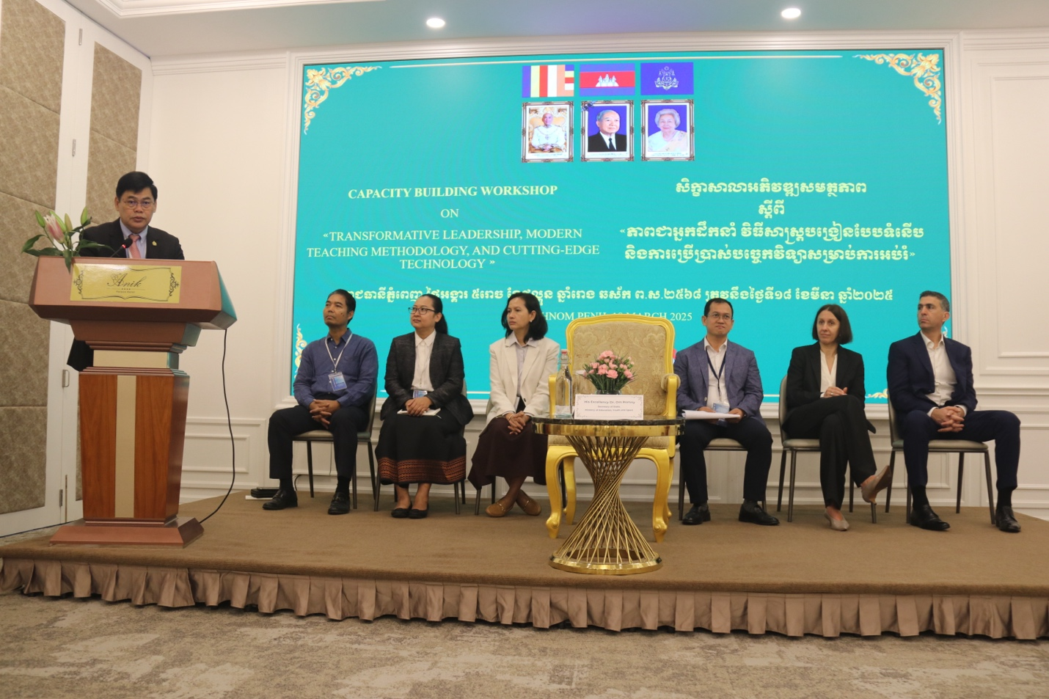
(Opening Ceremony of the Workshop)
His Excellency H.E. Dr. Om Romny, also this workshop is more than just a training session; it is a milestone in our journey toward educational excellence. By the end of today’s discussions, I hope each of you will feel empowered and inspired to bring transformative practices back to your institutions. Together, we can cultivate a student-centered education system that nurtures critical thinking, creativity, and lifelong learning. His Excellency would like to extend him deepest appreciation to CODEUS for their steadfast commitment to strengthening our education sector. I also commend each of you for your dedication to professional growth and excellence in education. Your unwavering commitment to learning and improving will shape the future of Cambodian students and, ultimately, the future of our nation.

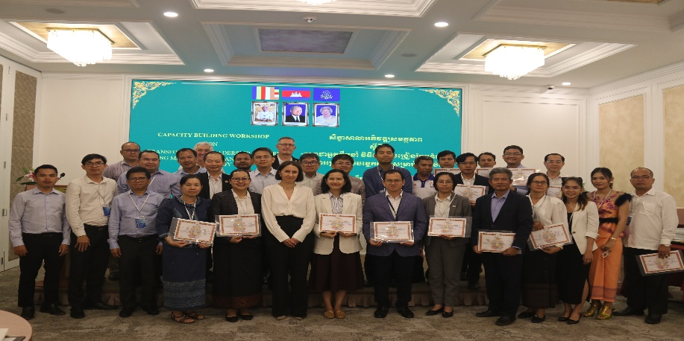

(Group Photo of Participants)

