International Expert Sharing Meeting on “International Cooperation on Vocational Education and Innovation inn Personnel Training” on April 11, 2025 (Virtually)

On April 11, 2025, the thrid International Experts Sharing Meeting of the year, hosted by CATECP, SEAMEO TED, and the International Youth Culture and Education (KEMG), successfully concluded. With the theme "International Cooperation in Vocational Education and Innovation in Personnel Training" the event focused on different international cooperation initiatives in promoting vocational education and personnel training in Southeast Asia. Experts from Thailand, Indonesia, and Malaysia gathered online to share their valuable experiences and unique insights on initiatives by their respective institutions on how to drive educational innovation. The event provided participants with a thought-provoking intellectual exchange and attracted enthusiastic participation from over 200 attendees worldwide.
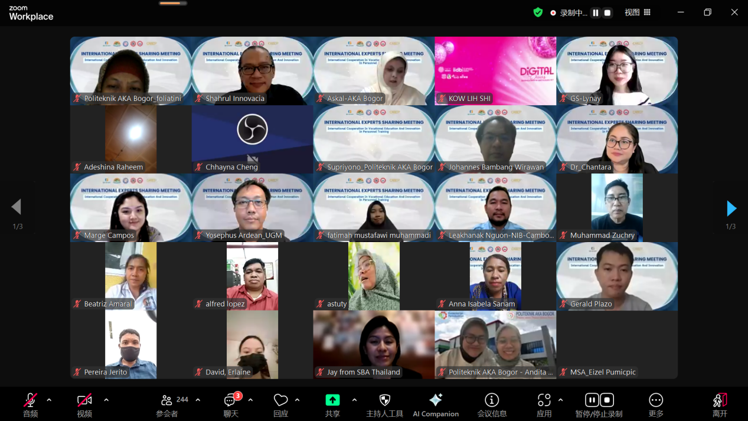
(Group Photo of all Participants)

The opening speech was delivered by Mr. Tim Vorn, Head of Head of Research and Development Division of SEAMEO TED. He emphasized on the importance of international collaboration in strengthening vocational education and advancing innovative practices. This helps to train young skill professionals in a rapidly changing world. He also mentioned how partnership and innovation is the key to develop the human capital making the future more adaptable and inclusive. Mr. Vorn encouraged participants to engage in the discussion with our esteemed experts as they are specialized in the topics that they choose to present.
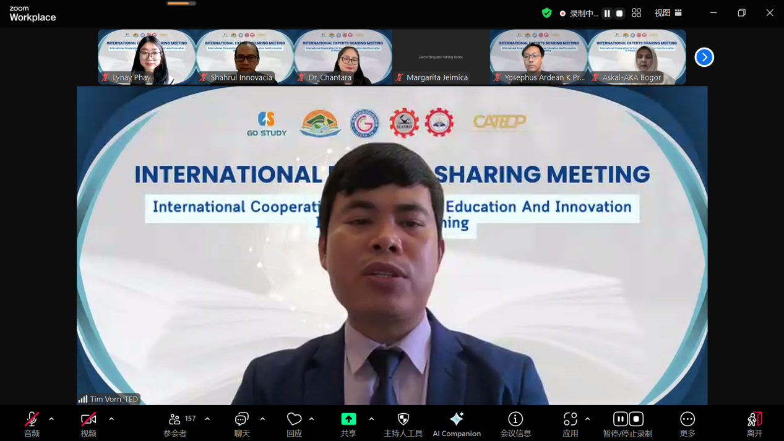

Topic: From Exchange to Innovation: The Thai Chinese Journey of Innovative Collaborative Approaches
Speaker: Dr. Soontornpathai Chantara, President of Udonthani Industrial and Community Education College, Thailand
Dr. Soontornpathai Chantara highlights the evolving collaboration between Thailand and China in vocational education, particularly through the efforts of UD-ICC and its partnership with INTERVEC since 2020. What began as a basic exchange program has grown into a comprehensive collaboration involving both online and onsite training courses, particularly in Electric Vehicle (EV) teacher training. These initiatives have laid the foundation for mutual knowledge sharing and skill development between the two countries. She mentioned how the Thai Chinese collaboration has progressed from traditional exchange models toward more innovative and practical applications, such as e-commerce for EV cooking, and integrated projects focusing on local tourism, Thai gastronomy, and the cultural arts of Thai wellness. The partnership promotes a "GLOCAL" mindset—acting locally while thinking globally—by combining Thai cultural strengths with advanced Chinese technologies and educational strategies. As part of the expanding vision, the collaboration includes reciprocal training opportunities: Chinese teachers and students are trained in Thailand, while Thai educators benefit from training in China. Future projects under discussion include incorporating AI in tourism business applications, further enriching vocational curricula with cutting-edge digital skills and entrepreneurship. Finally, Dr. Chantara presented key recommendations to strengthen future collaboration, calling for sustained exchange of teachers and students, joint program development, and deeper cultural integration to shape the next generation of innovative TVET (Technical and Vocational Education and Training). This initiative serves as a model for international cooperation, combining cultural diplomacy with educational innovation to prepare a globally competitive workforce.

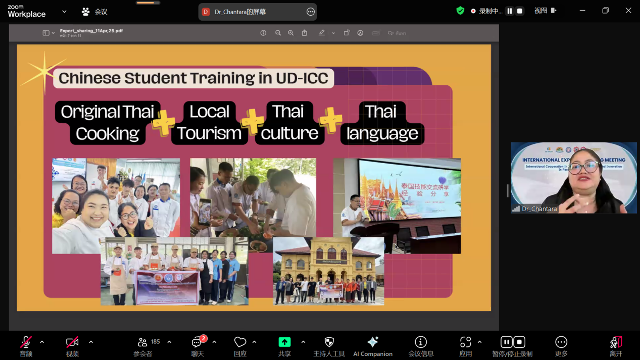
Topic: Bridging Continents: Leveraging International Collaborations for Advancements in Multiphase Flow Measurement Techniques
Speaker: Dr. Yosephus Ardean, Head of Research Department & Assistant Professor in Mechanical Engineering at Universitas Gadjah Mada, Indonesia
Dr. Yosephus core message emphasizes that modern scientific challenges transcend national borders, necessitating global, trust-based partnerships rooted in shared purpose and mutual benefit. He outlines three fundamental skills for researchers aiming to join international networks: strong academic capability, adaptability, and interpersonal competence. The presentation centers around best practices for global networking, using the University-Industry-Government-Community (UIGC) model as a framework for impactful collaboration. Key initiatives include joint research, team teaching, and exchange programs, all aimed at strengthening ties across institutions and countries. Dr. Yosephus presents the Fablab Jogja case as a success story—an innovation hub that supports prototyping, local manufacturing, food processing, and agri-tech development. The FabLab concept connects communities, customers, designers, and engineers to bring practical solutions to life through digital fabrication and localized entrepreneurship. He also shares the UGM-NUAA collaboration (with Nanjing University of Aeronautics and Astronautics, China) as an example of sustained academic partnership. Since 2021, this alliance has resulted in multiple international journal publications, over 20 joint seminars, and dozens of online academic lectures. These collaborative efforts showcase the power of bilateral cooperation in mechanical and electrical engineering, contributing to capacity-building and scientific progress in both Indonesia and China. He concludes the presentation by stressing three key takeaways: First, global collaboration accelerates innovation, especially in complex technical fields like multiphase flow. Second, international knowledge exchange strengthens local research ecosystems, empowering institutions like UGM to lead in regional development. Lastly, the future of scientific advancement lies in collaboration, where interdisciplinary and intercultural teamwork becomes the norm for addressing global challenges related to energy, environment, and technology.

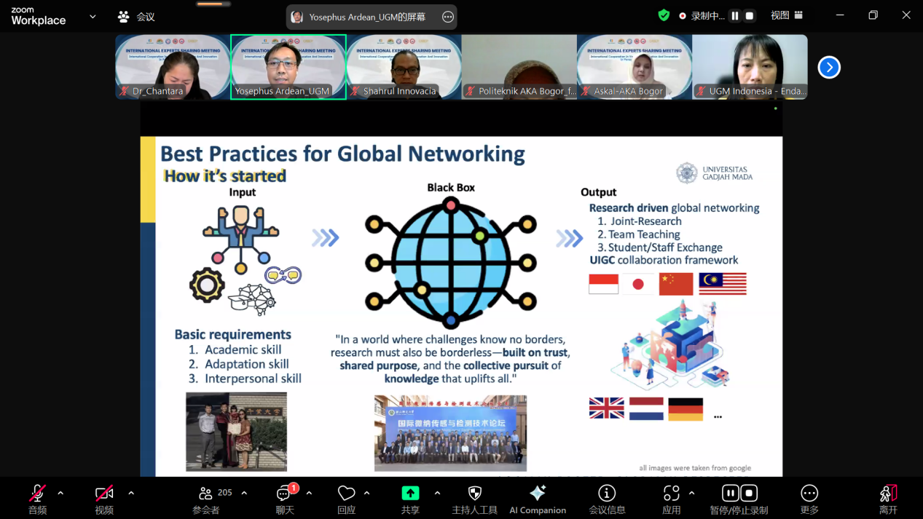

Topic: Partnering for Prosperity: Empowering Future-Ready Workforce for Industrial Growth through Vocational Education and Industrial Collaboration
Speaker: Prof. Dr. Askal Maimulyanti, M.Si., Director of Politeknik AKA Bogor, Indonesia
In this topic presenation, Prof. Dr. Askal Maimulyanti puts a firm emphasis the vital role of workforce readiness in driving industrial development and economic growth in Indonesia. It highlights how vocational education bridges the gap between academic learning and practical skills, offering industry-aligned, hands-on experience. Politeknik AKA Bogor, under the Ministry of Industry, exemplifies this through its strategic development of globally competitive STEM-based diploma programs, including unique offerings like the Diploma IV in Food Nanotechnology. The institution also provides specialized certifications in areas such as analytical chemistry, food safety, environmental management, and nanotechnology, aligning graduate competencies with industry needs. Collaboration with industries is central to this model, providing mutual benefits such as tailored training, knowledge sharing, and workforce development. Successful partnerships include internships and recruitment programs with both local and international companies, as well as international initiatives like the Korean Study and Career Center and a management trainee program in China. Research collaborations and lecturer apprenticeships further strengthen academic-industry ties. Looking forward, Politeknik AKA Bogor seeks to expand its partnerships through international internships, academic exchanges, joint research, and the development of industrial classes. The presentation concludes by affirming the critical role of vocational education in sustainable industrial progress and the institution’s commitment to long-term collaborative success.

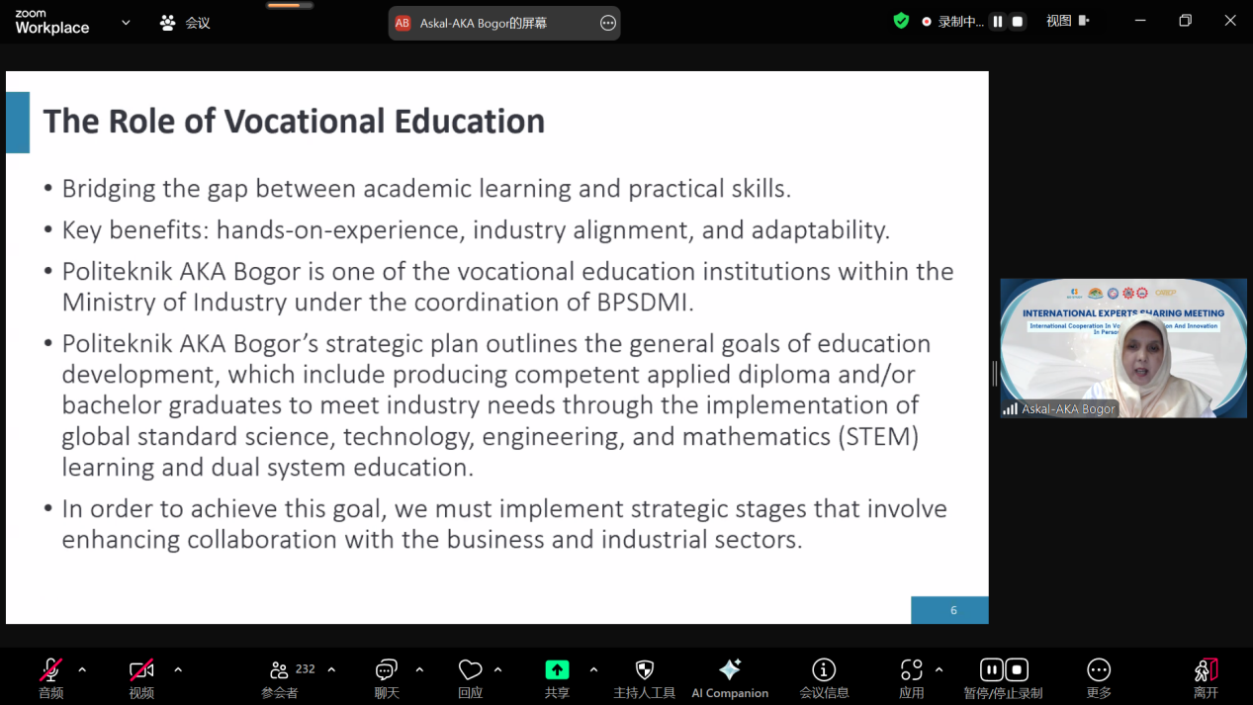
Topic: Offering Affordable Construction Digital Solutions and Training through Open Global Partnerships
Speaker: Ir. Shahrul Nizar Shaari, Director of Innovacia Sdn Bhd, Malaysia
Ir. Shahrul Nizar Shaari highlights efforts to transform the construction industry through accessible digital solutions and collaborative training initiatives. Innovacia’s core mission is to democratize access to construction technology and knowledge, particularly in developing countries, by forming open global partnerships that promote innovation in vocational education and training. He also emphasizes the importance of providing affordable and practical digital tools tailored to the needs of the construction sector. Innovacia focuses on leveraging open-source platforms and cloud technologies to reduce barriers to entry for small and medium-sized enterprises (SMEs). A major part of their strategy involves building capacity in Technical and Vocational Education and Training (TVET) institutions, ensuring that the workforce is equipped with the skills needed to thrive in the digital economy and Industry 4.0 era. To illustrate the effectiveness of this approach, he includes case studies from both local and international partnerships. These cases demonstrate the successful integration of tools like Building Information Modelling (BIM) and digital project management platforms into vocational training programs. Through these projects, Innovacia supports real-world applications of digital construction methods, enhancing productivity and sustainability in the sector. Ultimately, the initiative aims to create a global network of collaboration that enables knowledge sharing, promotes digital inclusion, and builds a skilled construction workforce capable of navigating the challenges of modernization. The outcomes are not only beneficial for workforce development but also contribute to broader goals of innovation, cost efficiency, and international cooperation in the construction and education sectors.
