Capacity-Building Workshop on
Transformative Leadership and Cutting-Edge Technology for TVET Policy Makers
Phnom Penh, March 17, 2025

Phnom Penh: Southeast Asian Ministers of Education Regional Centre for Technical Education Development (SEAMEO TED), CODEUS Parent Company ​ and Ministry of Labor and Vocational Training Co-organized a Capacity Building Workshop on «Transformative Leadership, Neuroscience in Education, and Innovative and Creative Technologies» at Anik Palace Hotel, Phnom Penh, March 17, 2025, participated by 31 participants (5 females) from various institutions of the Ministry of Labor and Vocational Training in Cambodia. This workshop concentrated on learning, teaching, and educational best practice distinguishing it from traditional skills-based on subject-oriented content.
​ 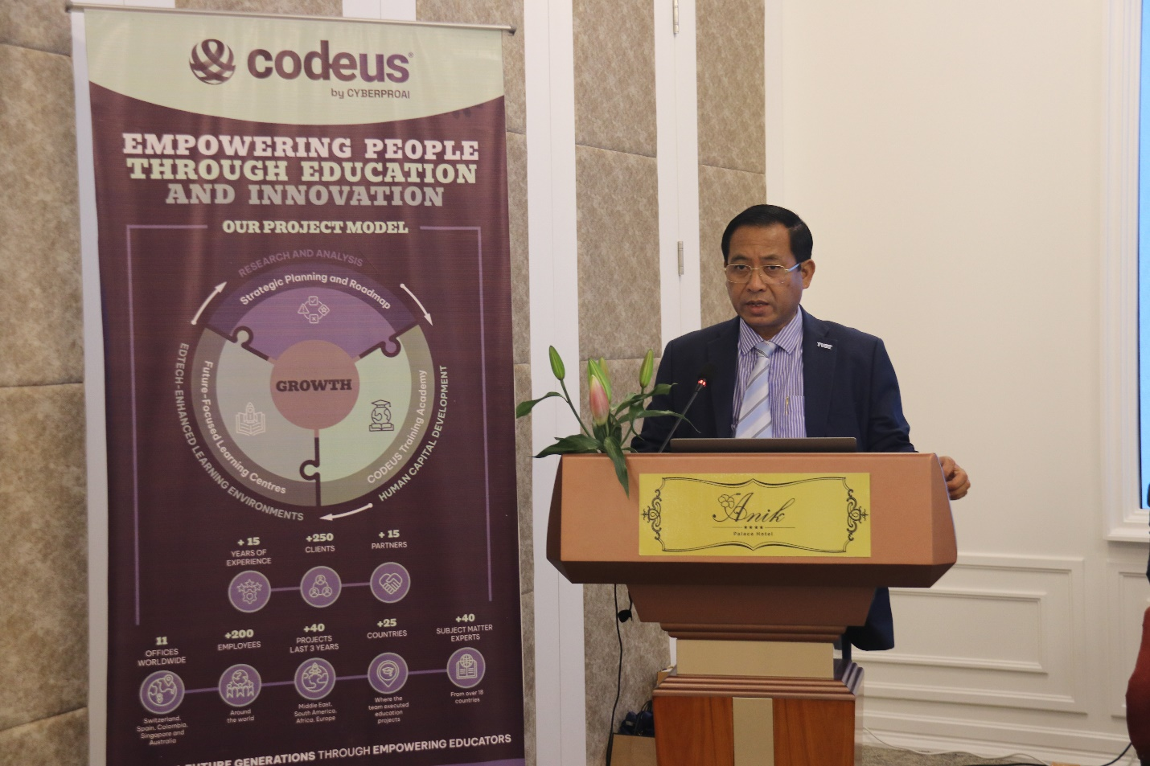
(H.E Dr. Hing Sideth Delivering Opening Remarks)

This workshop was presented by four experts, Dr. Songhean Ai, Center Director of SEAMEO TED, Mr. Tony Brandenburg, Director of Education at CODEUS, Ms. Alyona Datsenko Volodina, General Manager CODEUS, and Mr. Brad Ker, Advisor to CODEUS and Director of Digital Learning at Labtech International from Australia, which focus on four topics first Leadership, Transformative Leadership, Neuroscience in education, and Innovative and creative technologies, including Adaptive leaning Technologies.
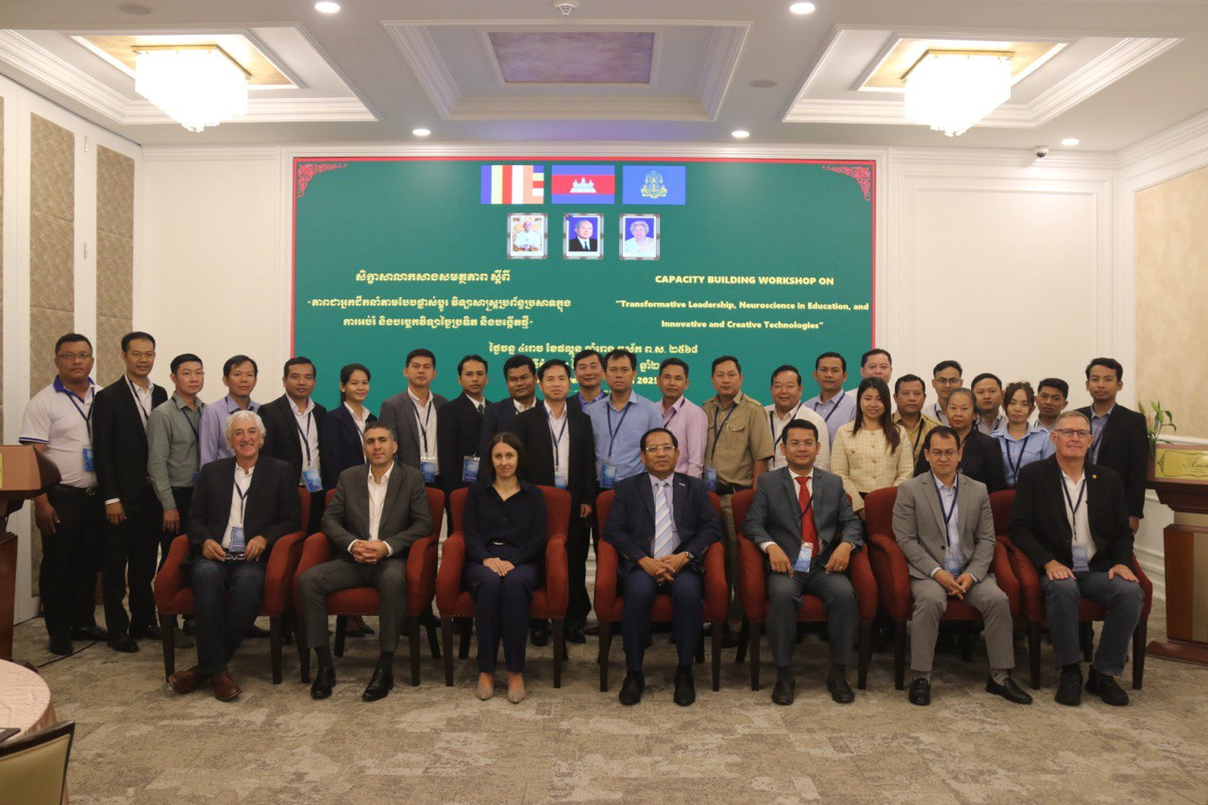
(Group Photo of all Participants)

The Opening Ceremony of the training course on Technical Drawing was presided over by H.E Dr. Hing Sideth, Director General of Directorate General of Technical and Vocational Education and Training. In his opening remarks he extends him sincere gratitude to Mr. Amit Cohen, Managing Partner of CODEUS parent company, Mr. Tony Brandenburg, Director of Education at CODEUS, Mr. Brad Ker, Advisor to CODEUS and Director of Digital Learning at Labtech International, Dr. Ai Songheang, Director of SEAMEO TED and distinguished guests, respected colleagues, esteemed partners from CODEUS and SEAMEO TED. It is an absolute honor and privilege to welcome you all to this important capacity building workshop on «Transformative Leadership, Neuroscience in Education, and Innovative and Creative Technologies» for Senior Education Staff under the Directorate General of Technical Vocational Education and Training (DGTVET). On behalf of the Ministry of Labor and Vocational Training (MLVT), He extend his deepest appreciation to CODEUS and SEAMEO TED, in collaboration with the MLVT, for organizing this capacity-building workshop. It is an initiative that reflects a strong commitment to enhancing the quality, relevance, and effectiveness of TVET Sector in Cambodia.
His Excellency mentioned that we are gathered here today not just as manager, director, administrators, or trainers, but as leaders of change—individuals with the power and responsibility to shape the future of Cambodia’s workforce. In an era defined by rapid technological advancements, digital transformation, and evolving labor market demands, the traditional approaches to education are no longer sufficient. We must rethink, reimagine, and innovate. He also highlighted about the workshop lies a critical theme: transformative leadership. As leaders in the TVET sector, we must go beyond administration and embrace a vision that is forward-thinking, adaptable, and innovative. Our educators are not merely instructors; they are mentors, facilitators, and catalysts for lifelong learning. It is our duty to empower them with the right tools, methodologies, and technologies to prepare students for the realities of the modern workforce.
Lastly, H.E Dr. Hing Sideth had expressed his sincere gratitude to CODEUS and SEAMEO TED, for bringing this initiative to Cambodia. He also commended each of participants for the dedication to strengthening the foundation of Cambodia’s education sector. By the end of the workshop, he looks forward to an engaging and productive workshop, and he was confident that our collective efforts will lead to transformative changes that benefit our directors, trainers, students, and the nation.

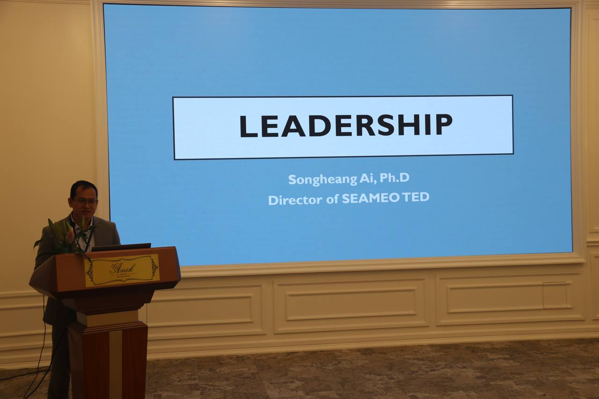
(Dr. Songheang Ai, Center Director of SEMEO TED, Lecturing Leadership)

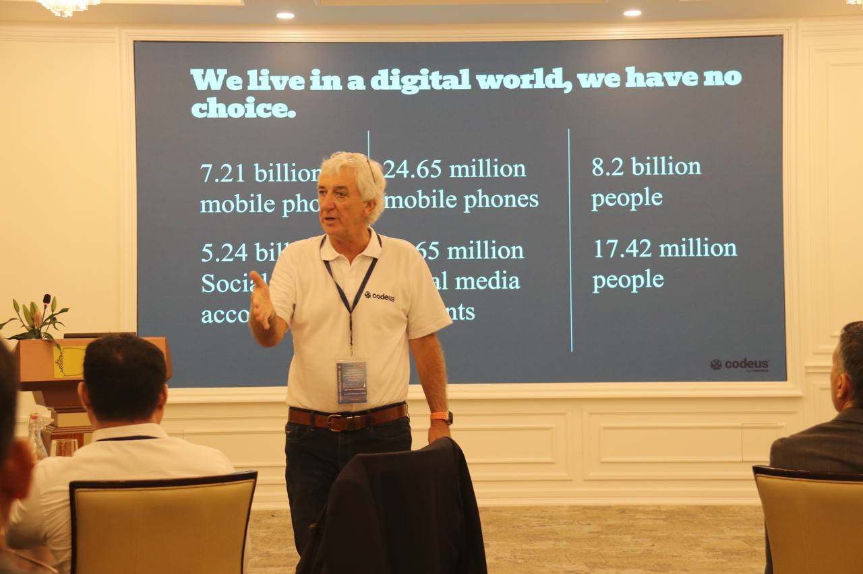

(Mr. Tony Brandenburg, Director of Education Division, CODEUS)

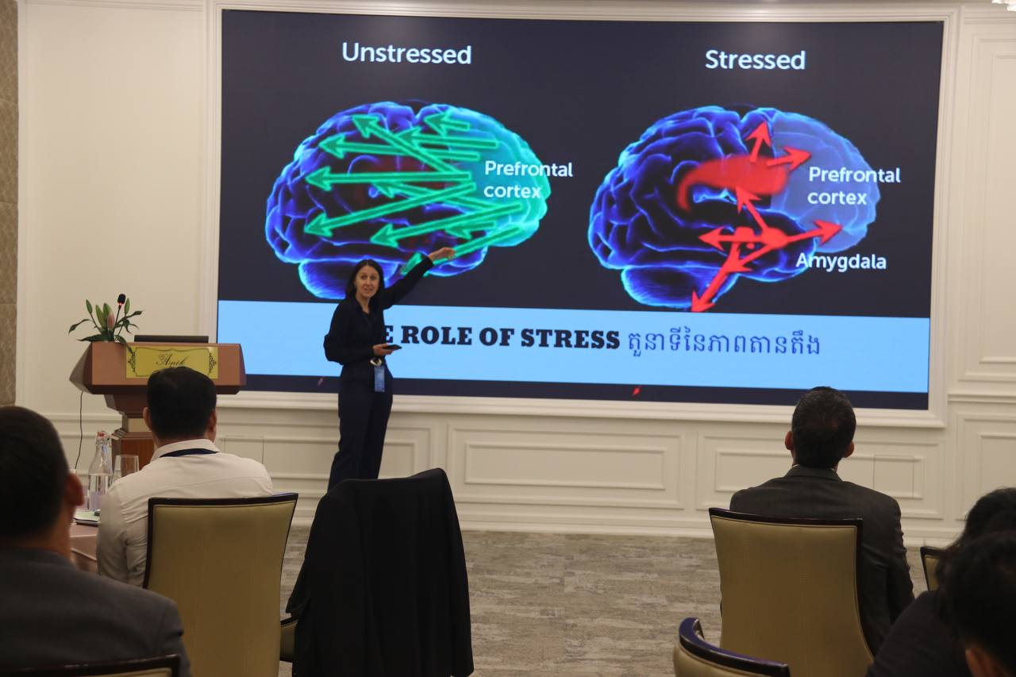

(Ms. Alyona Datsenko Volodina, General Manager CODEUS, on Neuroscience in education)

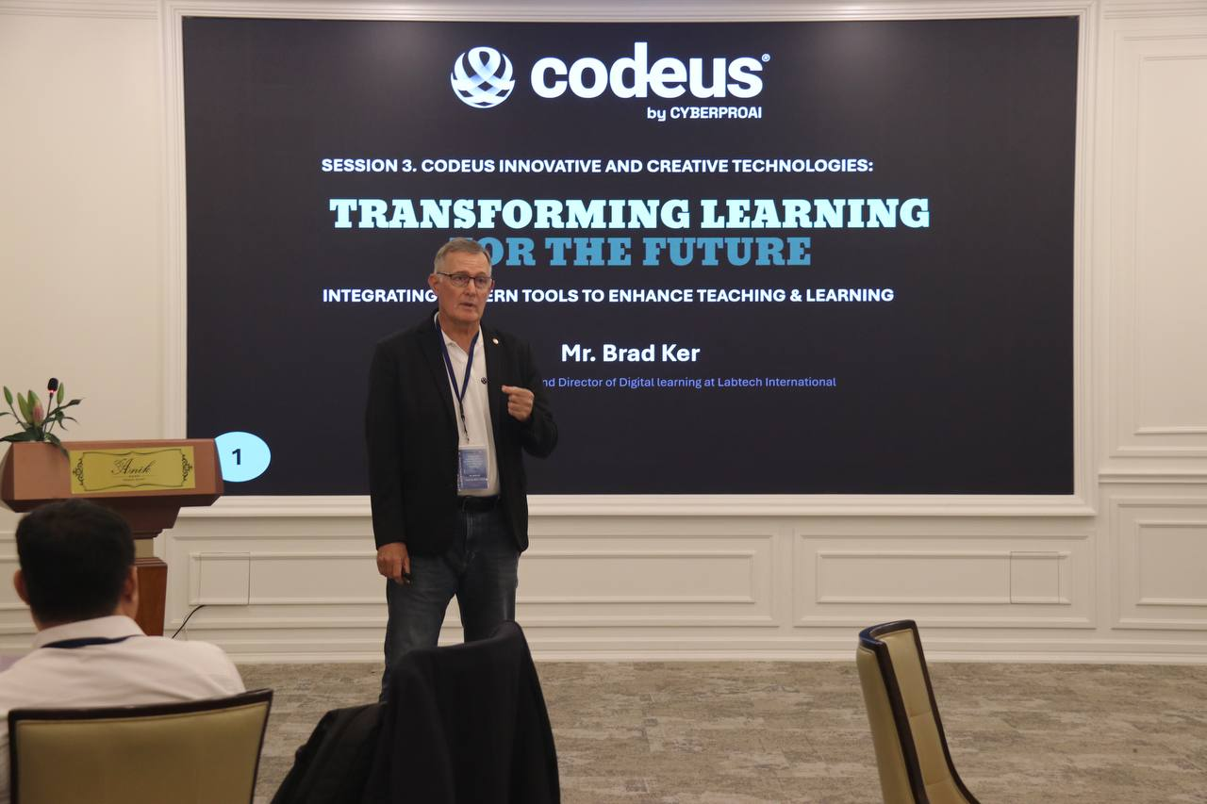

(Mr. Brad Ker, Advisor to CODEUS and Director of Digital Learning at Labtech)

