Chinese Frontier Mechanical Lecture
Step Shaft Turning (Online)
22nd April 2025, Time: 3:00 PM to 4:30 PM (GMT+8)

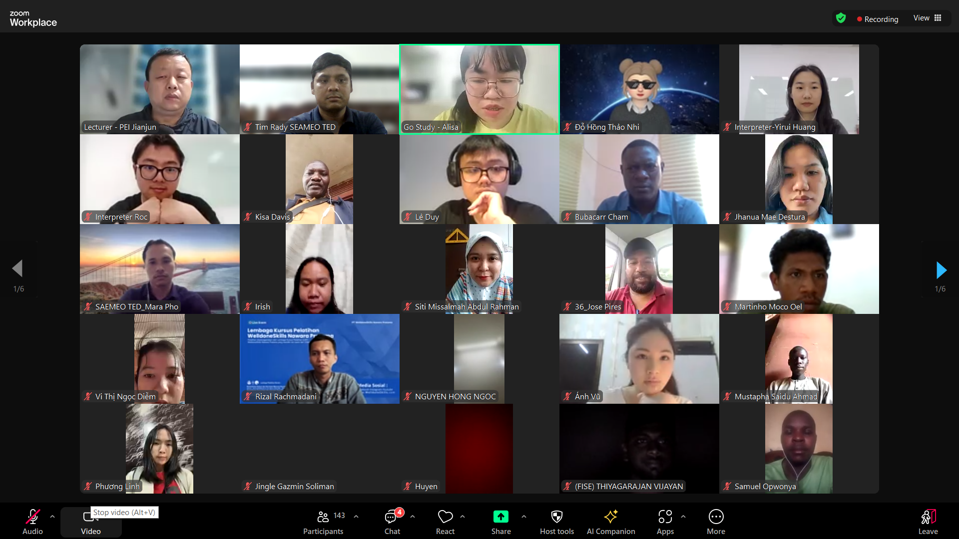
(Training Participants on Live lecture)

Southeast Asian Ministers of Education Organization Regional Centre for Technical Education Development (SEAMEO TED), Go Study Global Education, and Xinxiang Vocational & Technical College co-organized a Chinese Frontier Mechanical Lecture on “Step Shaft Turning” which was participated by over 140 participants from thirteen different countries consisting of Cambodia, Indonesia, the Philippines, Malaysia, Brunei Darussalam, India, Sri Lanka, Vietnam, Pakistan, Serbia, Uganda, Nigeria, and Timor-Leste. The Webinar was held from 3:00 pm to 4:30 pm (GMT+8), every conservative day on April 22 (live lecture), 2025 for the purpose of sharing knowledge and expertise of Step Shaft Turning by a Chinese expert Mr. PEI Jianjun, Special Government Allowances of State Council and Henan Province (Fruitful teaching experiences in CNC Milling: Machining Process Programming and Operation and CNC Machining Technology, Provincial Distinguished Teacher of Vocational Colleges, Henan Province, Technical Expert and Technical Model Worker of Henan Province, and Specialties: Mechanical Product Design and CAD/CAM Manufacturing).

In each session, the lecturer delivered the important contents of the step shaft turning such as feature of a stepped shaft, the function of design, components of stepped shafts, and application of stepped shafts. The participants were aware of the core conepts of step shaft turning, learn the high-end technology from the expert. Finally, the interaction and communication, as part of Q & A session, were encouraged in terms of answering participants’ questions, concerns or comments.

This workshop builds up a good relationship among participants as students, teachers and school management from different countries by sharing their common practices of Shaft Turning and raising comments and questions.

