4th International Youth Talk on Fun Skills in Vocational Education: Combining Technology and Creativity (Online)
April 24, 2025

On April 24, 2025: The 4th session of the International Youth Talk on "Fun Skills in Vocational Education: Combining Technology and Creativity," and it brought together youth representatives from universities in Cambodia, Indonesia, Vietnam, and Russia. Participants engaged in discussions on how the integration of technology and creativity can inspire innovation and vitality in vocational education, while nurturing future talent equipped with diverse skills.

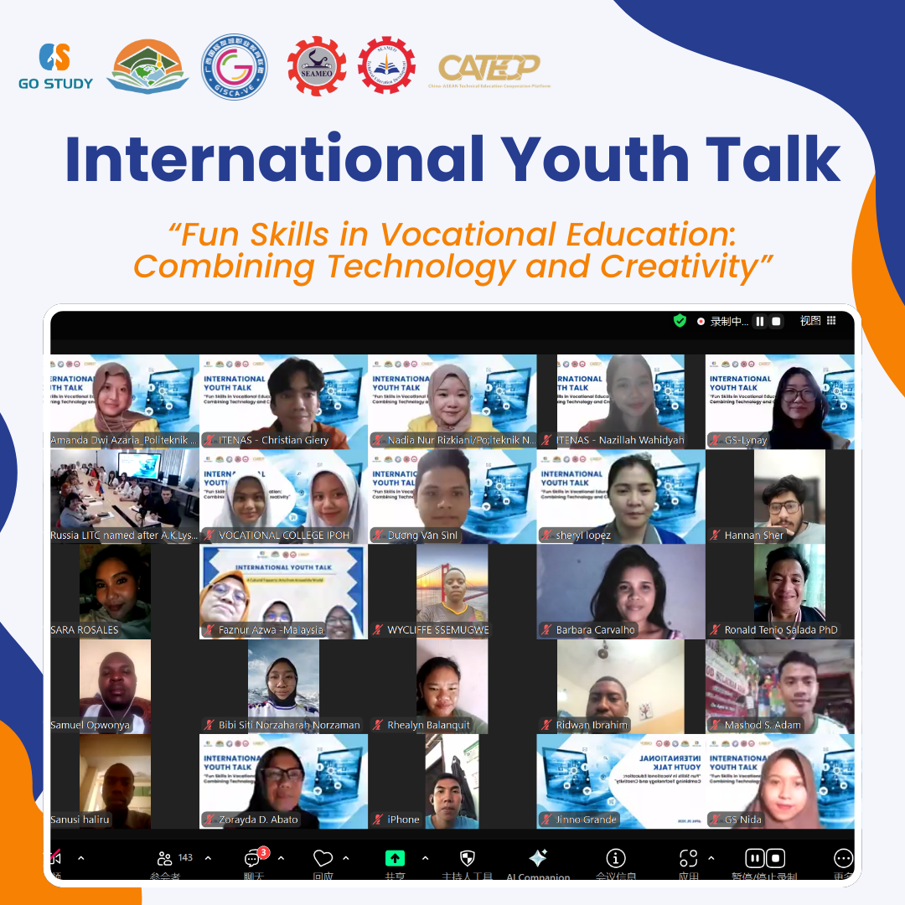

【Opening Remark】
The opening speech of the event was delivered by Ms. Cheng Chantola, Head of Administration, Finance, and Planning at SEAMEO TED. She highlighted the importance of vocational education in modern society, especially how combining technology and creativity can make learning more engaging and effective. She encouraged attendees to explore how this integration could shape the future of vocational education and create new directions for student development. She concluded by warmly welcoming the guests and expressing her hope for insightful discussions during the event.

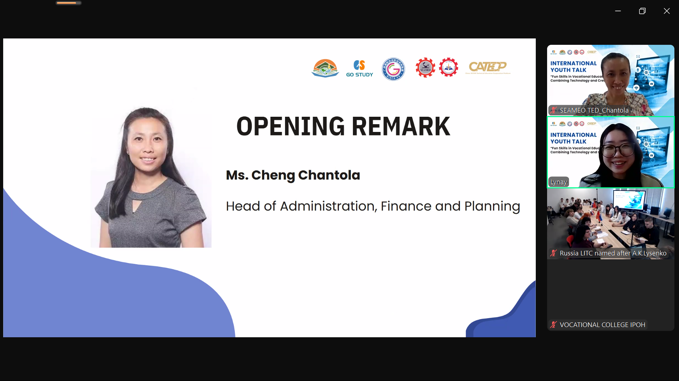

【Sharing Session】
Ivanushin Dmitry and Nikivorova Anastasiya from Jakarta State Polytechnic in Indonesia discussed the importance of vocational education in developed countries, highlighting its role in boosting economic productivity, solving labor market skill gaps, and fostering entrepreneurship. They shared three projects: eco-friendly packaging solutions (biodegradable cups, active packaging, and edible packaging) to reduce plastic waste and extend food shelf life; a bridge monitoring system (SIMON BATAPA) using sensors to monitor structural health; and eco-paving bricks made from mussel shell waste to solve local waste issues and improve road conditions. These projects demonstrate how vocational education fosters problem-solving, innovation, and sustainable development. Additionally, they emphasized how practical, hands-on projects like these enhance students' skills and prepare them for real-world challenges, making vocational education a vital tool for both personal and community growth.

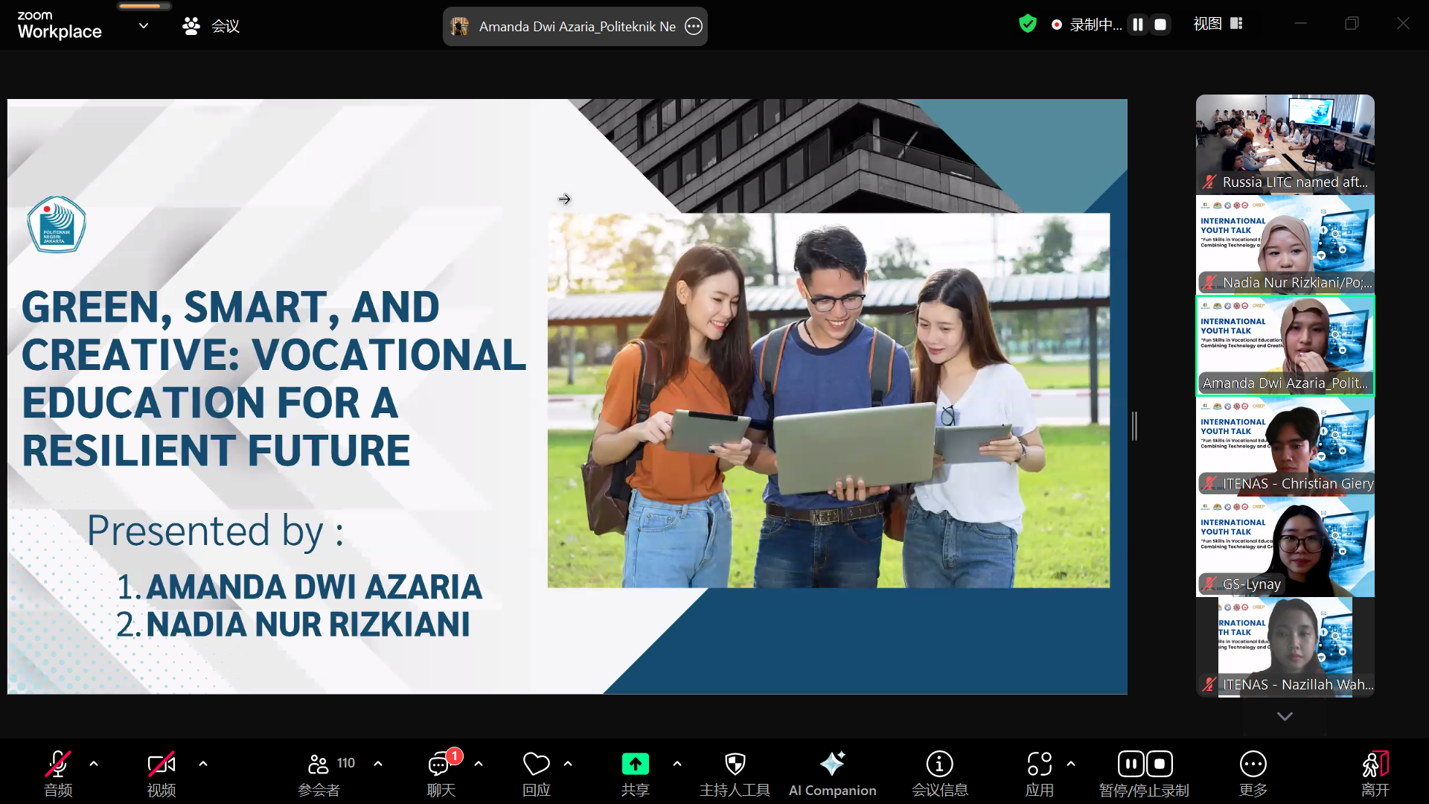

Duong Van Sinl, a student from Saigon University in Vietnam, shared how Generative AI can be integrated with technology and creativity in vocational education. He explained that generative AI creates new content and fosters innovation in the creative industries, while traditional AI focuses on pattern recognition and classification. In vocational education, generative AI enhances learning efficiency and creates engaging, interactive methods. Tools like chatbots and agent AI can help students understand complex technical concepts through realistic interactions. However, this technology brings ethical concerns and security risks, so it must be used cautiously. Overall, generative AI offers great creative potential and promotes the integration of technology and creativity in vocational education.

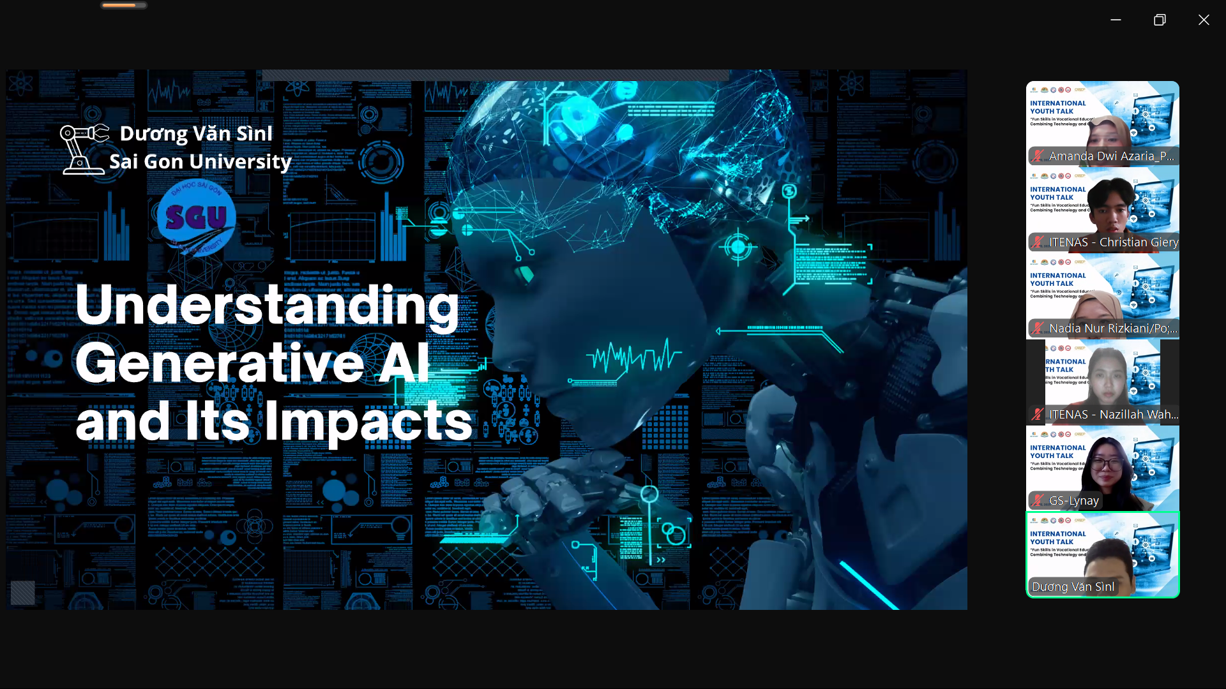

Adriana Qaseh Binti Ehsal Jesrin and Insyirah Binti Jaimehatta, students from Ipoh Vocational College in Malaysia, shared how integrating technology and creativity provides students with engaging learning experiences. They introduced the college’s innovative methods, where students develop technical skills and creativity through hands-on projects, such as designing eco-friendly packaging and smart transportation prototypes. This approach enhances their technical abilities while sparking passion for creativity and problem-solving. By combining technical knowledge with artistic design, students gain practical skills that prepare them for future careers. These experiences also encourage teamwork and collaborative problem-solving. Additionally, the integration of real-world challenges into projects equips students with the skills necessary to thrive in a rapidly evolving job market.
。
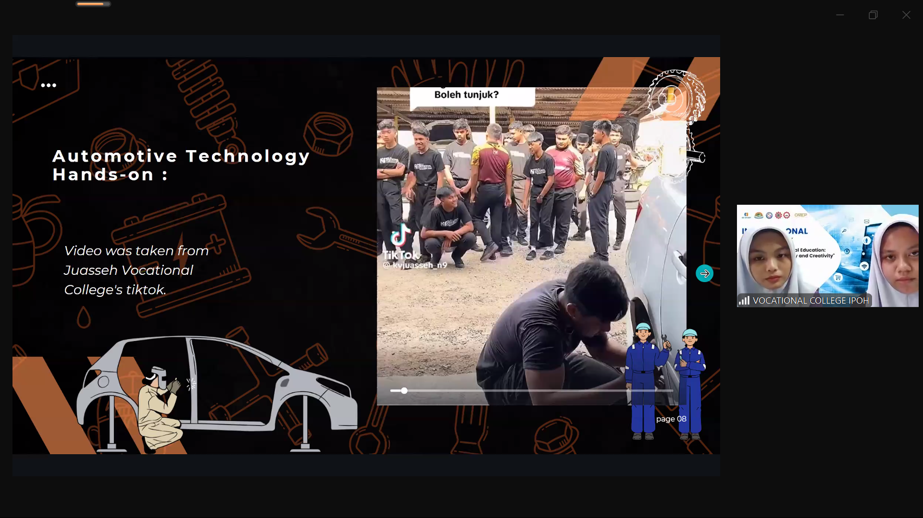

Students Ivanushin Dmitry and Nikivorova Anastasiya from Liskinsky Industrial and Transport Technical College in Voronezh in Russia, shared how integrating technology and creativity into vocational education enhances engagement and effectiveness. They emphasized that vocational education should not only focus on technical skills but also foster creativity and make learning enjoyable, boosting student motivation. Virtual reality (VR) technology sparks curiosity, helping students grasp complex concepts interactively and improve memory. Gamified learning, using points and badges, merges fun with education, increasing participation. Involvement in real-world projects is also crucial, enhancing self-development and sparking innovative thinking. The college uses CAD and Compas 3D to develop professional skills and incorporates VR and AR for practical training. Overall, the integration of technology and creativity boosts the appeal of vocational education and provides students with more practical learning experiences.

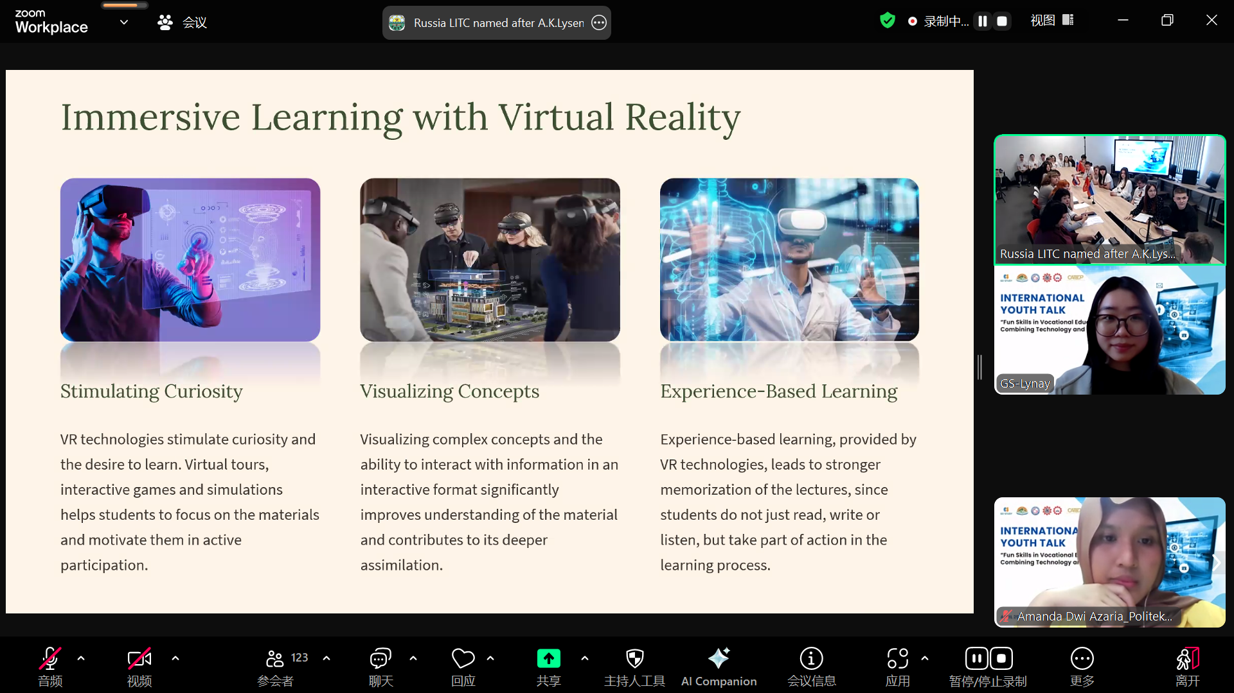

Students Christian Giery and Nazillah Wahidyah from Institut Teknologi Nasional Bandung in Indonesia explored the widespread use of technology in daily life, discussing how it transforms theoretical knowledge into practical tools to solve real-world problems. Technology bridges geographical distances, creates opportunities, improves communication, and addresses practical issues. However, to fully harness its potential, additional skills are necessary. They highlighted the importance of soft skills like critical thinking, adaptability, teamwork, creativity, and determination (C.A.T.C.H.), which are essential in navigating the changing technological landscape. The speakers emphasized that technology is not just about hardware but how we use these tools to transform our lives and work. By fostering C.A.T.C.H. skills, students will be better equipped to tackle future challenges and seize opportunities.

