Report
2nd China-SEA Partnership Workshop
12-13 May 2025, Phnom Penh, Cambodia

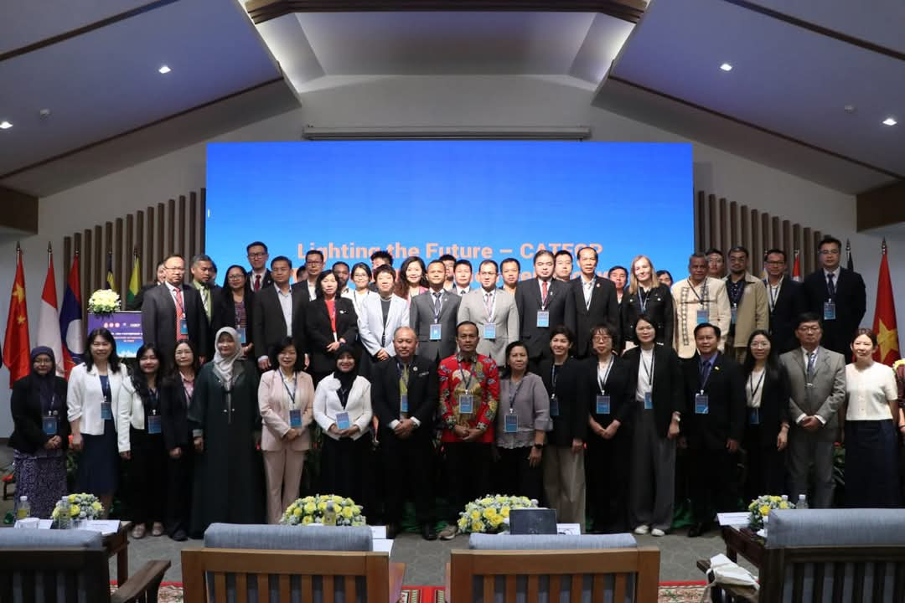
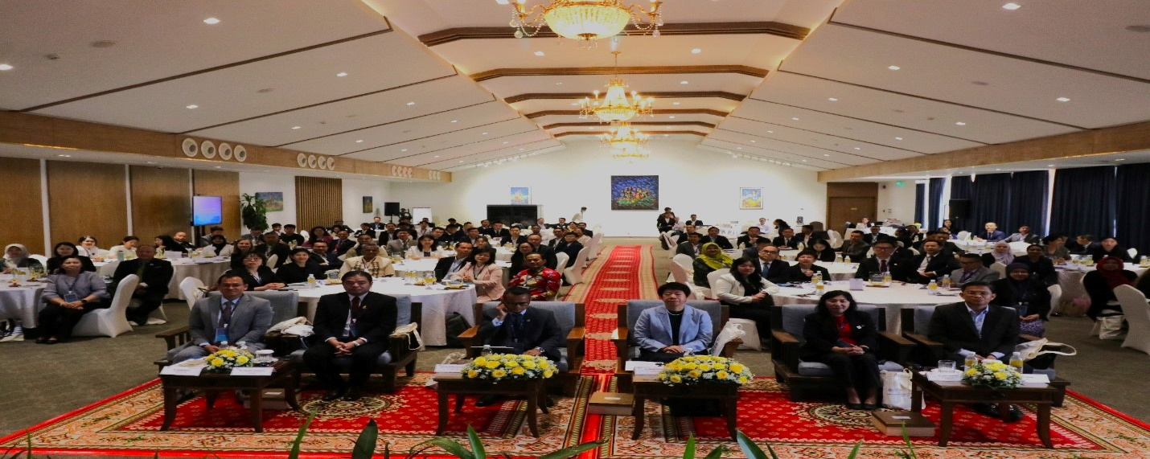
Aiming to bring together experts, educators, policymakers, and industry leaders to discuss the internationalization of digital technologies in TVET, SEAMEO TED, together with its Chinese partner, Go Study Global Education, initiated the 2nd China-SEA Partnership Workshop in Phnom Penh on 12-13 May 2025. This workshop was organized to promote educational cooperation between China and Southeast Asian countries, allowing Chinese institutions to showcase their expertise in vocational education and facilitating knowledge exchange with educational partners in Southeast Asia. Partner institutions from China and SEA countries were invited to share the opportunities, challenges, and best practices in incorporating digital tools, platforms, and curricula to enhance the quality of vocational training across countries in the Southeast Asia (SEA) region. The two main sessions of the workshop are (1) Collaboration Between Industry and TVET Providers for Digital Skills Development and (2) Adopting Industry 4.0 Technologies in TVET Training with thirteen topics presented by thirteen experts who specialize in technical education. In addition, all participants were coordinated to join Industrial Visit to Phnom Penh Special Economic Zone (RGPPSEZ) on 12 May 2025 as a part of learning and investigation of the production line and skills needed production at some factories and companies.
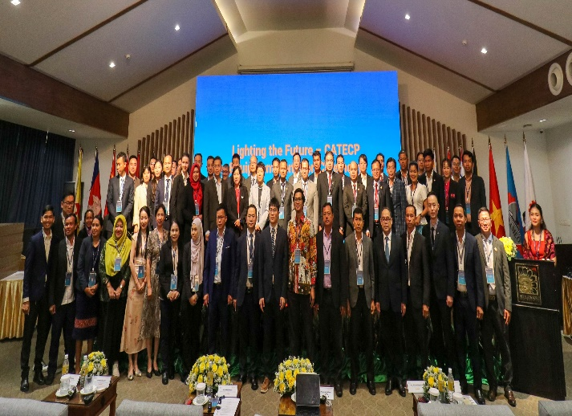

The workshop was participated by 134 people from China, 9 Southeast Asia countries (Cambodia, Brunei Darussalam, Indonesia, Malaysia, the Philippines, Singapore, Thailand, Timor-Leste, and Vietnam), and Russian Federation from 48 schools/institutes. Among them, 56 Chinese participants are from 24 Chinese schools/institutes; 31 Cambodian participants are from 31 schools/institutes; 25 Southeast Asia participants from 15 schools/institutes. And two participants are from Moscow Institute of Physics and Technology in Russian Federation.

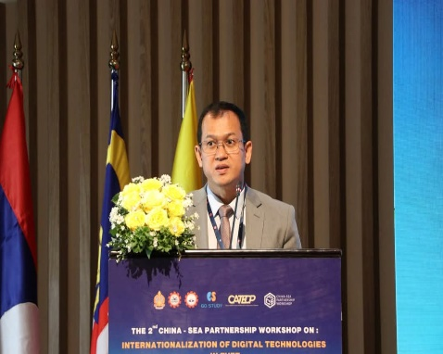
In Welcoming Remarks, Dr. Songheang Ai, Center Director of SEAMEO TED, stated that the workshop would pave new paths for cooperation and partnerships between China and Southeast Asia in the fields of digital technology and the transformation of TVET. He said: “China and Southeast Asia have long maintained a friendly and cooperative relationship in strengthening TVET”. As an example, he highlighted the China-ASEAN Technical Education Cooperation Platform (CATECP), which hosts many online course-sharing projects from China to ASEAN. He shared some key data, mentioning that in 2024, a total of 41 Chinese schools shared over 300 courses on CATECP. Through various channels, these courses reached all ASEAN countries, engaging 256,672 students. In just the first five months of 2025, more than 100 Chinese schools from 14 provinces had already joined the project collaborations with education ministries in Southeast Asia such as in Thailand, Malaysia, Indonesia, Vietnam, Brunei, and others have helped promote CATECP to over 200 higher education institutions across the region. He added that as of April, the platform had reached over 400,000 users, already surpassing the total number from the entire year of 2024.

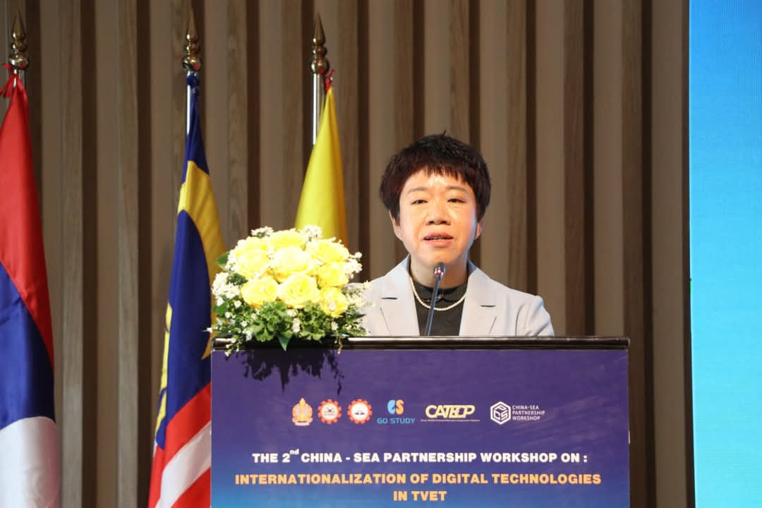
In Impressive Remarks, Dr. ZHANG Xufeng, Deputy Director-General of Education Department of Guangxi Zhuang Autonomous Region, China, highlighted Guangxi’s active role in promoting vocational education collaboration with ASEAN countries, including developing shared resources, establishing 17 Modern Craftsman Colleges, and hosting a number of trainings and exchange programs. She noted strong ties with Cambodia and emphasized Guangxi’s efforts to attract more ASEAN students. She proposed three initiatives: strengthening government cooperation to build a China-ASEAN vocational education community, using AI to empower bilateral education, and deepening cultural exchanges to enhance mutual understanding among youth.
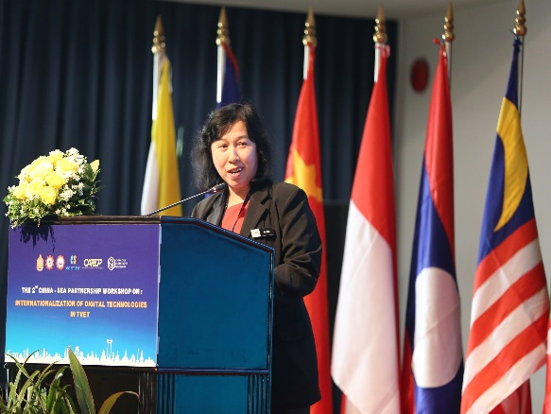
In Congratulating Remarks, Dr. Riam Chau Mai, Director of Community and Industry Collaboration Division, Department of Polytechnic and Community College Education, Ministry of Higher Education, Malaysia, gave special acknowledgments to Dr. Songheang Ai, Centre Director of SEAMEO TED for his visionary leadership in advancing TVET excellence in Southeast Asia. She highlighted that Malaysia is making strides in integrating digital solutions in education through online learning platforms and advanced assessments, as well collaboration with industry leaders like IBM and AWS is enhancing the digital skills of students and educators to meet the needs of Industry 4. 0. She marked that the workshop fosters regional collaboration, allowing experts to share insights and develop joint initiatives in areas like curriculum and teacher training. She urged continued efforts to create a resilient and innovative TVET environment for the region.
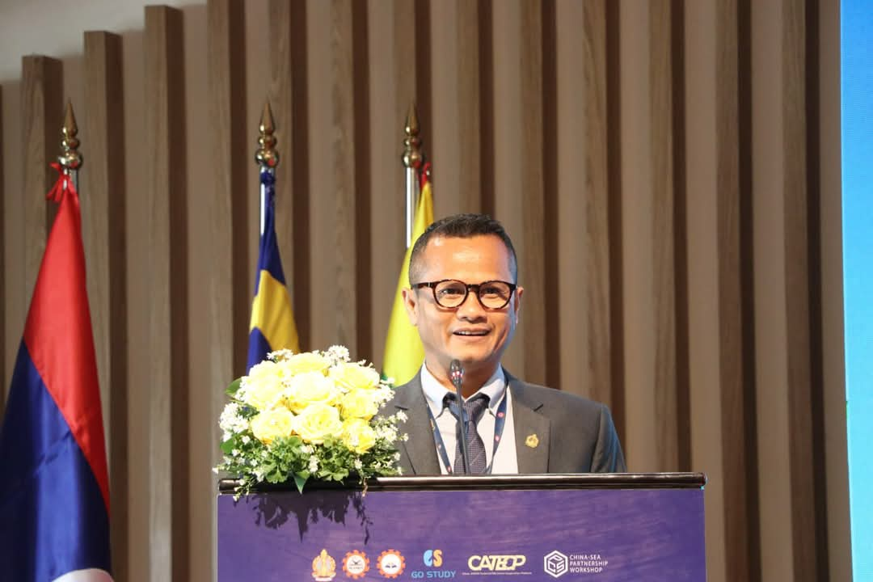
His Excellency Dr. Kolpheng Vaddhana, Under-Secretary of State representing H.E Dr. Hang Chuon Naron, Deputy Prime Minister, Minister of Education, Youth and Sport, Kingdom of Cambodia, and SEAMEO Council Member, presided over the opening ceremony of this important international workshop. In his opening remarks, he emphasized the importance of strengthening cooperation between China and ASEAN in advancing digital TVET (Technical and Vocational Education and Training). Speaking on behalf of Cambodia’s Ministry of Education, he highlighted the critical need for educators to possess a core set of skills including communication, problem-solving, adaptability, teamwork, emotional intelligence, strategic thinking, and decision-making. Dr. Vaddhana stressed the significance of continuous skills development, lifelong learning, and collaborative efforts among governments, businesses, and educational institutions to meet the demands of a rapidly evolving digital world. He concluded: “To truly enhance the quality of life of every citizen, we must cultivate a passion for lifelong learning through education enriched by technology advancement.”
Key Outcomes of Workshop
- Industrial and Cultural visit
All participants were invited to join Industrial Visit to Phnom Penh Special Economic Zone (RGPPSEZ) and they are also invited to join cultural visit at Royal Palace, National Museum and a local market on 12 May 2025 (one day prior to the workshop) as a part of learning and investigation of the production line and skills needed production at some factories/companies and also exploring local cultures of Cambodia.

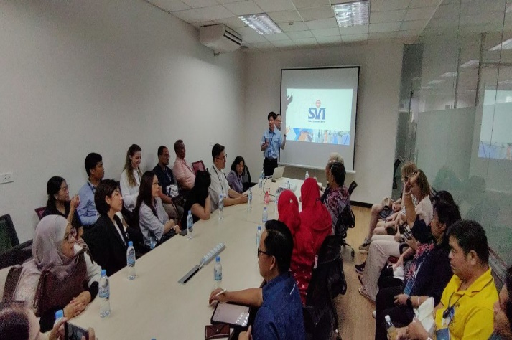
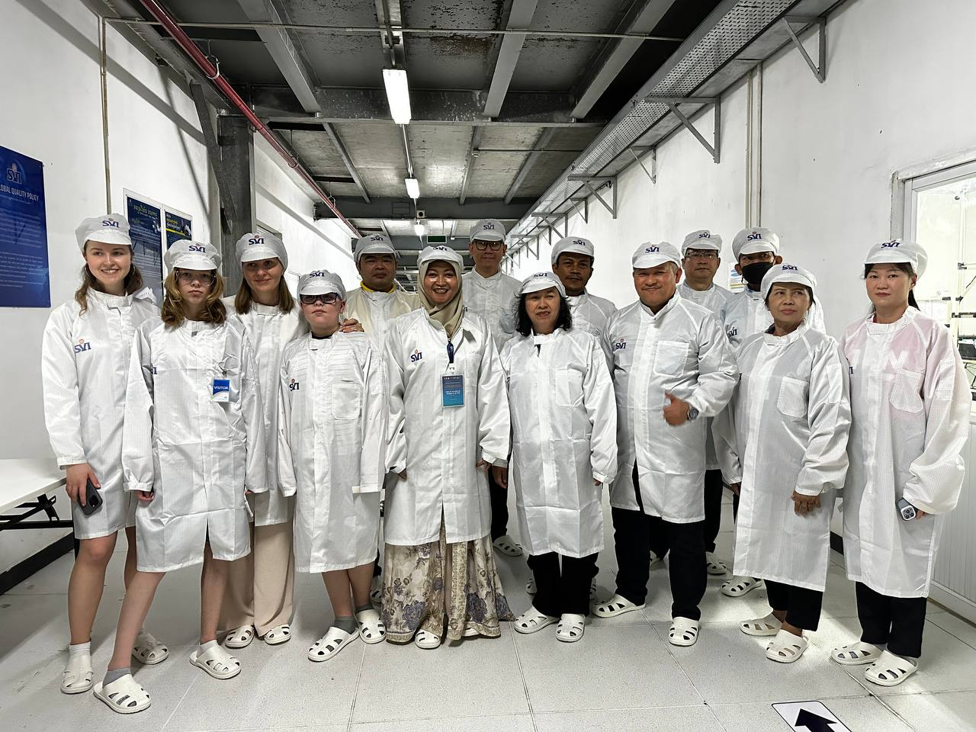
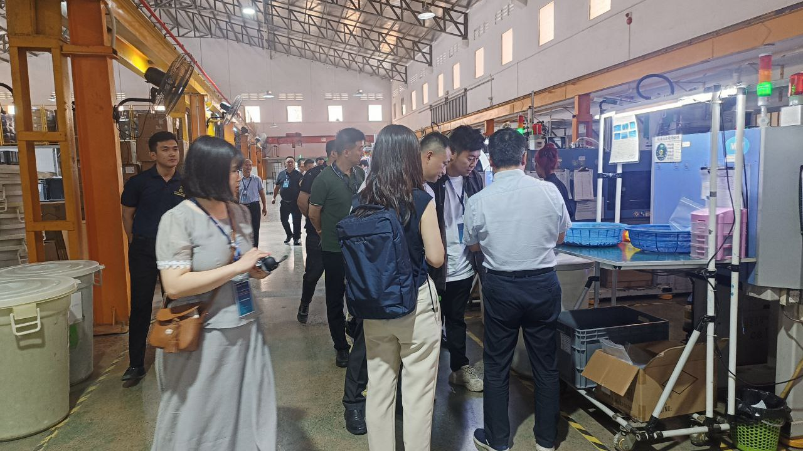
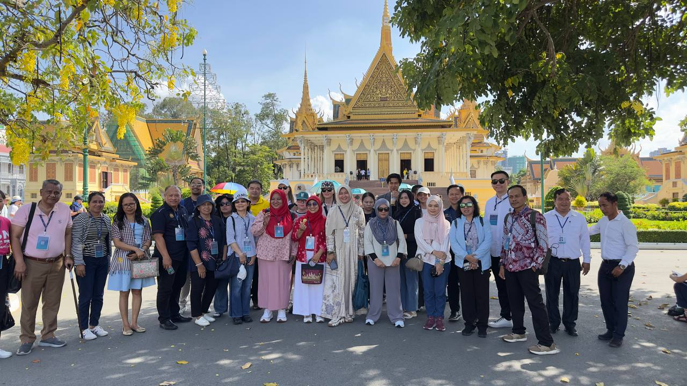

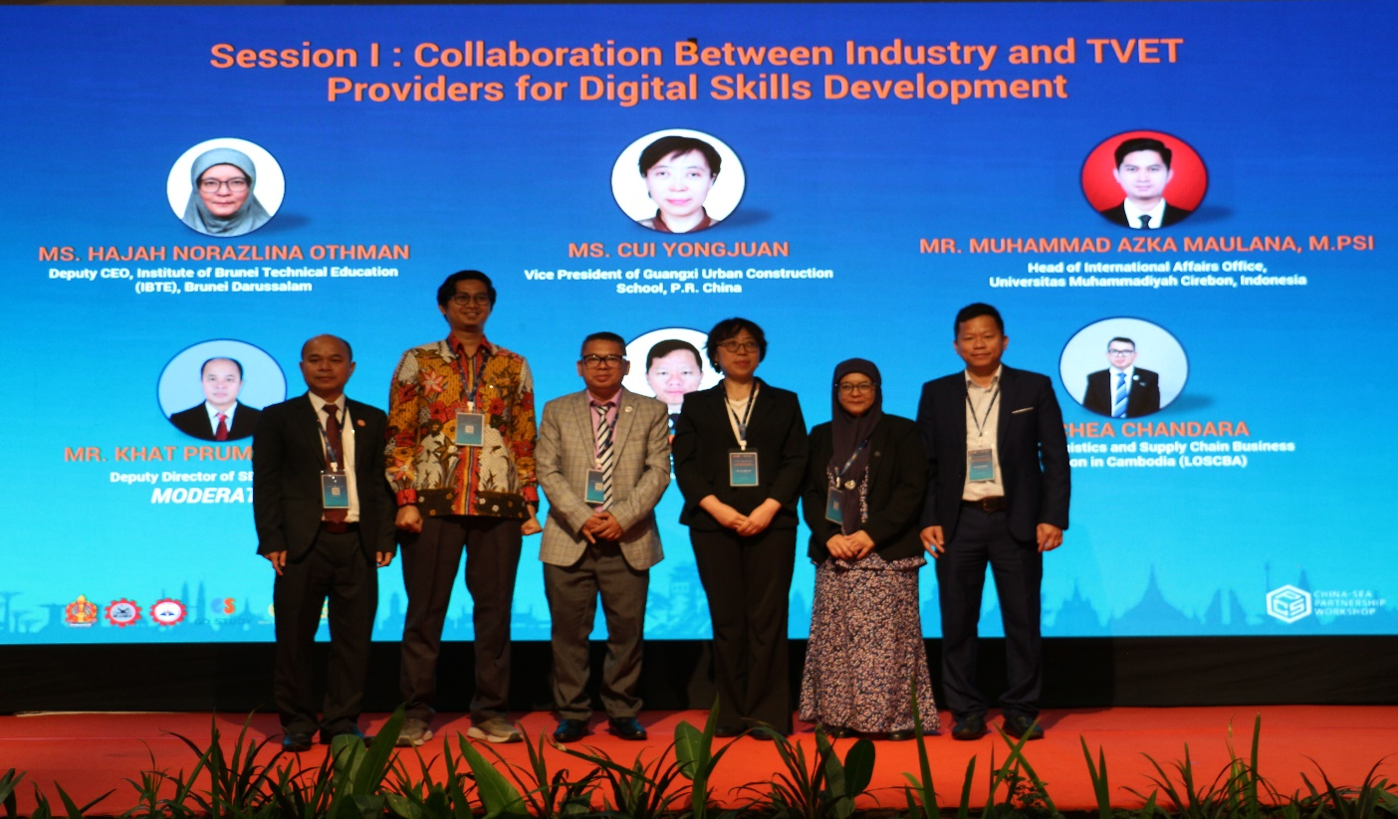
- Session I: Collaboration Between Industry and TVET Providers for Digital Skills Development
Key takeaways have been emphasized and discussed by five eminent speakers as followings:
- Strong industry-TVET linkages ensure relevant and future-ready skillsets
- Digital skills are essential for global competitiveness and workforce readiness.
- Brunei's model highlights sustainability and responsiveness in digital training
- Future focus: expanding digital courses and growing partnerships for emerging tech skills
- Proposed China-UMC Collaboration such as "Chinese + Skills" Program: Mandarin + IoT maintenance courses, Joint R&D: Low-cost sensors for tropical aquaculture, and SEAMEO TED Funding: Grants for pilot projects.
- IoT gaps today are tomorrow’s joint ventures
- Digital Technology is important for logistics and supply chain in Cambodia-ASYCUDA World, GPS, Telematics, National Single Window Apply, CDC Master List Online, ASEAN Single Window Integration, and Transportation Management Systems (TMS).
- Modernizing vocational education in construction and new energy and developing shared curricula, training programs, and mutual standards, while establishing industrial colleges and research centers
- Integrating education with industry, promote digital innovation, and support inclusive development across the region
- Equipping workforce with digital competencies to meet national and global demands
- It is essential to close the skills gap between education and real-world job requirements.
- Enabling curriculum relevance, work-based learning, and enhanced student employability.

- Session II: Adopting Industry 4.0 Technologies in TVET Training
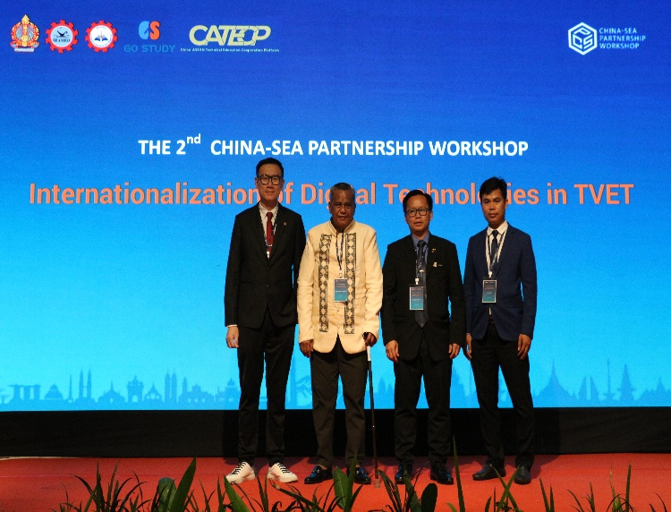
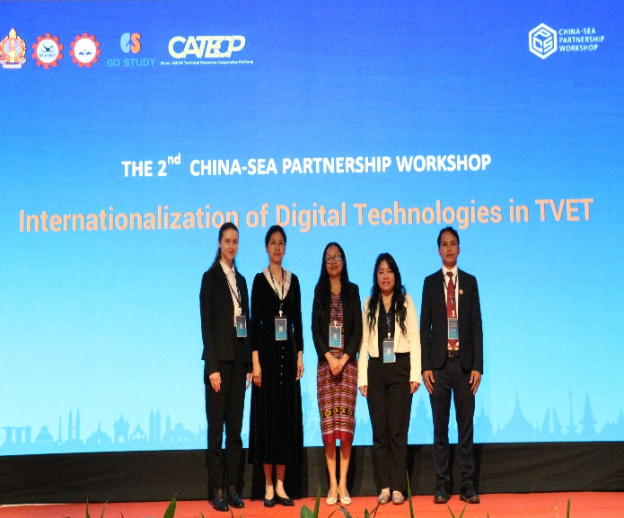

Seven eminent speakers have shared and discussed some key outlines including:
- Challenges in TVET should be resolved by Public-private partnerships (PPP) for funding, Teacher training programs and Compliance to International Standards
- Collaboration pathways such as regional Industry 4.0 skill standards for TVET, joint research initiatives between China and SEA institutions, industry-sponsored labs/equipment donations should be called to actions.
- Phased deployment strategy starting with pilot labs before scaling successful models, Strategic MOUs with industry leaders (such as Microsoft, Lenovo, AMD) ensure curriculum stays current with market demands, and Comprehensive instructor training programs with industry certifications and mentorship should be the solutions to challenges such as High Implementation Costs, Maintaining Industry Relevance, and Faculty Upskilling Needs.
- A call to action for advancing tech-driven TVET, urging training institutions to start pilot projects, partner early with industry, and invest in instructor development. Policymakers are encouraged to boost funding, create supportive policies, and offer industry incentives. Industry partners are asked to share technology, provide internships, and help shape curricula.
- Industry 4.0 is essential in TVET due to the rapid transformation of industries, increasing demand for intelligent technologies, and the need to equip learners with future-ready, adaptable skills.
- The MIPT School of Physics and Mathematics emphasizes high-quality training in math, physics, modeling, and computer science using advanced methods. It involves industry and scientific experts to align education with labor market demands and continually updates its programs to reflect current trends. Courses are tailored to each student’s goals and required skills.
- Continuously deepen cooperation with eastern enterprises specializing in large artificial intelligence models, and build a local computing power foundation and a large model platform.
- New strategies for talent cultivation, emphasizing education-industry integration to create a shared future between schools and enterprises, leveraging digital tools to develop an "intelligence skill" system, and fostering international cooperation to build a global vocational education ecosystem.
- Continuously deepen cooperation with enterprises specializing in large artificial intelligence models, and build a local computing power foundation and a large model platform
- Chinese institution is willing to equip with 5-axis CNC machining tools, to build intelligent manufacturing platforms based on Industry 4.0, to establish KUKA, ABB robot demonstration platforms. Using skill competitions as a bridge for ASEAN mechanical and electrical talent exchange, provide technical interaction windows for teachers and students, and promote regional intelligent equipment development and ASEAN smart manufacturing talent training and technical cooperation.
- Rapid transformation of industrial sectors, Demand for intelligent systems, automation, and data, and Need for future-ready skills and adaptability are the reasons behind the need of Industry 4.0 in TVET.
- Strategic recommendation to strengthen TVET in such as public-private partnerships, curriculum modernization, upskilling of trainers, and pilot project and awareness

- Networking Session
Networking Session was conducted in three phases:
- Phase 1
All participants were invited to complete a quick survey for their comments/suggestions on Regional Collaboration with three questions. Participants accessed to the three questions by scanning QR code which was provided at their table. It took 15 minutes for them to finish their responses.
Q1: What programs will your institutions intend to have collaboration on? (Please choose the most needed only 3)
Q 2: What are the challenges that your institutions encounter in order to extend cooperation?
Q 3: Please share with us the most effective strategies for enhancing proposed program cooperation.
Q 4: What programs/events do you want SEAMEO TED/Go Study to coordinate for your institutions?
Summary of responses from participants:
Three key cooperation programs: student/staff exchanges, digital/AI education (including teacher training), and green education/sustainability modules were raised by participants. However, each institution is facing some challenges such as limited facilities, budget constraints, government red tape, language barriers, and difficulties in finding suitable partners. To enhance cooperation, participants recommended some strategies like forming strong committees, increasing visibility through conferences and online meetings, securing matching grants, fostering industry partnerships, and creating win-win collaborations through workshops. They seek SEAMEO TED and GO STUDY's support in coordinating research collaborations, student exchanges, teacher training, TVET curriculum development, green education initiatives, and policy dialogues, with particular interest in AI, digital agriculture, and hybrid workshops.
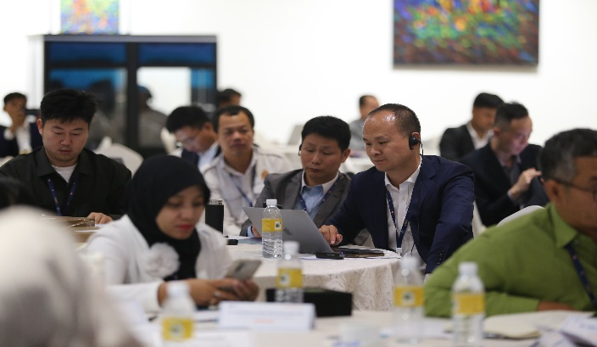
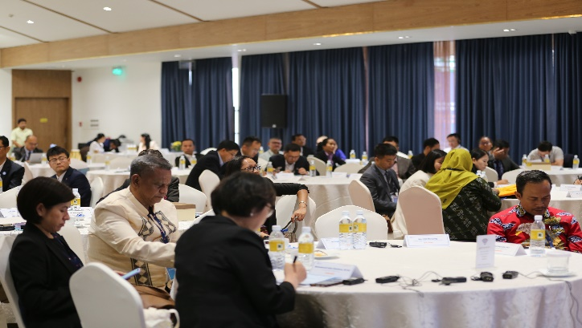

- Phase 2
All participants are encouraged to raise your suggestions, proposal, innovative, and call for collaborations.
Summary of outcome of phase 2:
Key opportunities include internship programs with Thai schools offering free accommodation, scholarships from Indonesian institutions for Southeast Asian students, and professional development through SEAMEO TED’s Training Academies to promote best practices in TVET. Additionally, some institutions are looking for partnerships in cooperative programs, human capital development initiatives, and joint research projects to advance education and workforce readiness across the region.

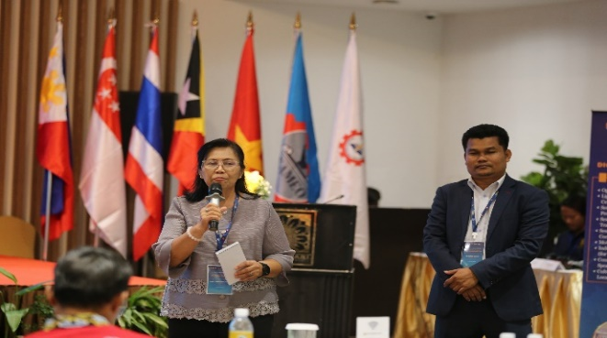
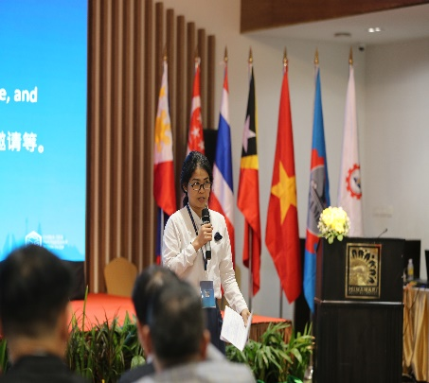
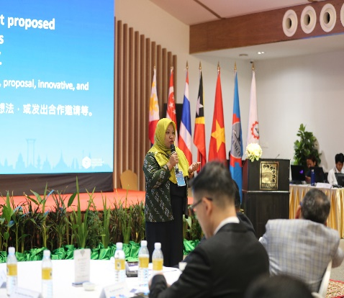

- Phase 3
All participants invited to freely walk around and explore for partners collaboration and share their contact with their counterparts in 15 minutes.

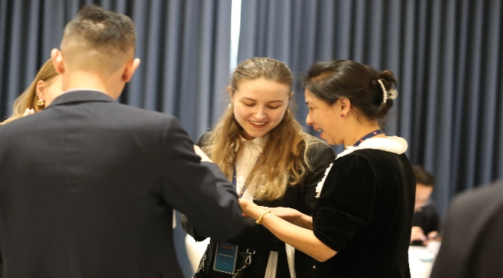
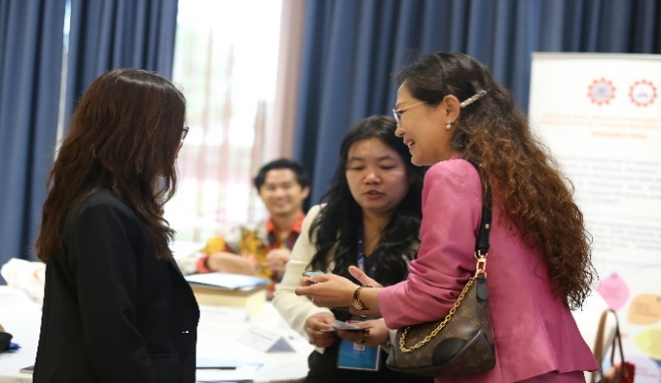
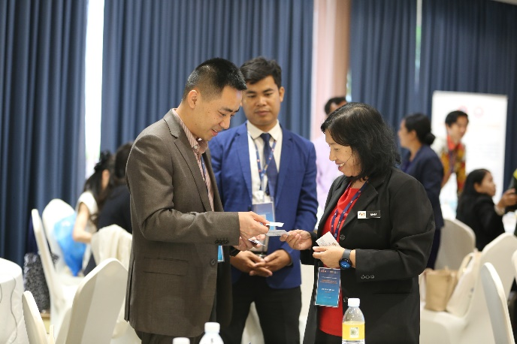
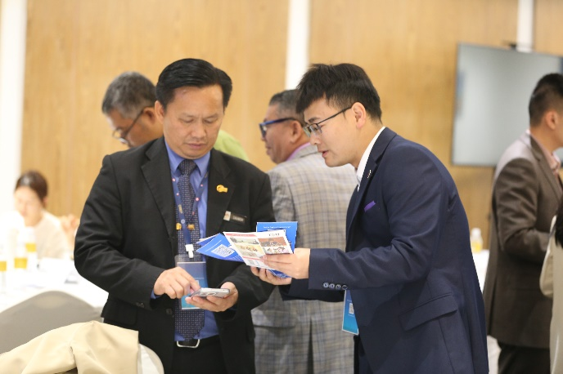

- MoU Signing Ceremony
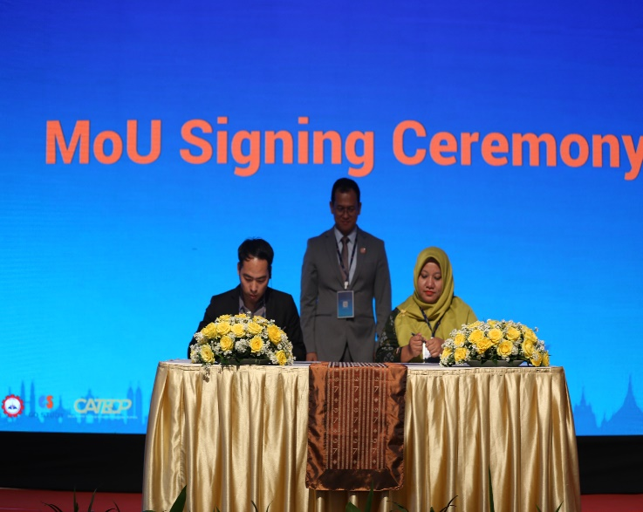
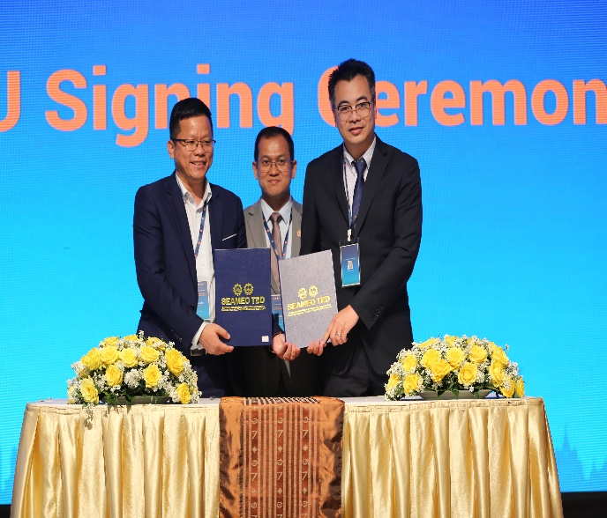
There were also 13 MoU Signing among 14 schools from China, SEA countries, and Russia for their further cooperations.

- Closing ceremony

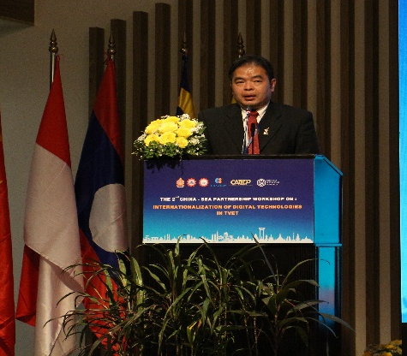
Mr. Laksasak Yangsaman, Director of International Strategy and External Relations Division, Bureau of Policy and Planning, Office of Vocational Education Commission (OVEC), Thailand, was invited to deliver his impressive remarks.He thanked SEAMEO TED for the invitation and highlighted the event's role in fostering dialogue and collaboration. He emphasized the transformative impact of digital technologies on TVET systems and the need for international cooperation to align with global standards and equity. He acknowledged the contributions of participants and partners, urging continued commitment to inclusive and future-oriented strategies for digital transformation. He concluded by wishing everyone success and safe travels, expressing hope for future collaborations.

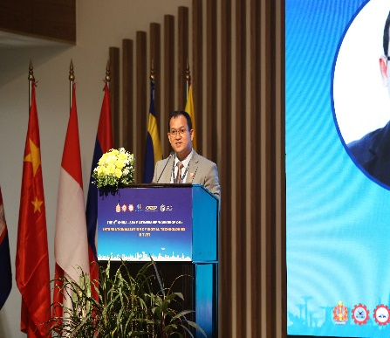
Dr. Songheang Ai, Director of SEAMEO TED, delivered his closing remarks by giving his special thanks to eminent speakers and all participants who have actively contributed in making the workshop a success with fruitful results. He said that this workshop has reflected another millstone of partnership and cooperation between China and SEA countries in term of TVET. He elaborately wrapped up all sessions by highlighting the key outcomes of each one. He hopes everyone will keep in touch and have closer relations in strengthening and promoting TVET.

