
Training​ on
CNC Milling Programming and Machining Technology
8th May 2025, Time: 10:00-11:30 AM (GMT+8)

Southeast Asian Ministers of Education Organization Regional Centre for Technical Education Development (SEAMEO TED), Xinxiang Vocational and Technical College, and Go Study Global Education China co-organized the training on “CNC Milling Programming and Machining Technology” participated by over 150 participants with 19 females. The participants are from thirteen countries consisting of Cambodia, India, Vietnam, Thailand, Philippines, Nigeria, Malaysia, Indonesia, Uganda, Pakistan, Timor-Leste, Brunei Darussalam and Sri lanka.
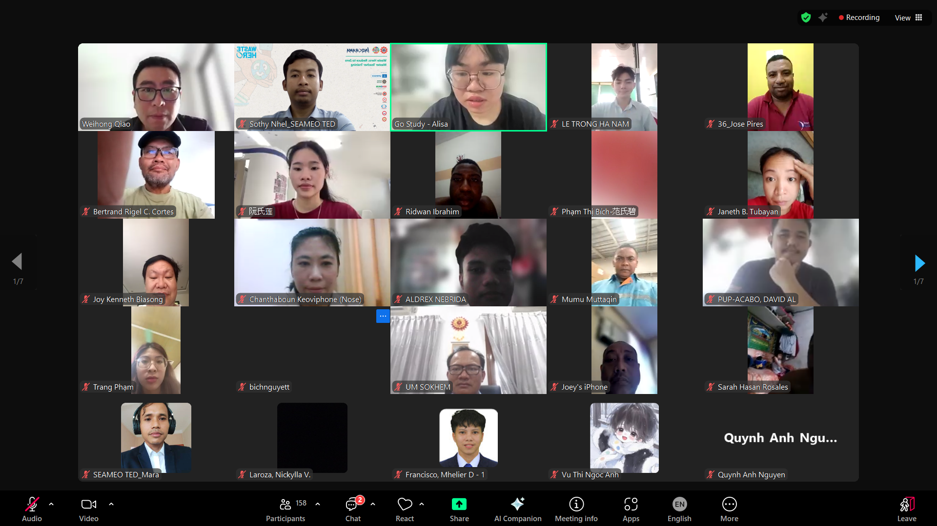
(Participants in the Photo Session on May 8, 2025)

The training was held from 10:00 am to 11:30 am (GMT+8) on May 8, 2025. The training is designed and aimed to build technical skills and promote knowledge exchange in the field of mechanical engineering shared by a Chinese lecturer named Mr. QIAO Weihong.

In the whole session, Mr. QIAO delivered several important topics including Brief Introduction to CNC Machining Center, Categories of CNC Machining Center, Components of CNC Machining Center and Application of CNC Machining Center. The course enables students to know briefly about the CNC Machining Center equipped with an automatic indexing rotary worktable or a spindle box that can automatically swing angles, enabling the workpiece to automatically complete multiple processes such as milling, boring, drilling, reaming, and tapping in multiple planes and angles after one clamping. CNC Machining Center is the most developed and a powerful tool in CNC machining of the mechanical engineering. Moreover, the course also provides both theoretical knowledge and practical expertise in mechanical technologies. Finally, the interaction during the Q & A session enhanced further understanding of the participants.
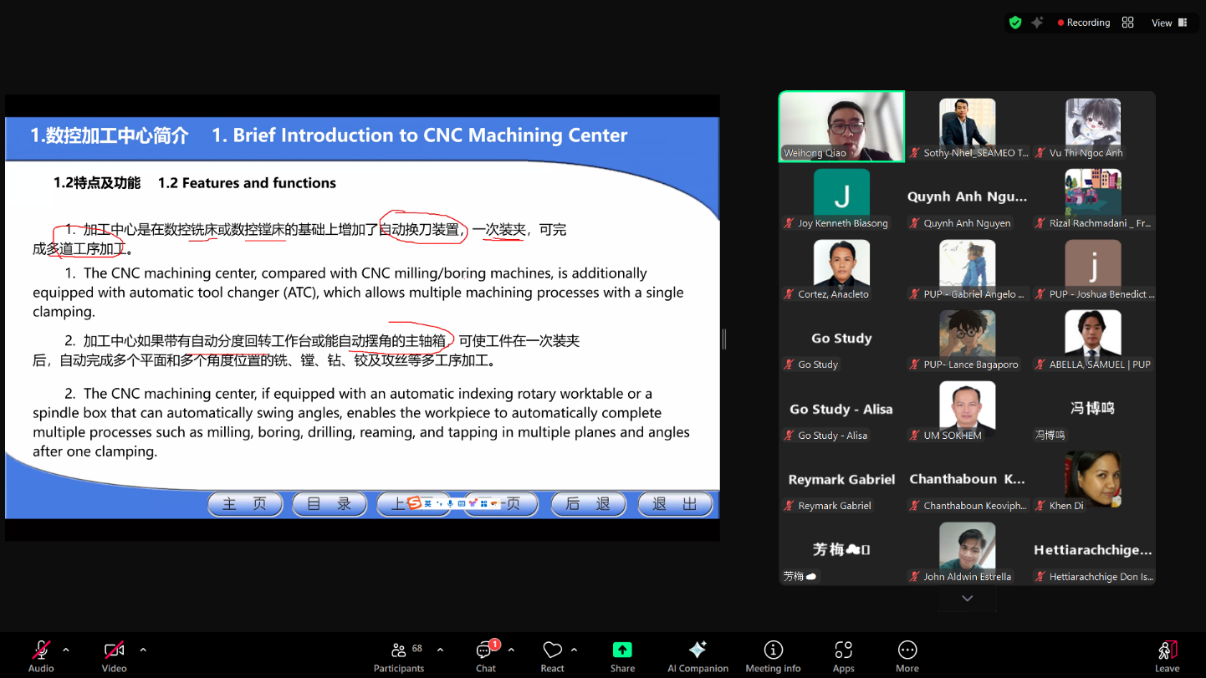

(Explanation on the Introduction to CNC Machining Center)

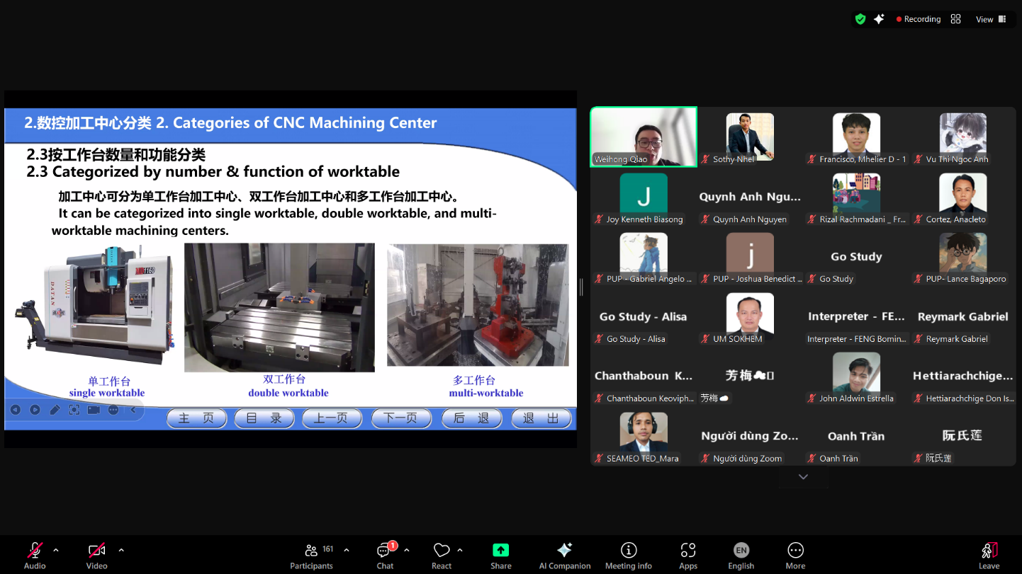
(Explanation on the Categories of CNC Machining Center)
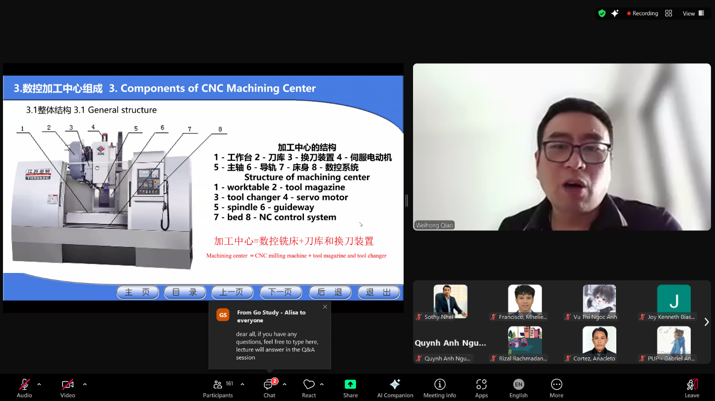
(Explanation on the Components of CNC Machining Center)

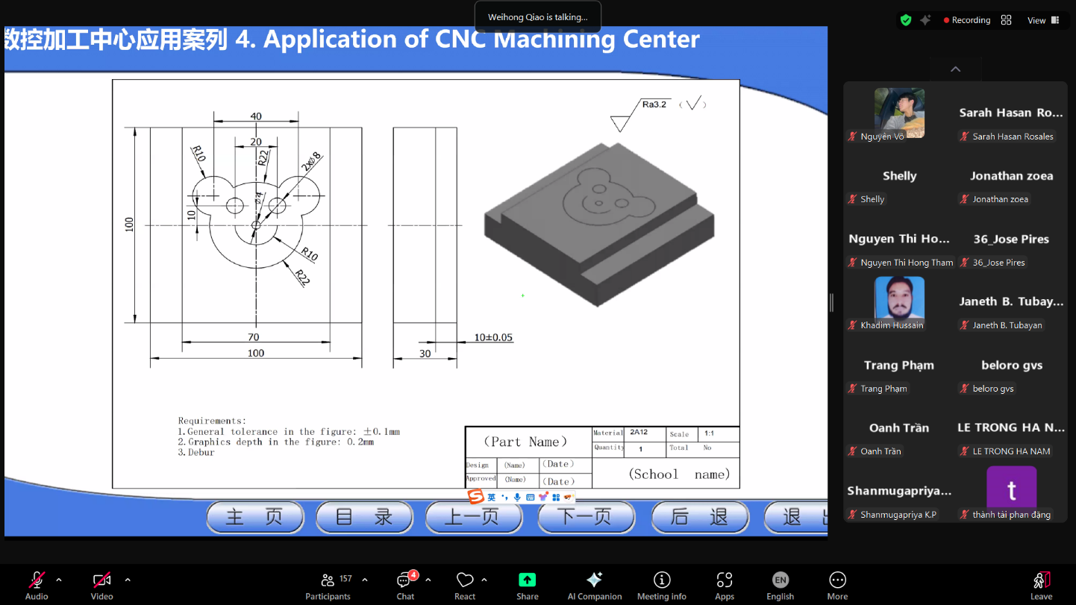
(Explanation on the Application of CNC Machining Center)

In conclusion, the training course combines theory with visual illustration, enabling participants to gain useful skills for today’s manufacturing environment. It also builds up a good relationship among participants and students in the ASEAN region and beyond.

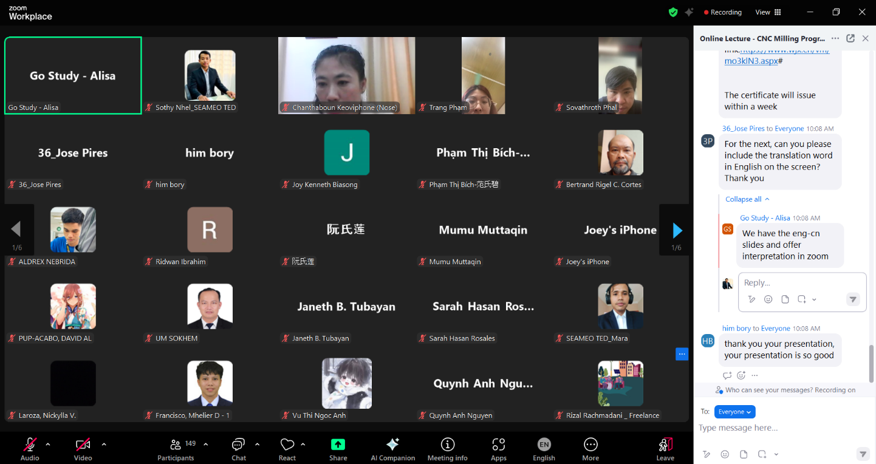

(Participants Posted Questions in the Chat Box)

