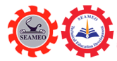
Southeast Asian Ministers of Education Organization
Regional Centre for Technical Education Development
(SEAMEO TED)

Report on International Youth Talk on “Big Data and Social Media: Where Does our Data Go” (Virtually)
May 30, 2025

On the afternoon of May 30, 2025, the fifth session of the International Youth Talk successfully concluded online. Centered on the theme "Big Data and Social Media: Where Does Our Data Go?", the event brought together young representatives from universities in Indonesia, Malaysia, the Philippines, and other countries. Participants engaged in discussions on how youth can navigate the global digital wave by balancing the “sharing culture” of social media with personal data security, enhancing data literacy, and becoming responsible digital citizens.

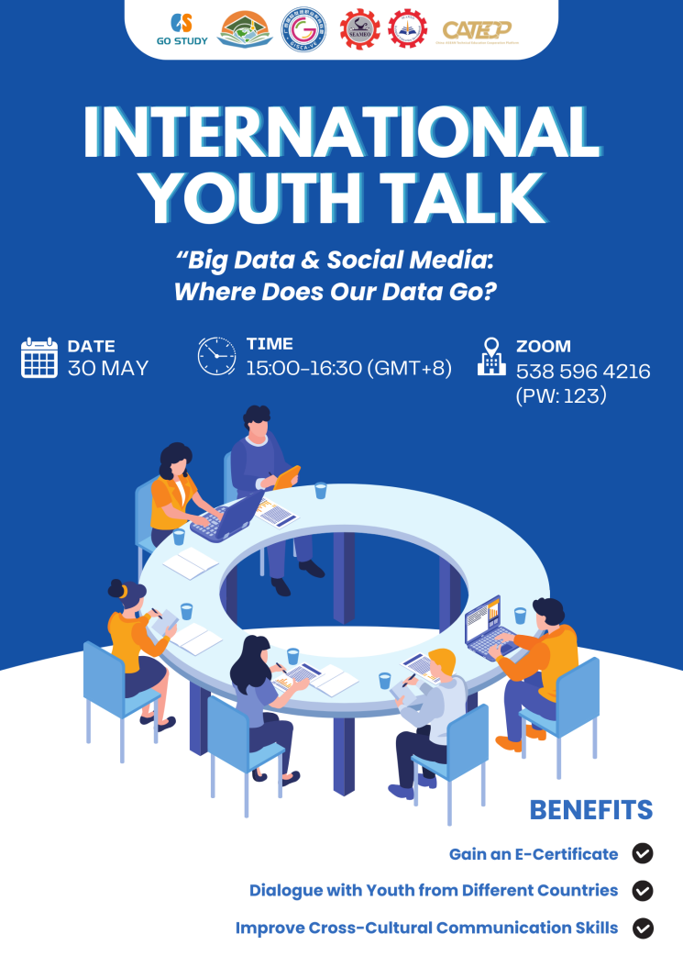

【Opening Remarks】
The opening speech of the event was delivered by Ms. Cheng Chantola, Head of Administration, Finance and Plannings of SEAMEO TED. She pointed out that with the advancement of technology, our digital lives are generating an unprecedented volume of data. Every click, like, share, and comment on social media becomes part of what we call "Big Data." Questions such as who collects this data, how it is used, and what rights we have over it deserve thoughtful consideration. She emphasized that understanding the relationship between big data and social media is not merely a technical issue—it is also deeply connected to our awareness of privacy and our level of digital literacy. In the digital age, only by grasping the logic behind data can we consciously engage in the online world and strengthen our ability to meet future challenges.
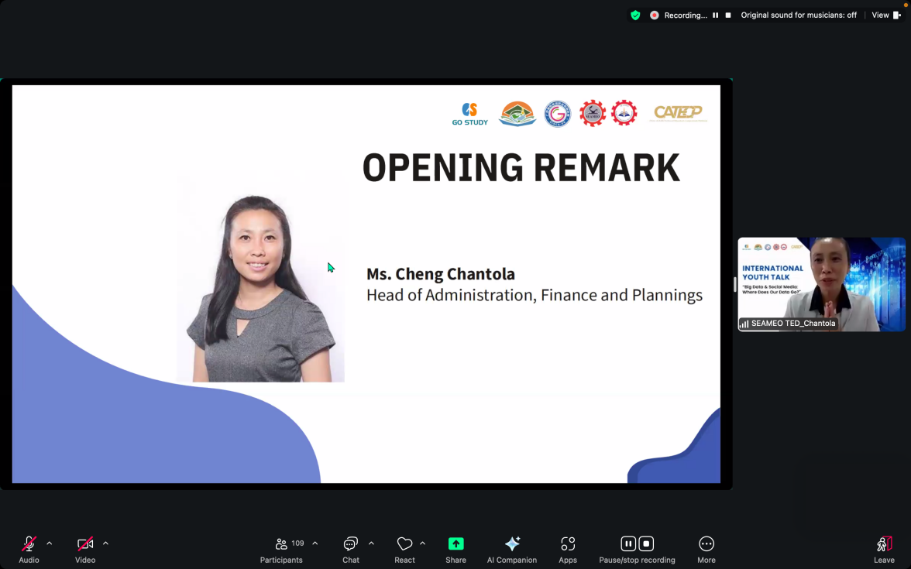

【Sharing Session】
Dewi Yasmin and Yossi Carmel Rahawarin from the University of Merdeka Malang in Indonesia explored the tension between privacy protection and the pursuit of popularity in the age of social media, highlighting the severe challenges facing personal data security. They analyzed this social phenomenon through four key dimensions: First, they pointed out that Indonesian youth tend to overshare personal information due to their desire for social recognition, the influence of influencer culture, and a general lack of digital literacy. Second, they detailed the risks arising from such behavior, including identity theft, digital fraud, and cyberbullying. Third, they introduced the core content of Indonesia’s 2022 Personal Data Protection Law, covering user data rights and legal penalties for violations. Finally, they offered practical suggestions for personal data protection, such as setting private accounts and enabling two-factor authentication. This research not only revealed the mechanisms through which social media culture erodes personal privacy but also emphasized the urgent need to build a digital security barrier from both legal and individual perspectives, providing a practical path to balance social media engagement with privacy protection.

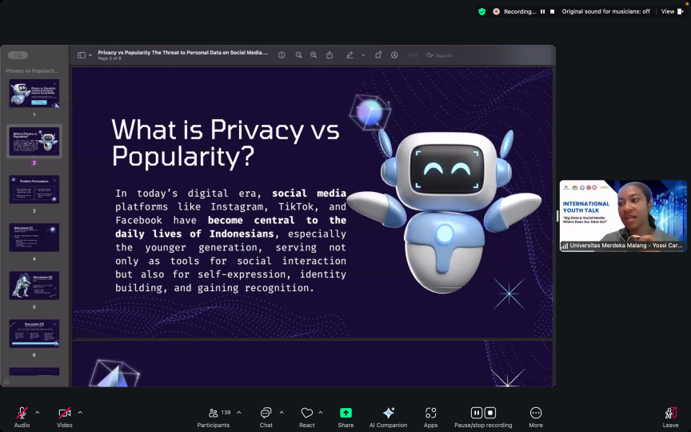

Muhammad Ariel Bin Harun and Afrina Nayli Binti Mohd Muzafar from Kerian Vocational College in Malaysia explored the flow of data in the era of big data and social media, highlighting key issues related to data collection, usage, and security. Their analysis covered four core dimensions: First, using Malaysian practices as examples, they explained how big data is collected in real time through user clicks, location tracking, and social behaviors, and how it is applied in crisis response—such as the “safe check-in” feature on social media during the 2017 Penang floods. Second, they demonstrated how tagging campaigns and apps during the pandemic leveraged big data to connect relief resources, manage vaccinations, and support decision-making. Third, they pointed out the risks of data breaches and emphasized the regulatory role of Malaysia’s 2010 Personal Data Protection Act (PDPA) in protecting sensitive data such as IC numbers and location information. Finally, they called on the public to become “responsible digital citizens,” advocating for rights protection through reading terms of service and monitoring corporate data usage while enjoying the convenience of data. This study not only showcased the innovative value of big data in public services but also warned about balancing data power and personal privacy, providing a practical framework for building digital citizenship in the information age.
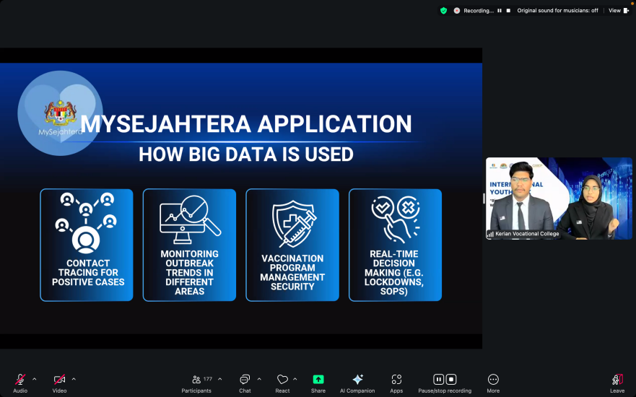

Mark Anthony D. Casasis and Ariane T. Satiada from Rizal Technological University in the Philippines explored the flow of data in the era of big data and social media, highlighting key issues related to data collection, usage, and ethical challenges. Their analysis focused on three core dimensions: First, they explained the fundamental characteristics of big data, including real-time data streams, cloud storage mechanisms, and comprehensive collection of user behaviors on social media platforms such as likes, location, and browsing habits. Second, they illustrated how mainstream platforms commercialize user data through cases such as fines for social media data misuse, cross-platform tracking, and Google history storage. Finally, they proposed the concept of “youth data empowerment,” calling for rebuilding data sovereignty through innovative solutions and ethical awareness. This study not only revealed the widespread commodification of personal data in the digital economy but also provided an action framework for youth to transform from “datafied subjects” into “agents of data ethics reform,” emphasizing the importance of turning data security awareness into popular culture.
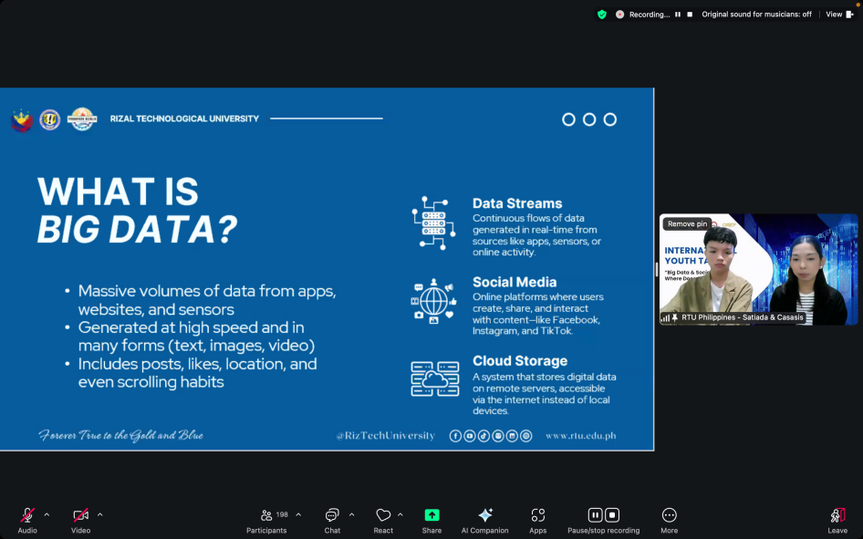

Nabilah Raniyah Nada Ramadhani from Universitas PGRI Adi Buana Surabaya in Indonesia explored the data footprints and security challenges faced by youth on social media platforms in the digital age. The study analyzed the issue through three core dimensions: First, statistical data showed that 70% of Indonesian youth actively use social media platforms, engaging primarily in activities such as accessing news (entertainment, politics, disasters, etc.), participating in global discussions (e.g., #ClimateChange), content creation and exchange, and expressing mental health concerns. Second, the study revealed platform risks, noting that even anonymous use leaves permanent digital footprints that may be exploited by malicious actors. Finally, the research proposed a "Five-Dimensional Digital Citizenship Literacy Framework" (digital ethics, privacy protection, data responsibility, reputation management, and healthy balance), emphasizing that youth should maintain self-expression while building security defenses through strategies like "think before you post" and "data sovereignty awareness." This study not only acknowledged the value of social media as a space for emotional release and global dialogue for youth but also warned of the dangers of excessive personal data exposure, providing practical guidance for digital natives on balancing freedom of expression with data security.

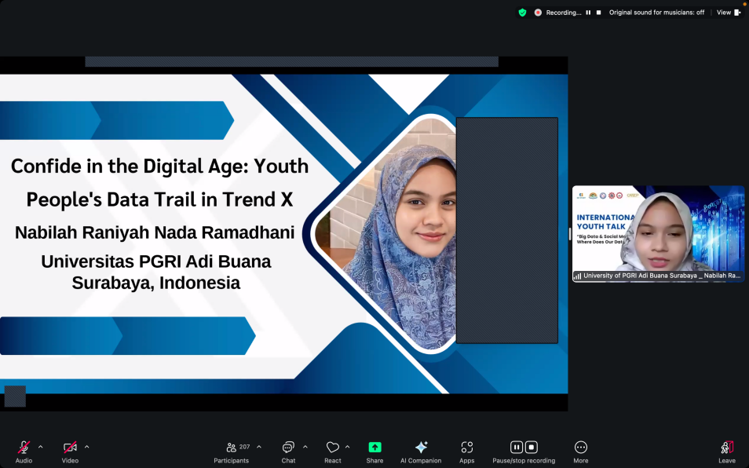

#201 Preah Norodom Blvd, Sangkat Boeung Keng Kang I, Khan Boeung Keng Kang, Phnom Penh, Cambodia.
12302 song.heang@yahoo.com +855 12 527 117  www.seameoted.org

