Kickoff Workshop for the Project on
“Developing Teachers to Raise One-Health Awareness at General and Technical High Schools in Cambodia” Phase II (Virtually)
May 16, 2025
Phnom Penh, 16 May 2025 – The Southeast Asian Ministers of Education Organization Regional Center for Technical Education Development (SEAMEO TED) and the Southeast Asia One Health University Network (SEAOHUN) co-organized the online Kickoff Workshop for the Project on “Developing Teachers to Raise One-Health Awareness at General and Technical High Schools in Cambodia” Phase II Online, May 16, 2025 to implement the project on "Developing a Pool of Teachers to Raise One-Health Awareness at General and Technical High Schools in Cambodia”.
The main objectives of the event are as follows : (1) to inform and seek support from teachers and principals of concerning general and technical high schools about the implementation of OH project Phase II.; (2) to inform and seek support from ministry leaders, and officials of relevant departments about the implementation of OH project Phase II.
The workshop aims to get the buy-in from stakeholders such as the management of the Ministry of Education, Youth and Sport, relevant departments, and general and technical high schools. The workshop was participated by 50 people from relevant organizations.
H.E. DR. KOLPHENG VADDHANA, under-secretary of state, Ministry of Education, Youth and Sport (MoEYS), presided over the opening workshop, expressed that at the conclusion of the One Health Project Phase I, there were overwhelming calls by various stakeholders such as implementing general and technical high schools (GTHSs), and other GTHSs, school trainers, teachers, students and the community members for the expansion of this project to other General and Technical High Schools and communities throughout the country.
Again, He would like to extend his heartful thank to SEAOHUN for its technical support and Chevron for financial support of One Health Project Phase II. This is a testament of their commitment to prioritizing health, public health, and education which is fundamental to improving the quality of life for people in Cambodia and beyond.
Promoting school health is still a challenge, food safety has not been taken seriously by people, vendors and students as it should be. For instances, many students still have unhealthy habits of consuming energy drink, and high level of sugar intake, and are not aware of the negative impacts these have on their health.
He also points out that the workshop marks a major milestone as we launch the project “Developing Teachers to Raise One-Health Awareness at General and Technical High Schools in Cambodia” Phase II to three more target schools. This project seeks to develop nine new national teacher trainers from the 3 target schools. This expansion aims to deepen understanding of One Health, promote sustainable practices in agriculture, animal husbandry, and food processing, and address global health challenges related to zoonoses. The project will help build a knowledgeable network of educators and communities, strengthening Cambodia's capacity to manage health risks at the human-animal-environment interface. One Health concepts align with the key policy in the pentagonal strategy of the Royal Government of Cambodia and the Ministry of Education, Youth and Sport. Those policy actions set out to enhance public educational institutions including Paying High Attention to Students’ Health through feeding nutritious food to children and regulating the food quality sold within the schools.
This project is a very important addition to the school health endeavor which the Ministry of Education, Youth and Sport has prioritized. Thus far, the Ministry of Education, Youth and Sport has put forward regulations and guidelines for schools such as school food delivery programs, primary health care programs, student medical check-up, tap water and sanitation enhancement programs, healthy food promotion, school health subject instruction, etc.
School health is a complex matter particularly for school management, teachers, and students. It is crucial for students to be healthy in order to succeed academically. According to research, school health has a positive effect on the learning outcomes of students of technical education. This means that students with good health from eating nutritious food with sufficient vitamin receive better grades.
This project is of great importance as it will benefits students, teachers, and community members through One Health education and outreach. He strongly believes that this collaborative project to raise One Health Awareness at these target schools will achieve the best health outcomes for people, animals, plants and our shared environment.
He hoped that the kickoff workshop will pay the way for a successful project implementation. To ensure a successful implementation of this project, he requested that all participants who are school management, teachers, and representatives of relevant technical department endorse and provide necessary support it needs.
At the end of his remark, H.E. DR. KOLPHENG VADDHANA had announced the official launch of the Project on “Developing Teachers to Raise One-Health Awareness at General and Technical High Schools in Cambodia” Phase II from this moment on.
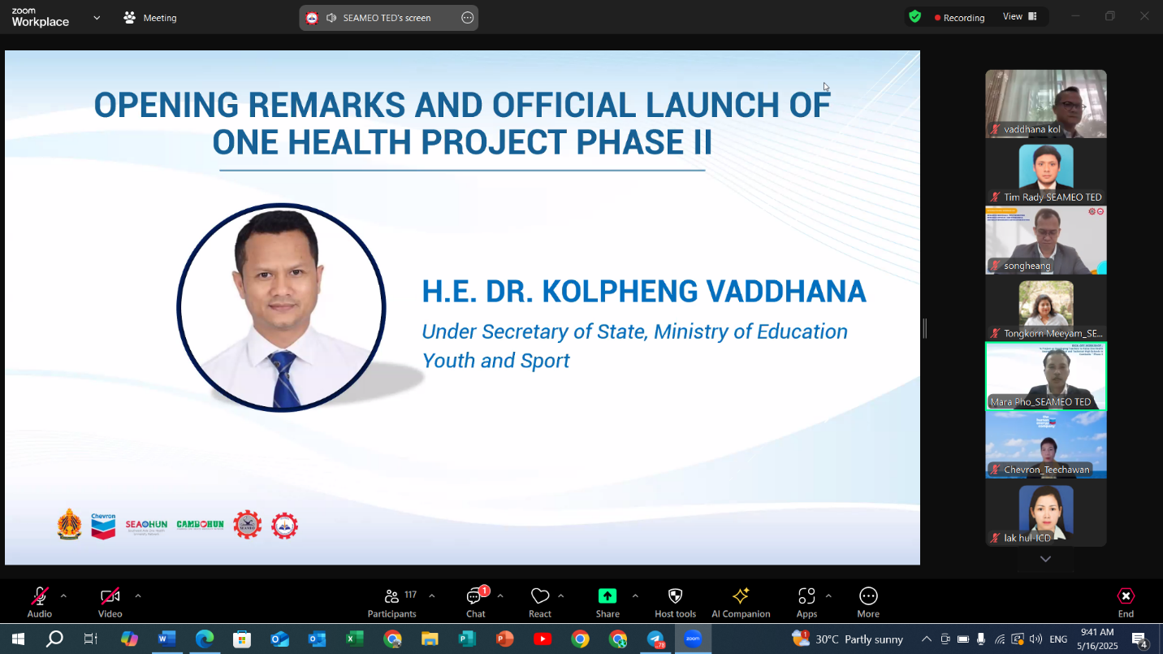

H.E Dr. KOLPHENG VADDHANA, under-secretary of state, Ministry of Education, Youth and Sport (MoEYS), Delivering Opening Remarks

Dr. Songheang Ai, Center Director of SEAMEO TED, and Project Manager, pay his high respect to Excellency Dr. KOLPHENG VADDHANA, under-secretary of state Ministry of Education Youth and Sport that always support and help in extending the network and activities that we have done regionally nationally and internationally and high respect to Dr. Tongkorn Meeyam, Executive Director of SEAOHUN, who always support in extending the project for Phase 2 and has facilitated with Chevron, the partner in order to work cooperatively to enhance our one health activity and awareness in Cambodia last one let, and high respect as well to Miss Techawan Janudom, representative of Chevron that always supports as well even though financially technically to guide us to come up with the project proposal 2 and to all representatives, who cooperatively and closely work with the project for Phase 2 of one health awareness raising activity today. He also highlighted the key objective of the workshop, the first one was to gather the support and coordination from teacher, school management, TVET student and education provincial department management in order to engage our stakeholder to work actively to disseminate one health concept in their target community school and locality. He hope that the activity will be enlarged not only just to get school province and locality, but further than the project in 3 general and technical high schools from phase 1 to other 3 GTHS for phase 2 consisting of Preah Norodom Sihamoni General and Technical High School in Kampot province , Community Development Institute, Chea Sim University of Kamchaymea, Prey Veng province, and Hun Sen Peamchikorng High School in Kampong Cham province. He also expressed that we have another city province to engage in our project implementation ensure that the active participation of our stakeholder will be in hands and work smoothly for the face to project and benefit finally to the communities as in large for the project implementation during this time. At last, He would like to give the profound thanks to Chevron and SEAOHUN for the consistent support to make face the reality today as a starting not only finishing just starting and ensure that the project will work productively smoothly from the beginning today the end.
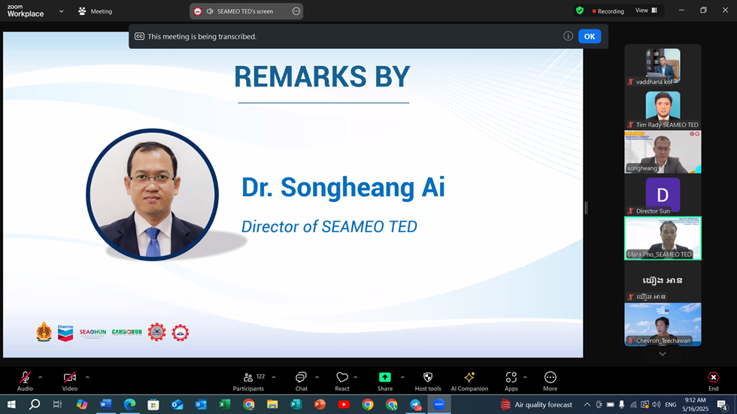

Dr. Songheang Ai, Director of SEAMEO TED (MoEYS), delivering Welcome Remarks
Ms. Teechawan Yanudom, Representative of Chevron, she is very delighted to meet you all today even though it is a virtually to celebrate the remarkable achievement of our one Health initiative in Cambodia over the past months. She has witnessed this program become an essential educational tool, enabling educators and teacher in Cambodia to incorporate essential one health concept into the curriculum and classroom. As a Chevron representative, she is truly proud to support this project and hopes this collaboration and commitment that have defined our journey will enable our partner to continue making a positive impact on your country. Early this year She think it's probably in January, She had visited the implementing school and also the community and has learned that beside the National School trainer who will continue to advocate for this foundation sharing their knowledge and experiences with peers and students our program effort also extended into community impacting many community members through awareness raising activity. These interactions have already begun to shift the attitude and practices showcase the tangible effect of our collaborative actions as we move into Phase 2 of the program, She’s very thrilled and very excited about what's ahead we have achieved so much already so setting a strong foundation for even greater success to come and let's keep the momentum going on. She eagerly anticipate seeing the profile impact on even more beneficiary as we continue to expand our effort She would like to pass her gratitude and congratulation to our great partner SEAMEO TED, SEAOHUN, CAMBO HUN, the Ministry of Education Youth and Sport and also all involved school educators and community members with your support and dedication to one health we are set to reach a new milestone and create lasting change the passion and commitment from everyone involved inspire every day and she is so confident together that we will continue to foster healthier more resilient communities together. We can make a better outcome and as Chevron representative it is very honored to be part of this remarkable journey. In her final note, she congratulated and extended her heartful thanks to all the participants for their contribution to the success of the project.
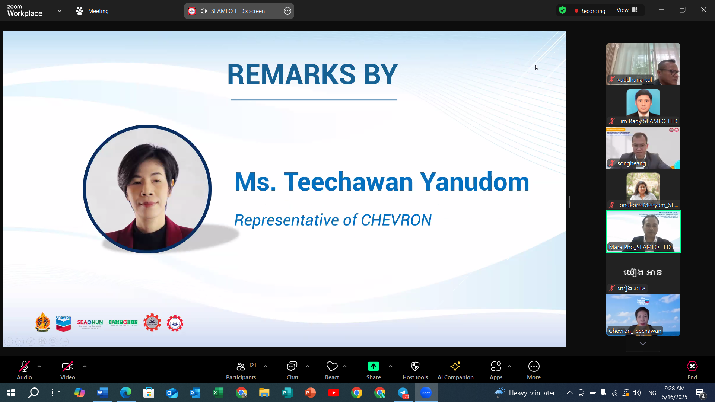
Ms. Teechawan Yanudom, Representative of CHEVRON, delivering Impressive Remarks
Dr. Tongkorn Meeyam, Executive Director of SEAOHUN, acknowledged the success of Phase 1 and congratulated SEAMEO TED team, all committed teachers, students, CAMBOHUN trainers and all stakeholders for their dedication, hard work, and belief in the power of education. She emphasized the importance of the One Health approach, which integrates human, animal, and environmental health sectors to address health threats that cross borders. The project aligns with SEAOHUN’s mission by equipping high school and technical school teachers with the knowledge and resources to educate students about One Health principles. She also thanked Chevron for its continuous support and investment, which has helped make the project possible and impactful. Phase 2 aims to build on the achievements of the first phase by refining tools, enhancing training availability, and reinforcing systems to ensure long-term success. Dr. Tongkorn noted that the project’s benefits will extend beyond Cambodian schools and could serve as a model for other countries in the region. In closing, she expressed SEAOHUN’s appreciation for the ongoing collaboration, trust, and shared vision among all partners.
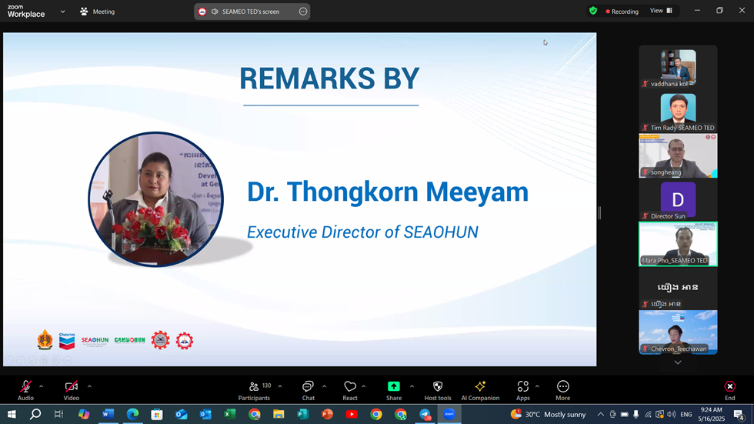

Dr. Thongkorn Meeyam. Executive Director of SEAOHUN, at the opening remarks

Dr. Thongkor Meeyam, delivering Addressing Remarks

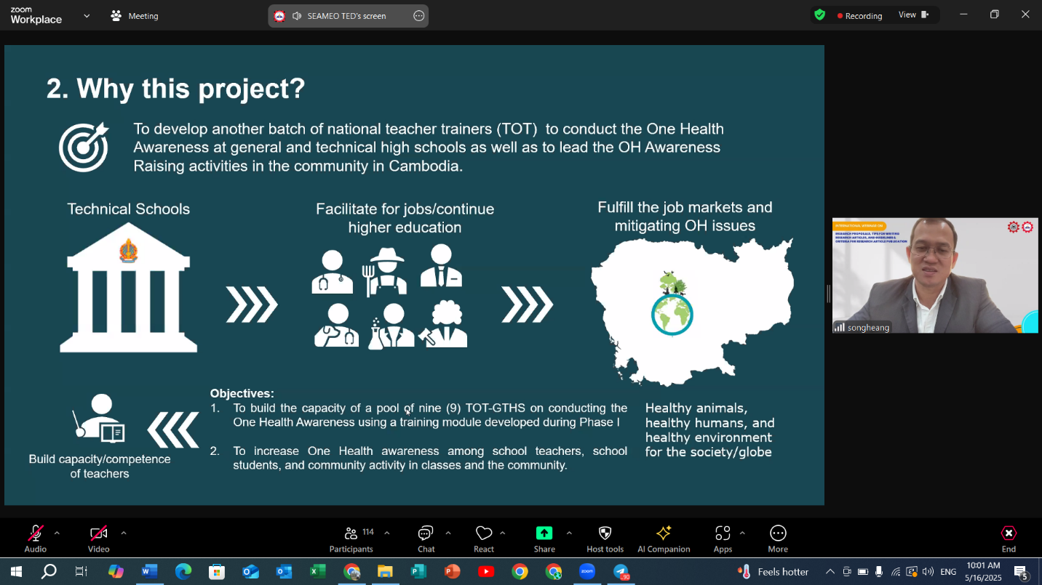

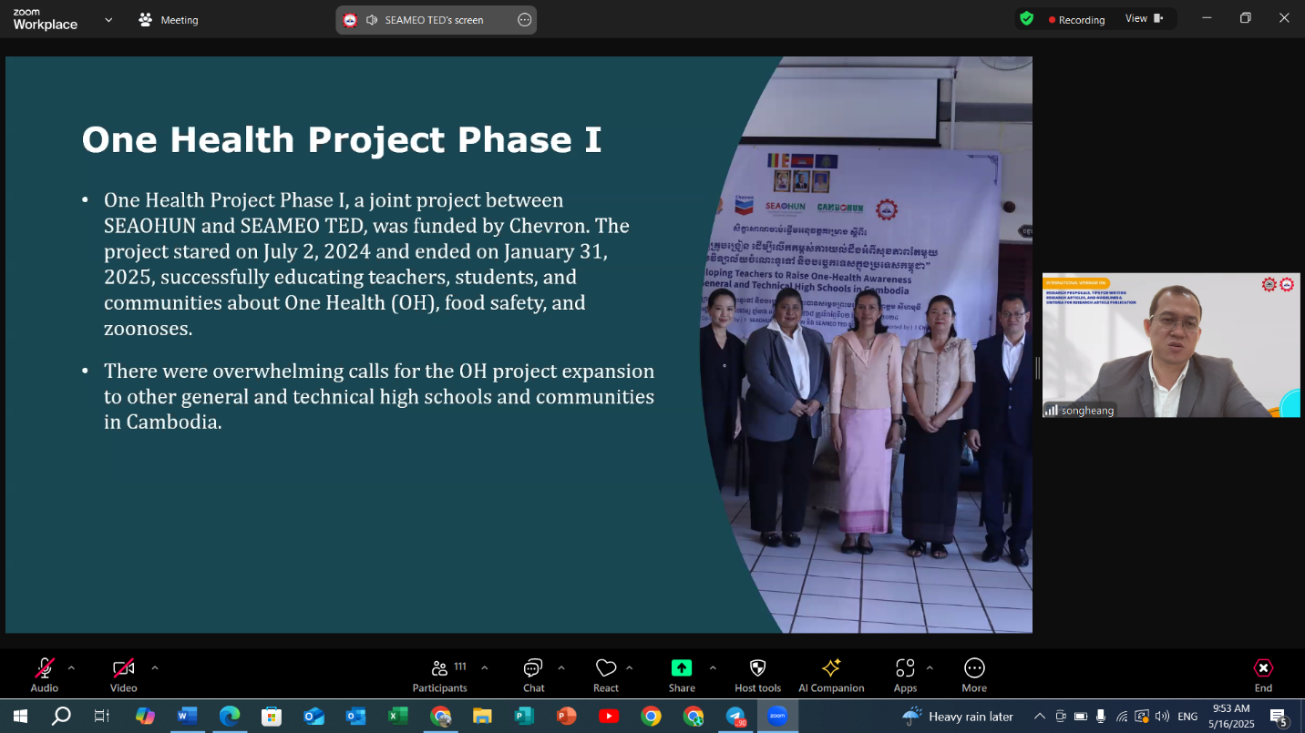

(Dr. Songheang Ai Presenting the Project Overview)

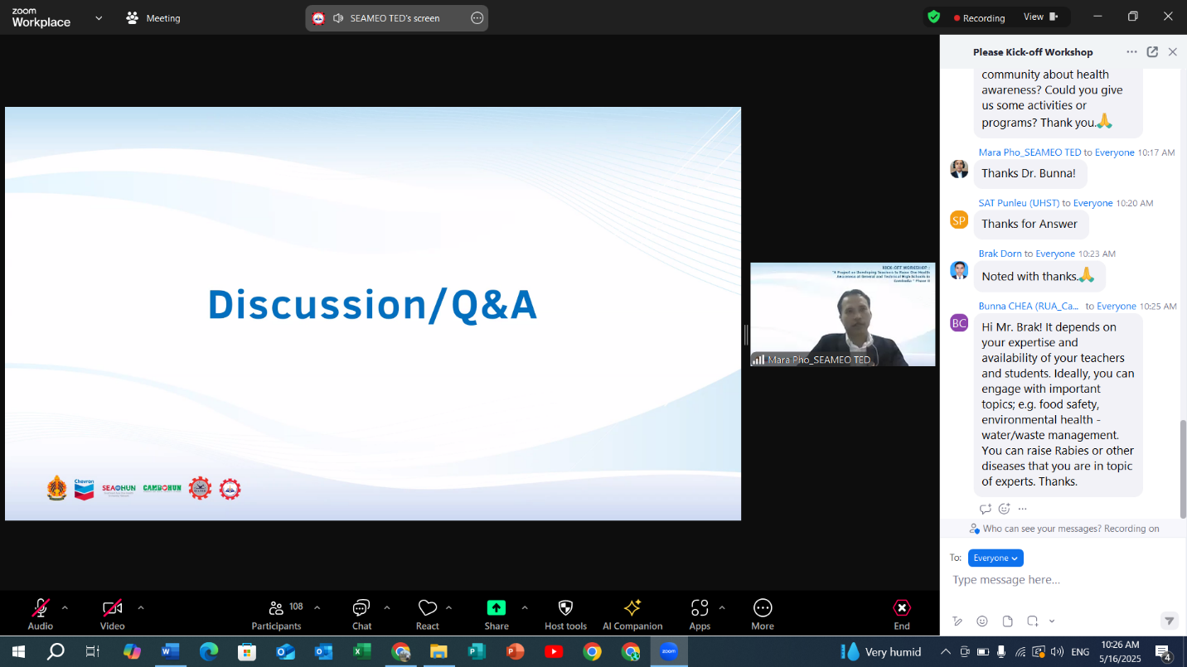

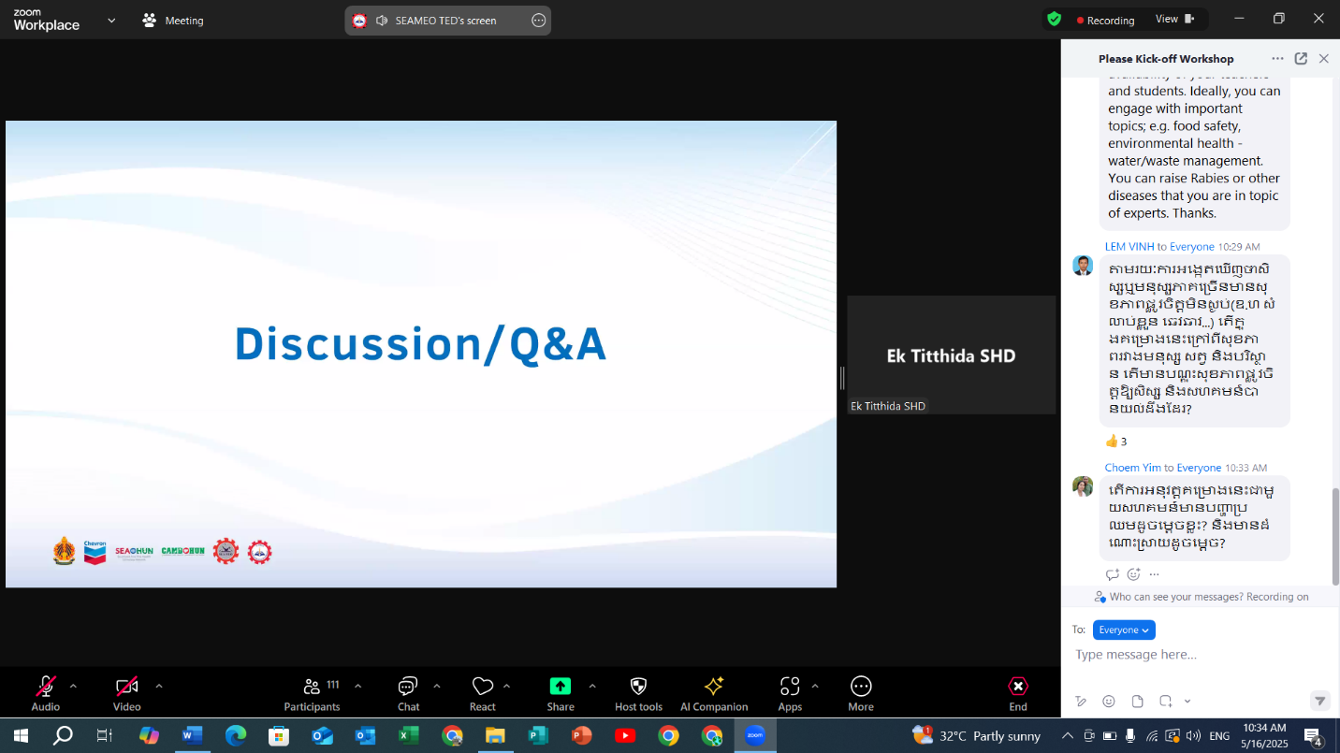

(Q&A activities)

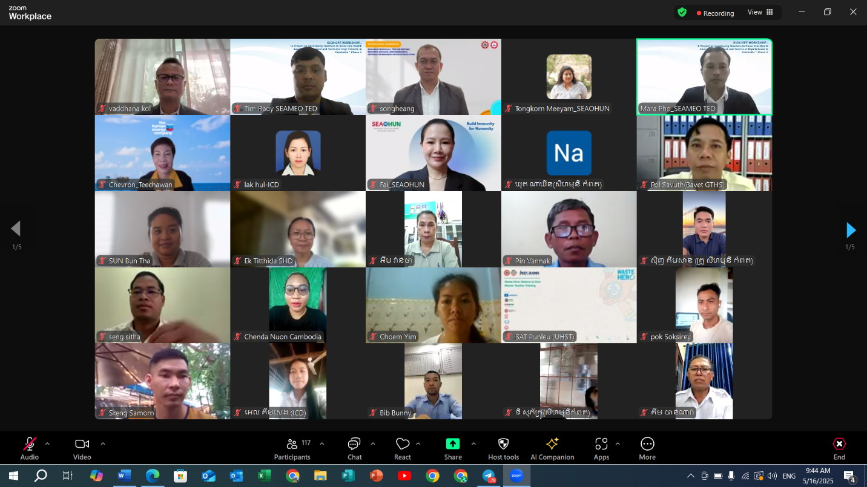

What is One Health?
One Health is a collaborative approach—working at the local, regional, national, and global levels—with the goal of achieving optimal health outcomes recognizing the interconnection between people, animals, plants, and their shared environment. Schools play a key role in the development of knowledge, positive attitude, and behaviors early in life, incorporating the One Health concept into the school curriculum will help children understand the interdependencies between humans and animals in a shared environment and develop long-lasting preventative behaviors to be less prone to zoonotic diseases. Additionally, children can bring the concept home to their parents and the greater community.

About SEAMEO TED
The Southeast Asian Ministers of Education Organization Regional Centre for Technical Education Development (SEAMEO TED) is one of the 26 SEAMEO centers, based in Phnom Penh, Cambodia. SEAMEO TED assists SEAMEO member countries in identifying technical education problems and finding alternative solutions through capacity-building programs, research and development, and public relations and partnership for supporting administrators, technical teachers, management of technical and vocational high schools and colleges. Currently there are 87 technical and vocational high schools/colleges as the members of Southeast Asian Technical and Vocational High School/College Network from all 11 SEAMEO country members working collectively.

About SEAOHUN
The Southeast Asia One Health University Network (SEAOHUN), established in 2011, is an academic and research network promoting the One Health concept. Comprising over 100 educational institutions from eight ASEAN countries, SEAOHUN builds professional capacity to address complex One Health issues, conducts research for evidence-based decision-making, and assists governments with public health surge capacity. The SEAOHUN Secretariat is located in Mueang district, Chiang Mai, Thailand.
About Chevron
Chevron is one of the world’s leading integrated energy companies. We provide affordable, reliable, and ever-cleaner energy to people in the Eurasia Pacific region that is essential to achieving a more prosperous and sustainable world. In Cambodia, Chevron (Cambodia) Limited markets automotive fuels and products under the Caltex® brand at 76 service stations, 40 of which are in Phnom Penh. Of the total number, 17 are company-owned, and 59 are owned by retailers. We operate 24 Star Mart® convenience stores and 72 Coffee Plus® gourmet cafés. In addition, we support the community through health, education, and safety initiatives.
Media Contacts:
SEAMEO TED
Songheang Ai, Ph.D
Alternate SOCA Leader for Cambodia, Center Director of Southeast Asian Ministers of Education Organization, Regional Center for Technical Education Development (SEAMEO TED)
Email: song.heang@yahoo.com What’s Up/Telegram: 855-12-527-117

Chevron (Cambodia) Limited
Uzma Nawawi
Corporate Affairs Manager – Southeast Asia
T +603 2289 6688
M +6017 521 9294
uzma.nawawi@chevron.com

