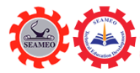
Southeast Asian Ministers of Education Organization
Regional Centre for Technical Education Development
(SEAMEO TED)

Report on International Expert Sharing Meeting on Application and Challenges of Big Data Analytics in Various Industries (Virtually)
May 16, 2025

In today's rapidly advancing technological era, digital technologies are reshaping the world at an unprecedented pace. The fourth session of the 2025 "International Experts Sharing Meeting" seminar themed "Applications and Challenges of Big Data Analytics in Various Industries" successfully held on May 16th. This seminar brought together top experts from China, Indonesia, Cambodia, Malaysia, and other countries. Through a hybrid format combining online and offline participation, the event offered a vibrant platform for intellectual exchange among audiences from diverse nations. It attracted numerous professionals from education, technology, culture, and other fields to jointly explore how digital technologies empower industrial upgrading and drive social progress.

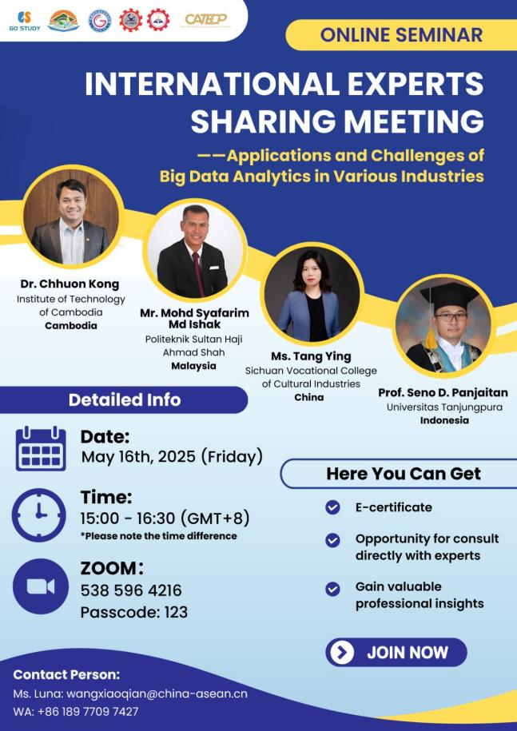

Mr. Mara Pho, Head of Technical Education and Training Division, SEAMEO TED delivered the opening remarks. He highlighted that amid the wave of digital transformation, big data analytics has become the core engine for innovation and development across industries. Centered on the theme of “Applications and Challenges of Big Data Analytics in Various Industries,” the event aimed to build a cross-border, cross-sector knowledge-sharing platform. Mr. Mara Pho emphasized that Southeast Asia must seize the opportunities brought by big data by deepening cooperation in talent cultivation, technology standards, and data security, collaboratively meeting the challenges of the digital era and harnessing the benefits of digitalization.

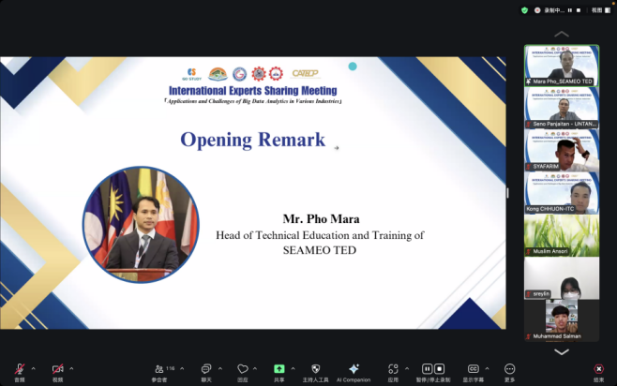

Topic: IoT-Enabled Data Analysis and Forecasting in Energy Systems: Applications and Key Challenges
Expert: Prof. Seno D. Panjaitan, Professor of Electrical Engineering at Universitas Tanjungpura, Indonesia
Prof. Seno explained how the Internet of Things (IoT) uses sensors, network connectivity, and data platforms to enable real-time data collection and control in energy systems. IoT applications span smart grids, building energy management, and industrial energy systems. Data generated from smart meters and meteorological sensors are transmitted via cloud computing and analyzed using AI and machine learning models for visualization and decision-making to enhance energy efficiency. Forecasting in energy systems includes load, price, and renewable energy predictions across short-, medium-, and long-term horizons using statistical and machine learning methods such as Random Forest (RF) and Polynomial Exponential (PE) models. In a case study of a building in Indonesia, a combined RF+PE algorithm achieved high accuracy in predicting energy consumption and power quality. Challenges remain in data quality, security, privacy, scalability, and model adaptability. Prof. Seno emphasized the need for optimized machine learning data processing and standardized, highly secure solutions to address the “big data” challenges brought by IoT scale-up, driving energy systems toward intelligence and sustainability. While IoT and machine learning offer a promising technological pathway, their implementation requires balancing accuracy, cost, and security. Future progress will depend on cross-disciplinary collaboration and standard setting to unlock IoT’s full potential in energy data.

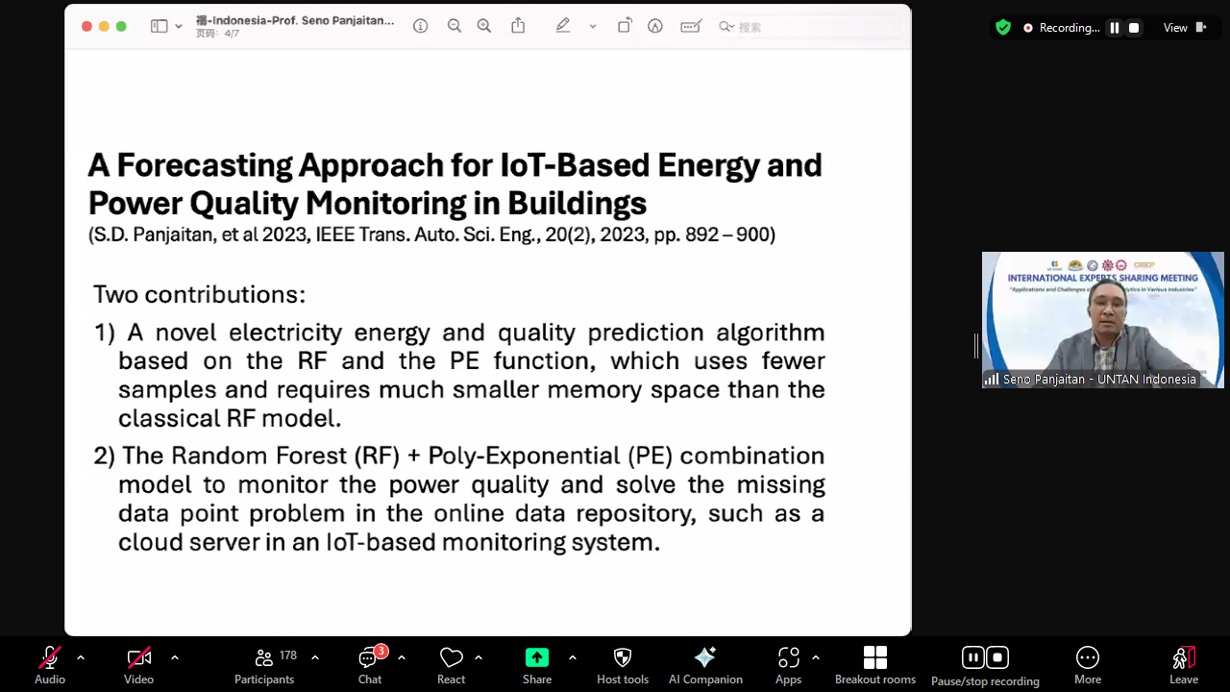

Topic: Digital Technology in Water Management
Expert: Dr. Chhuon Kong, Dean of Faculty of Hydrology and Water Resources Engineering, Institute of Technology of Cambodia
Dr. Chhuon Kong discussed how the growing global water crisis has accelerated the adoption of digital technologies in water resource management and disaster risk reduction. He introduced various solutions including blockchain, IoT sensors, machine learning, and Geographic Information Systems (GIS). Digital technologies also play critical roles in flood detection, disaster prediction, and resource allocation. Their integration has improved the efficiency and sustainability of water management but faces challenges such as data privacy, high costs, and a shortage of specialized personnel, which require policy support, funding, and cross-sector collaboration. Dr. Chhuon presented Cambodian case studies showing how combining local research with digital tools — including smart rain gauge networks, dynamic groundwater management platforms, and community mobile warning systems — effectively mitigates the dual pressures of flooding in rainy seasons and drought in dry seasons. Moving forward, implementing digital water strategies, promoting public-private partnerships, sharing data infrastructure, and localizing advanced algorithms and hardware will accelerate sustainable water resource governance in Cambodia and the broader region.
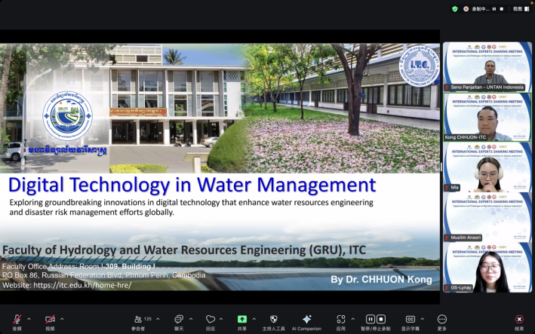

Topic: Integration of Multimodal Data and Construction of Museum Communication Knowledge Graph
Expert: Ms. Tang Ying, Vice President of the School of Cultural Relics and Museology, Sichuan Vocational College of Cultural Industries, China
Ms. Tang Ying explained how museums are evolving from static repositories into smart institutions driven by data and knowledge dissemination. She highlighted that multimodal data integration and knowledge graph construction are key to deepening artifact interpretation and enhancing visitor experience. Multimodal data includes diverse formats such as text, high-resolution images, 3D scans, immersive videos, and expert audio commentary, which enrich the semantic nodes and relational edges of knowledge graphs. Using the Sanxingdui Museum as an example, the institution employs high-precision imaging to restore bronze artifact patterns and supplements historical context with archaeological documentaries and scholar interviews. These heterogeneous data are mapped into a knowledge graph and presented interactively through semantic search and cross-platform visualization, allowing visitors immersive exploration via AR, VR, and mobile apps. This model significantly enhances knowledge dissemination and opens new avenues for education, tourism, and cultural innovation. However, the expert also cautioned that with the increasing scale and intelligence of data, museums must address challenges such as data security and privacy, knowledge graph update mechanisms, and interdisciplinary talent development to ensure sustainable digital transformation.

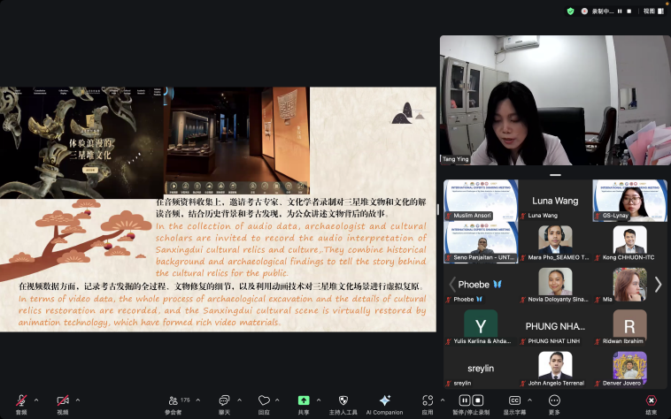

Topic: Application and Challenges of Big Data Analytics in Food Industries
Expert: Ts. Mohd Syafarim Md Ishak, Head of Technology Development Unit - Center of Food Science and Technology (CFOST), Politeknik Sultan Haji Ahmad Shah, Malaysia
Mr. Syafarim discussed big data analytics applications in the food sector. These include real-time tracking of ingredient sources, transport temperatures, and inventory via IoT sensors and blockchain; predictive maintenance and contamination risk analysis on production lines through machine learning models; mining consumer preferences, purchasing behavior, and health trends from social media, e-commerce, and reviews; and optimizing agricultural production to reduce water and fertilizer use. Key challenges are data format heterogeneity and insufficient real-time capabilities, leading to high integration costs; small and medium enterprises often lack investment and data analytics talent to deploy advanced big data platforms; and the absence of unified data-sharing standards and cross-enterprise collaboration causes severe data silos along the supply chain. Ts. Mohd Syafarim suggested future improvements through edge computing, 5G, and augmented reality to enhance data collection and real-time analysis; government and industry initiatives to promote data standards and shared platforms; and driving the food industry toward low-carbon, zero-waste goals by optimizing packaging and demand forecasting to reduce food spoilage.

#201 Preah Norodom Blvd, Sangkat Boeung Keng Kang I, Khan Boeung Keng Kang, Phnom Penh, Cambodia.
12302 song.heang@yahoo.com +855 12 527 117  www.seameoted.org

