Report on
International Experts Sharing Meeting on “AI and Automation: The Work Revolution in the Future Workplace”
June 06, 2025 (Virtually)
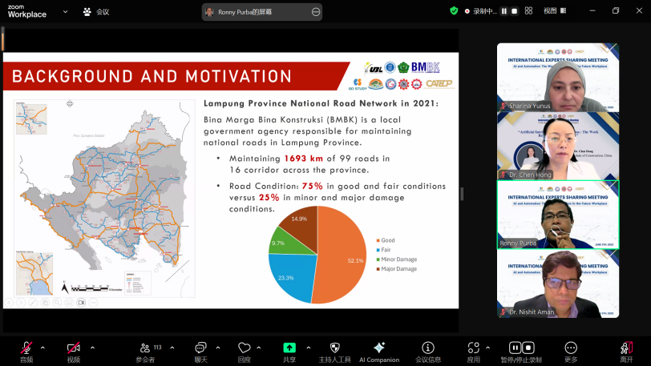
(113 International Participants)
On the afternoon of June 6, 2025, the 5th session of the International Experts Sharing Meeting successfully concluded online accommodating 113 international participants. Centered on the theme “AI and Automation: The Work Revolution in the Future Workplace,” the session brought together experts from Brunei, Thailand, China, and Indonesia to explore how artificial intelligence and automation are reshaping future work models, enhancing industry efficiency, and driving societal transformation. Core topics included workplace transformation, evolving skill demands, industry applications, and human-machine collaboration.
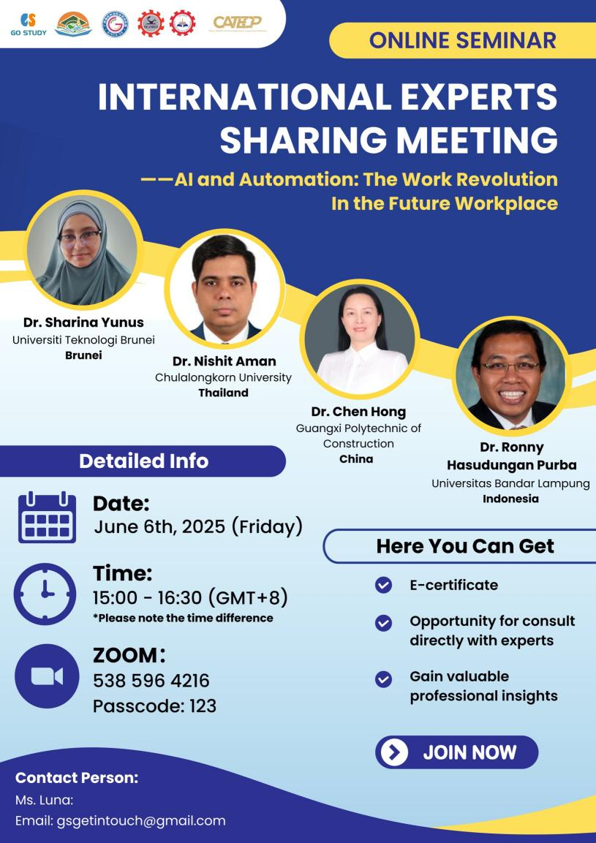

The opening remarks of the event were delivered by Mr. Veoum Ravy, Vice-Head of Research and Development Division of SEAMEO TED. He noted that as technology continues to advance, we are living in an era full of vitality and transformation. This meeting provided a platform for participants to engage in meaningful discussions about the opportunities and challenges brought by artificial intelligence and automation. He emphasized that this is not only a chance for knowledge sharing but also a valuable moment for cross-cultural exchange. Mr. Ravy encouraged all participants to actively engage, express their views boldly, and make the most of this opportunity. He also expressed great anticipation for the insightful perspectives and in-depth sharing from the four invited experts.

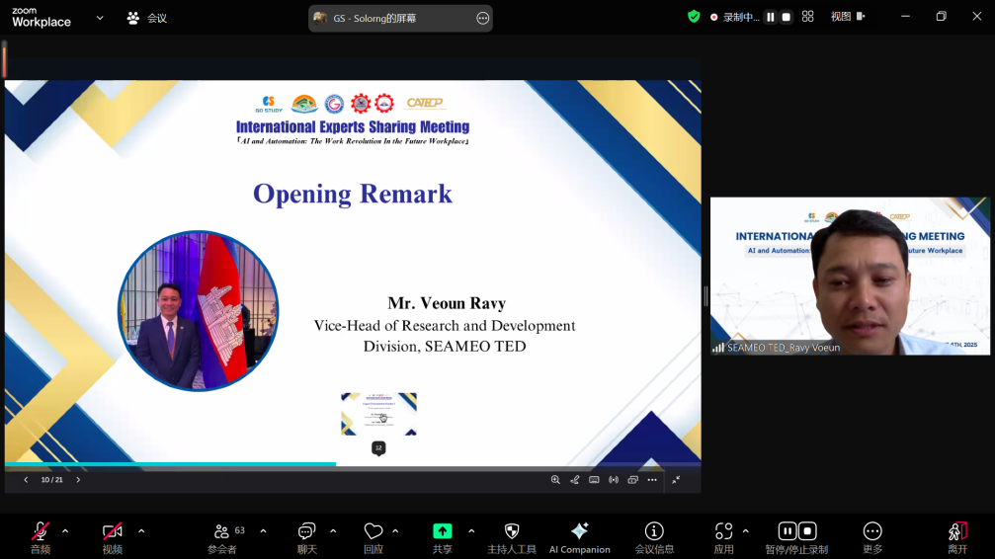
(Mr. Voeun Ravy Delivering Opening Remarks)
Presentation by Dr. Sharina Yunus, Assistant Professor & Director of Enterprise Office, Universiti Teknologi Brunei
Dr. Sharina Yunus provided an in-depth discussion on how human-centered artificial intelligence (AI) and automation technologies are reshaping the future workplace. She emphasized that the future work model is not about humans competing against machines, but rather about achieving human-machine collaboration through intelligent system design to improve overall efficiency and the work experience. The main challenges currently faced include alert fatigue caused by system design flaws, inefficient operational processes, and resistance to change among employees. Additionally, security vulnerabilities in Operational Technology (OT) systems and the technological gap between Information Technology (IT) and OT pose potential risks. She recommended close collaboration with end users during the system design process to ensure that designs meet practical operational needs. At the same time, embedding a culture of security awareness to strengthen employee safety consciousness; adopting a microlearning approach combined with workflow to enable flexible and efficient skills training; and breaking down departmental silos to build scalable, intelligent system platforms that facilitate organizational collaboration and resource sharing. Finally, Dr. Yunus called on the industry to view Industry 4.0 as essential for business survival, investing in human-centered technology to bridge the talent gap and create a resilient workplace where “automation clears obstacles and humans lead the direction,” promoting a smarter, more collaborative, and sustainable future of work.
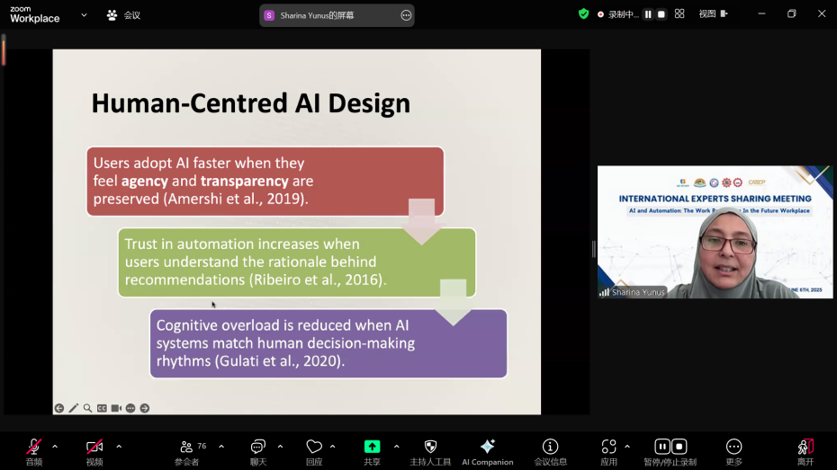
(Dr. Sharina’s Presentation)

Presentation by Dr. Nishit Aman, Researcher, Department of Environmental and Sustainable Engineering, Chulalongkorn University, Thailand
Dr. Nishit Aman shared his research on quantifying PM2.5 pollution in the Greater Bangkok area using machine learning approaches in relation to meteorological factors. By integrating ground-based monitoring data, satellite-derived Aerosol Optical Depth (AOD), and meteorological variables, the study applied six machine learning models—including Random Forest and Gradient Boosting—to assess pollution levels, with Light Gradient Boosting Machine (LightGBM) demonstrating the best performance, particularly during morning hours. The findings revealed that PM2.5 concentrations peaked in the early morning and declined in the afternoon due to increased boundary layer height facilitating dispersion. The most severe pollution occurred in winter (December–February), with meteorological factors contributing up to 67.8% of the variation. High variability was observed in Bangkok's urban PM2.5 due to stable emissions from traffic and industry, whereas surrounding provinces experienced greater fluctuations linked to agricultural burning. The study also found that PM2.5 composition showed stronger persistence during winter, reflecting the cumulative effects of long-term emissions. SHAP analysis identified relative humidity, boundary layer height, and wind speed as the most influential variables. Dr. Aman concluded by emphasizing the need for targeted winter emission control measures—such as traffic restrictions and burn bans—and called for the integration of meteorological forecasting into air quality alerts. He also advocated for leveraging satellite and machine learning technologies to enhance monitoring capabilities and develop region-specific pollution management strategies.
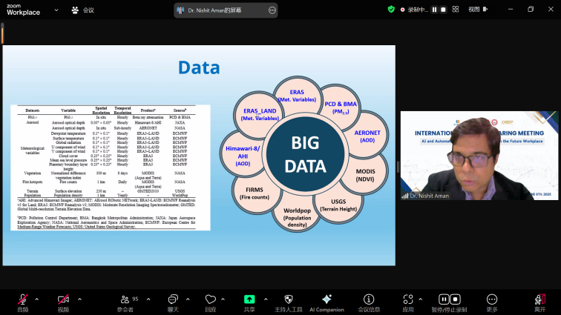
(Dr. Nishit’s Presentation)

Presentation by Dr. Chen Hong, Expert, Guangxi Polytechnic of Construction, China
Dr. Chen Hong explored the revolutionary impact of artificial intelligence (AI) and automation technologies on future work models, providing an analysis spanning their definitions, historical development, and practical applications. AI empowers automation by simulating human intelligence to execute physical tasks, and together they significantly enhance operational efficiency. Using comparative charts, Dr. Chen illustrated marked improvements in efficiency and accuracy before and after automation implementation. The study highlighted the dual impact on employment: while new roles such as data scientists emerge, low-skilled jobs face the risk of replacement. This underscores the urgent need for skill transformation—including data analysis and programming—and educational reform emphasizing STEM curricula and lifelong learning. Looking ahead, Dr. Chen proposed a new human-machine collaboration model, where AI handles routine tasks and humans focus on innovation and complex decision-making. He also called on policymakers to improve labor regulations and training systems. The core conclusion stressed the importance of proactively adapting to change by continuously acquiring interdisciplinary skills and soft competencies, thereby seizing competitive advantages in the AI era workplace.
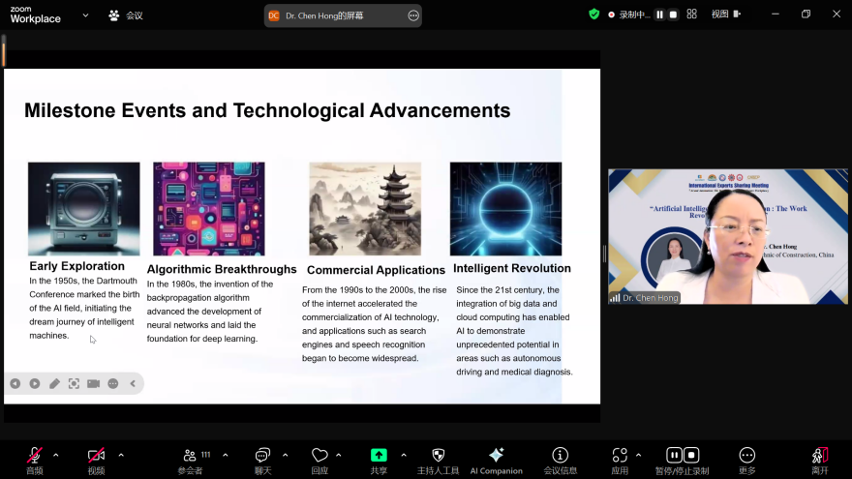
(Dr. Chen Hong’s Presentation)

Presentation by Dr. Ronny Hasudungan Purba, Assistant Professor of the Department of Civil Engineering, Universitas Bandar Lampung, Indonesia
Dr. Ronny Hasudungan Purba introduced an innovative automated road condition assessment system called JALANKU, developed for Lampung Province, Indonesia, which integrates photogrammetry technology and artificial intelligence (AI). The system utilizes vehicle-mounted equipment such as DSLR cameras and GPS devices to capture detailed road images, which are then processed to create digital twin models of the road infrastructure. By leveraging AI algorithms, JALANKU automatically analyzes these images to detect and classify road damages with high accuracy, significantly improving the efficiency and reliability compared to traditional manual inspections. Dr. Ronny emphasized how the system employs classification methods based on the Pavement Condition Index (PCI) and Road Condition Index (RCI) standards, which assist the regional transportation agency (BMBK) in optimizing resource allocation and making more informed maintenance decisions. Furthermore, he discussed future to expand this technology beyond roads to include other critical infrastructure such as bridges and tunnels, as well as the integration of unmanned aerial vehicles (drones) and satellite imagery to enhance data collection and monitoring capabilities. This advancement promises to contribute greatly to smarter, data-driven infrastructure management in Indonesia.

