Report
China-Southeast Asia Capacity Building Workshop
Transforming Learning for Sustainable Rural Development
Beijing, 16-19 June 2025

- Introduction
The United Nations Secretary-General’s Transforming Education Summit (2022) reaffirmed global commitments to advancing inclusive, resilient, and future-oriented learning systems. Governments pledged to strengthen investments in lifelong learning, technical and vocational education and training (TVET), and skills development to meet evolving labour market demands and support transitions to green and digital economies. The Marrakech Framework for Action, adopted at the Seventh International Conference on Adult Education (CONFINTEA VII), underscores the critical role of lifelong learning in fostering social inclusion and economic growth. It calls for high-quality adult education aligned with labour market needs, ensuring that all individuals, particularly those from marginalized communities, have access to education and sustainable livelihoods. Additionally, UNESCO’s TVET Strategy 2022–2029 prioritizes equipping individuals with skills for learning, work, and life, with a focus on green and digital transitions and the promotion of inclusive and peaceful societies. These global initiatives provide essential policy guidance and practical frameworks to advance lifelong learning and skills development worldwide.
Recognizing the shared challenges and opportunities in skills development and lifelong learning, the UNESCO International Research and Training Centre for Rural Education (INRULED), in collaboration with the Southeast Asian Ministers of Education Organization Regional Centre for Technical Education Development (SEAMEO TED), the China Education Association for International Exchange (CEAIE), the ASEAN-China Center (ACC), and other local partners, is organizing the China-Southeast Asia Capacity Building Workshop under the theme “Transforming Learning for Sustainable Rural Development”. This workshop is a platform for policymakers and practitioners from Southeast Asian countries and China to exchange knowledge, share best practices, and explore collaborative solutions on TVET, adult education and lifelong learning.

- Opening Session
- Prof. ZHOU Zuoyu, Vice Chairman of Beijing Normal University Council, Director of UNESCO INRULED

  - Extend a warmest welcome to all education professionals from Southeast Asia and China joining the workshop
  - Adult learning and technical and vocational education demonstrate transformative potential for confronting the intensifying climate change, demographic shifts, and rapid digital transformation, humanity faces unprecedented systemic challenges
  - To advance global sustainable development, inclusive lifelong learning systems must be built to offer flexible pathways and diverse modalities to meet learners’ needs across all ages.
  - Targeted skills training, retraining, and upskilling can empower rural workers to adapt to dynamic labor markets, foster employment and entrepreneurship, harness opportunities in the green and dig

- H.E. Mr. SHI Zhongjun, Secretary-General of the ASEAN-China Centre (ACC)

  - 6 LUBAN workshops have been set up in ASEAN countries
  - China ASEAN potential collaboration in digital transformation and technologies
  - TVET is the priority and students, and institutional exchange shall be encouraged.
  - Today workshop bring policy makers from ASEAN and China to discus and share the impact of TVET and Lifelong Learning, Adult Education which are very crucial for the future of regional education agenda
  - Inter-Governmental collaboration strategies are to be more innovative and synergistic to support ASEAN-China partnership

- Dr. AN Yan, Deputy Secretary-General, China Education Association for International Exchange (CEAIE)

  - Under the Regional Comprehensive Economic Partnership framework, bilateral trade and investment between China and ASEAN continue to expand, injecting robust momentum into regional economic development
  - In recent years, guided by our shared vision of building a China-ASEAN Vocational Education Community, we have actively exchanged experiences in using vocational education to reduce poverty, revitalize rural areas, and drive industrial transformation
  - This workshop, themed "Capacity Building for Transformative Learning in Rural Development," addresses critical issues in rural education and development.
  - For ASEAN nations, bridging the urban-rural education gap and promoting rural development are equally urgent tasks
  - CEAIE looks forward to working with INRULED, the SEAMEO Regional Centre for Vocational and Technical Education Development (SEAMEO VOCTECH), and other partners to leverage our collective strengths, share best practices, seize opportunities, and advance China-Southeast Asia vocational education cooperation. Together, we can contribute to achieving the UN 2030 Sustainable Development Goals.

- Prof. Shahbaz Khan, Director of the UNESCO Regional Office for East Asia (Video Address)

  - As outlined in the ​​United Nations Sustainable Development Goal 4 and the ​​2030 Agenda​​, we recognize that inclusive, equitable education is the cornerstone of sustainable development.
  - This workshop highlights innovative models: China’s ​​Dual Learning System​​ (blending classroom and workplace training) and Southeast Asia’s community-driven TVET approaches.
  - This workshop, we will witness inspiring examples and practices which reflect the guiding principles of adaptability, inclusivity, and resilience in transforming learning for sustainable rural development
  - The ​​decades-long partnership between UNESCO and INRULED​​. As UNESCO’s specialized institute for rural education, INRULED has been instrumental in driving innovation across Asia.
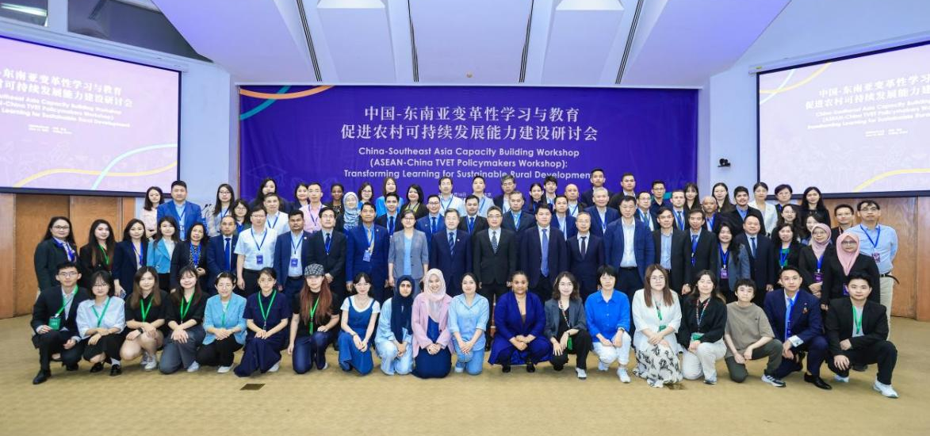

- Keynote presentation
Moderator: Dr ZHAO Yuchi, Executive Director of UNESCO INRULED
- Mr. LI Yingli, Deputy Director-General, Department of Vocational and Adult Education, the Ministry of Education of the People’s Republic of China shared a national policy overview, shared China’s strategies, and framed collaborative aims for TVET in rural contexts.

  - Key Highlighted Points
      - Policy Leadership in Vocational Learning
As MOE Deputy, Mr. Li Yingli outlined China’s national roadmap for skills education to support rural revitalization—highlighting institutional leadership and regulatory support.
      - TVET & Adult Learning for Sustainability
Emphasized the dual focus on vocational and adult learning (ALE) to advance green, resilient, and inclusive rural communities.
      - Digital & Green Transition in Rural TVET
Stressed integrating digital tools (e-learning, remote labs) and green technologies into rural vocational programs to modernize agricultural practices and promote environmental sustainability.
      - Cross-Border Collaboration
Highlighted the importance of cooperation between China and ASEAN nations in sharing best practices and building capacity via collaborative field learning and joint policy development
      - Bridging Theory and Practice
Advocated for strategies that link TVET curricula with local economic and social needs, ensuring practical, context-aware training for rural learners.
  - Key Takeaways
      - China’s MOE is prioritizing vocational education as a vehicle for rural transformation, providing direction, funding, and institutional support.
      - Sustainability requires not only initial vocational training, but ongoing adult education tailored to evolving rural economies.
      - Modern rural TVET must equip learners with both digital competencies and environmentally friendly practices to foster resilient livelihoods.
      - Mutual learning across China and Southeast Asia enhances the effectiveness of rural TVET, fostering policy innovation, regional coherence, and shared capacity.
      - Programs aligned with specific regional industries and cultural contexts yield greater relevance and impact in rural communities.
- Dr. YUAN Ying, Lecturer of School of Journalism and Communication, Beijing Normal University shared about the Empowering Rural Revitalization through Digital Intelligence

  - The presentation is rooted in China’s national strategy to eliminate poverty and ensure equitable education across rural and impoverished areas. Following directives from President Xi Jinping, particularly focused on Liangshan Yi Autonomous Prefecture, this initiative positions education—especially digital literacy—as a cornerstone of rural revitalization.

  - Key Highlighted Points
      - Policy Alignment with National Goals:
Grounded in Xi Jinping’s strategy for poverty eradication via education and digital empowerment.
      - Three-Pillar Framework:
“New Literacy,” “New Curriculum,” and “New Vision” guiding structured, scalable implementation.
      - Rural Media and Teacher Empowerment:
Strengthening local storytelling and teaching capacity to fuel rural development narratives.
      - Multi-province Engagement & Partnerships:
Reaching across 5 provinces with cross-sector cooperation (e.g., Tencent, China Press Association).
      - Scalable Digital Literacy Models:
Developed cloud-based and scenario-driven curricula, integrating AI and youth innovation challenges.
  - Key Takeaways
      - Digital empowerment is a strategic tool in breaking intergenerational poverty in rural China.
      - Collaborative, localized education initiatives—backed by policy and technology—can rapidly accelerate rural revitalization.
      - Youth engagement via digital storytelling strengthens cultural identity and connects communities to national narratives.
      - Multidisciplinary partnerships are critical to long-term success—blending education, journalism, technology, and policy.
      - The project serves as a national model for integrating education, technology, and rural development.
- Dr. ZHU Min, Associate Professor at the Institute of Vocational Education, Department of Education, East China Normal University; Principal Researcher of the ESD Programme, Shanghai Municipal Institute for Lifelong Education: Research Reflection and Practical Exploration on Green Talents in China

  - Key Highlighted Points

  - Policy Continuity & Strategic Vision:
China's long-term commitment to ecological development provides a strong framework for green talent cultivation.
  - Urgent Talent Gap:
Growing demand for green skills far exceeds current educational supply—urgent upskilling is required across sectors.
  - VET as Green Skill Incubator:
Vocational schools are pioneering curriculum transformation in green technology and industries.
  - Shanghai's ESD Model:
Practical, community-based models integrating universities, local governments, and industries in green education.
  - Intergenerational and Localized Learning:
Shanghai projects uniquely blend intergenerational learning and localized eco-practice, offering a replicable model.
  - Key Take-Away Points
  - Green talent is central to achieving national carbon and sustainability goals. It is not just a policy issue, but a workforce imperative.
  - Cross-sector collaboration and community engagement are key to promoting ecological literacy and fostering green values.
  - Localized education programs create greater impact—tailoring content to region-specific industries (e.g., EV in Nanhu, water in Pudong).
  - Interdisciplinary and intergenerational learning models are effective in promoting shared green values across age groups and educational levels.
  - China is building an evolving, systematized approach to integrate green competencies into lifelong education—from K-12 to vocational to enterprise HR systems.
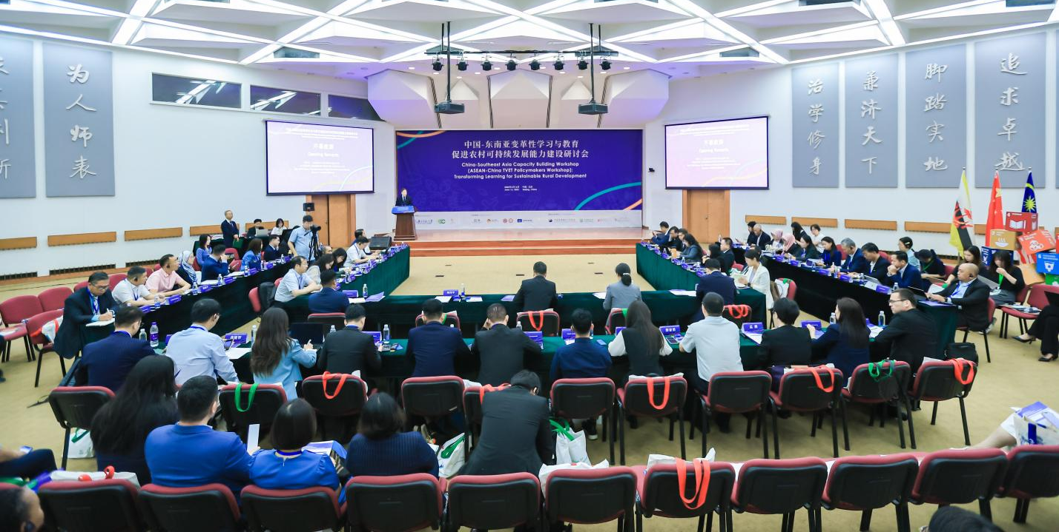

- Key points of Session I: Country report on TVET and adult education policies
Moderator: Dr. QI Xinjian, Assistant Director of UNESCO INRULED
- Brunei: Mr. Armi Durani Durhman, Principal, Institute of Brunei Technical Education, Institute of Brunei Technical Education (IBTE)
- Cross-Cutting Enablers of TVET in IBTE Brunei include: Enhance IT Infrastructure and Innovative Technology, Create a Safe and Conducive Learning Environment and Workplace, Promote Greening IBTE and Sustainable Development and Promote IBTE’s Brand Identity and Image
- Establishment of Centre of Technology Enhanced Learning (CETL) is very important. The function of CTEL is to provide resources, tools, and services to support the integration of technology into teaching and learning.
- TVET Entrepreneurship and Innovation Challenge includes to cultivate entrepreneurial mindsets and skills among students, to enhance interdisciplinary collaboration across TVET fields and to develop innovative and sustainable solutions relevant to 21st-century challenges and to expose students to the fundamental concepts of innovation & green economy

- Cambodia: Dr. Dy Samsideth, Secretary-General of the Lifelong Learning Secretariat of the Ministry of Education, Youth and Sports of Cambodia
- Featured Programs of lifelong learning in Cambodia includes:
  - Vocational and technical training are crucial to contribute poverty reduction especially for young people from poor and vulnerable background receiving free of charge training with a monthly allowance Introducing new education pathways by guiding lower secondary students toward subject-specific streams and enabling flexible transitions between general education and vocational training
  - Introducing a 'fast-track' program in upper secondary education, with selected online courses designed and delivered to students.
  - The Lifelong Learning Standard serves as a licensing framework for Community Learning Centers, Youth Centers, and Women’s Development Centers, aimed at enhancing institutional development and ensuring quality service delivery.
  - The Basic Education Equivalency Program is a flexible, alternative education initiative to provide out-of-school youth and adults for receiving a second chance to achieve an equivalent qualification through non-formal, blended learning approaches.
  - Digital transformation is crucial to enable lifelong learning opportunity for all
- Increase access of a completion of 9-year basic education in rural areas as a schooling expansion in rural poor areas.
- Digital learning content development and assessment issues – partnership within the line ministries and private agencies learning contents available for all learners.
- China: Mr Zhang, Dean of Nigbo Vocational and Adult Education Institute

- Presentation on the Innovative and Practices of Ningbo Authority in terms of rural education development: These are Key Highlighted Points
  - Integrated Training Network:
A four-tier system connects the city, county, township, and village for seamless skills delivery.
  - Specialized Training Zones:
387 agricultural-industry-aligned programs developed through higher education and vocational collaboration.
  - Experiential and Community-Based Learning:
Training is not abstract—it is delivered in workshops, farms, and real business settings.
  - Digital Learning Infrastructure:
GIS-based campus mapping and online platforms make lifelong education accessible anywhere.
  - Rural Revitalization Through Talent Empowerment:
The model positions education as the key driver of common prosperity.

- These are Key Takeaways
  - Context matters: Designing training based on farmers' actual challenges enhances engagement and relevance.
  - Blended learning works: The combination of classroom, fieldwork, and digital modules ensures both knowledge and skills acquisition.
  - Digital inclusion is essential: Smart platforms and learning maps bridge urban-rural education gaps.
  - Education fuels innovation: Farmers are not just laborers—they're creators, entrepreneurs, and community leaders.
  - The Ningbo model is scalable and adaptable: Its structure, tools, and outcomes can be a template for national or global rural skills programs.

- Lao PDR: Dr. Sengaloun: National Strategy on TVET/ Adult Learning

- 6 TVET strategies in Lao PDR:
  - Improve access to TVET to enhance employment opportunities
  - Improve the quality and relevance of TVET provision
  - Develop TVET teachers
  - Promoting TVET in Support of Digitalization, Green Development, Sustainability, and Lifelong Learning
  - Strengthening TVET Institutional Capacities in Administration, Management, and Financing
  - Promote cooperation between TVET institutions at the national and local levels and the public and private sectors, as well as international organizations.
- Key Actions of Lifelong Learning
  - Integrating lifelong learning into teaching and learning
  - Advertising Lifelong Learning
  - Improve and ensure high-quality digital learning resources and curricula are accessible to all students for effective learning

- Malaysia: Dr. Riam: Strengthening: Malaysia’s TVET through lifelong learning and Adult Education

- TVET is a key pillar in developing Malaysia’s skilled, competitive and future ready/workforce
- Global Trends in Vocational and Adult Learning: International Framework & alignment (UNESCO Strategy for TVET 2022-2029-Ensure inclusive & Equitable quality education and promote lifelong opportunities for All
- National Policies on TVET: (National Policy 2030: Focus is to produce highly skilled and high-income workers….
  - NATIONAL TVET POLICY 2030 - focus is to produce highly skilled and high-income workers
  - It is a comprehensive framework and will serve as a reference point for all initiatives and
  - implementations by public and private TVET providers as well as the 12 ministries involved in TVET
  - National TVET Council (MTVET)
  - National TVET Master Plan - Focuses on strengthening coordination, quality assurance, and industry collaboration across ministries and institutions as well as sets a strategic direction for holistic TVET transformation.
  - 12th Malaysia Plan (2021-2025) - Emphasizes TVET reform, industry-driven training, digital
  - economy skills, and upskilling/reskilling for IR4.0, supports the whole-of-government approach through the Majlis TVET Negara (MTVET).

- Adult Learning and Lifelong Learning Policies: Lifelong Learning Policy, Digital Education Policy, Industry 4.0 Policy, National Human Capital Policy, National Skills Development Policy
  - Lifelong Learning Policy - Promotes access to education for adults and lifelong learners, encourages flexible learning via micro-credentials, modular courses, and Recognition of Prior Learning (RPL).
  - Digital Education Policy - Aims to integrate digital tools and platforms across all education levels, supports digitalization of TVET through Learning Management Systems (LMS), e-assessments, and hybrid learning.
  - Industry 4.0 Policy - Aligns TVET with national digital and industrial transformation, encourages curriculum enhancement to meet Industry 4.0 demands (e.g., AI, IoT, cybersecurity, automation).
  - National Human Capital Policy - Focuses on developing a future-ready workforce, TVET is positioned as a critical enabler of economic growth and productivity.
  - National Skills Development Policy - Governs the Malaysian Skills Certification System (Sijil Kemahiran Malaysia, SKM), provides structured skill development pathways from basic to advanced levels.
- The Philippines: Dir. Peter Marc D. Magsalin, PhD (Director IV – TVET, Office of the Secretary of Department of Education)
- Key strategies to address the challenges of Skills mismatch, fragmented pathways, limited industry engagement including:
  - Strengthen Senior High and TVET alignment with labor market
  - Institutionalize lifelong learning
  - Enhance recognition of non-formal/informal learning
  - Invest in teacher and trainer capacity
  - Foster multi-stakeholder collaboration

- DeEd’s Alternative Learning System (ALS) Prgoram provides non-formal education for out-of-school youth, adults and marginalized groups by implementing flexible learning pathways, modular and community-based instruction.
- Key features of Enterprise-Based Education and Training Framework Act (2024):
  - Expand enterprise-based learning opportunities including apprenticeships, on-the-job- training and upskilling programs
  - Requires all EBET programs to be registered with TESDA, ensuring competency-based and industry-aligned standards
  - Provides trainees with allowances and incentivizes participating enterprises through tax benefits
  - Promotes collaboration across government agencies, industries and TVET institutions
- Key elements of the Lifelong Learning Development Framework Act
  - Expands access to formal education beyond formal classrooms
  - Strengthens the Philippine qualifications Framework (PQF) by broadening inter-agency coordination
  - Introduces “Learning Cities” and “Learning Municipalities” to promote community-based lifelong learning.
  - Supports upskilling and reskilling for students, workers, entrepreneurs, and senior citizens

- Thailand: Asst.Prof. Phanita Phakdi, Ph.D. (Thailand)
- National Policies and Frameworks on Adult Education and Lifelong Learning includes the National Education Act (1999, amended 2002), The 20-Year National Strategy (2018–2037), and National Scheme of Education (2017–2036)
- Programmes and Initiatives of lifelong learning:
  - Non-Formal and Informal Education Centers (NFIECs)
  - Village Learning Centers***
  - Digital Learning Platforms
  - Skills Development Initiatives

- Smart farming for local needs Project is a good initiative that can lead to a high adult literacy rate and broad access, build Community-based learning hubs and Digital platforms

- Vietnam: Nguyen Van Trang, Ph.D (Ho Chi Minh City University of Technology and Education (HCMUTE)

- Adult Education in VN: Literacy and continuing education centers, Programs for ethnic minorities and rural workers and Mobile training units and community learning centers
- Vietnam's Educational Strategies: Aligning with International Frameworks
  - Curriculum Reforms: New competency-based learning focuses on 21st-century skills. Critical thinking and creativity are key.
  - Teacher Training: Continuous Professional Development programs enhance teacher skills. This ensures high-quality instruction.
  - STEM Investment: Investment in labs and equipment strengthens STEM education. Pilot programs like Cambridge International Examinations are in place.
- Recent Innovations and Reforms includes AI and green skills in TVET, Integration of Industry 4.0 competencies and UNESCO Learning Cities and cross-sectoral policy coordination
  - Strategies to overcome the challenges and align with global in lifelong learning including Expand Recognition of Prior Learning, strengthen data systems for adult learning, foster public-private partnerships in lifelong learning, Investing in digital literacy and Strengthening local governance
- Challenges: Addressed Disparities by reducing regional gap in education outcome, Improved remote access (enhancing quality education in remote region…
- Myanmar: Dr. Thaung Htike (Acting Rector of Pathein University)
- Gender-Sensitive Policies, Inclusive Education: Ensure that girls and marginalized group have, equal access to education (Particularly in rural and conflict-affected areas)
- Promote inclusive education by Creating classrooms that accommodate students with disabilities and Providing teachers with training to support diverse learning needs.
- Promote Technical and Vocational Training by:
    - Equipping youth with employable skills and creating pathways to sustainable livelihoods,
    - Establishing vocational training centers that teach marketable skills such as agriculture, livestock, catering, tailoring, farming techniques, IT skills and so on
    - Encouraging private sector to create internship opportunities to students
    - Micro-credits for education: offering micro-loan or scholarship to disadvantaged groups to complete their education, attend vocation programs with mentoring and jobs placement for youth program
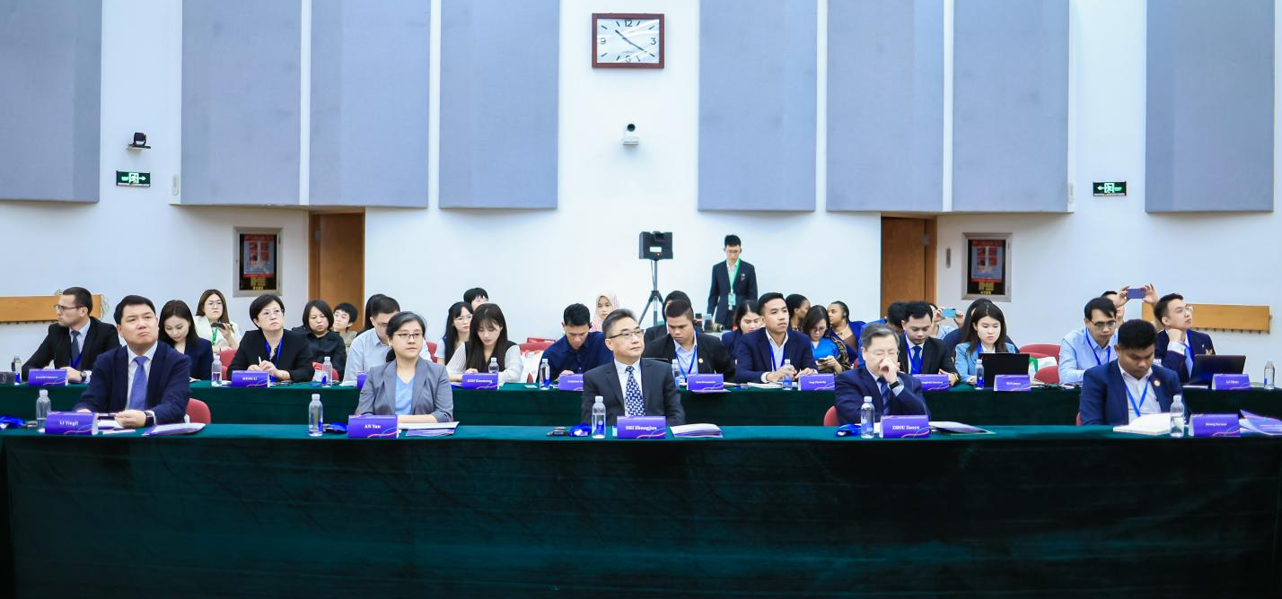
- Session II: Best practices in vocational education and adult education
Moderator: Mr. Suong Saruon, Head of Public Relations and Partnership, SEAMEO TED
Speakers:
- Cambodia: Mr. Hem Suntrakwadh, Acting Dean of Faculty of Science and technology, Svay Rieng University
- China: Mr. TONG Wuzhou, Principal of the Adult Secondary Cultural and Technical School of Dajiahe Town, Ninghai County, Zhejiang Province
- China: Mr. XU Zuping, Principal of Xikou Town Adult Cultural and Technical School, Fenghua District, Ningbo, Zhejiang Province
- Lao PDR: Mr. Sengaloun Boutsady, Deputy Director General, Department of Non-Formal Education, Ministry of Education and Sport
- Malaysia: Ms. Nur Azureen Binti Jaafar, Director, Hulu Selangor Community College
- The Philippines: Dr. Racidon P. Bernarte, University Professor/Managing Director, Holy Trinity University /Asia-Pacific Consortium of Researchers and Educators
- The Philippines: Ms. Rita R. Obsequio, Vocational School Superintendent, Camarines Sur Institute of Fisheries and Marine Sciences (CASIFMAS), TESDA Region V
- Thailand: Miss Phimpicha Poonprasit, Deputy Director of Nonghan Industrial and Community Education College, Office of Vocational Education Commission, Ministry of Education, Thailand
- Vietnam: Dr.Nguyen Van Trang, Vice Dean, Faculty of Vehicle and Energy Engineering, Ho Chi Minh City University of Technology and Education (HCMUTE)
Key Takeaway of China-ASEAN TVET Policymaker Workshop Session II on Transforming Learning for Sustainable Rural Development
- Lifelong Learning International Frameworks includes many actions and strategies to be considered. These are Skills for Green Transitions, Inclusive Training, Career Guidance, Digitalization of Training and Learning Centers, Work-Based Learning and apprenticeship, skills anticipation, Governance System and Policy and Finance and So on.
- Collaboration and systematic development in Lifelong Learning need more active and comprehensive roles of all stakeholders from policy level to implementation level including community centers, schools and beneficiaries.
- Village/farming classroom play crucial roles in the new ways of improving learning of students through practical demonstrations and field activities, agricultural technologies, community or villager engagement and government support and other resources.
- Industrial-education linkage in integration in the skills training and market orientation are also important factor for lifelong learning.
- Community Learning is the heart of lifelong learning development. Therefore, there is more need for a good system to activate the roles of target groups (students school leaders, and learners, industrial workers, professional executive and manager) and supporting groups. Strong partnership and wide range of academic programs relevant to community needs and responsive to the current market trend are very important.
- Lifelong Learning with skills development can help improve social and economic development.
- The roles of nation-wide learning centers at the community level enable to decentralize better adult learning and community education development. Therefore, it needs more attention to push community engagement, serviced-learning, and public-private partnership on learning community center development
- It is very important to considered community-center to promote learning programs. Therefore, industrial-education linkage and partnership on curriculum innovation and digital technology enable to improve rural education and adult learning and skill development
- Skills Certification and promoting income generation during studies are lesson learnt in promoting skills development
- Improving accessibility and equity in technology in education need more availability of infrastructure and M&E system
- Art is also playing an important role in supporting education especially for rural education development
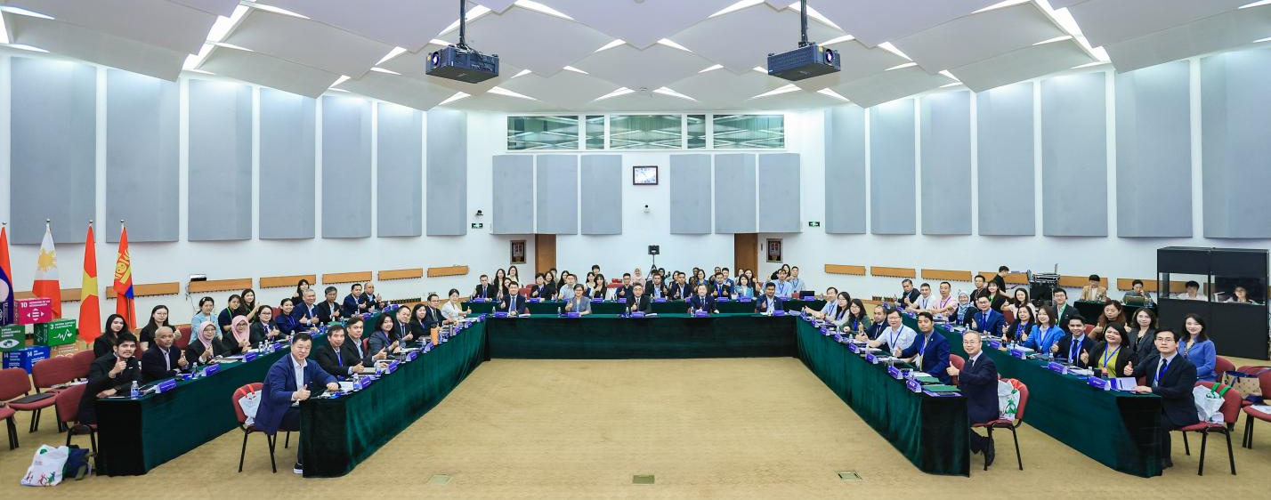
- Lifelong Learning must not stop when have a degree. It should be incorporate into a good learning system.

- Industrial, Educational Investigation and Cultural Visit

The Open University of China (OUC)

Overview of OUC: The Open University of China (OUC) is a modern higher education institution directly supervised by China’s Ministry of Education (MOE). Committed to promoting lifelong learning, OUC provides open education nationwide, leveraging modern information technology under the "Internet Plus" initiative. It offers degree and non-degree programs, coordinates the national open education system, and serves as a public service platform for lifelong learning. OUC’s mission aligns with the principle that "Everyone can study anytime, anywhere."

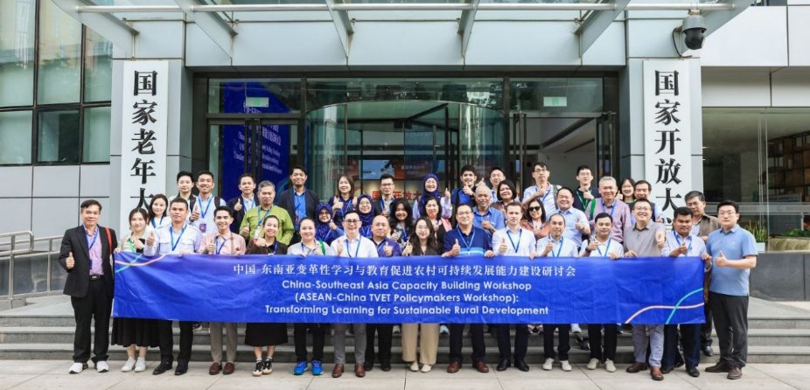
Visit Highlights: Distinguished participants toured key facilities, including a computer lab, virtual teaching classroom, experiential college, and the ASEAN-China Cooperation Centre. Later, they attended an institutional introduction session led by an acting dean, who highlighted advancements in online teaching and learning. Notably, most students study remotely from across China. OUC operates one headquarters, 44 provincial branches, and 2,692 learning centers.

Cuihu Science & Technology Backyard (STB)
Overview of STB: The Science and Technology Backyard (STB) is a rural hub bridging knowledge and practice to drive technological innovation. Its framework supports sustainable intensification for smallholder farmers by:
- Developing demand-driven technologies,
- Disseminating innovations through mixed top-down and bottom-up approaches.

This model offers insights for agricultural transformation in China and other developing nations.
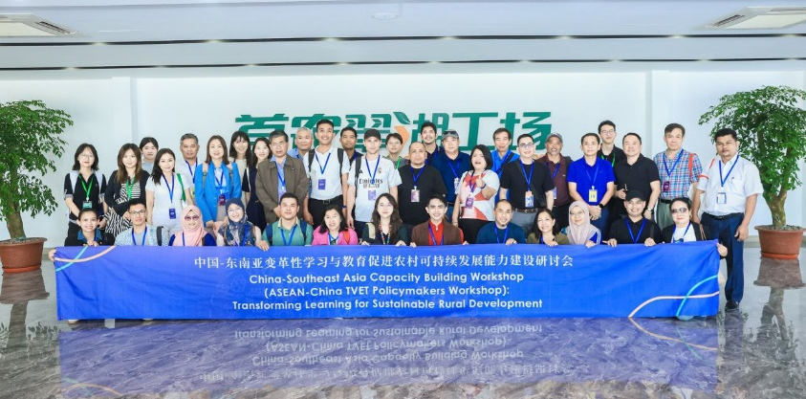
Visit Highlights: Participants were warmly welcomed by Dr. Tian Yongqiang and his team, who guided them through planting areas, a seedling production base, a vegetable-fruit washing facility, and a packaging center. Dr. Tian also introduced STB’s international collaborations with Laos, Australia, and European countries, noting its top-ranked reputation in Chinese agriculture.

Beijing Changping Vocational School
Overview: Founded in 1958, the school offers 41 majors, including aviation services, automotive maintenance, landscaping, drone technology, and preschool education. With 334 faculty and 3,000+ students, it operates across four campuses, one park, and a branch school. Recognized as a national model for vocational education, it has won awards such as "National Advanced Collective in Education."

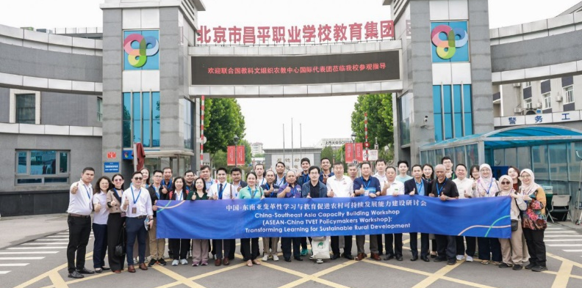
Visit Highlights: Participants received a warm welcome and learned about the school’s achievements in agricultural education. After a 40-minute drive, they explored a second campus, featuring training bases for automotive, marketing, hospitality, food service, and skiing—all set in a spacious, pristine environment.

Beijing HUATEC Information Technology Co., Ltd.
Overview: Founded in 2004, HUATEC specializes in educational technology and holds 29 patents. Headquartered in Beijing, it drives innovation in digitization and ICT.

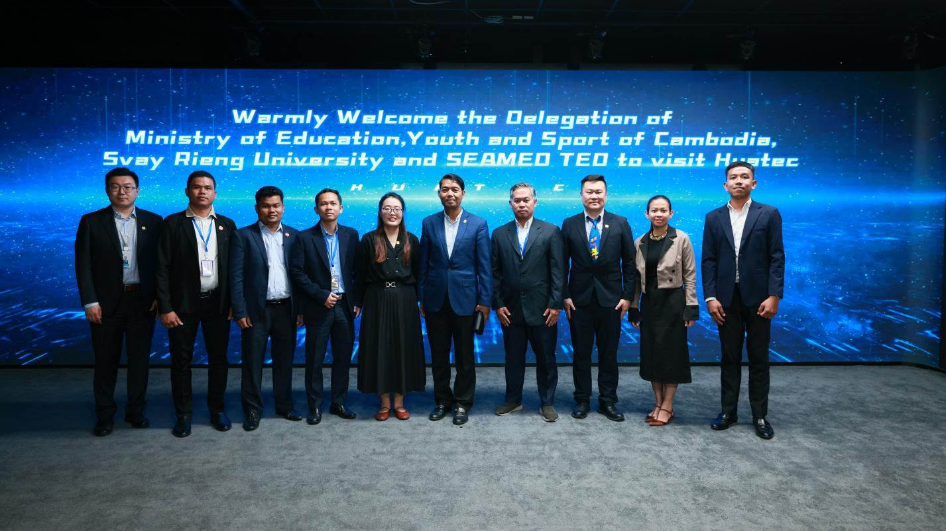
Visit Highlights: Delegates from MoEYS, SEAMEO TED, and the University of Svay Rieng were greeted by Mr. Tony Sun (Director of International Education Planning) and colleagues. They toured the Digitization Center and Intelligent Manufacturing/ICT Experience Center, followed by a meeting. HUATEC highlighted its Jingshi Project, a collaboration with NTTI, the University of Svay Rieng, and ASEAN partners. Mr. Sun proposed expanding cooperation via MoEYS and SEAMEO TED, urging swift MoU/MoA signings and project implementation.

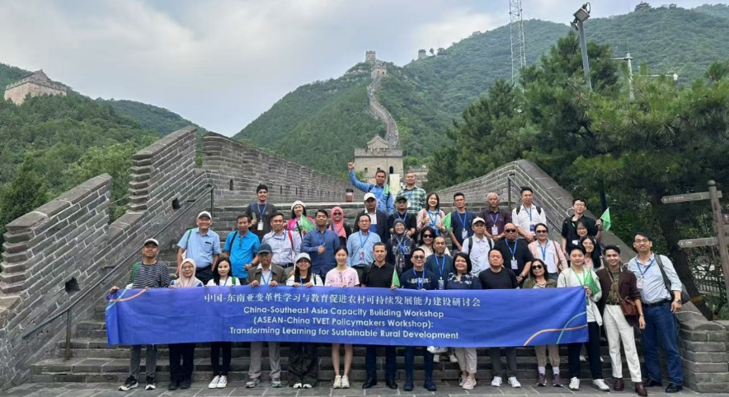
The Great Wall (Juyongguan Pass)
Participants embraced a physical challenge, hiking to the highest point of Juyongguan Pass for hours. At the summit, they enjoyed breathtaking views, fresh air, and a well-deserved respite from stress.

- Key Lessons Learned

- Vocational Education as a Pillar of Rural Revitalization
  - Across China and Southeast Asia, Technical and Vocational Education and Training (TVET) is being leveraged not only for employment but also as a strategic tool for rural transformation, environmental sustainability, and digital inclusion.
- Policy Integration is Essential
  - Strong government leadership and cross-sector policy integration are necessary for scaling up lifelong learning and rural education. China's national strategies and ASEAN countries’ reforms reflect an increasing alignment with SDG 4 and the 2030 Agenda.
- Community-Based and Context-Driven Learning Models Work
  - Models like China's “village/farming classrooms” and localized training in Cambodia, Lao PDR, and Vietnam demonstrate that education tailored to local economies and needs leads to stronger engagement and outcomes.
- Digital and Green Skills Are the Future
  - The growing emphasis on green skills, digital literacy, and Industry 4.0 (e.g., AI, IoT, sustainability) highlights the urgency of curriculum modernization and workforce transformation in rural and underserved communities.
- Public-Private Partnerships Multiply Impact
  - Case studies from China (e.g., Ningbo’s integrated network, HUATEC’s digital labs) and Malaysia (TVET-Industry Council) stress the role of private sector collaboration in skills development, innovation, and technology access.
- Inclusivity and Equity Must Remain Central
  - Emphasis on inclusive education for marginalized, gender-sensitive policies (e.g., Myanmar), and flexible learning pathways (e.g., Philippines’ ALS) underlines the need for systems that leave no one behind.

- Lifelong Learning Requires Systemic Structures
  - The importance of institutionalizing lifelong learning through recognition of prior learning (RPL), flexible pathways, and decentralized community learning centers is recognized across all participating countries.

- Conclusion
The China–Southeast Asia Capacity Building Workshop on Transforming Learning for Sustainable Rural Development was a comprehensive and dynamic platform for knowledge exchange, policy dialogue, and partnership building among educational leaders and practitioners from across ASEAN and China. Held in Beijing from 16 to 19 June 2025, the event effectively highlighted shared challenges and diverse solutions in using transformative education for rural development.
Participants engaged in a series of thematic discussions, country presentations, and institutional visits, showcasing innovative models and strategies for TVET and lifelong learning. From China's dual learning system and digital empowerment campaigns to ASEAN nations’ policy reforms and community-centered learning hubs, the workshop revealed a collective shift towards more inclusive, sustainable, and future-oriented education systems.
Through immersive study tours at institutions such as the Open University of China, the Cuihu Science and Technology Backyard, and vocational schools and enterprises, participants saw firsthand how digital technologies, green skills, and industry linkages are reshaping rural education and labor markets.
The workshop concluded with a strong consensus on the importance of cross-border collaboration, policy alignment, and local empowerment in advancing the rural education agenda. It underscored that rural transformation is no longer just about infrastructure and agriculture—it is fundamentally about people, their skills, and their ability to adapt, innovate, and thrive in a rapidly changing world.

