Report on
International Youth Talk on “Exploring Cultural Heritage and Innovation in Architecture and Youth Voice: How is AI Empowering Future Cities”
June 25-27, 2025 (Virtually)

The two sessions of International Youth Talk, jointly organized by SEAMEO TED, CATECP and Go Study Global Education in June 2025, were successfully held on June 25 and June 27, 2024. The events featured online presentations by youth representatives from universities across multiple countries including Vietnam, Cambodia, Laos, Malaysia, Thailand, Indonesia, Brunei, Russia, and the Philippines accommodating 138 participants. Centered around the themes of “Exploring Cultural Heritage and Innovation in Architecture” and “Youth Voice: How is AI Empowering Future Cities?”, the youth showcased fresh perspectives with a global vision, sparking creative and cross-cultural exchanges.

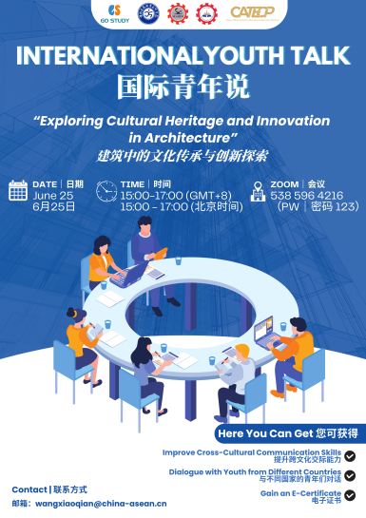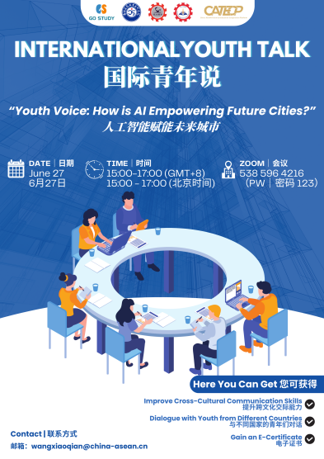

The opening remarks were given by Mr. Khat Prumsochetra, Deputy Director of SEAMEO TED. He emphasized the vital role of youth in regional cooperation as leaders of innovation and cultural exchange. He highlighted the importance of nurturing young talents with global vision and multicultural skills to deepen international education and promote sustainable development. He expressed hope that the series would offer a platform for youth to connect, learn, and contribute to the region’s future.

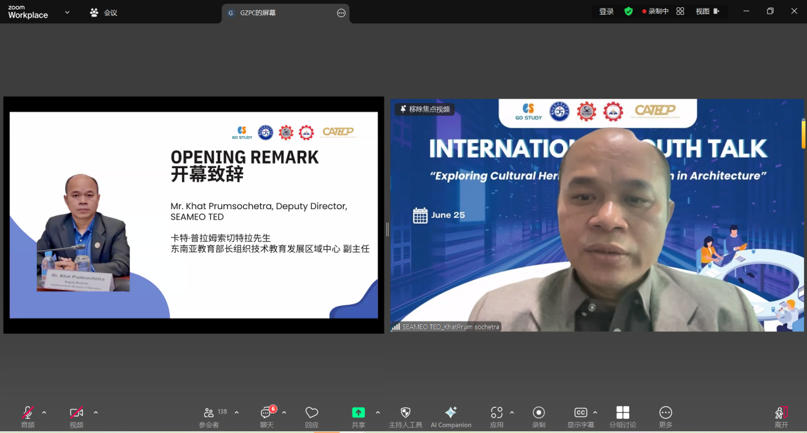

On June 25, the International Youth Talk “Exploring Cultural Heritage and Innovation in Architecture”—featured youth representatives from universities across multiple countries, who shared insightful presentations on the protection of world heritage sites and the preservation of architectural culture in their respective countries.

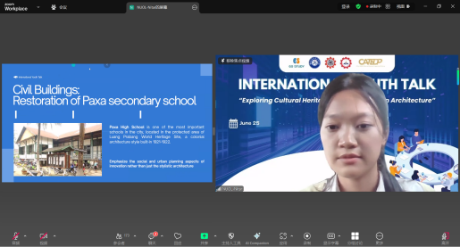
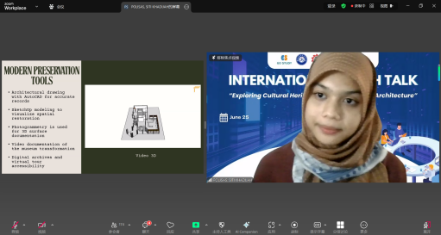

The speaker from Ho Chi Minh City University of Technology, Vietnam, presented an in-depth study of the Imperial City of Hue, Vietnam’s first UNESCO World Cultural Heritage site, focusing on its distinctive “double-ridge beam” architectural structure. Through detailed historical document analysis and on-site surveys, the team systematically explained Hue’s strategic layout within its military defense system and how its architectural style blends aesthetic values with environmental design adapted to the tropical monsoon climate. The research further highlighted the Imperial City’s exemplary role in preserving traditional culture while implementing modern heritage management, offering valuable references for cultural heritage protection in Southeast Asia.

Representatives from the Institute of Technology of Cambodia centered their presentation on four UNESCO World Heritage sites, including Angkor Wat, proposing a comprehensive conservation framework encompassing “historical heritage, religious architecture, colonial heritage, and New Khmer architecture.” The team detailed how advanced technologies such as remote sensing, Geographic Information Systems (GIS), and digital twin technologies are applied for precise protection and management of stone architectural sites. This study not only deepened the understanding of Cambodia’s multi-layered cultural heritage values but also provided innovative ideas for applying modern technology in cultural relic preservation.

The speaker from the National University of Laos focused on the protection and adaptive reuse of buildings in Luang Prabang, showcasing the fusion of colonial architectural history and traditional Lao styles. The team highlighted restoration projects of temples and school renovations, emphasizing the principle of “restoring as it was,” which maintains the historical appearance of buildings while meeting modern functional needs. These experiences offer practical references for cultural heritage preservation in Luang Prabang and the wider region.

The student from Politeknik Sultan Haji Ahmad Shah, Malaysia, used the Sungai Lembing Museum as a case study. Combining digital modeling and historical archives, they systematically analyzed the structural features and cultural significance of this colonial-era building. The team focused on how adaptive reuse strategies have enabled the successful transformation of the building into a modern museum with both cultural exhibition and educational functions, highlighting the balance between heritage conservation and contemporary demands, and demonstrating the ongoing vitality of cultural heritage in modern society.

The international student speaker from Guizhou Polytechnic of Construction, China, explored the similarities and differences between Cambodian traditional architecture and Chinese traditional architecture in terms of structure and decoration. The presentation emphasized the unique stone carving techniques and roof structures in Angkorian architecture, compared with China’s traditional timber framing systems. It highlighted the differences and integration in material selection, climate adaptation, and cultural symbolism, showcasing cross-cultural reflections and practices in architectural heritage preservation.

The speaker from King Mongkut’s Institute of Technology Ladkrabang, Thailand, addressed cutting-edge topics in digital-era cultural heritage preservation. They explored the application of virtual reality (VR), augmented reality (AR), and artificial intelligence (AI)-based storytelling in cultural transmission. Emphasizing that technology should go beyond mere form to support the continuation and revitalization of cultural spirit, the team advocated for a protection model combining “immersive experience” and “community co-creation,” providing innovative ideas and practical pathways for the future development of digital humanities.

On June 27, the International Youth Talk “Youth Voice: How is AI Empowering Future Cities?”—brought together youth representatives from universities across multiple countries for in-depth discussions on how AI is shaping smarter, safer, and more sustainable urban futures.
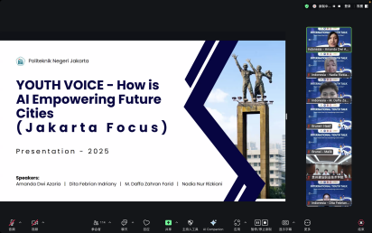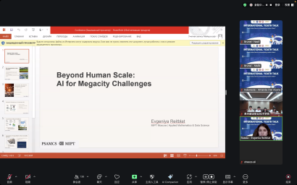
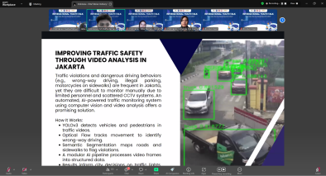

The team from Politeknik Negeri Jakarta, Indonesia, showcased multiple local innovative cases of AI applications in urban smart transformation, including the EcoBin smart waste sorting system, facial recognition at airports, traffic violation detection, and priority seat monitoring on trains. The students highlighted that with Indonesia’s urbanization rate expected to reach 70% by 2045, AI technologies will be vital tools to enhance urban operational efficiency and residents’ quality of life, and that youth are the key drivers in building smart cities.

Students from University of Santo Tomas, Philippines, began by describing the significance of AI for contemporary youth and then shared perspectives on AI’s interaction with future cities. They emphasized that AI should be human-centered, focusing on public interest and improving quality of life. AI is not merely a technical tool but a strategic resource for sustainable urban development, with synergistic applications in disaster prediction, safety management, and economic growth.

The student team from Guizhou Polytechnic of Construction, China, shared diverse applications of AI technology in urban traffic management and social services. They noted that AI can significantly improve road efficiency and safety through real-time traffic monitoring, intelligent traffic light control, and route planning, thus contributing to creating a safer and more orderly urban mobility environment.

The students from Laksamana College of Business, Brunei, systematically reviewed AI applications across intelligent transportation, urban security, energy management, and healthcare services. Using successful examples from cities like Singapore, Barcelona, and Dubai, they stressed the importance of responsible AI deployment to achieve inclusive and sustainable urban development.

Student from Moscow Institute of Physics and Technology (MIPT), Russia, discussed cutting-edge challenges faced by megacities such as climate uncertainty, technological changes, and urban security. They proposed integrated optimization of traffic, energy, and climate sytems through cross-sector data platforms and AI modeling to tackle future urban uncertainties and introduced the core concepts of Russia’s “2025 City AI Development Plan.”

Representatives from Capiz State University, Philippines, addressed data privacy and security concerns in digital city development. Highlighting the relevance of the Personal Data Protection Act, the speaker emphasized that as AI technologies become widespread, risks of data misuse and privacy breaches increase. They called on youth to improve digital literacy and enhance cybersecurity awareness and self-protection, aiming to prevent privacy risks at their source in the application of new technologies.

