Observation Workshop Report
on
Digital Transformation and TVET Platform
Batam City, Indonesia, July 13-16, 2025

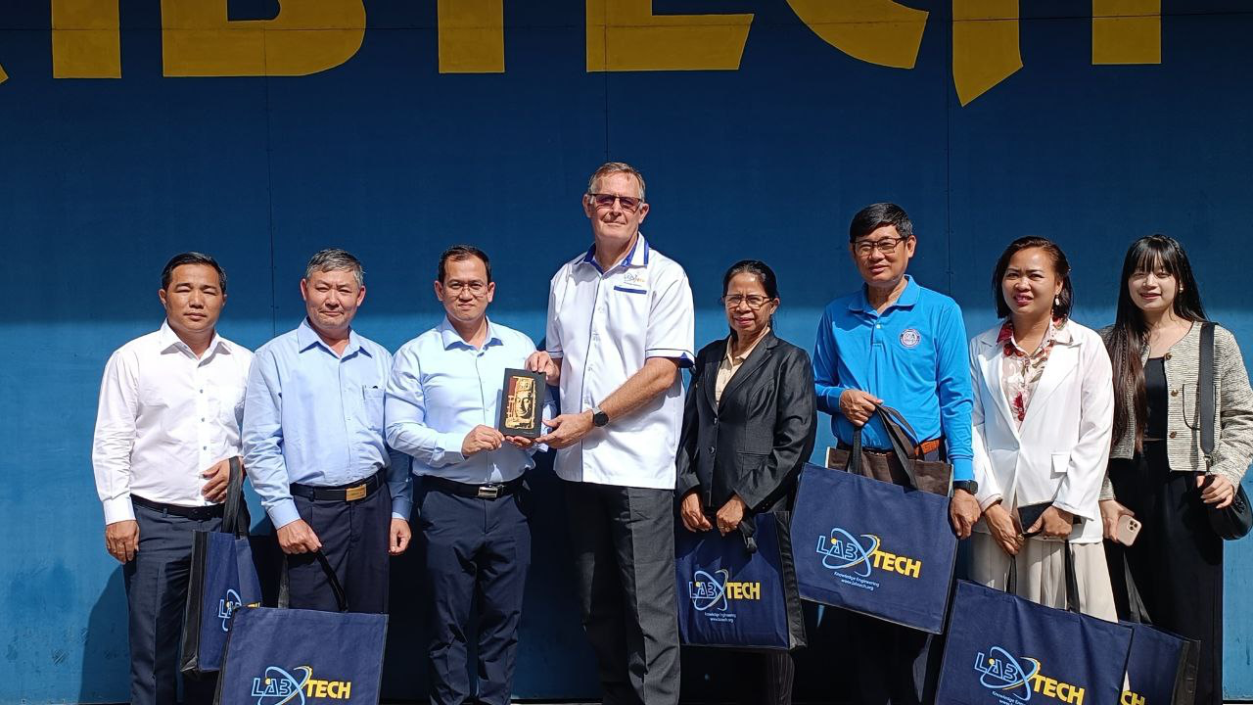
(Gift Exchanges)

Batam City: On July 13-16, 2025, a delegation of 05 Cambodian general and technical high school management led by Dr. Songheang Ai, director of SEAMEO TED joined the observation workshop on digital transformation and TVET platform, co-organized by Labtech International Ltd and SEAMEO TED at Batam factory in Batam City, Indonesia for purposes to benchmark the digital TVET system and framework for Cambodian TVET system practices, to seek cooperation opportunities between general and technical high schools and Labtech International Ltd, and to enhance cooperation on TVET field between SEAMEO TED and Labtech International Ltd.

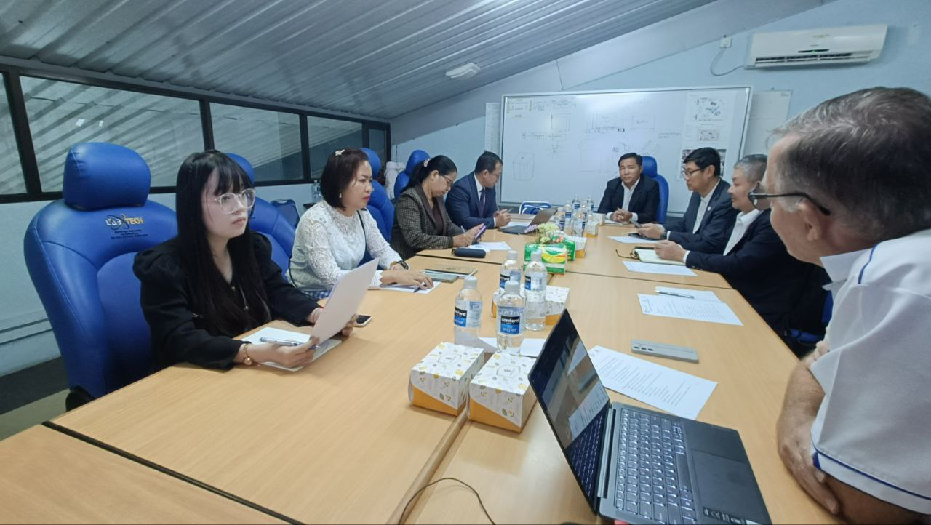
(Participants Listening to Mr. Bradley’s Presentation)

During the workshop, Mr. Bradley Ker, director of Digital Programs of Labtech International Ltd, presented the digital TVET system and framework, smart classrooms, XR simulations, Digital Twin Systems, etc. He also shared the experience of teacher training programs and Labtech Total Solutions. The delegation observed the demonstration of digital devices and equipment of the factory.

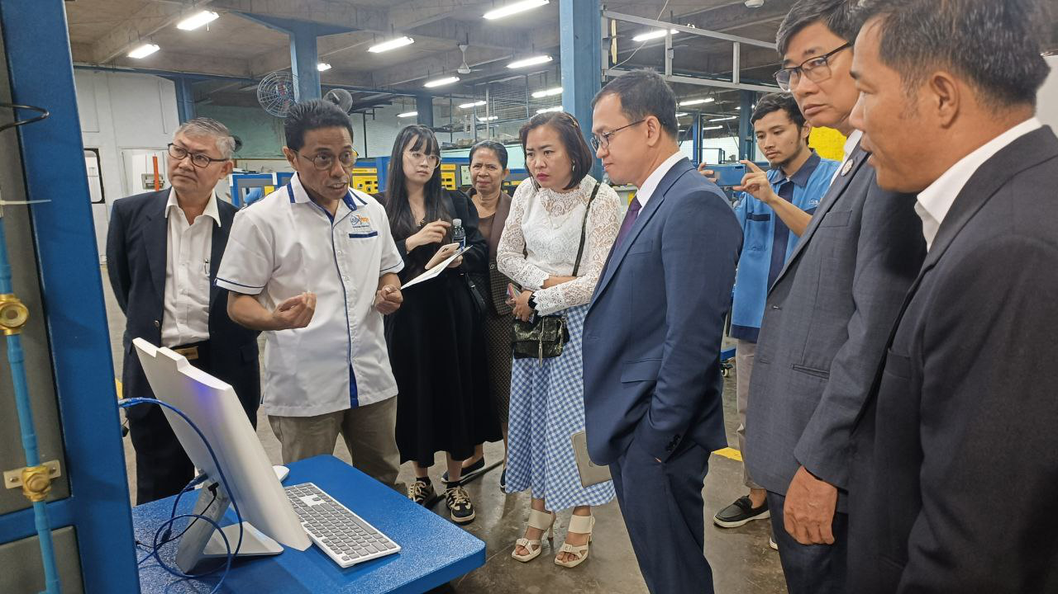
(Participants Observing the Digital Twin System)

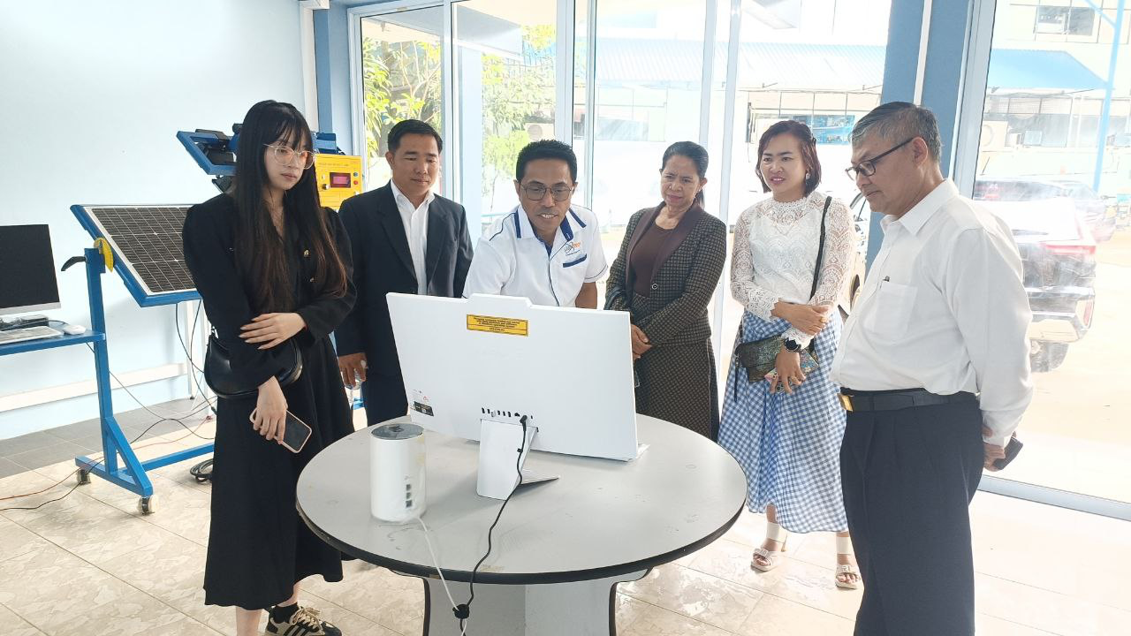
(Participants Listening to Demonstration of Technician)

All concerned parties (Labtech International Ltd, General and Technical High School Management) have agreed with some key highlights as follows:
- Labtech International Ltd will provide the 3-month complimentary trial logins to all visiting delegates for full access to all subject areas_Automotive, HVAC, Electronical, Electronics, Renewable Energy, etc_within the Labtech TVET LMS platform with the completion of Khmer-language navigation support
- SEAMEO TED, in cooperation with Labtech International Ltd, will co-host a 2-day intensive training course on Immersive Digital TVET Methodologies focusing on Labtech’s Virtual TVET systems for Cambodian TVET teachers from general and technical high schools. After the training course, each participant will receive 6-month free access to Labtech Academy as part of the professional development program. The tentative date and location of the training will be shown by due course
- Labtech International Ltd will offer a 3-month internship program for up to 4 Cambodia TVET teachers at Labtech factor. To be eligible for the intern program, Cambodian TVET teachers should possess Automotive, HVAC, Electrical, Electronics, Renewable Energy, ICT, Smart Agriculture, and Welding and Plumbing. Labtech International Ltd will cover accommodation, meals, and local transportation during the internship period in Batam City. Sending general and technical high schools or intern teachers will cover their own airfares
- SEAMEO TED will explore the opportunity to integrate Mobile Learning Kits of Labtech International Ltd into some projects funded by ADB, WB, ILO, etc. Labtech International Ltd will provide quotation and product catalogues for SEAMEO TED’s consideration in writing the project proposals to relevant partners/donors for financial support
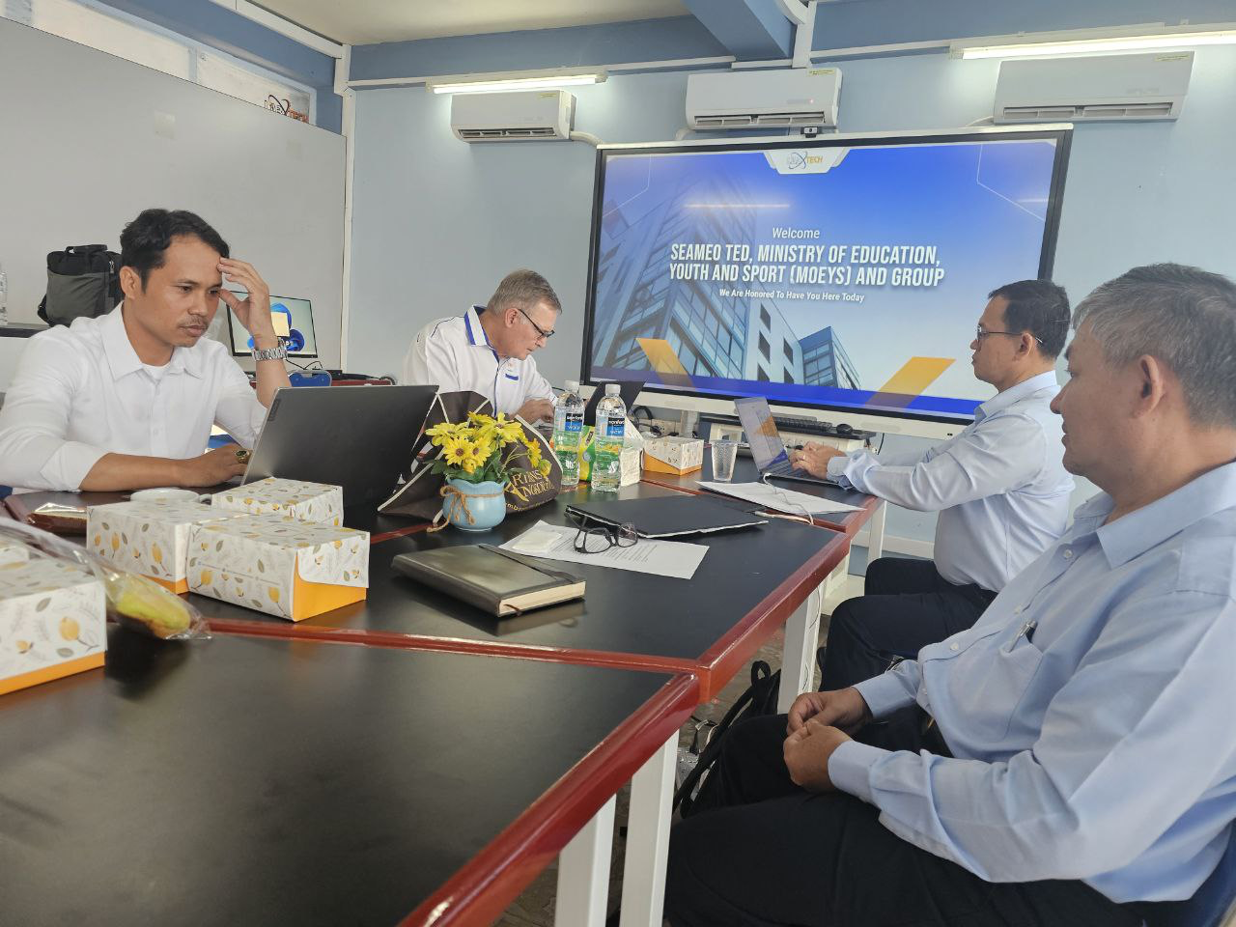
(Discussion on the points of cooperation)

Both parties were committed to working closely in achieving the common points of agreement by appointing Mr. Mara Pho, Head of Technical Education and Training Division of SEAMEO TED and Mr. Bradley Ker, Director of Digital Programs of Labtech International Ltd to be focal points of contact for following-up action. Finally, participants explored Batam City by touring to some tourism attraction sites.

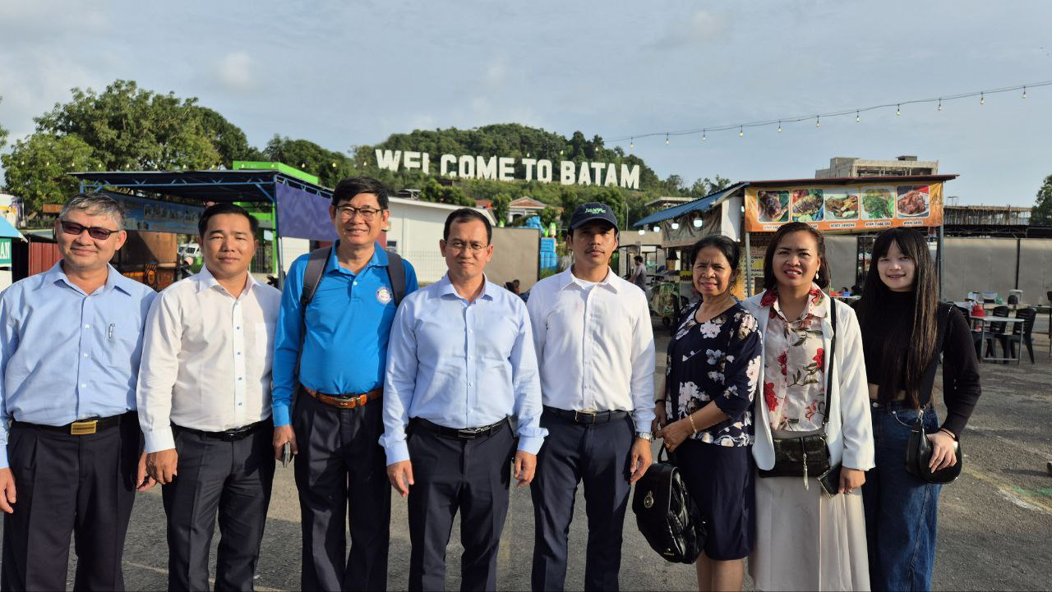
(Participants Exploring the City)

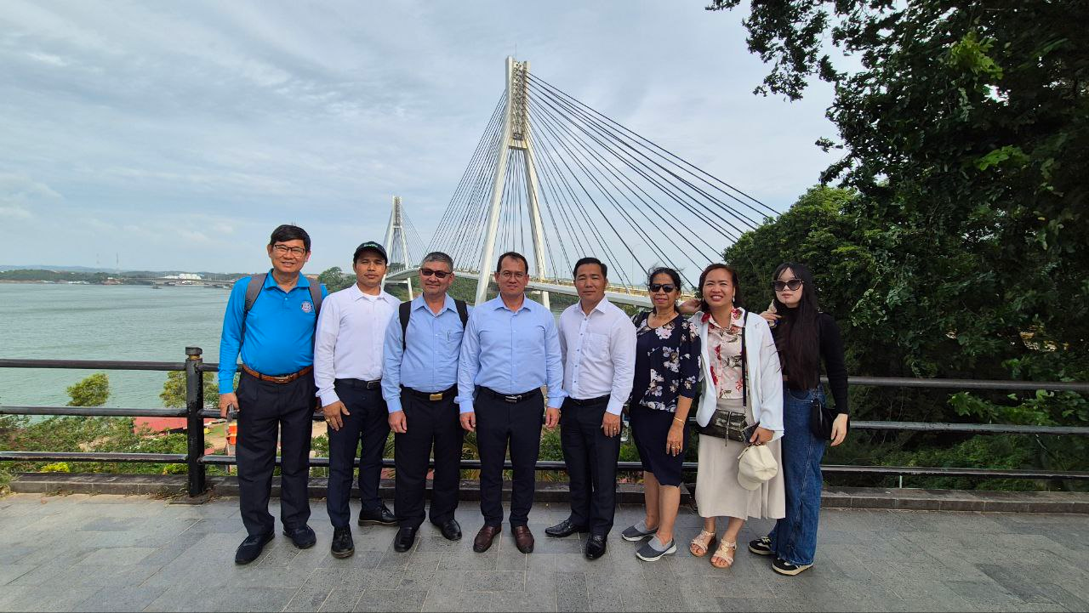
(Participants Visiting the Bridge)

