Report on
International Experts Sharing Meeting “Smart Transportation and Sustainable Urban Development”
23 July 2025

On the afternoon of July 23, 2025, the 6th session of the International Experts Sharing Meeting, hosted by the Southeast Asian Ministers of Education Organization Regional Centre for Technical Education Development (SEAMEO TED) and the China-ASEAN Technical Education Cooperation Platform (CATECP), co-host by Go Global Education, and the International Youth Culture and Education Organization (KEMG), was successfully held online. Themed "Smart Transportation and Sustainable Urban Development," the meeting brought together renowned scholars from Indonesia, Vietnam, and Laos. They engaged in in-depth discussions on topics such as innovations in smart transportation technology, pathways to sustainable urban development, and the relationship between smart transportation and sustainable tourism.

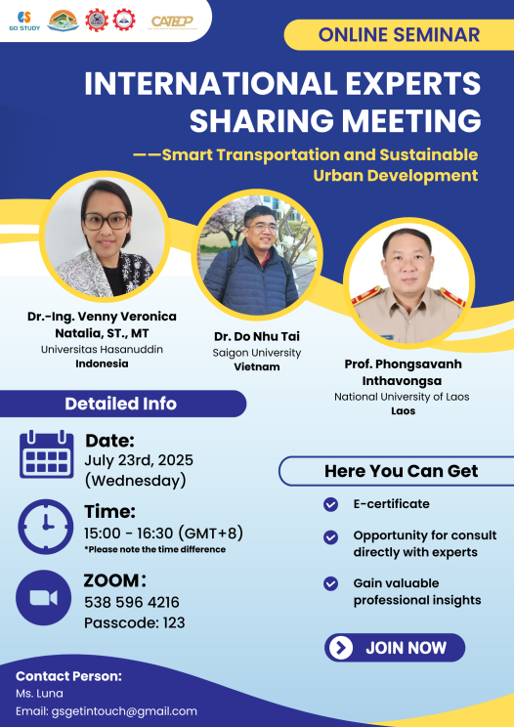

The opening speech was delivered by Mr. Veoum Ravy, vice chief of Research and Development Division, SEAMEO TED. He emphasized that promoting smart transportation and sustainable urban development is a key strategic direction for regional cooperation. He called for deeper collaboration among countries in areas such as policy coordination, technological innovation, and talent development and expressed hope that this meeting would bring together diverse expertise to explore innovative approaches to sustainable urban transportation, providing professional support for building green, low-carbon, smart, and efficient cities.
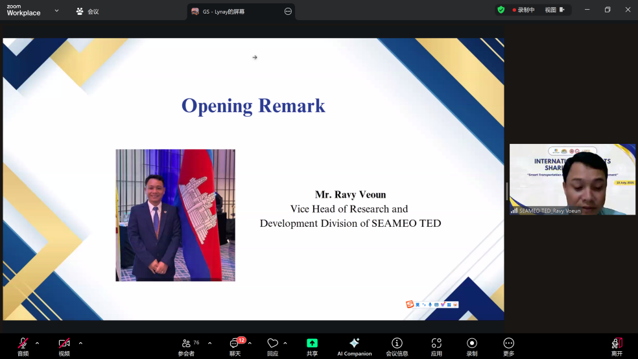

Speaker: Prof. Phongsavanh Inthavongsa
Vice Dean and Professor, Faculty of Logistics and Transportation, National University of Laos
Prof. Phongsavanh analyzed the challenges and policy responses related to sustainable transportation in the Vientiane Capital Region of Laos. Data indicates that the region is experiencing a steady annual growth of 5% in motor vehicle ownership, with mixed traffic flows contributing to an average annual increase of 5.19% in traffic-related fatalities. Meanwhile, public transportation services account for less than 10% of total travel demand. The study focuses on evaluating the implementation of the Vientiane Sustainable Urban Transport Project (VSUTP), which includes the construction of a 12.9 km Bus Rapid Transit (BRT) corridor, the deployment of 40 smart traffic signals, and the redevelopment of non-motorized transport infrastructure. The project adopts a layered governance model that integrates strategies such as roadway expansion with right-of-way reallocation, electronic parking fee systems to enhance fiscal mechanisms, and public behavioral campaigns aimed at promoting modal shifts. Preliminary monitoring suggests a significant improvement in pedestrian accessibility within a 500-meter radius of BRT stations. However, the study also highlights several institutional barriers, including weak enforcement capacity and resistance from private paratransit operators. These findings offer critical policy insights for managing motorization transitions in medium-sized Southeast Asian cities.
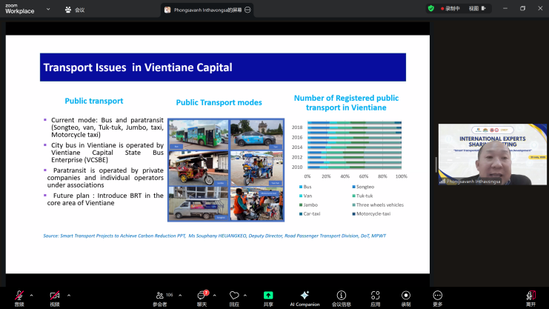

Speaker: Dr. Venny Veronica Natalia
Senior Lecturer, Department of Urban and Regional Planning, Universitas Hasanuddin, Indonesia
Using the case of Makassar City (Kota Makassar), Indonesia, Dr. Venny explored the potential of “Digital Placemaking” in increasing public transportation usage. She pointed out that the local bus system has long struggled with inadequate infrastructure and limited payment options, resulting in low ridership and even the suspension of some routes. To better align with citizens' actual mobility needs, her team conducted surveys and gathered feedback via social media platforms, focusing on key improvement elements such as bus shelters, real-time information systems, and charging facilities. Targeting young students as the primary audience, they launched a digital advocacy campaign under the hashtag #AyoNaikBus (“Let’s Take the Bus”). Dr. Venny emphasized that the project not only enhanced public awareness and acceptance of bus transit but also fostered collaboration between government agencies and private stakeholders. This initiative helped revive several suspended routes, showcasing the practical value of digital tools in public transport governance.
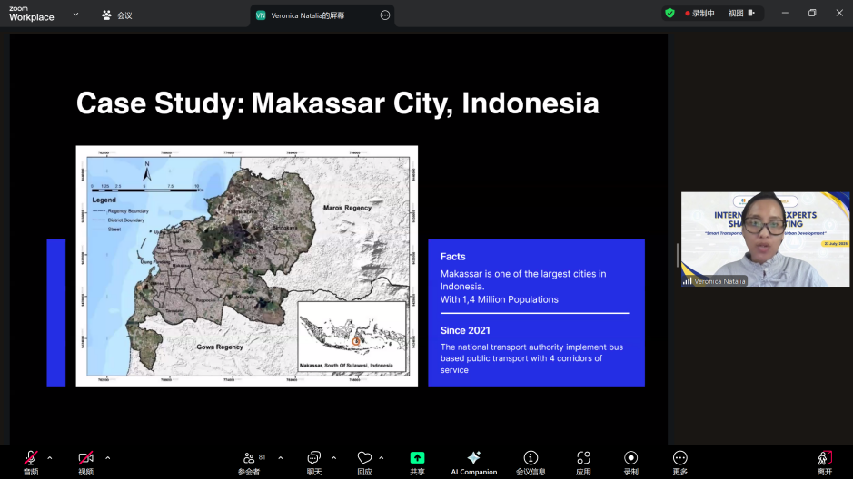

Speaker: Dr. Do Nhu Tai
Senior Lecturer, Faculty of Information Technology, Saigon University, Vietnam
Dr. Do explored the integrated application of generative artificial intelligence (AI) and Internet of Things (IoT) technologies in the context of smart tourism and urban traffic management. He noted that traditional tourist cities commonly face challenges such as environmental overloading, traffic congestion, and insufficient personalization of visitor services. In response, his team developed an intelligent service system combining real-time IoT data collection with generative AI analysis. This system uses a sensor network to monitor crowd density, traffic flow, and environmental indicators, enabling functions such as dynamic route recommendations, intelligent navigation, and multilingual interaction. A pilot application at the Da Nang Museum in Vietnam demonstrated that the system significantly improved the efficiency of visitor flows and overall experience, alleviated peak-period pressure on transportation and infrastructure, and reduced management and operational costs. Dr. Do emphasized the system’s scalability, noting its potential for broader use in urban transport hubs, tourist site traffic dispersion, and the promotion of green mobility. The project showcases the vast potential of next-generation digital technologies in enhancing urban operational efficiency and advancing sustainable development.

