2025 China-ASEAN "Future Architect" Summer Camp Successfully Held in Guiyang
Guiyang: From 22 to 28 July 2025, the 2025 China-ASEAN “Future Architect” Summer Camp was successfully held in Guiyang, Guizhou Province, China, jointly organized by the Southeast Asian Ministers of Education Organization Regional Centre for Technical Education Development (SEAMEO TED), Guizhou Polytechnic of Construction, and Go Study. The event brought together 21 young delegates from nine ASEAN countries—namely the Philippines, Cambodia, Laos, Malaysia, Myanmar, Thailand, Brunei, Indonesia, and Vietnam. The camp aims to inspire youth, strengthen China-ASEAN exchanges, and promote mutual understanding and friendship through architecture as a shared cultural language.
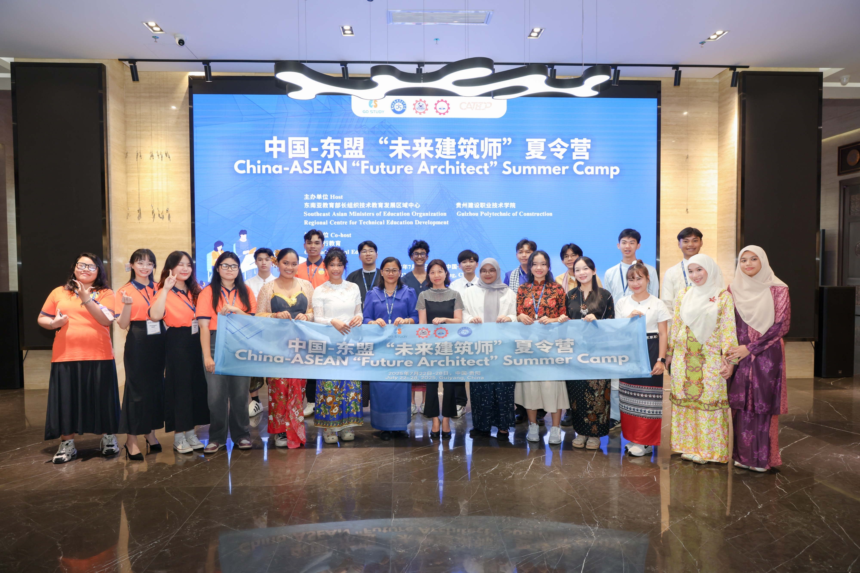
(ASEAN Youth Participating China-ASEAN “Future Architect” Summer Camp Forum)

Focusing on architecture as a cross-cultural theme, the summer camp engaged participants through site visits, intangible cultural heritage experiences, enterprise exchanges, and youth dialogues. These immersive activities offered youth a hands-on perspective into China’s architectural culture and technological advancements, while fostering mutual understanding and cooperation among participants from diverse backgrounds.

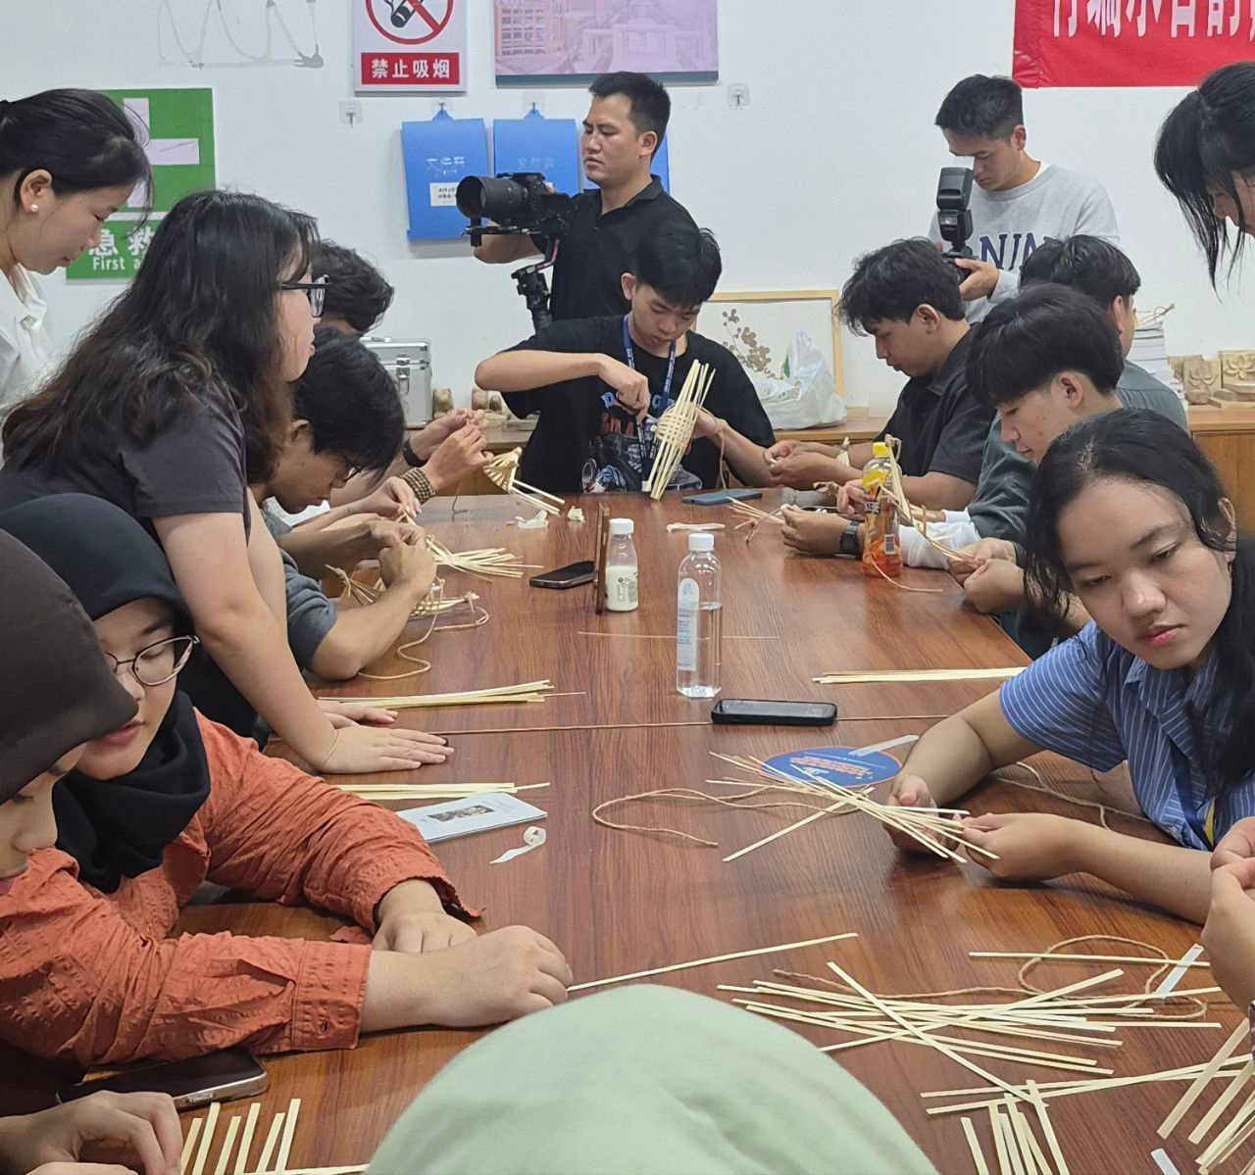
(Bamboo Weaving Activities of ASEAN Youth)

During the camp, the delegates visited Qingyan Ancient Town, a historical and cultural heritage site in Guiyang, where they experienced traditional Chinese craftsmanship such as bamboo weaving and mortise-and-tenon woodworking. They also toured leading companies in China’s architectural technology sector, gaining insights into cutting-edge developments in green construction and smart manufacturing.

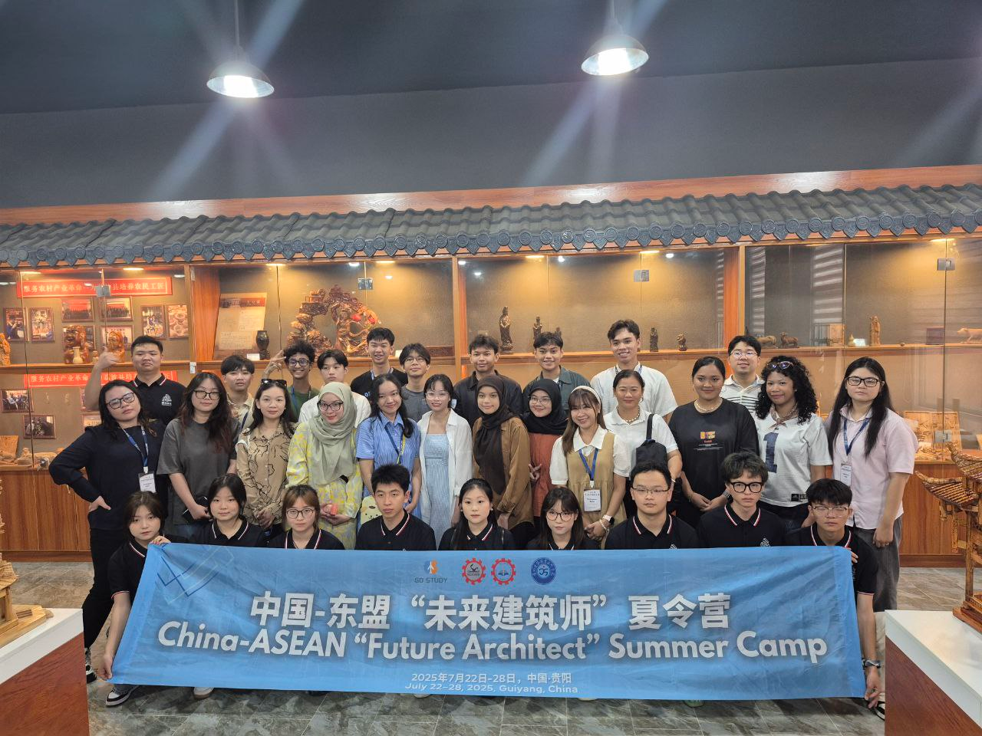
(ASEAN Youth Visiting Qingyan Ancient Town)

At the International Youth Roundtable Talk, youth from different ASEAN nations engaged in in-depth discussions on topics such as sustainable architecture and urban- cultural preservation. They shared iconic architectural examples and construction experiences from their respective countries, highlighting the exchange and integration of perspectives rooted in diverse cultural contexts.

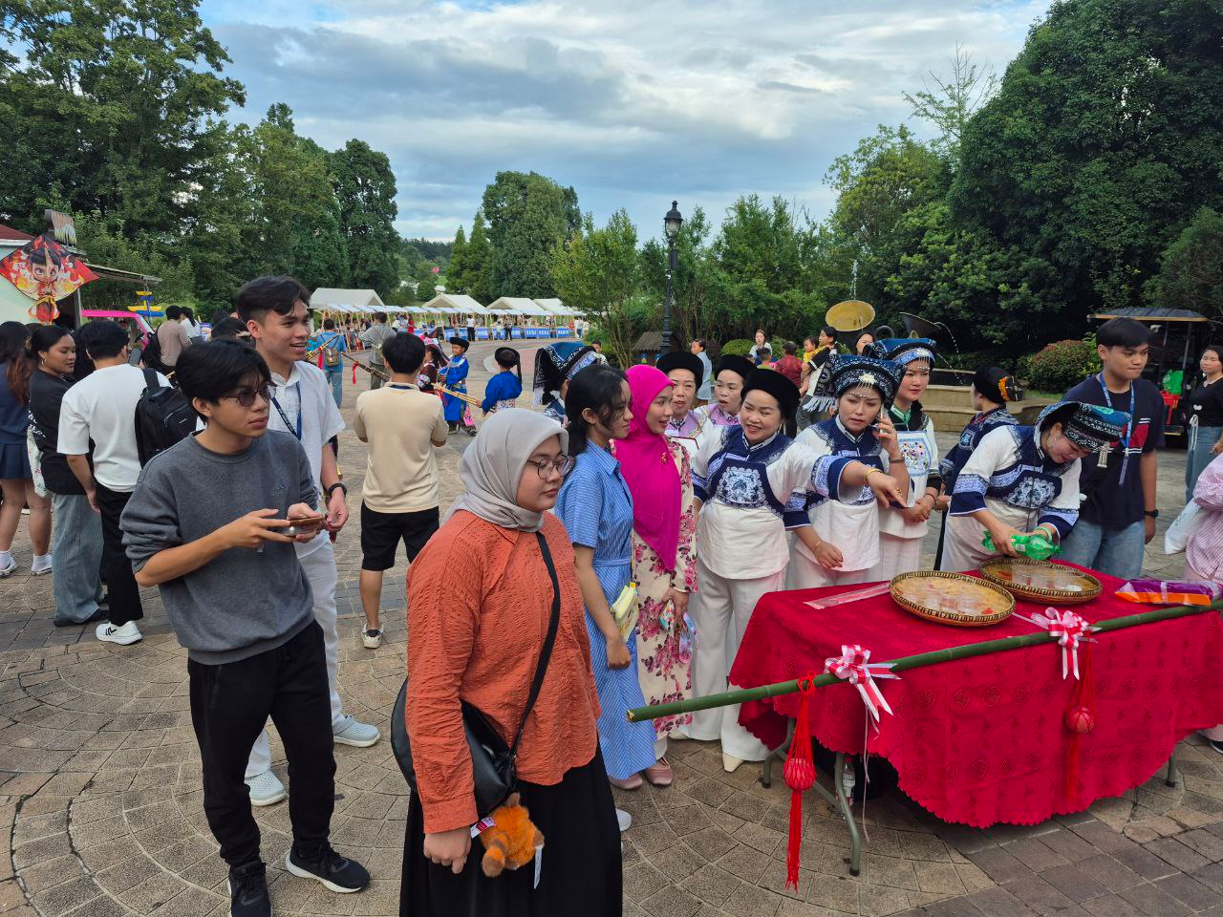
(ASEAN Youth Visiting the Chinese Cultural Performance)

The closing ceremony of the summer camp was held in conjunction with the Forum on Jointly Building a New Ecosystem for China-ASEAN Vocational Education Development: Innovative Integration and Digital Empowerment. During the ceremony, the campers reflected on their experiences through video presentations, showcases, and musical performances—demonstrating their enthusiasm for regional cooperation and shared development.
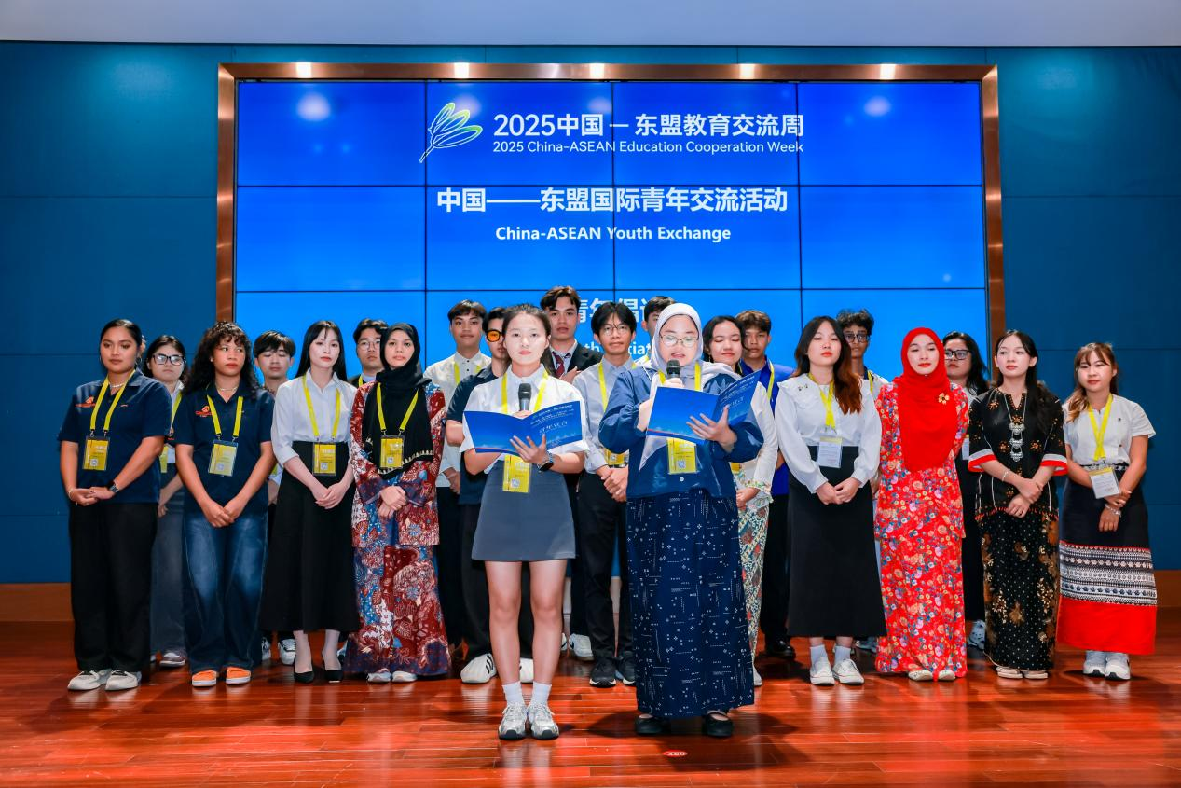
(ASEAN and Chinese Youth Signing Chinese Song During the Forum)

As one of the key organizers, SEAMEO TED remains committed to promoting regional cooperation in vocational education and youth engagement. The successful completion of the summer camp not only provided ASEAN youth with a meaningful opportunity to learn about Chinese culture and advancements in architectural science, but also further strengthened multilateral education collaboration in the region—injecting fresh energy into the building of an open, inclusive, and mutually beneficial educational ecosystem.

