SEAMEO TED Director Dr. Songheang Ai Attends CAECW 2025 Forum in Guiyang, China

Guiyang: On July 27, 2025, the Forum on Jointly Building a New Ecosystem for China-ASEAN Vocational Education Development: Innovative Integration and Digital Empowerment was successfully held in Guiyang. The forum was led by the National Urban Renewal Industry-Education Integration Community and co-organized by Guizhou Polytechnic of Construction along with 10 other vocational institutions.
As one of the key thematic events of the 2025 China-ASEAN Education Cooperation Week (CAECW 2025), the forum brought together education officials, university representatives, industry experts, and youth delegates from ASEAN countries including Brunei, Cambodia, Indonesia, Laos PDR, Malaysia, Myanmar, the Philippines, Thailand, and Vietnam. The participants explored new pathways for regional collaboration and integration of industry and education, focusing on the themes of digital transformation and vocational education reform.
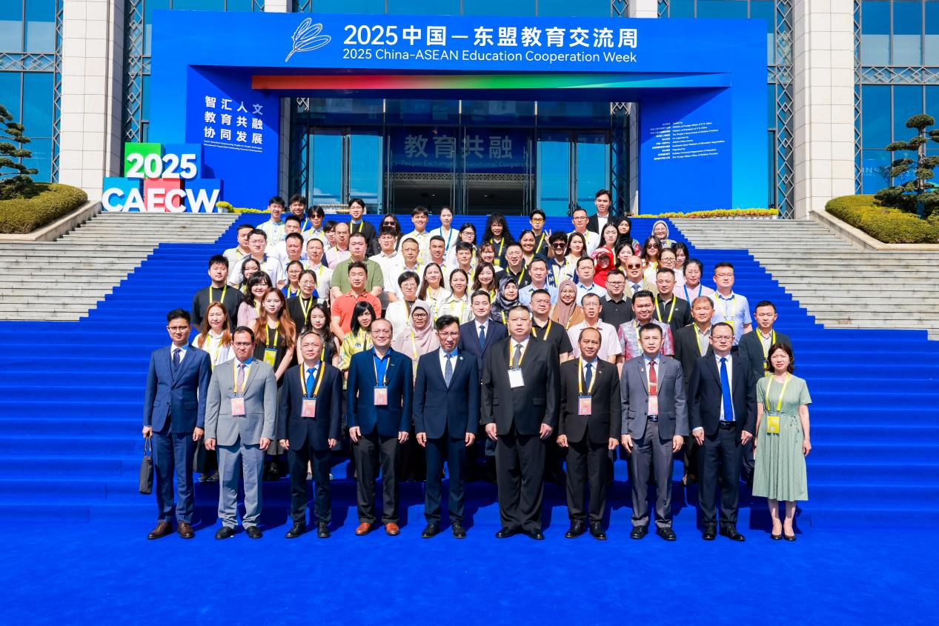
(Group Photo of the Session Participants)

During the Digital Education Achievements Showcase, Dr. Songheang Ai, Director of the Southeast Asian Ministers of Education Organization Regional Centre for Technical Education Development (SEAMEO TED), delivered a keynote presentation titled "SEAMEO TED: Practitioner and Enabler of Collaborative Innovation in China-ASEAN TVET & Industry". Dr. Ai provided a comprehensive overview of the pathways to building an integrated ecosystem for regional industry-education collaboration. He highlighted SEAMEO TED’s strategic practices in promoting the digital transformation of vocational education in the region — including the development of joint curriculum standards, encouraging deeper industry involvement in talent cultivation, and advancing open online courses and digital certification mechanisms.
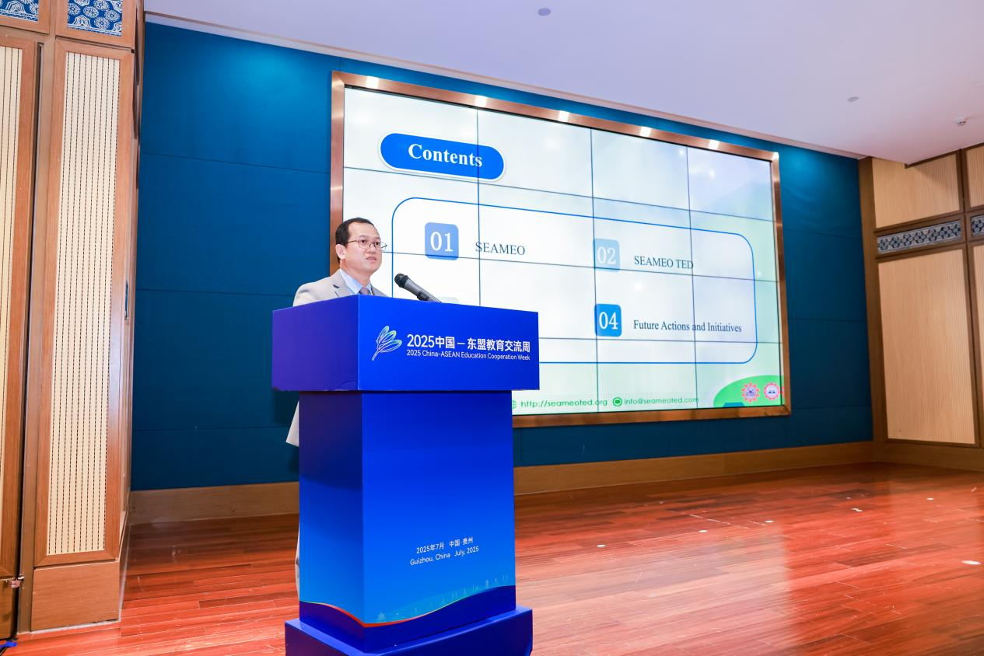
(Dr. Ai’s Presentation)
Among these efforts, the China-ASEAN Technical Education Cooperation Platform (CATECP), spearheaded by SEAMEO TED, plays a crucial role in promoting equitable and inclusive development in regional digital education.
Dr. Ai emphasized that SEAMEO TED will continue to serve as a bridge connecting policymakers, educational institutions, and industry stakeholders to co-create a shared digital education ecosystem, supporting the high-quality development of regional skills systems.
As a regional collaborative platform committed to facilitating the alignment of China-ASEAN vocational standards and implementing course-based practices, CATECP will further advance the systemic interconnection of policies, curricula, resources, and platforms—injecting sustained momentum into high-level vocational education cooperation across the region.

