
Online Seminar International Expert Sharing Meeting on
Cultural Adaptation and Acceptance of New Energy Vehicles in Southeast Asia
8th August 2025

Southeast Asian Ministers of Education Organization Regional Centre for Technical Education Development (SEAMEO TED), China-ASEAN Technical Education Cooperation Platform (CATECP), Go Study Global Education, and International Youth Culture and Education (KEMG) co-organized online Seminar the 7th International Experts Sharing Meeting on "Cultural Adaptation and Acceptance of New Energy Vehicles in Southeast Asia" participated by 135 participants with 56 females. The participants are from fourteen countries consisting of Cambodia, India, Vietnam, Malawi, Philippines, Nigeria, Malaysia, Myanmar, Indonesia, Uganda, Pakistan, Timor-Leste, Brunei Darussalam and the Gambia.

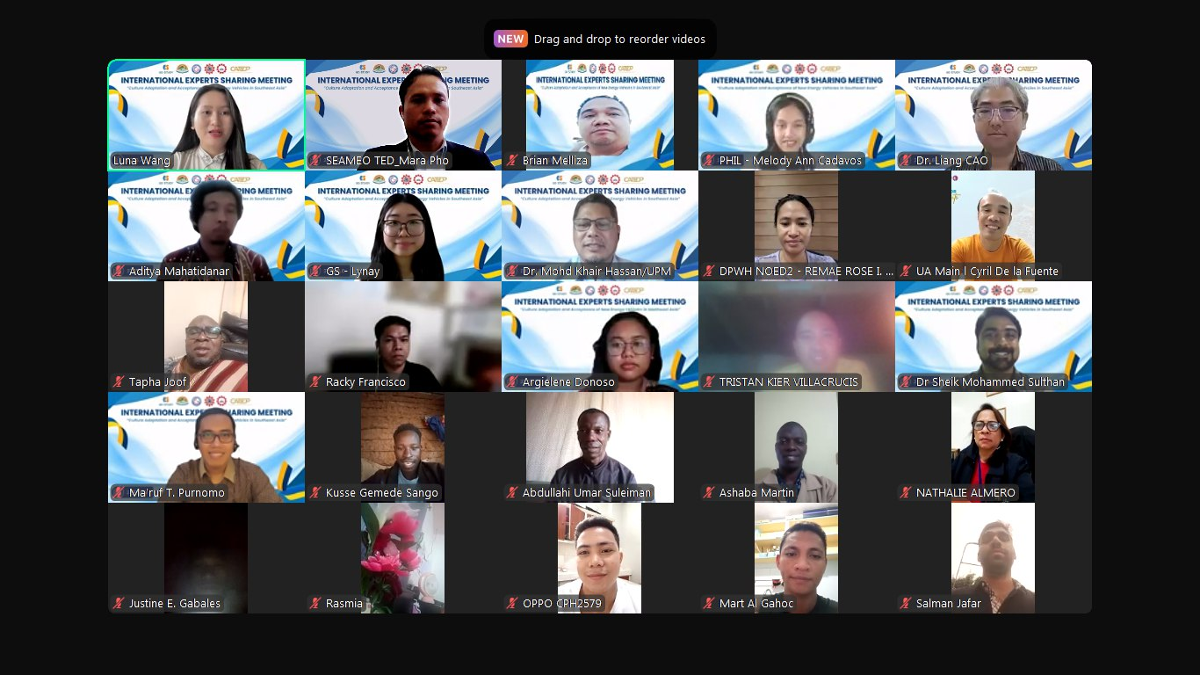
(Participants in the Photo Session on August 8, 2025)

The Seminar was held from 15:00 am to 16:30 am (GMT+8) on August 8, 2025. This Seminar was brought together experts from Indonesia, Malaysia, China, and Brunei to engage in insightful discussions on the development trends of new energy vehicles and their cultural acceptance in the region.

Mr. Mara Pho, Head of the Technical Education and Training Department at the Southeast Asian Ministers of Education Organization Regional Centre for Technical Education Development (SEAMEO TED), delivered the opening remarks for the meeting. Mr. Mara highlighted that promoting new energy vehicles involves not only technological innovation and policies but also complex cultural, social, and consumer factors in Southeast Asia. Understanding these cultural differences is key to localizing and sustainably developing the technology. He expressed hope that the meeting would encourage collaboration to explore cultural influences on technology adoption and help expand acceptance of new energy vehicles in the region.

In the whole session, the experts from Indonesia, Malaysia, China, and Brunei delivered several important topics including Brief Introduction to "Cultural Adaptation and Acceptance of New Energy Vehicles in Southeast Asia":

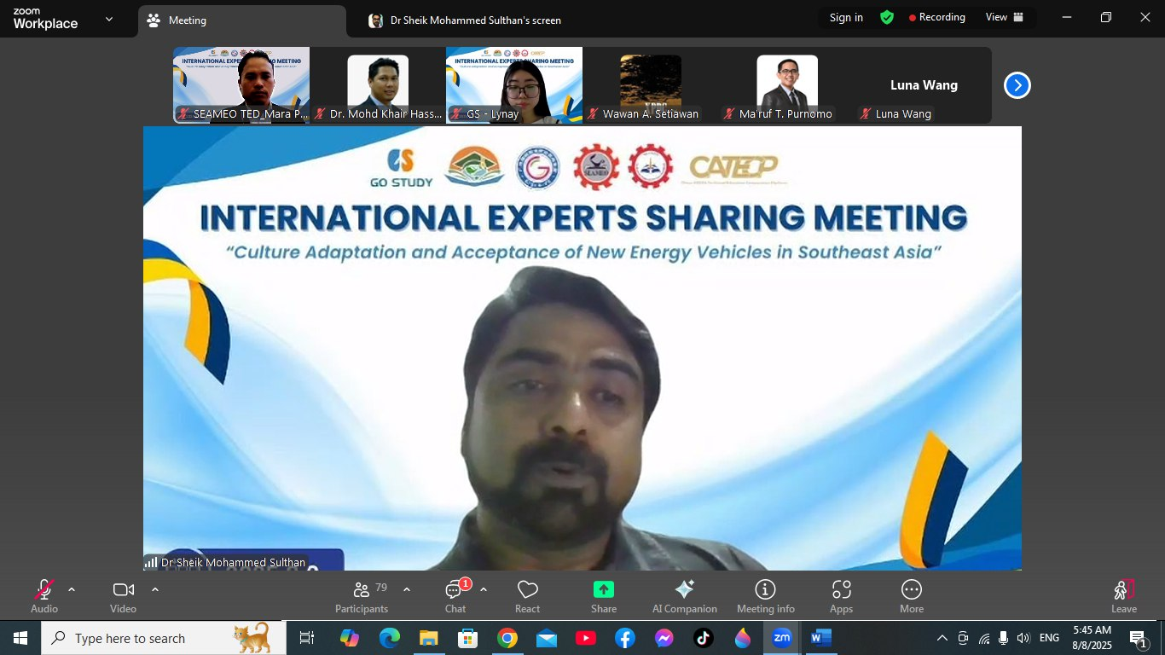
(Sharing session on August 8, 2025)

Speaker: Dr. Sheik Mohammed Sulthan
Associate Professor and Deputy Director of the Transportation Research Centre at Universiti Teknologi Brunei.
Dr. Sheik began by highlighting that transportation is a significant source of greenhouse gas emissions within the context of global climate change. Brunei, with the highest vehicle ownership rate in Southeast Asia, faces substantial pressure in transitioning its transport sector. To address this, Brunei introduced the National Climate Change Policy (BNCCP) in 2020, aiming for electric vehicles (EVs) to account for 60% of new car sales by 2035. Currently, a joint working group for EVs has been established, with plans to develop charging infrastructure and electrify government fleets. Dr. Sheik presented trends in EV and hybrid electric vehicle (HEV) sales and various models, noting that despite growth potential, challenges such as slow policy implementation, high technology costs, and limited public acceptance remain. He recommended developing more practical strategies to enhance promotion efforts and accelerate the transition to green transportation.

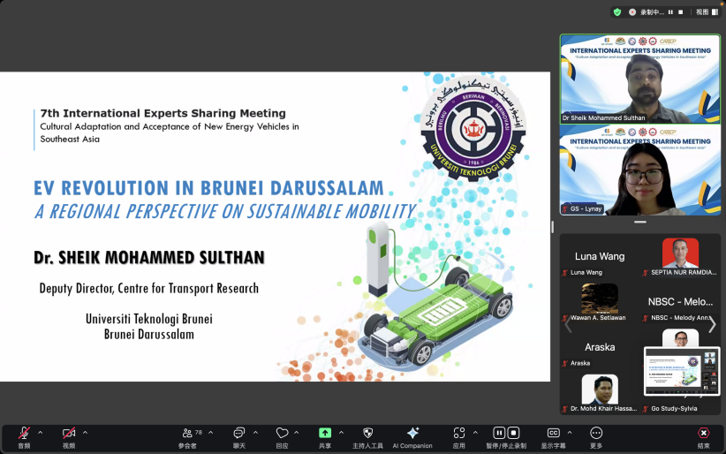

(Sharing session on August 8, 2025)

Speaker:Dr. Aditya Mahatidanar Hidayat
Lecturer, Department of Civil Engineering, Faculty of Engineering, University of Bandar Lampung, Indonesia
Dr. Aditya’s presentation focused on the "Hyperloop," exploring the feasibility and socio-cultural adaptability of new, efficient transportation technologies in the era of clean energy. He began by tracing the development and technical principles of the Hyperloop, linking its origins to 18th-century pneumatic tube systems and comparing its speed and energy consumption with current transportation modes. Powered by electricity, the Hyperloop offers advantages such as high speed, energy efficiency, low carbon emissions, and strong resistance to weather conditions, also opening new possibilities for urban space utilization. However, he objectively addressed challenges including motion sickness at high speeds, difficulties in emergency evacuation, and environmental adaptability. Dr. Aditya believes that while the Hyperloop holds potential as a future sustainable transport mode, its development requires integrated efforts across technology, safety, and cultural acceptance dimensions.

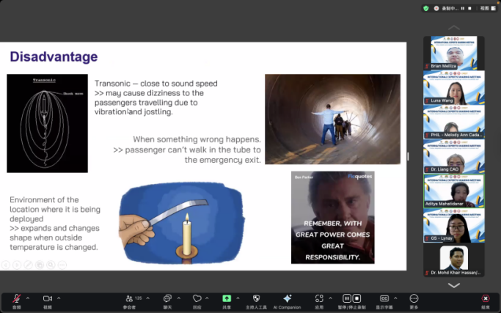
(Sharing session on August 8, 2025)

Speaker:Dr. Mohd Khair Hassan
Associate Professor, Faculty of Electrical Engineering, University of Putra Malaysia
Dr. Hassan’s presentation focused on the issue of retired lithium-ion batteries generated during the rapid adoption of new energy vehicles (NEVs) in Malaysia. As NEVs quickly gain popularity, the number of retired lithium-ion batteries is increasing. Although these batteries have degraded to 70%–80% of their original capacity, they still possess significant energy storage potential. Utilizing these batteries for second-life applications aligns with the principles of the circular economy, extending battery lifespan and improving resource efficiency, while also reflecting the integration of technology and sustainable development. However, Malaysia faces challenges in recycling infrastructure, policy standards, and dependence on imported technologies, which also affect public acceptance of NEVs and related technologies. Dr. Hassan emphasized that establishing a comprehensive battery management system and applying artificial intelligence technologies can enhance safety and reliability, thereby increasing societal trust and acceptance of NEVs and promoting their cultural adaptation and widespread use in Southeast Asia.
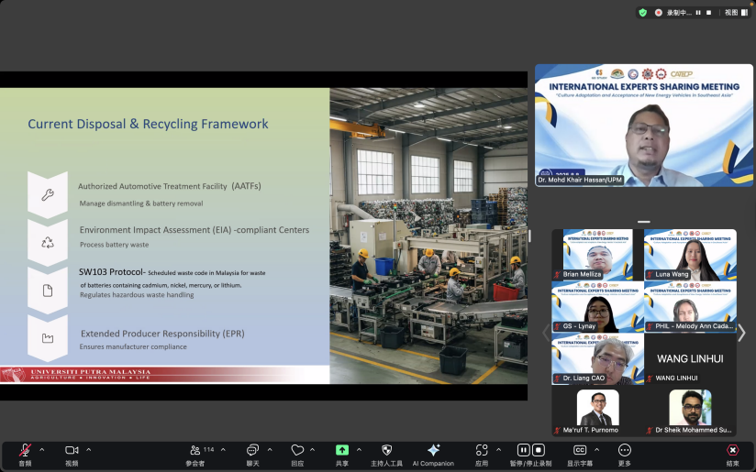
(Sharing session on August 8, 2025)

Speaker: Mr. Ma’ruf Tsaghani Purnomo
Lecturer, Faculty of Civil Engineering, Diponegoro University, Semarang, Indonesia
Mr. Ma’ruf’s presentation focused on the development status and cultural acceptance of electric vehicles (EVs) in Indonesia, particularly Jakarta. Although EV sales have been increasing annually, they remain far behind traditional gasoline-powered vehicles, with transportation still regarded as a symbol of social status. With growing environmental awareness, some citizens have shifted toward public transport or EVs; however, issues such as inadequate infrastructure, battery reliability concerns, and high costs have limited widespread adoption, especially for long-distance travel during holidays. Through case studies, user surveys, and price comparisons, the report highlighted that while policy incentives—such as exemptions from license plate restrictions, purchase subsidies, and tax benefits—are in place, there remains a need to strengthen infrastructure development, particularly outside Java Island, and to improve public awareness and understanding of EVs.
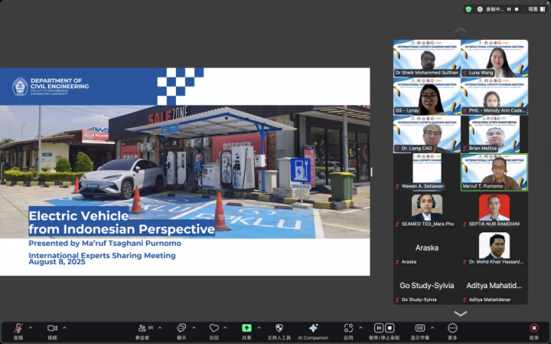
(Sharing session on August 8, 2025)

Speaker: Dr. Cao Liang
Associate Professor, School of International Relations, Guangxi Polytechnic of Construction, China
Dr. Cao’s presentation provided a comprehensive review of China’s development and policy framework in promoting sustainable transportation. He first highlighted the significant impact of transportation on energy consumption and carbon emissions, emphasizing the critical role of green transportation in achieving carbon peak and carbon neutrality goals. China advances low-carbon transportation through building efficient rail transit systems, promoting new energy vehicles, and developing urban green mobility options such as bike-sharing and pedestrian-friendly infrastructure. Dr. Cao detailed the “public transport priority” strategy and the development of green logistics, particularly the synergy between electric trucks and smart logistics. Furthermore, he pointed out that technological innovation—such as Building Information Modeling (BIM) and AI-based scheduling—along with policy support like carbon market mechanisms, are key drivers of sustainable transport systems. Lastly, he shared successful urban and regional case studies, offering the Chinese model as a valuable reference for other countries.

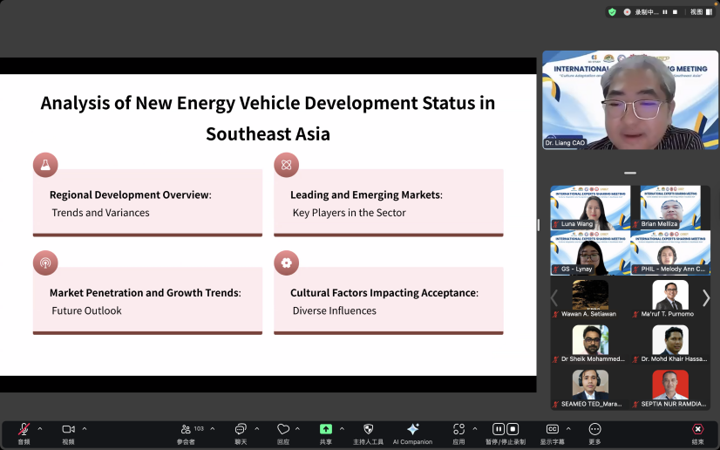

(Sharing session on August 8, 2025)

