Report on International Youth Talk on
“How Electric Vehicles Changed My View of Transportation”

On the afternoon of August 22, 2025, the 8th session of the International Youth Talk online youth exchange successfully concluded. With the theme “How Electric Vehicles Changed My View of Transportation”, the conference brought together youth representatives from universities in Indonesia, Malaysia, the Philippines, Thailand, and Cambodia. They engaged in lively discussions on topics such as the development trends of new energy vehicles, the application of clean energy, and the prospects of sustainable transportation, while also sharing their personal learning experiences and daily life reflections.

The young participants not only exchanged views on how electric vehicles have reshaped individual perspectives on mobility but also explored their broader significance in tackling climate change, driving green transition, and fostering regional cooperation.
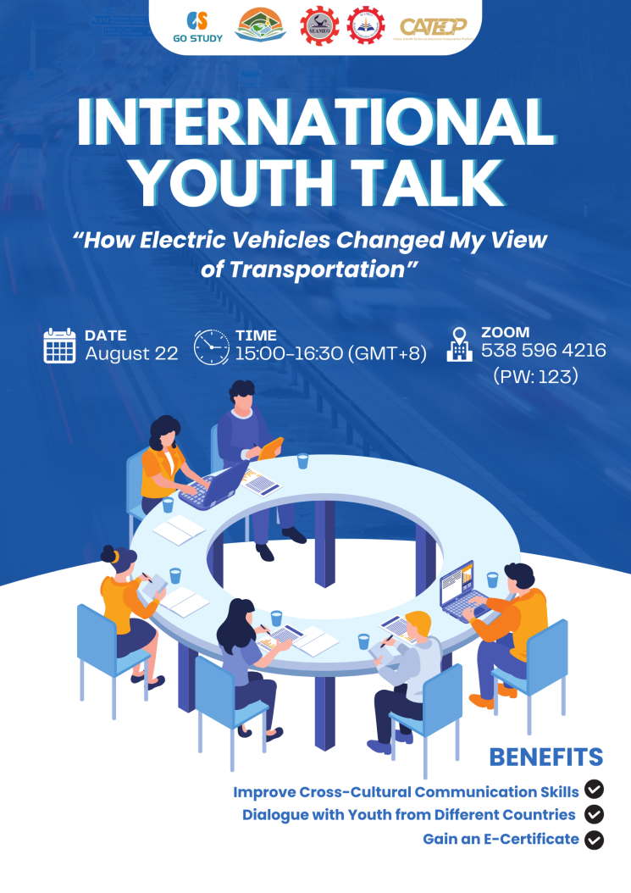
The event opened with remarks by Mr. Ravy Voeun, Deputy Director of the Research and Development Department at SEAMEO TED. He highlighted that electric vehicles are not only a new means of transportation but also an important driver of clean energy, green development, and mobility transformation in Southeast Asia. Mr. Ravy called on the youth to embrace this trend, deepen their understanding of sustainable transport through dialogue, and actively contribute to regional cooperation for a greener and more inclusive future.
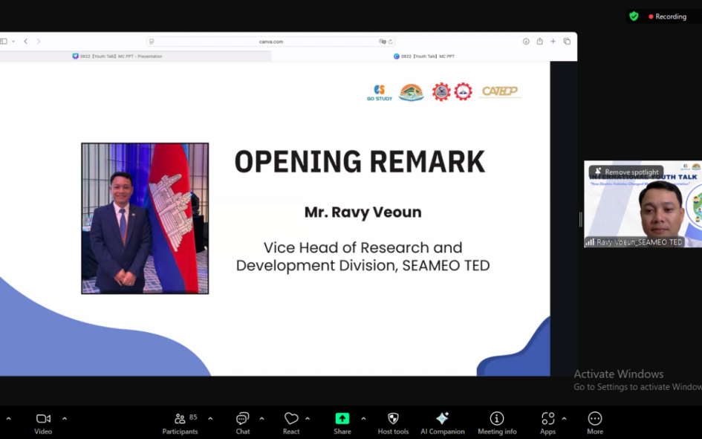

Youth representatives from the National Polytechnic Institute of Cambodia shared their perspectives on electric vehicles and how they may transform future transportation. They highlighted that EVs can bring economic benefits, such as reducing daily commuting costs and enjoying government incentives, while also enhancing Cambodia’s energy independence. In addition, EVs can improve air quality, reduce noise, and promote healthier and more environmentally friendly living. The students emphasized that with expanded charging infrastructure, increased business investment, and intergovernmental cooperation, electric mobility will become more widespread. Their insights demonstrated that EVs represent not only a shift in transportation but also a step toward green travel, sustainable development, and the younger generation’s vision for a better life and environmental protection.

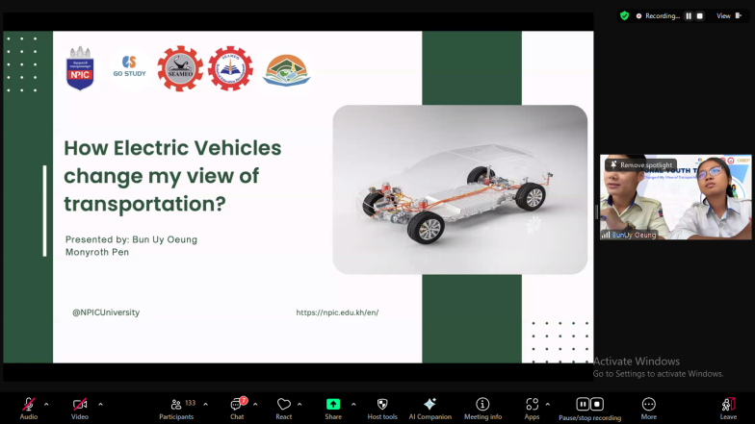

The representatives from Gadjah Mada University, Indonesia shared their observations on electric vehicles in Indonesian transportation. They noted the current heavy reliance on fuel-powered motorcycles and private cars, which contributes to congestion, pollution, and energy pressure. They also discussed government efforts to promote EVs, as well as challenges related to cost, charging infrastructure, and public awareness. And analyzed the environmental, social, and economic advantages and disadvantages of EVs, emphasizing the crucial role of youth in advocating green mobility, driving policy innovation, and participating in sustainable transitions. Their insights highlighted the potential of EVs to transform Indonesian transportation and called for policy improvements, infrastructure development, and active youth engagement to collectively advance an inclusive and sustainable electric mobility future.

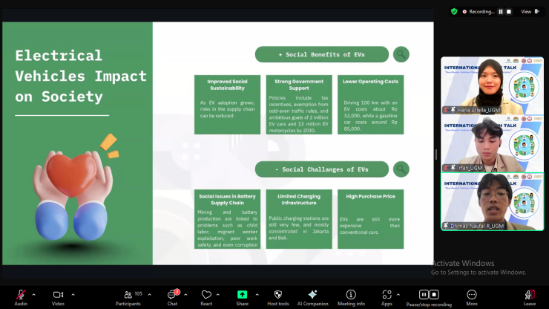

Youth representatives from the National University of Laos shared their observations on electric vehicles, describing the shift in perception from “expensive and impractical” to “quiet, powerful, and environmentally friendly.” They highlighted local EV developments, including LOCA EV taxi operations and government tax exemptions, and emphasized the social benefits of EVs, such as improved air quality, enhanced safety, and equal opportunities. The students also discussed the role of youth in advancing electric mobility—participating in technology development, proposing community-based charging solutions, and using social media and policy advocacy to influence public perception. Their sharing demonstrated not only the environmental and social significance of EVs but also called on youth across countries to turn green transportation into reality through knowledge sharing and innovative collaboration.

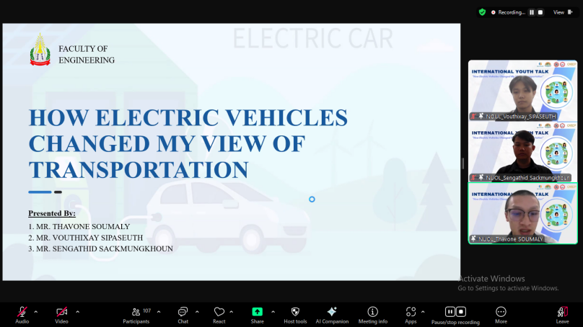

Youth representatives from Politeknik Tawau Sabah, Malaysia shared their observations on public perceptions and influencing factors regarding electric vehicles in Malaysia. They noted that despite government incentives such as tax reductions and charging station subsidies, the Malaysian EV market remains in its early stages, constrained by high vehicle costs, limited infrastructure, and a fossil-fuel-dependent power grid. The students analyzed the positive attitudes of the public viewing EVs as environmentally friendly, cost-effective, and technologically trendy, while also highlighting concerns over price, range, charging convenience, and energy cleanliness. They further discussed the value of EVs in reducing air pollution, lowering greenhouse gas emissions, improving energy efficiency, integrating renewable energy, and delivering economic and health benefits. Their sharing illustrated the mixed perceptions of electric mobility in Malaysian society and underscored the importance of policy optimization, infrastructure development, and public education in promoting clean transportation.

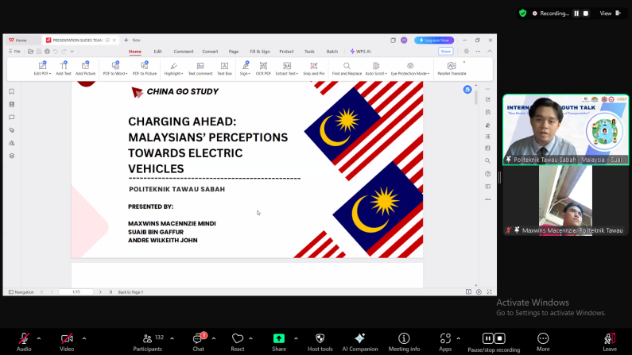

Youth representatives from King Mongkut's University of Technology Thonburi, Thailand shared their observations on how electric vehicles are reshaping transportation systems in Thailand and Sri Lanka. They noted that road transport accounts for 11.9% of global greenhouse gas emissions, highlighting the urgency of EV adoption to reduce fossil fuel dependence and improve air quality. The students reviewed the current EV market in both countries: Thailand’s registrations and charging infrastructure are steadily growing, while Sri Lanka has experienced rapid EV sales growth post-economic recovery, with brands like BYD dominating. They also analyzed challenges such as battery cost, lifespan, insufficient charging infrastructure, range anxiety, and safety risks, suggesting innovations like solid-state batteries, vehicle-to-grid (V2G) interaction, and hydrogen fuel cells to drive industry development. Looking ahead, they projected that by 2030, EVs will account for 60% of major global markets and integrate closely with autonomous driving and ultra-fast charging technologies. Their sharing highlighted the central role of EVs in promoting low-carbon transportation and emphasized the importance of technological innovation, infrastructure development, and policy coordination for sustainable mobility.

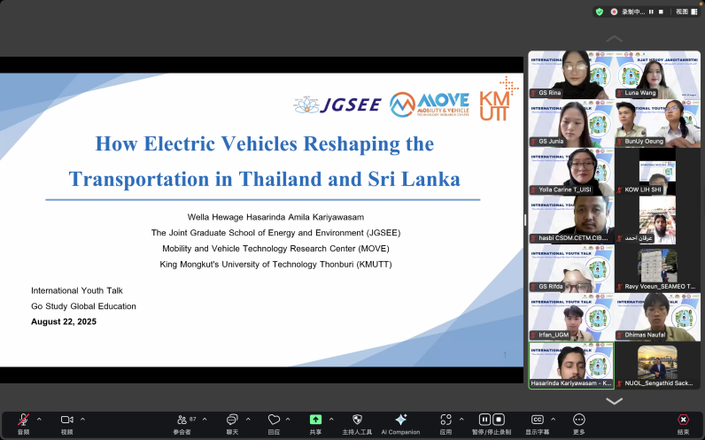

Youth representatives from Universitas Internasional Semen Indonesia shared their perspectives on the development of electric vehicles in Indonesia. They began by outlining national policies supporting the transition from fossil-fuel vehicles to EVs, such as Perpres No. 55/2019 and the target of reaching 2 million EVs by 2030. They then discussed the main EV applications in Indonesia, including electric buses, ride-hailing services, and charging infrastructure, analyzing their economic and energy-saving benefits while highlighting technological and promotional challenges. Finally, the students raised a realistic concern: although EVs help reduce emissions, the extraction of nickel and lithium for batteries poses environmental and social burdens. Their sharing demonstrated the positive impact of EVs on green mobility while emphasizing the need for responsible resource management and environmental protection to achieve a truly sustainable clean future.

