International Experts Sharing Meeting: How E-Commerce is Shaping Modern Consumer Behavior

On the afternoon of September 5, 2025, the 8th session of the “International Experts Sharing Meeting,” jointly organized by the China-ASEAN Technical Education Cooperation Platform (CATECP), the Southeast Asian Ministers of Education Organization Regional Centre for Technical Education Development (SEAMEO TED), and Go Study Global Education, was successfully concluded online themed “How E-Commerce is Shaping Modern Consumer Behavior”, the meeting brought together experts and scholars from Indonesia, the Philippines, and Laos. Discussions focused on e-commerce development trends, changes in consumer purchasing behavior, digital marketing strategies, and enterprise innovation practices, explored through keynote speeches, case studies, and interactive exchanges.

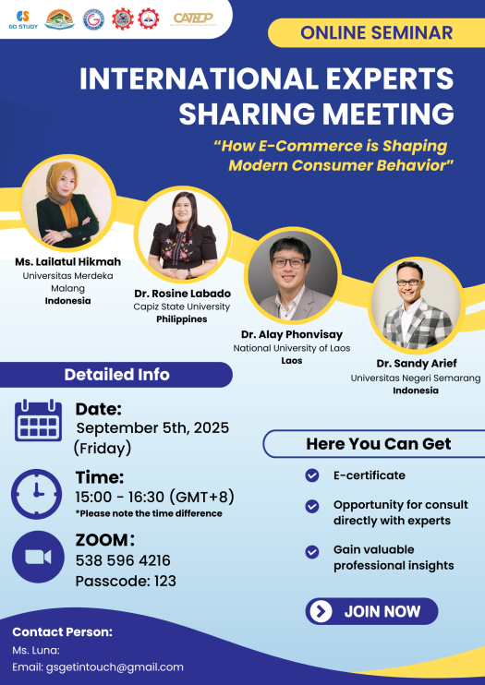

The opening remarks were delivered by Ms. Cheng Chantola, Head of the Finance and Planning Department of SEAMEO TED. She emphasized that with the rapid growth of e-commerce, both consumer behavior and market structures are undergoing profound transformations. These shifts not only influence business models but also pose new challenges to education and skills training.

In the digital economy era, regional cooperation in education and technology has become particularly critical. Strengthening exchanges and collaboration in education, research, and technology between ASEAN countries and China will help address the opportunities and challenges arising from industry transformation. She further encouraged participating experts, scholars, and youth representatives to actively share their experiences and perspectives, and to explore innovative educational and practical models in the context of e-commerce.

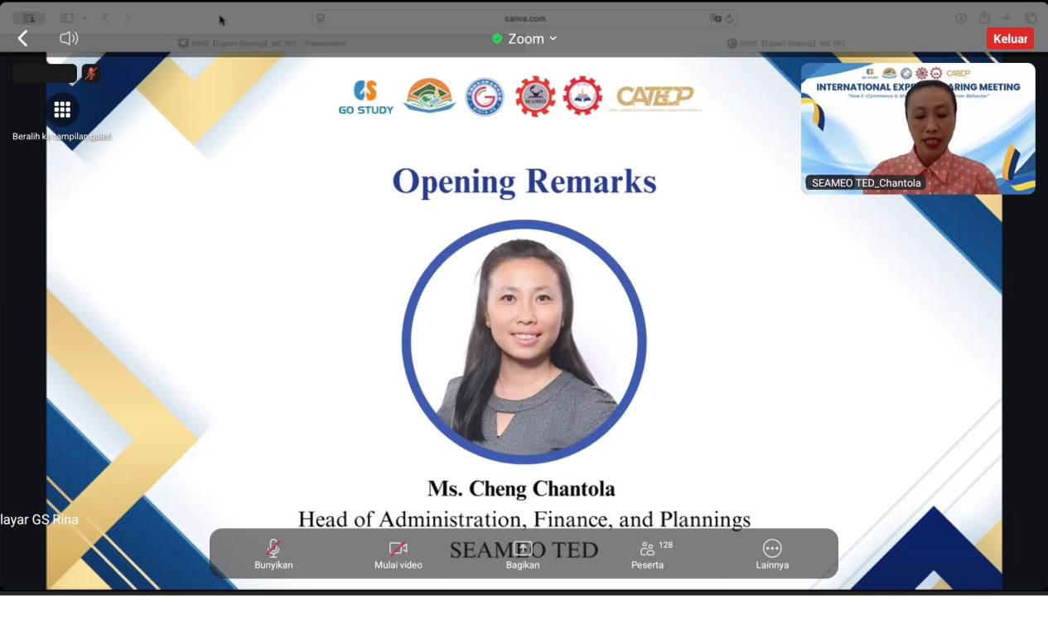

Speaker: Dr. Rosine O. Labado
Dean, College of Management, Capiz State University, the Philippines
Topic: E-Commerce and the Redefinition of the Shopping Journey
Dr. Labado highlighted how e-commerce has completely reshaped and redefined the modern shopping journey. Key transformations include: The rise of omnichannel shopping, enabling seamless switching between physical stores, online platforms, and mobile apps. Personalization and data-driven recommendations, allowing businesses to provide tailored products and ads that strongly influence consumer choices. The growing impact of social commerce and influencer marketing—for example, in the Philippines, 70% of consumers purchase products recommended by top TikTok influencers. The pursuit of seamless checkout and instant gratification, driving features such as “one-click purchase,” diverse payment options, fast free delivery, and easy return policies. Reviews, trust, and community as the foundation of decision-making, where consumers heavily rely on others’ feedback to build trust in brands and products. In sum, e-commerce has transformed the once-linear shopping process into a dynamic, interconnected, data- and socially driven journey.
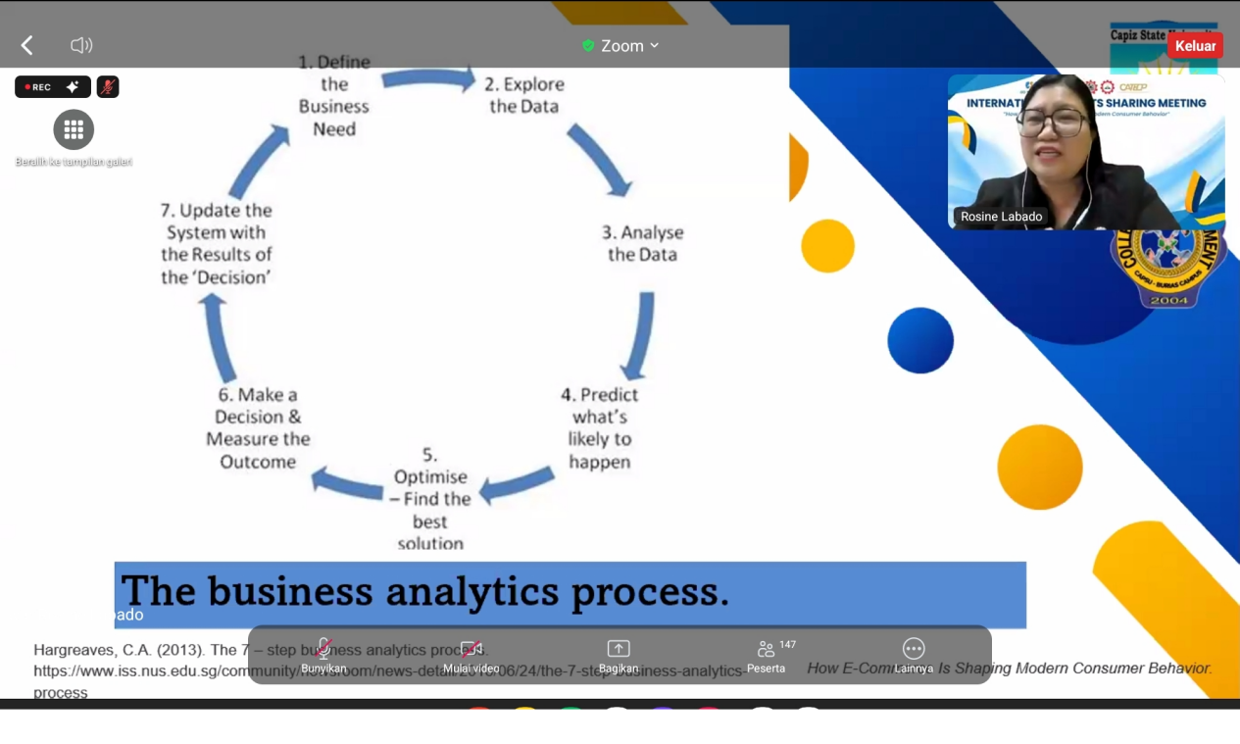
Speaker: Dr. Sandy Arief
Lecturer, Department of Accounting Education, Universitas Negeri Semarang, Indonesia
Topic: E-Commerce Archipelago: Unlocking the Potential of Innovation, Inclusion, and Impact
Dr. Arief described Indonesia’s diverse e-commerce ecosystem, which includes traditional platforms (e.g., Shopee, Tokopedia), online marketplaces (e.g., OLX), and quick commerce (e.g., GrabMart). By 2024, Indonesia’s gross merchandise value (GMV) had reached USD 90 billion, showing strong momentum. Over 90% of consumers shop online, with browsing and purchasing patterns varying by platform. E-wallets and cash-on-delivery remain the most popular payment methods.
He noted that Indonesia’s digital financial services—including payments, lending, wealth management, and insurance—continue to grow steadily, driven by robust demand. Interest in AI applications is also rising, particularly in marketing, gaming, and education. Dr. Arief concluded with six key elements for successfully achieving technology and business transformation, and highlighted innovation, inclusivity, and socioeconomic impact as the cornerstones of Indonesia’s “e-commerce archipelago.”
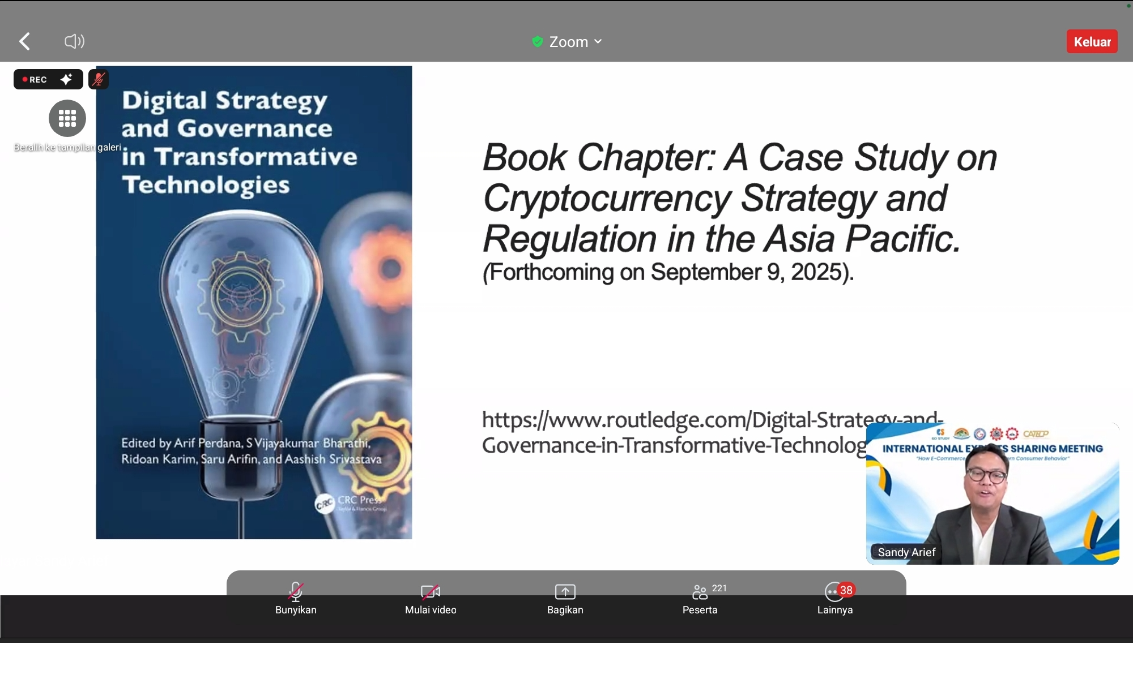
Speaker: Ms. Lailatul Hikmah
Lecturer, Faculty of Economics and Business, Universitas Merdeka Malang, Indonesia
Topic: The Evolution of E-Commerce and Its Impact on Modern Consumer Behavior
Ms. Hikmah focused on how the evolution of e-commerce has profoundly influenced consumer habits, expectations, and decision-making processes. Consumers are increasingly shifting from offline to online channels, relying more on price comparison tools, reviews, and social media recommendations. Impulse buying is on the rise, while expectations for fast delivery, transparent information, and personalized services are growing.
These shifts pose challenges for businesses, such as intensified global competition, the need for stronger online visibility and SEO, and maintaining consumer trust and data security. She also discussed future trends, including AI and chatbot integration, mobile shopping growth, AR shopping experiences, and the rise of sustainable consumption.
Using Shopee as an example, Ms. Hikmah illustrated how leading e-commerce platforms have supported SMEs, employment, and the digital economy in Indonesia. She emphasized that companies must embrace technology, optimize online engagement, and deliver seamless customer experiences to remain competitive in today’s digital-first market.
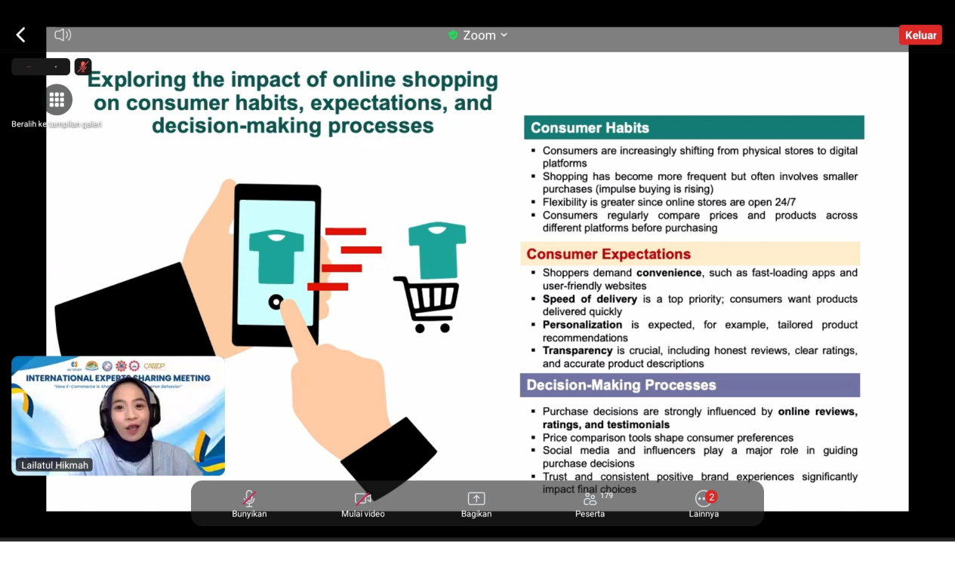
Speaker: Dr. Alay Phonvisay
Associate Professor, Faculty of Economics and Business Management, National University of Laos
Topic: E-Commerce and Market Transformation in Laos: From Consumer Behavior Shifts to Market Failure Solutions
Dr. Phonvisay shared how e-commerce has helped Laos address traditional “market failure” issues and drive market transformation. With mobile internet penetration reaching 87–88% of the population, Laos has a strong foundation for e-commerce development. Traditional markets often suffer inefficiencies due to information asymmetry, high transaction costs, geographical barriers, and market control. E-commerce reduces these inefficiencies by: Providing product details and consumer reviews to minimize information asymmetry. Lowering transaction costs through online browsing and delivery services. Expanding market access for producers in remote areas by connecting them directly with national markets. Increasing competition and efficiency through price transparency. The growth of digital payments (e.g., Lao QR standard) and third-party logistics are critical enablers. While COVID-19 accelerated e-commerce adoption, Laos still faces challenges such as lack of trust, infrastructure gaps, and limited digital literacy. In conclusion, e-commerce is far more than online shopping. By correcting market inefficiencies, empowering small producers, and reshaping consumer behavior, it is fostering a more inclusive and efficient economy, thereby improving overall economic welfare in Laos.

