Brief Report
China-Southeast Asia Capacity Development Workshop on
“TVET Digital Transformation for Sustainable Rural Development”
17th-22th August 2025, Beijing, China

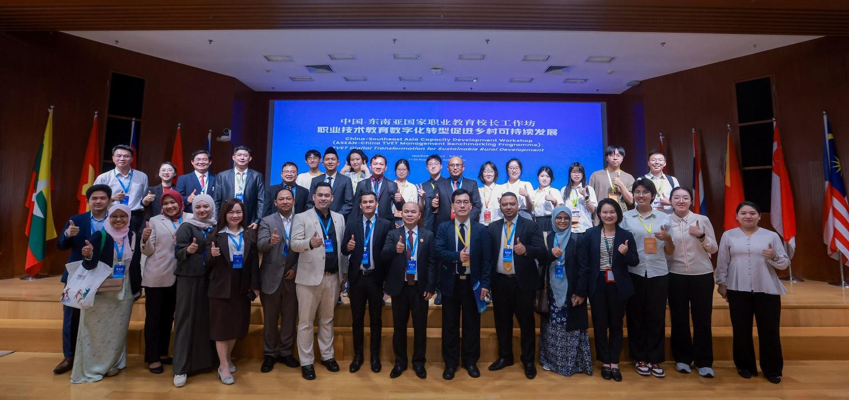
Group photo of The Opening Symposium on "TVET Digital Transformation for sustainable rural development”

With good collaborations with its partners such as UNESCO International Research and Training Centre for Rural Education (UNESCO INRULED), China Education Association for International Exchange (CEAIE), and ASEAN-China Centre (ACC) , SEAMEO TED has successfully organized China-Southeast Asia Capacity Development Workshop on “TVET Digital Transformation for Sustainable Rural Development”, as a thematic event of Global Smart Education Conference 2025 in Beijing City, China. 34 participants from 11 countries in Southeast Asia, from 27 technical education institutions, including Brunei Darrusalum (4) Cambodia (4), Indonesia (5), Lao PDR (1), Malaysia (4), Myanma (3), Philippines (6), Singapore (2), Thailand (2), Timor Leste (1) and Vietnam (2). They are education officials, TVET vocational school/colleges principals, managers, institute and university management and head teachers who are TVET partitioners. The 5-days program included field trips, forums, workshops, and cultural activities.

The visit to Alibaba Group, where all participants discovered a leading cloud computing and AI company with its proprietary Apsara Operating System, was on August 18, 2025 (in the morning). Alibaba Cloud provides a comprehensive suite of cloud services structured around a three-tiered architecture of Infrastructure-as-a-Service (IaaS), Platform-as-a-Service (PaaS), and Model-as-a-Service (MaaS).

The Opening Symposium, under the theme "TVET Digital Transformation for sustainable rural development" was organized in the afternoon on August 18, 2025. The Opening remarks and keynote speeches were given by representatives of ACC, SEAMEO, UNESCO Beijing, SEAMEO TED, UNESCO INRULED and Beijing Normal University at the Opening Symposium. Thirteen representatives from 12 countries, including Brunei Darussalam, Cambodia, China, Indonesia, Lao PDR, Malaysia, Myanmar, the Philippines, Singapore, Thailand, Timor-Leste, and Vietnam, were invited to deliver their presentations in the Country Reports and Best Practices session.

In the morning on August 19, 2025, all participants were invited to participate in a Parallel Session on TVET. This session was opened by the representative of Department of Vocational Development, Ministry of Education, China, Prof. Ali Haidar Ahmed, Minister of Higher Education, Labour and Skills Development, Maldives. Mr. FENG Yu, General Manager of Sports and Education Business Group of CCTV and Dr. Andreas Schleicher, Director for Education and Skills, Organization for Economic Co-operation and Development(OECD), France (Video). The conference focused on the digitalization and intelligent development of vocational education, featuring several prominent speakers and topics. Dr. Habibah Abdul Rahim from SEAMEO secretariat discussed the professionalization of vocational education empowered by digital intelligence. Prof. HE Zhen from Beijing Normal University explored stimulating generative AI to empower independent development, while Dr. Käthe Schneider from Friedrich Schiller University Jena also contributed. Mr. ZHANG Chengtao from Huawei addressed challenges and solutions in school-enterprise cooperation in digital transformation. Other speakers include Prof. CHEN Jiangfeng from Beijing Vocational University of Science and Technology, Prof. HAN Xibin from Tsinghua University who discussed new situations and approaches for deepening the digitalization of vocational education, and Prof. ZHANG Buhe from the Chinese Academy of Educational Sciences.

The GSE Forum on Smart Villages and Education for Rural Transformation was held at BNU Changping Campus in the afternoon of August 19, 2025. The opening remarks were delivered by Professor ZHOU Zuoyu, Vice Chairman of Beijing Normal University, Director of UNESCO INRULED and Ms. LIN Huifang, Deputy Director-General of Foreign Economic Cooperation Center (China-EU Center for Agricultural Technology), Ministry of Agriculture and Rural Affairs, P. R. China. Keynote presentations were delivered by Ms. Duriya Amatavivat, Director of the SEAMEO Regional Centre for Sufficiency Economy Philosophy for Sustainability and Prof. LIU Ji from Shaanxi Normal University. The forum also included case reports from various educational leaders, a roundtable discussion on TVET for Smart Villages and Rural Transformation with speakers from Brunei, Cambodia, Indonesia, Malaysia, and the Philippines.

In the morning of August 20, 2025, all participants were organized to visit The Great Wall. This visit was arranged for the purpose of cultural exchanges and exploration. In the afternoon, there was an exchange visit to Centre for Language Education and Cooperation of China where participants learned more about Confucius’s language academy and philosophy. Participants also had a meeting with the management team of Centre for Language Education and Cooperation of China to learn more about "Chinese + Vocational Skills" program. This program creates a comprehensive system for Chinese language learning and professional skills training, promoting employability and enabling participants to thrive in the global economy. Event Reflections and Cultural Night was organized in the evening time for exploring and strengthening cultural exchange among participants from Southeast Asia countries and China.

In the morning of August 21, 2025, a visit to Beijing Polytechnic University was organized for all participants. During the visit there was a China-ASEAN TVET Exchange Meeting on International Cooperation and Talent Cultivation in which five presentations by 3 representatives from Southeast Asian Countries and 2 representatives from Beijing Institutions were conducted in the form of knowledge and best practices exchange. In the afternoon, all participants were arranged to pay a visit to Smart TVET Development Centre, Higher Education Press of China. HEP is a publishing house in China, specializing in educational materials, particularly for higher education. Participants had opportunities to explore the Smart TVET Development Centre on its achievements and vision.

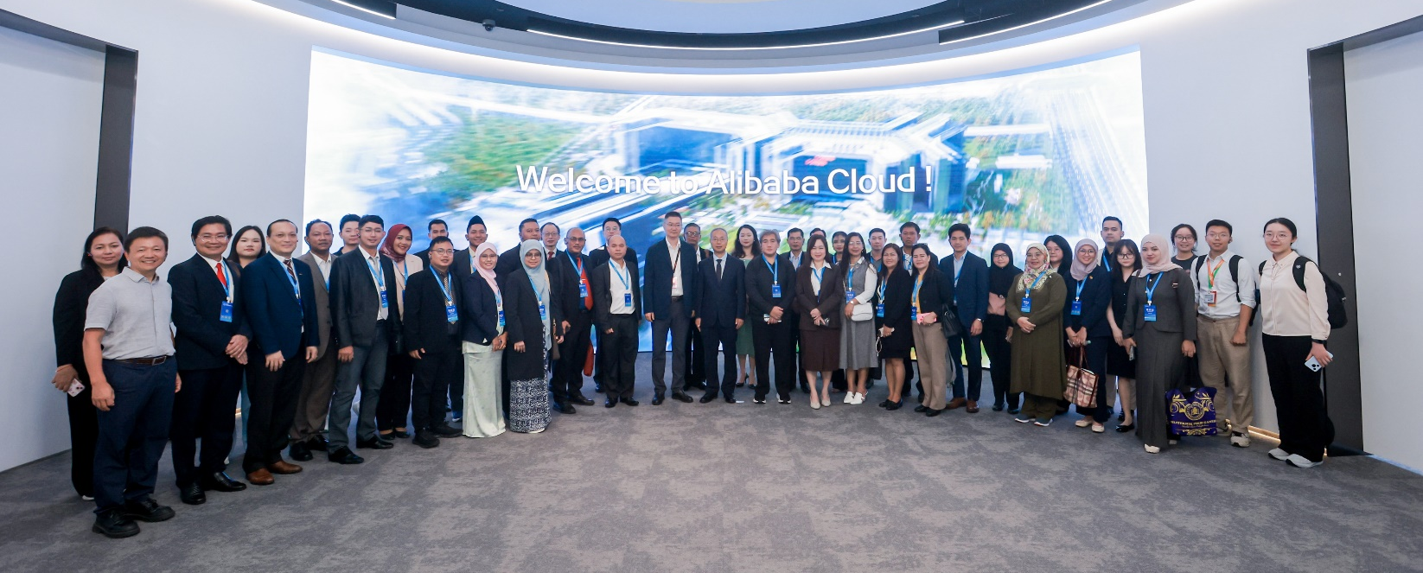
Group photo of The visit to Alibaba Group
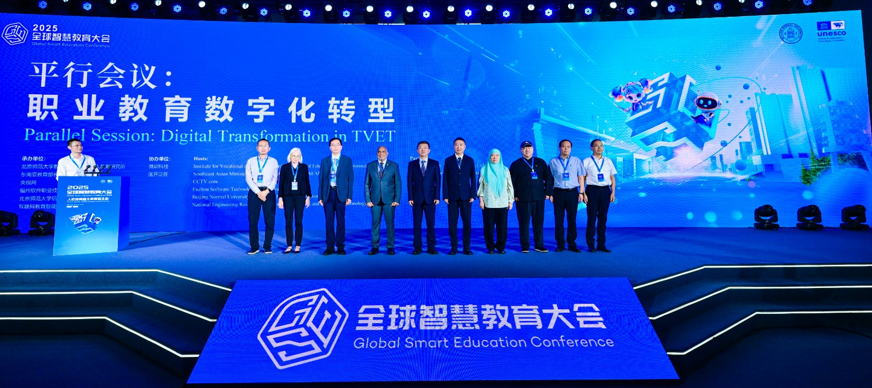
Group photo of Parallel Session on TVET
Group photo of Parallel Session on TVET

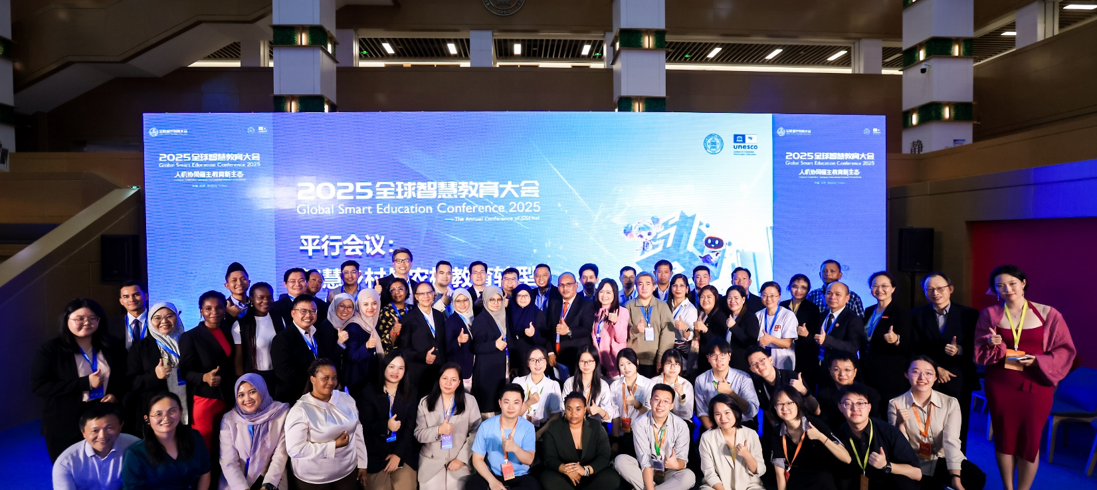
Group photo of The GSE Forum on Smart Villages and Education for Rural Transformation

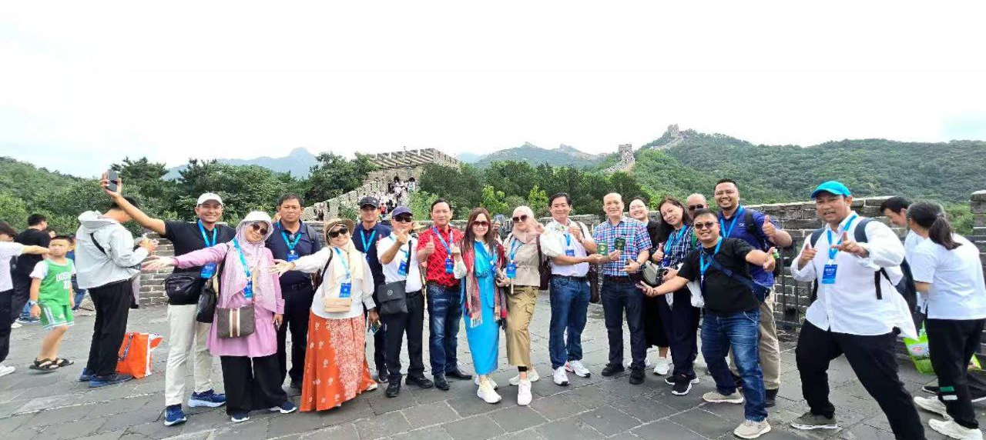
Group photo of Visit to Great Wall

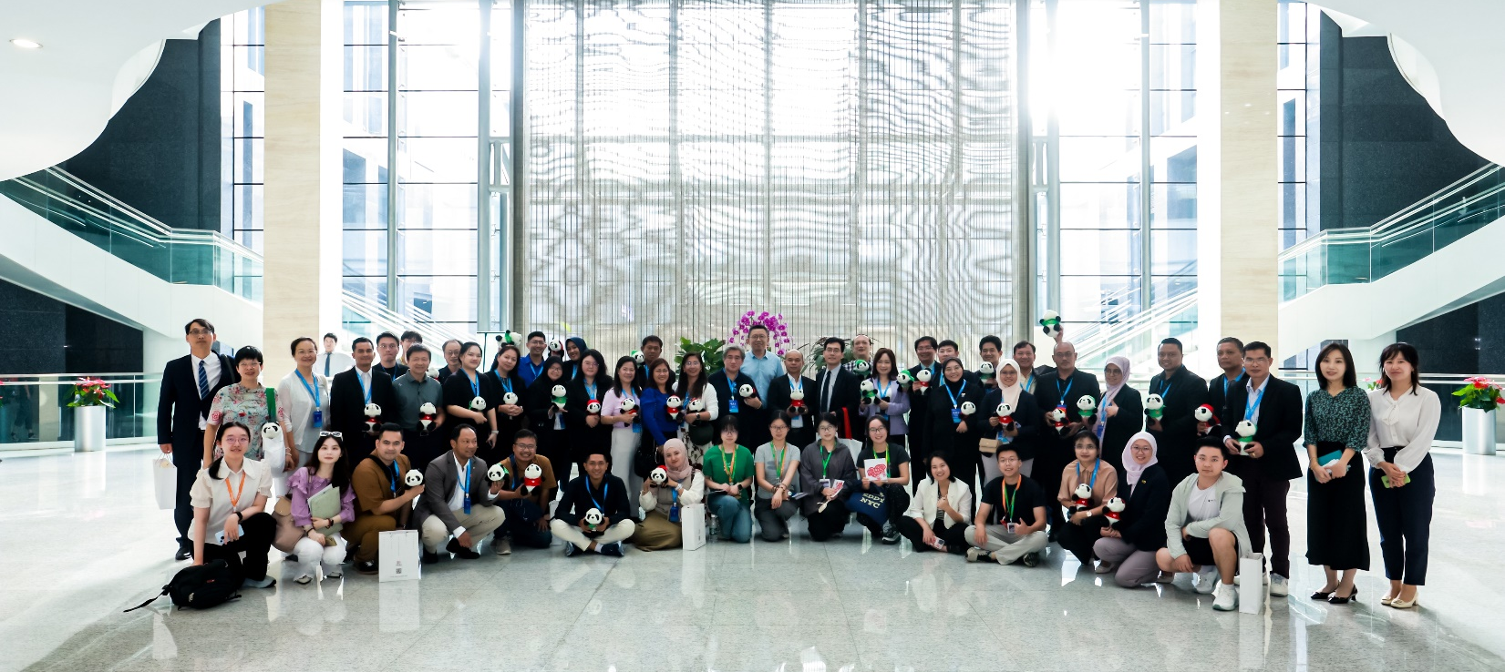
Group photo of The Visiti to Centre for Language Education and Cooperation of China

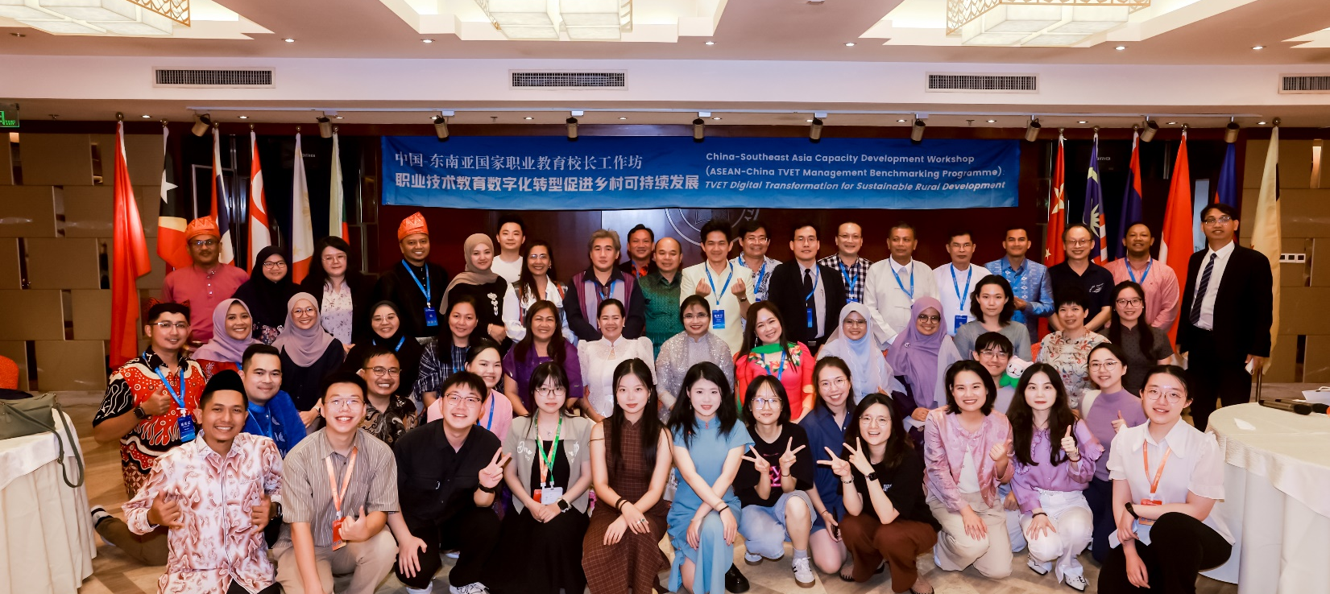
Group photo of Cultural Night

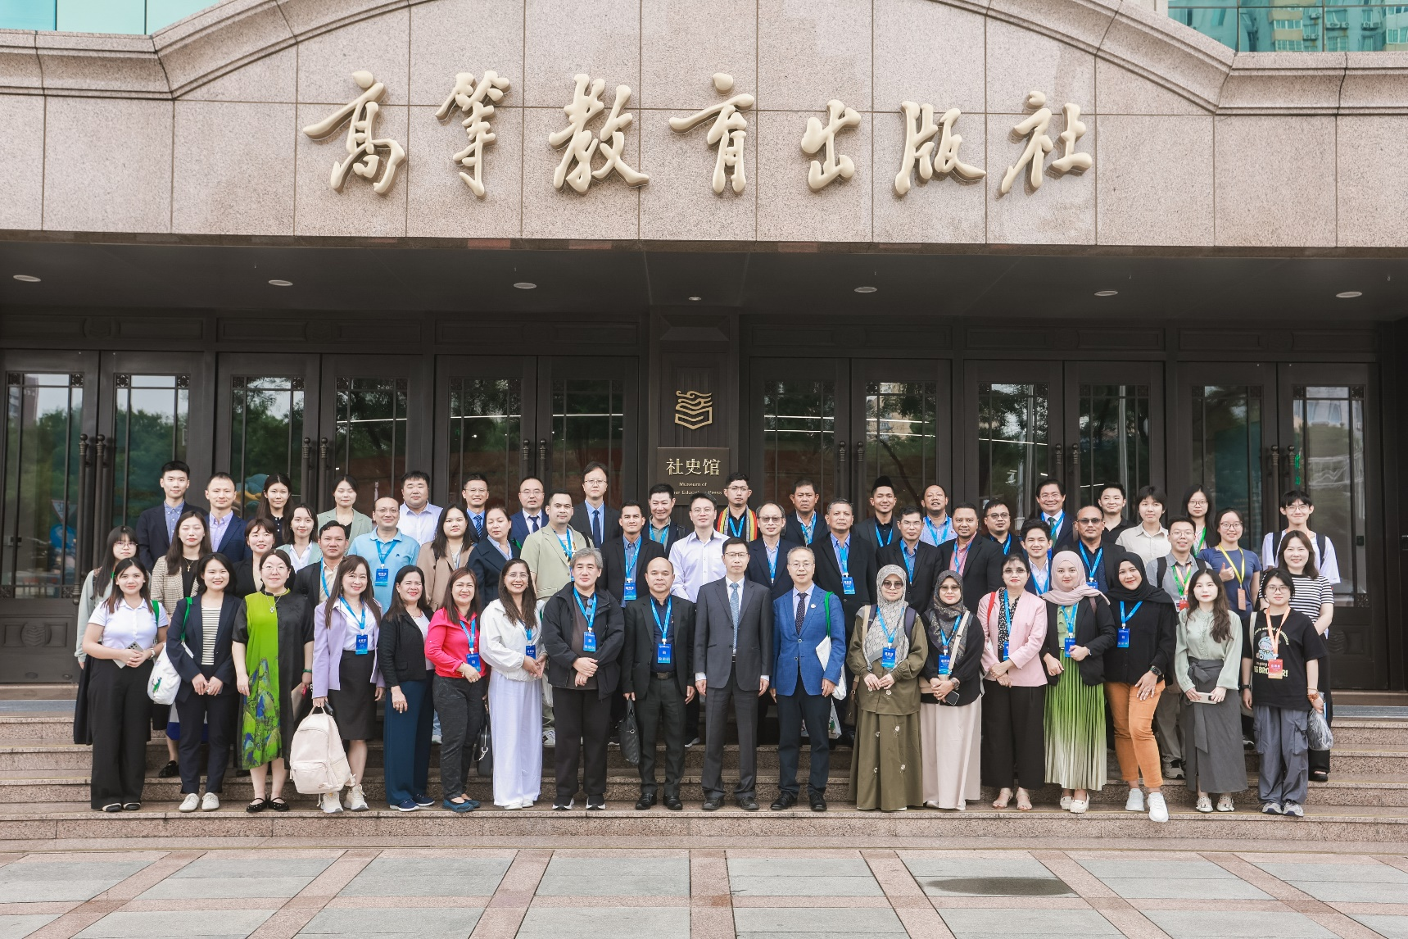
Group photo of visit to Smart TVET Development Centre, Higher Education Press of China (HEP)

