The 8th Governing Board Meeting of SEAMEO TED
2-3 October 2025, Siem Reap, Kingdom of Cambodia
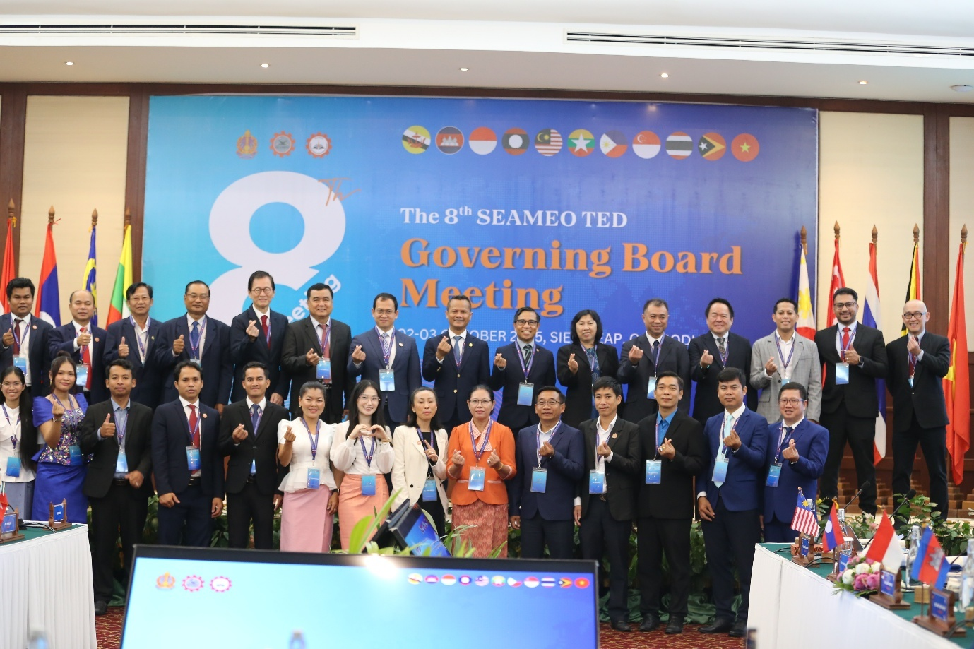
(Photo of All Participants including GB Members)
The SEAMEO Regional Centre for Technical Education Development (SEAMEO TED) proudly hosted its 8th Governing Board Meeting (8th GBM) from October 2-3, 2025, at the Royal Angkor Resort in Siem Reap, Cambodia. This significant annual event underscored SEAMEO TED's unwavering commitment to advancing technical education across the Southeast Asian region.
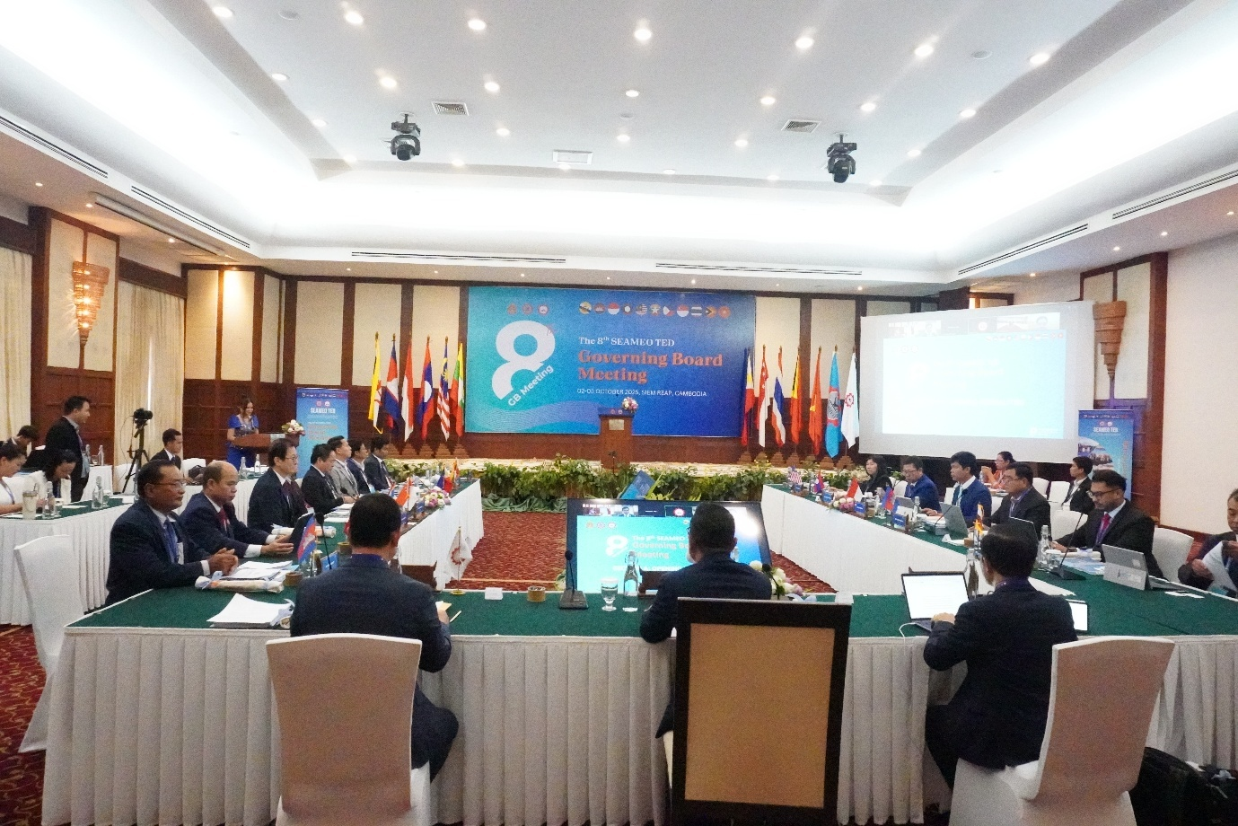
(Plenary Meeting)
Conducted in a hybrid format to facilitate broader participation, the meeting brought together Governing Board members and dedicated representatives from all eleven SEAMEO member countries. Delegations from Brunei Darussalam, Cambodia, Indonesia, Lao PDR, Malaysia, Myanmar, the Philippines, Singapore, Thailand, Timor-Leste, and Vietnam actively engaged in extensive discussions and strategic decision-making.
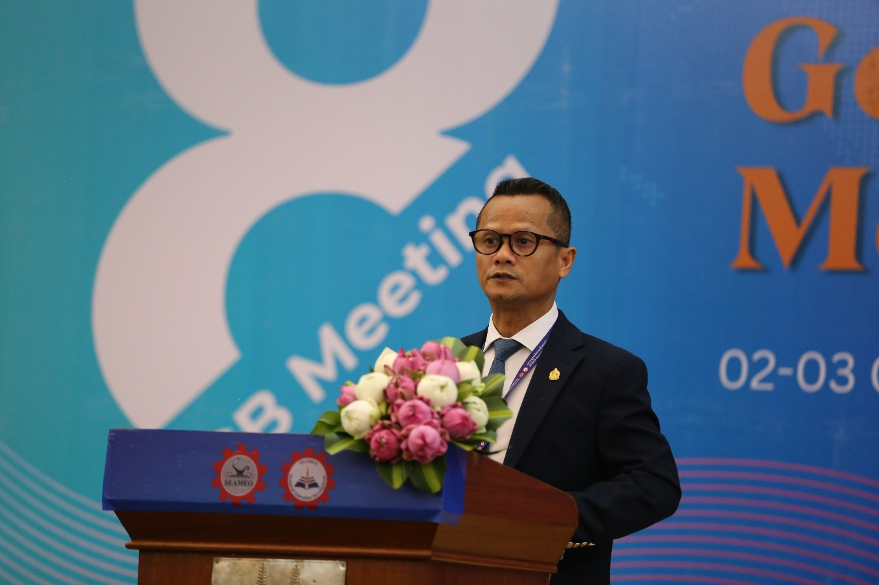
(H.E. Dr. Kol Pheng Vaddhana, Under-Secretary of State, Ministry of Education, Youth and Sport Delivering Opening Remarks)
The prestigious meeting was formally inaugurated by His Excellency Dr. Kol Pheng Vaddhana, Undersecretary of State for the Ministry of Education, Youth and Sport. Representing the esteemed His Excellency Dr. Hang Chuon Naron, Deputy Prime Minister and Minister of Education, Youth and Sport, Dr. Kol Pheng Vaddhana's opening address highlighted Cambodia's unwavering support for robust regional cooperation in education. He profoundly emphasized the critical role of Technical and Vocational Education and Training (TVET) in fostering national development, driving economic growth, and crucially, empowering the youth of Southeast Asia with essential skills for the future. His speech set a collaborative and forward-looking tone for the entirety of the proceedings.
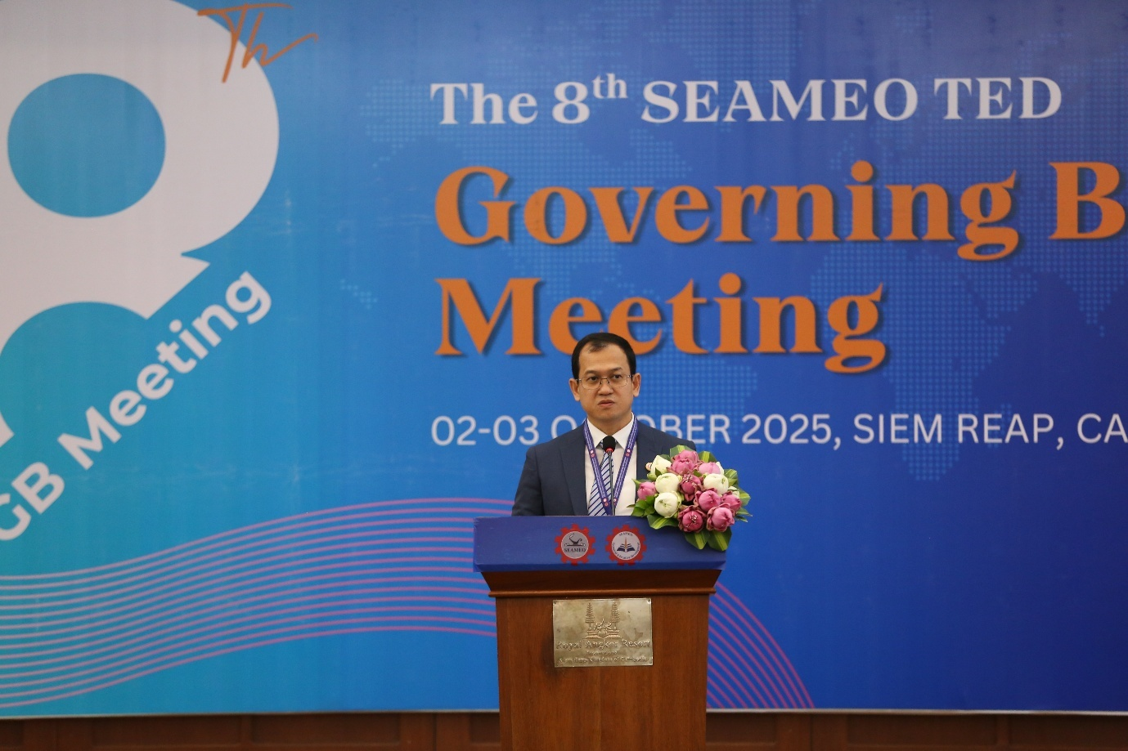
(Dr. Songheang Ai, Director of SEAMEO TED Delivering his Welcome Remarks)
Dr. Songheang Ai, Director of SEAMEO TED, extended a warm welcome to all participants, utilizing his address to present a comprehensive overview of the Centre's remarkable achievements over the past year. He articulated a compelling vision for future initiatives, emphasizing innovation, enhanced regional integration, and adaptability within technical education. Dr. Ai underscored the paramount importance of sustained collaborative efforts among member countries to effectively address both emerging challenges and promising opportunities within the dynamic TVET landscape.
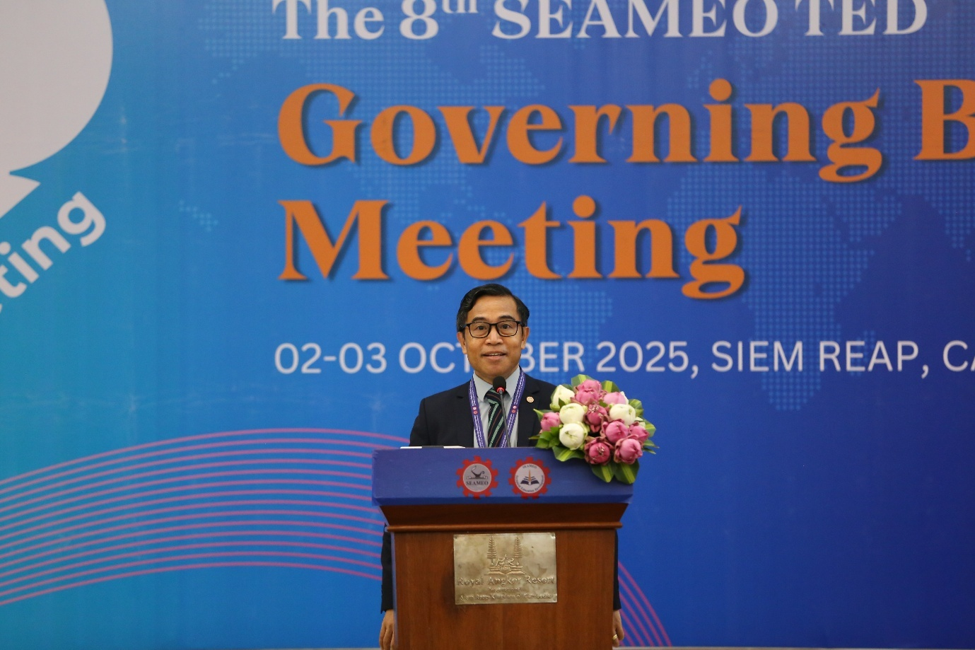
(Mr. John Arnold Siena, Deputy Director of SEAMEO Secretariat Delivering his Impressive Remarks
Following this, Mr. John Arnold Siena, Deputy Director for Programme and Development of the SEAMEO Secretariat, delivered an insightful address. He reaffirmed the Secretariat's steadfast commitment to providing comprehensive support for SEAMEO TED's programs and initiatives. Mr. Siena's remarks critically reinforced the strategic alignment of the Centre's activities with the broader overarching goals of SEAMEO, which are dedicated to fostering sustainable human resource development and educational excellence throughout Southeast Asia.
This annual gathering serves several critical objectives. Firstly, it provides a crucial platform to present and review the Centre's significant achievements and activities accomplished over the preceding year. Secondly, members convene to examine and endorse key policies that are vital for ensuring the sustainable operation and strategic future direction of SEAMEO TED. Finally, the meeting also involves the important task of evaluating and approving the Centre's annual budget plan.
Notably, the 8th Governing Board Meeting operated with a comprehensive agenda, featuring fourteen (14) prepared reports and proposals (Working Papers). These documents were submitted for the Governing Board's thorough review, constructive input, endorsement, and final approval, guiding the Centre's operational and strategic plans moving forward.
During the meeting, all Governing Board Members and Representatives unanimously approved the proposal for the 9th SEAMEO TED's Governing Board Meeting (GBM 2026) to be held in Phnom Penh, Cambodia, on October 1-2, 2026. This decision reflects the ongoing strong collaboration and strategic foresight within the SEAMEO community, ensuring continuity and progressive advancements in our collective efforts to foster excellence in technical education.

