China-ASEAN Industry-Education Integration Specialized
Technical Skills Training Program

From September 25 to 30, 2025, the China-ASEAN Industry-Education Integration Specialized Technical Skills Training Program, jointly conducted by multiple partners from China and ASEAN countries, was successfully concluded.
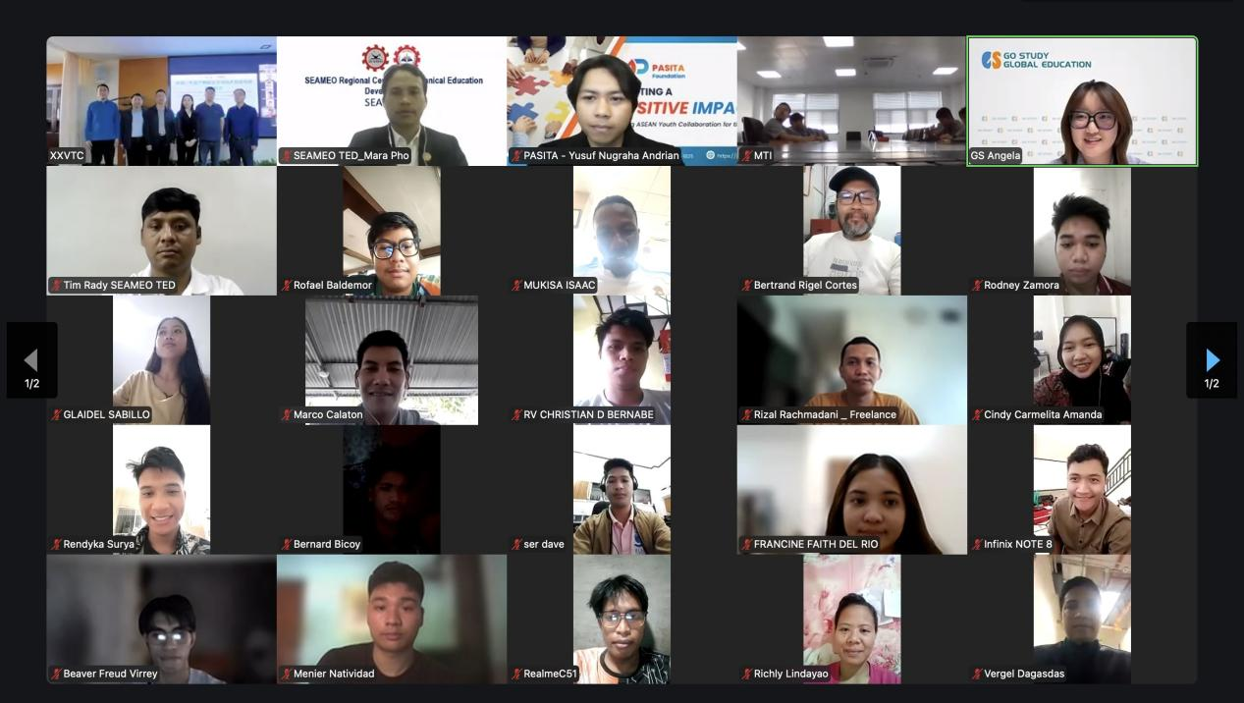
（Group photo: opening ceremony)

Co-organized by the Southeast Asian Ministers of Education Organization Regional Centre for Technical Education Development (SEAMEO TED), Xinxiang Vocational and Technical College, and Go Study Global Education, the program comprised three training sessions aimed at promoting talent cultivation in the field of intelligent manufacturing and deepening cooperation and exchange between China and ASEAN in vocational education. The initiative attracted 220 participants from ASEAN countries including Indonesia, Vietnam, Malaysia, and the Philippines. Chinese enterprises operating in ASEAN—such as PT. MTI, the Indonesian subsidiary of Zhongce Rubber Group Co., Ltd. —actively organized more than 30 local employees to participate in the training.

The opening ceremony brought together distinguished representatives from China and ASEAN. Among the keynote speakers were Mr. Mara Pho, Head of the Department of Technical Education and Training of SEAMEO TED; Ms. Yuan Shuhui, Vice President of Xinxiang Vocational and Technical College; Ms. Windi, Human Resources Manager of PT. MTI; and Mr. Yusuf Nugraha Andrian, supervisor of the Southeast Asia Youth Sustainable Development Foundation (PASITA). The guests delivered opening remarks, expressing their shared commitment to strengthening industry-education integration and advancing vocational education collaboration between China and ASEAN. Their speeches marked the official launch of the training program and set the tone for a week of productive learning and exchange.

The training program was designed in alignment with enterprise needs in areas such as automated production line maintenance and mechanical equipment optimization.
Enterprise and college jointly determined the core training modules, ensuring a precise match between talent cultivation and industrial demand. It is a meaningful practice of industry-education integration, not only fulfills the company’s demand for localized skilled talent but also provides trainees with valuable opportunities for upskilling—achieving a win-win outcome for enterprises, educational institutions, and individuals.

The three online sessions focused on core skills in industrial automation, covering: Fundamentals of PLC, Fundamentals of Mechanical Design, and Fundamentals of CNC Lathe Programming. Each course combined theoretical knowledge with practical case analysis and live demonstrations, ensuring close alignment with real-world industrial applications.
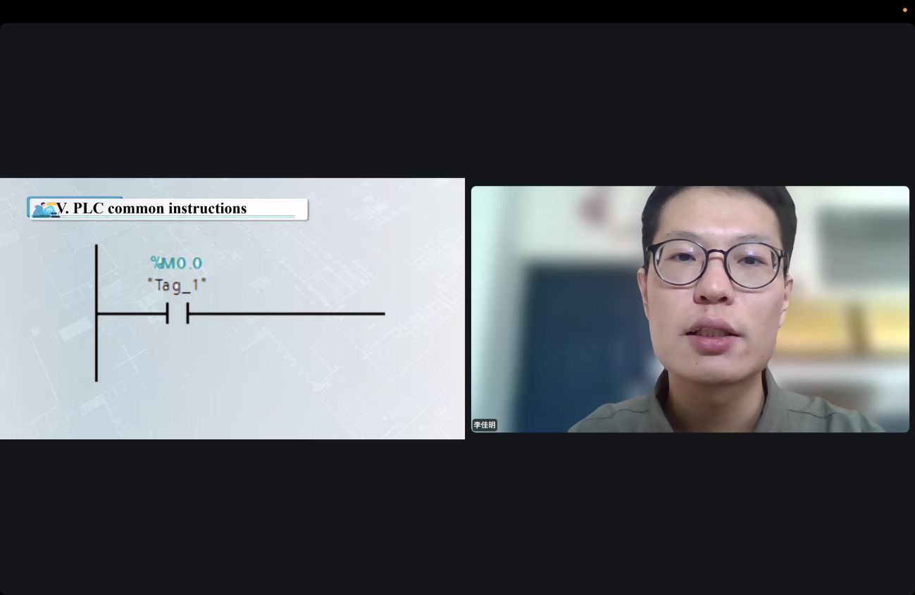

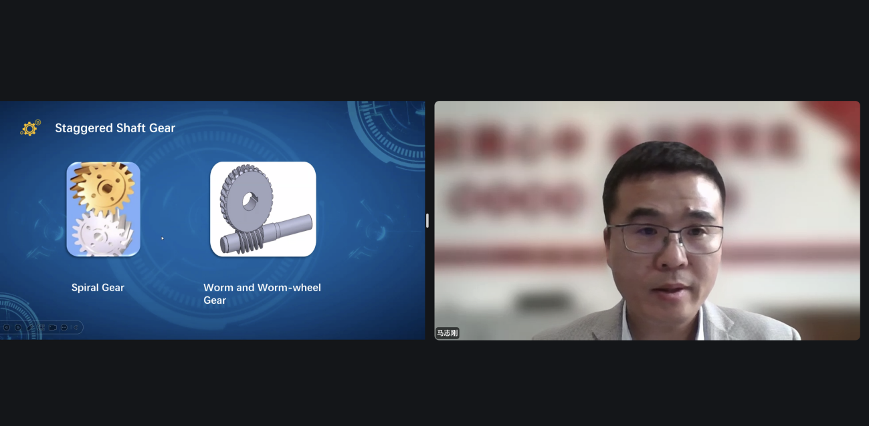

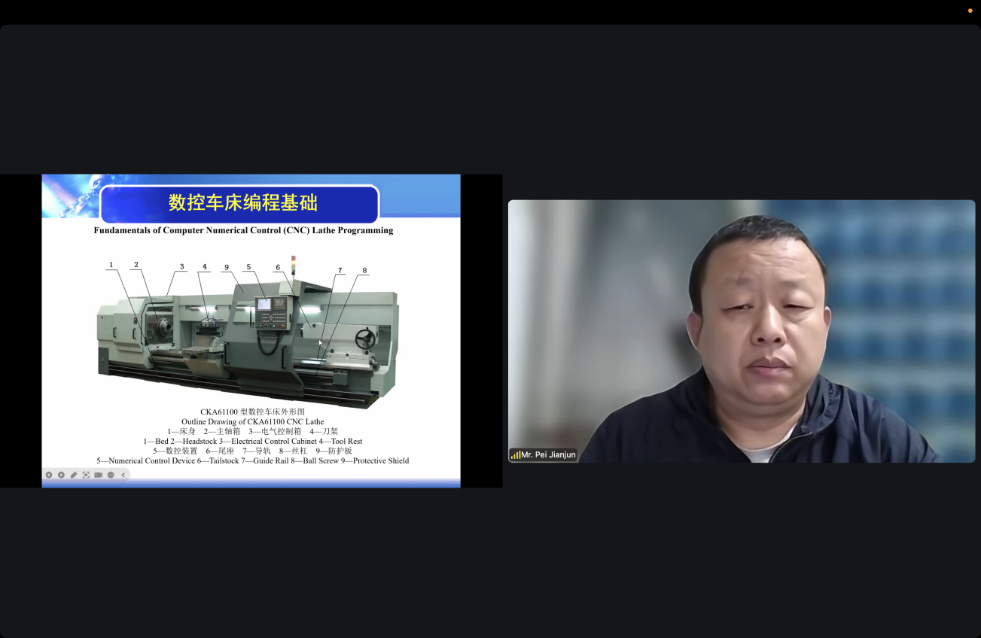
(Training Sessions)

Looking ahead, the China-ASEAN Industry-Education Integration Specialized Technical Skills Training Program will continue to advance a systematic and internationalized curriculum, effectively supporting the development of ASEAN youth technical talent, strengthening multi-party collaboration among enterprises, institutions, and regional organizations, and energize China-ASEAN production capacity cooperation and vocational education exchange—providing a solid foundation for sustainable regional economic growth.

