SEAMEO TED Conducts Training on Curriculum Development and Teaching Methodology for Technical Education in Preah Vihear Province
November 1-2, 2025, Preah Vihear Province, Cambodia – The Southeast Asian Ministers of Education Organization Regional Centre for Technical Education Development (SEAMEO TED) of the Ministry of Education, Youth and Sport successfully organized a training course on “Curriculum Development and Teaching Methodology for Technical Education” on November 1-2, 2025 at Chea Sim Tbeng Meanchey General and Technical High School, Preah Vihear Province. The training was attended by 53 teachers (17 females) from 17 General and Technical High Schools and one New Generation School across Cambodia. The program aimed to strengthen participants’ capacity in curriculum development and teaching methodology for technical education, with a particular focus on enhancing the implementation of the Technical Education curriculum.
Opening Ceremony
The opening ceremony was presided over by Dr. Songheang Ai, Director of SEAMEO TED. In his remarks, Dr. Ai extended congratulations to Mr. Bun Pengkeang, Director of Chea Sim Tbeng Meanchey General and Technical High School and the Preah Vihear Department of Education, Youth and Sport, for the school’s notable achievements thus far. Dr. Ai emphasized the critical role of the Technical and Vocational Education and Training (TVET) sector in national development. He highlighted TVET as a school-to-work pathway that enables youth to transition efficiently into the labor market. The training course, he explained, was designed in response to a training needs assessment that identified the importance of equipping technical education teachers with strong foundations in curriculum development and pedagogy.
He also underscored the value of peer learning, encouraging participants to share their newly acquired knowledge and best practices with colleagues upon returning to their institutions.

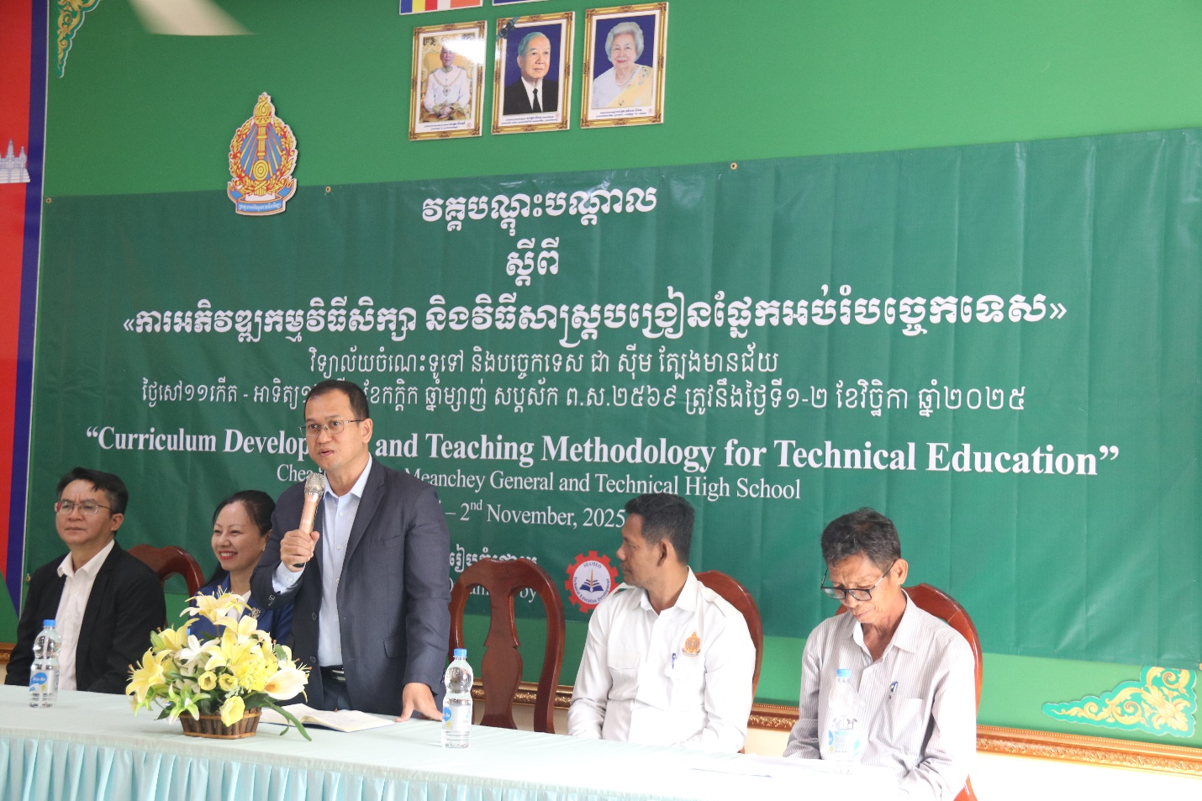
Dr. Songheang Ai delivered the Opening Remarks

Training Sessions
The course was conducted by three experts from SEAMEO TED:
- Dr. Songheang Ai, Director of SEAMEO TED
- Ms. Zhao Peili, Professor at Guangxi Polytechnic of Construction (core trainer)
- Mr. Wei Qinghua, Senior Engineer at Guangxi Vocational College of Water Resources and Electric Power (trainer)
The training program combined theory and practice across four key topics:
- Curriculum Development and Implementation
- Integrating Modern Technology in the Classroom
- Test Development and Evaluation
- Skills Competitions for Teachers and Students in China
This training was taught by three experts—Dr. Songheang Ai, Director of SEAMEO TED, Ms. Zhao Peili, Professor of Guangxi Polytechnic of Construction, and Mr. Wei Qinghua, Senior Engineer of
Guangxi Vocational College of Water Resources and Electric Power. The training covered fours topics with a balance of theory and practices: Curriculum Development & Implementation, Integrating modern technology in the classroom, Test Development and Evaluation, Skills competition for teachers and students in China.

Interactive Learning
During the sessions, Dr. Songheang Ai discussed on Curriculum Development and Implementation from the perspective of from the perspectives of the Ministry of Education, Youth and Sport. In addition, Mr. Wei Qinghua led discussions on skills competitions in China, sharing insights on how such events can foster innovation and excellence among teachers and students. Meanwhile, Ms. Zhao Peili facilitated training on test development and evaluation, guiding participants through practical exercises that enhanced their understanding of effective assessment techniques.
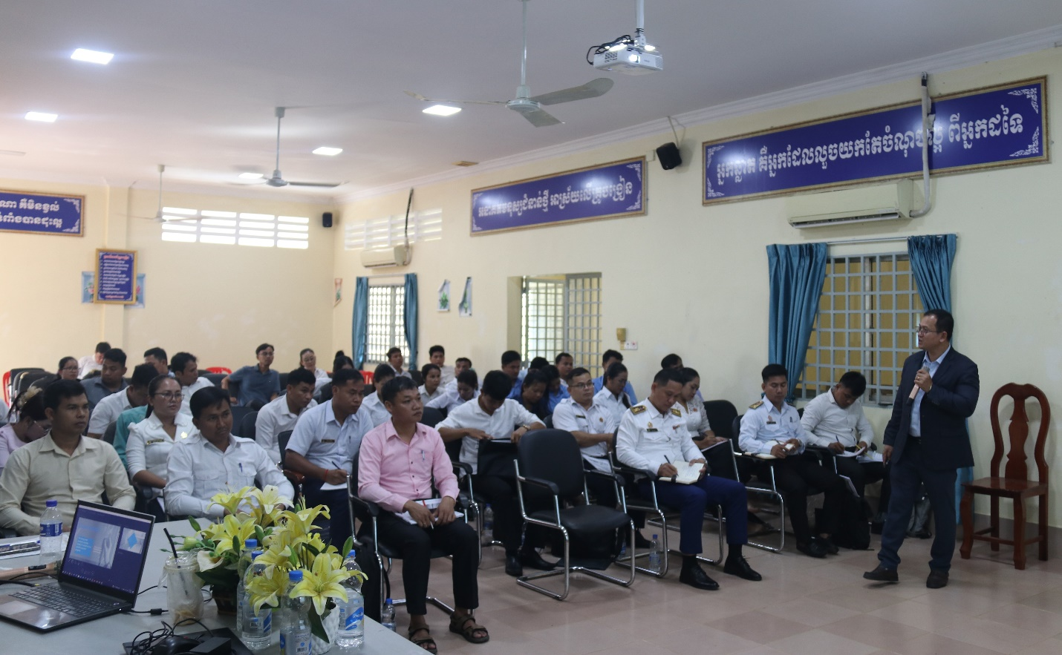
Dr. Songheang Ai discussed on Curriculum Development and Implementation.
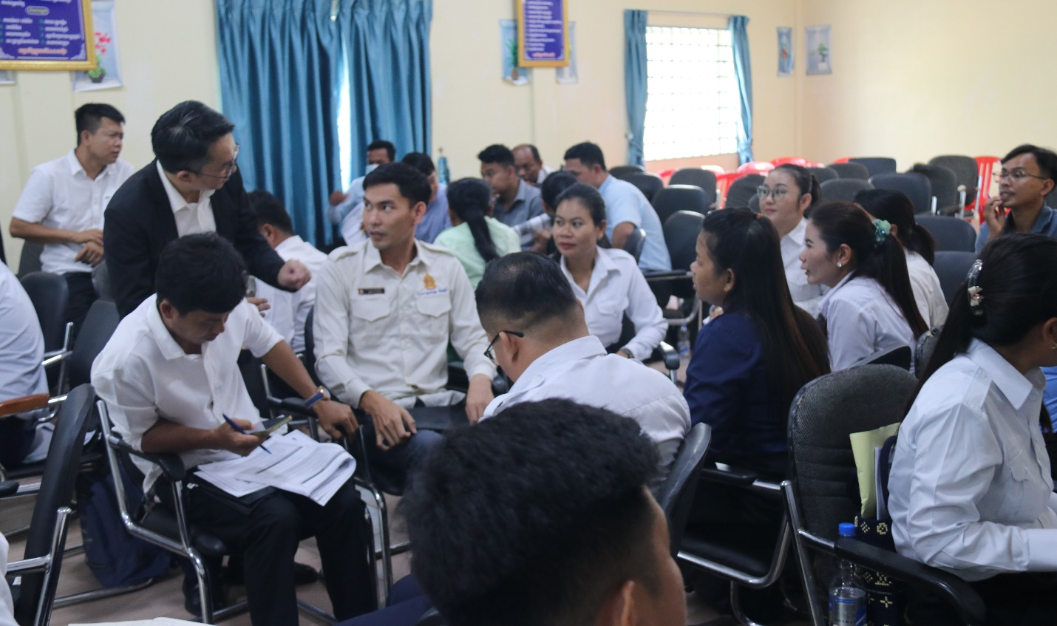
Mr. Wei Qinghua, the trainer, explaining the participant about Skills competition for teachers and students in China.

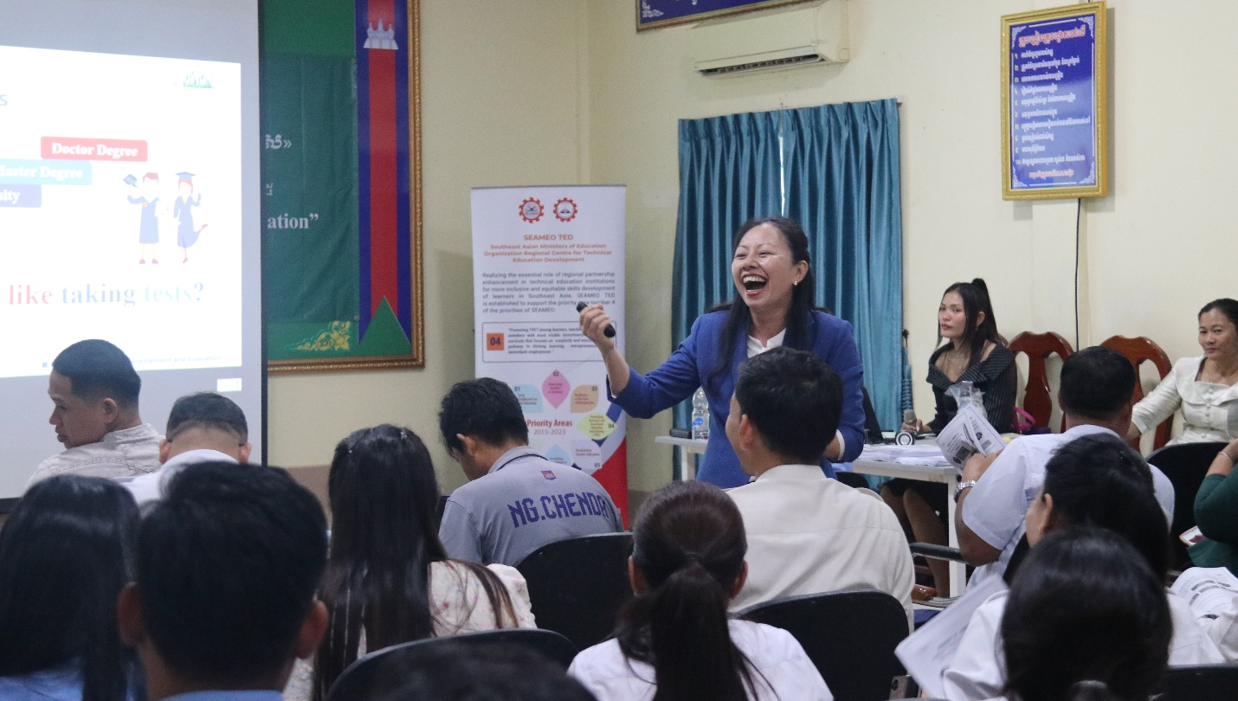
Ms. Zhao Peili, the trainer, engaged with the participants during her session.
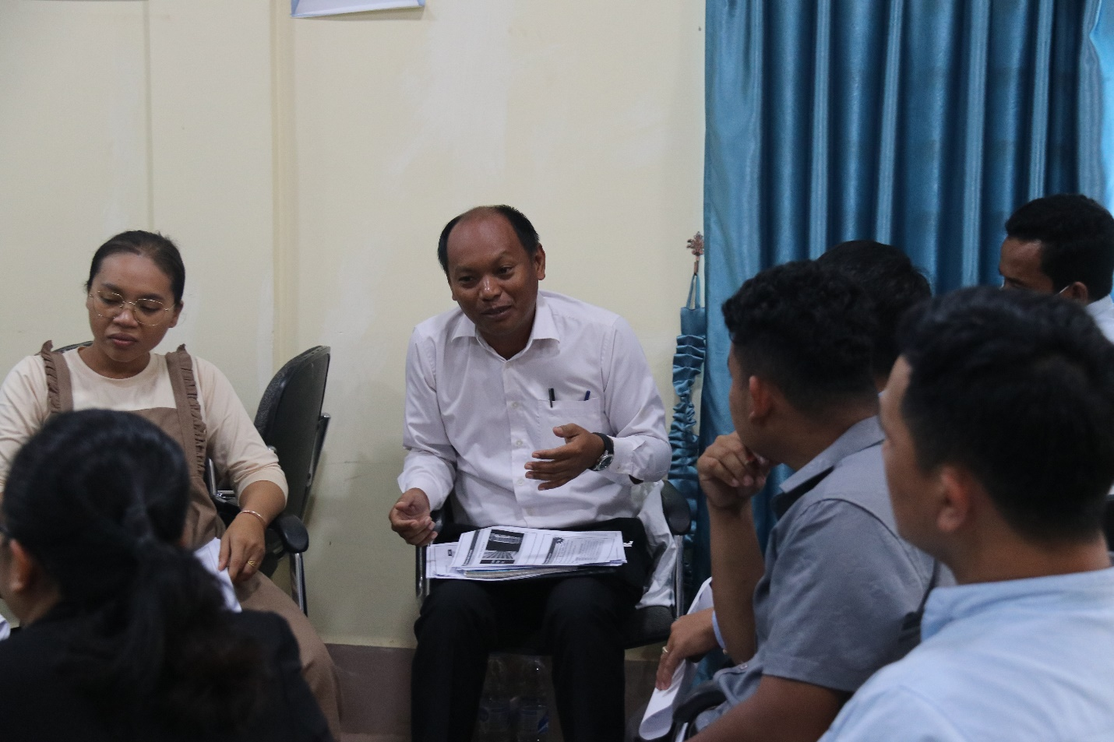
Participants during group discussion
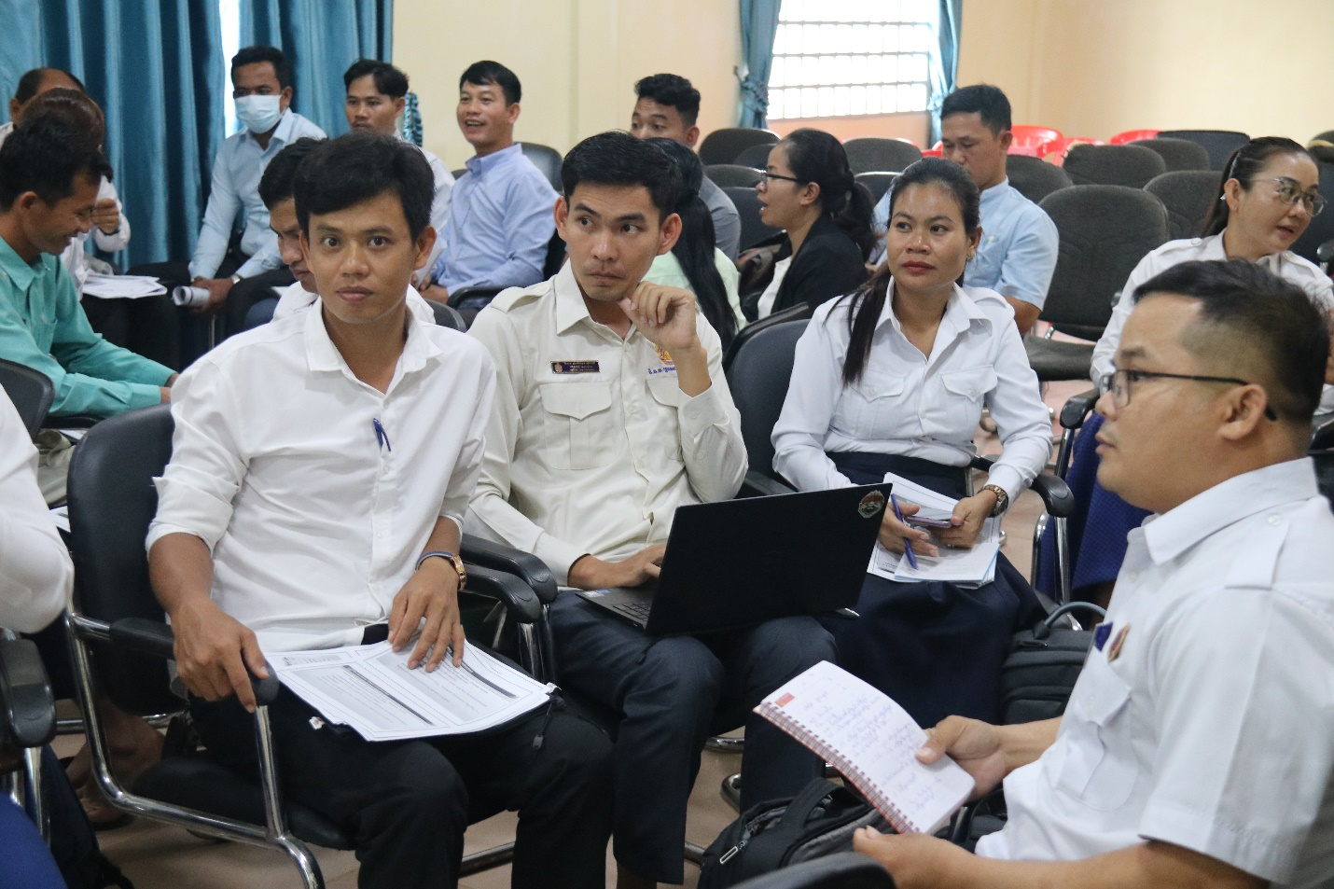
Participants during group discussion
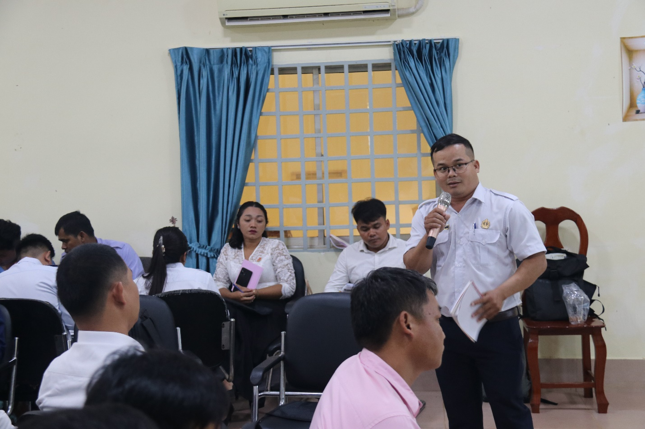
A participant presenting their group work to the whole class.
Overall, the training course was interactive and well-received, contributing significantly to improving the professional competencies of Cambodia’s technical education teachers and supporting the country’s broader goals for quality TVET development.
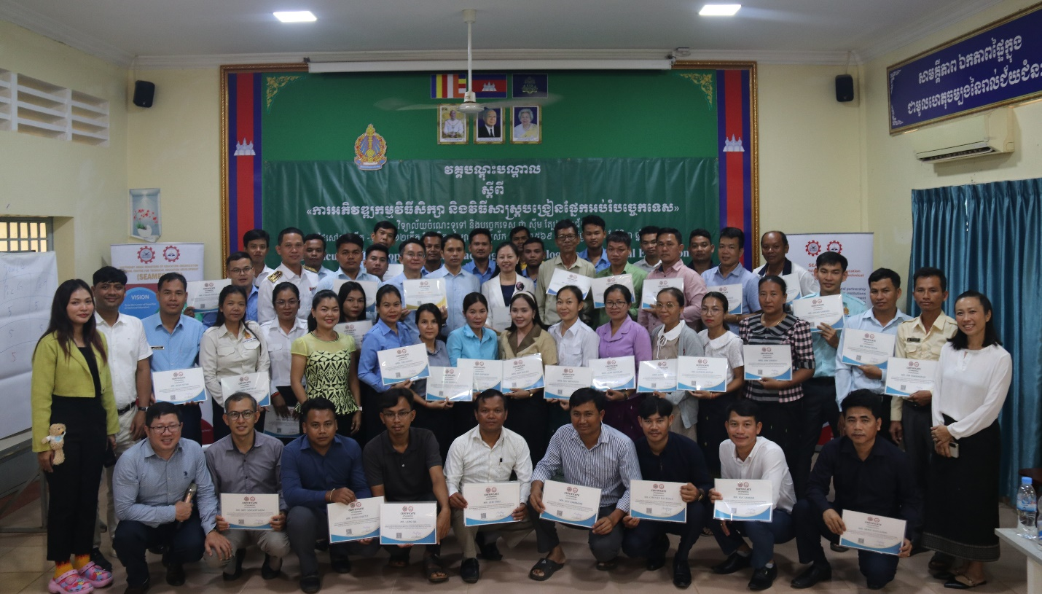
Group photo during the closing ceremony.

