Second World Summit for Social Development
4-6 November, Doha, State of Qatar
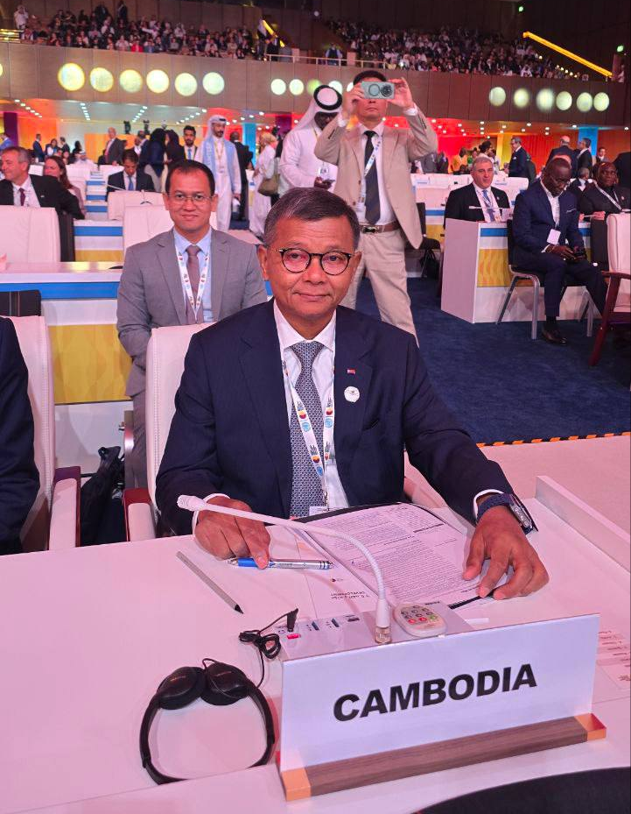
(H.E Dr. Hang Chuon Naron and Dr. Songheang Ai at the Plenary Meeting Hall)

Doha: On November 4-6, 2025, there was the Second World Summit for Social Development to be held in Doha, State of Qatar, participated by heads of states, heads of government, civil societies, and stakeholders of the United Nations. H.E Dr. Hang Chuon Naron, Deputy Prime Minister, Minister of Education, Youth and Sport, representing Samdech Maha Bovorthipdei Hun Manet, Prime Minister of the Kingdom of Cambodia. The summit purposed to (1) adopt the Draft Political Declaration of the “World Social Summit” under the title “The Second World Summit for Social Development”; (2) present the progress of Copenhagen Declaration on Social Development; (3) showcase the achievements and progress of Copenhagen Declaration implementation through exhibition booth display; and (4) contribute to the summit as speakers and panelists for some side events during the summit.
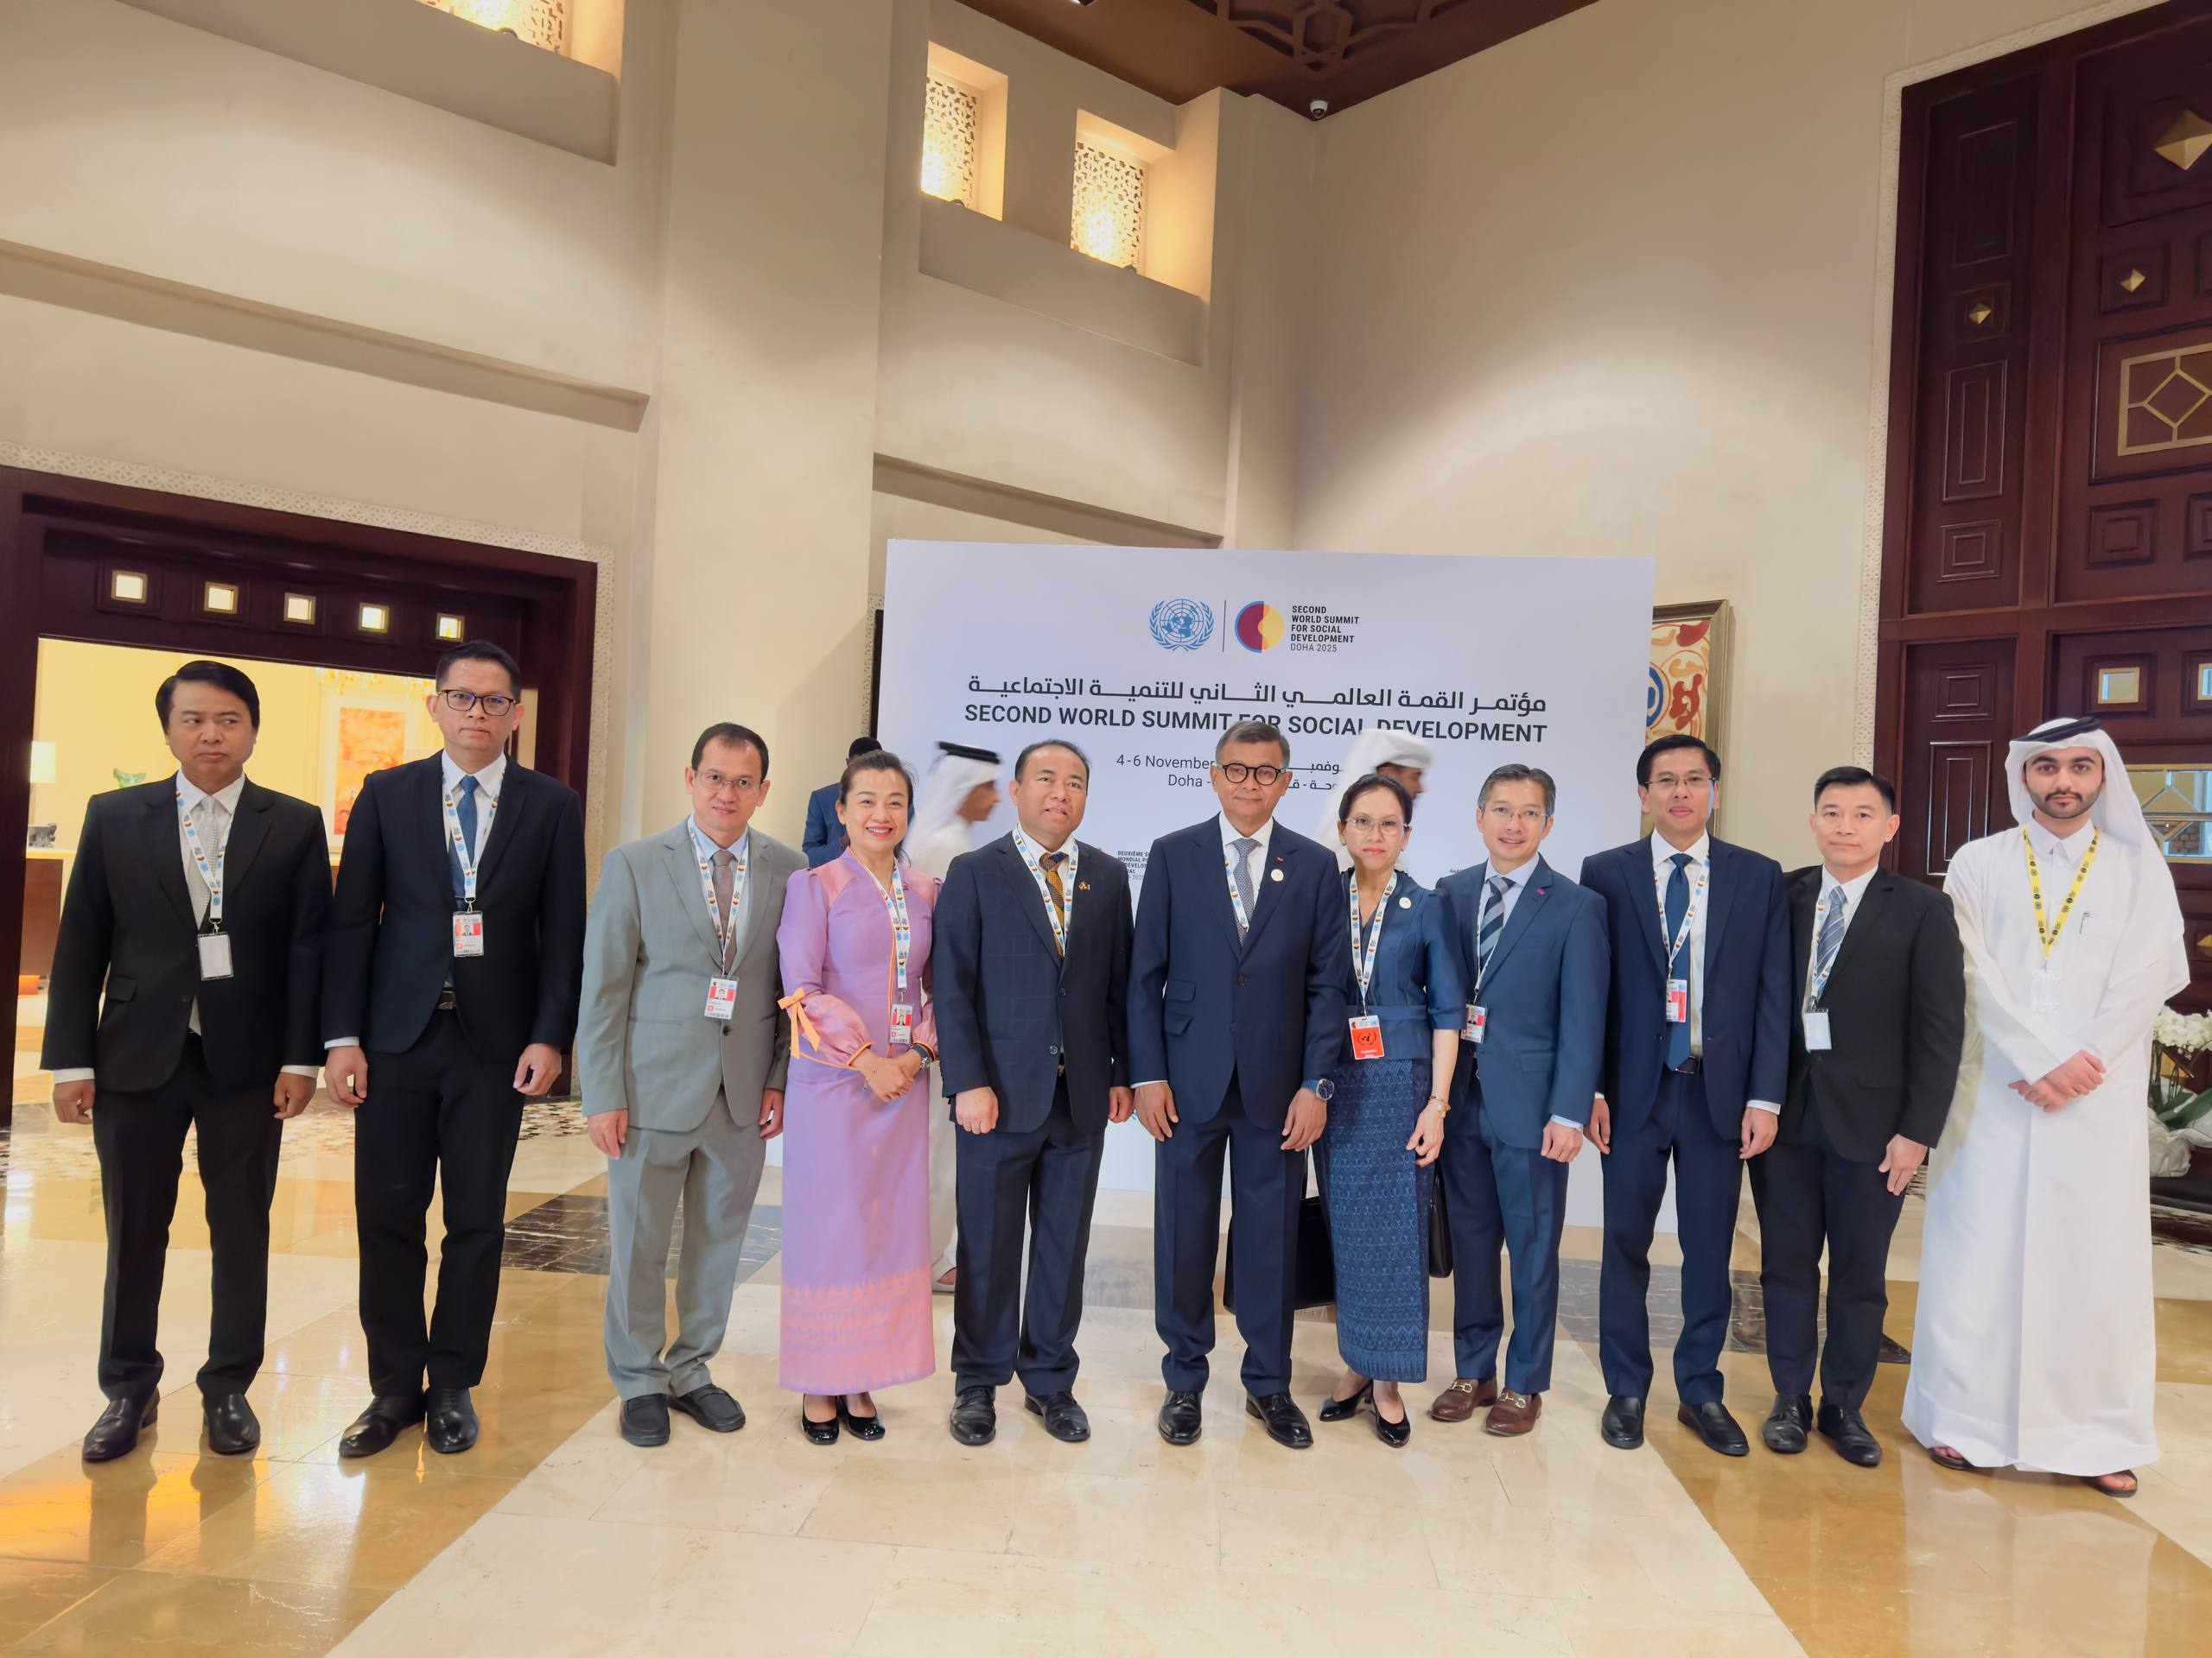
(Cambodian Delegation with LO of the summit)

During the summit, Dr. Sognheang Ai, director of SEAMEO TED and alternate SOCA leader for Cambodia has escorted H.E Dr. Hang Chuon Naron for the summit. He serves as a focal point of communication for Cambodian delegation. Cambodia contributed to the summit as the speakers and panelists for some side events consisting of (1) First Leaders’ Meeting of the Global Alliance Against Hunger and Poverty held on November 3; (2) Advancing Universal Social Protection through Digital Transformation: Insights from the Digital Convergence Initiative (DCI) held on November 5; (3) High-Level Panel: Making Every Result Count for the SDGs-Delivering Credible SDG Results by Striking the Right Balance between Donor Frameworks, Local Ownership, and Methodological Rigor held on November 5; and (4) Accelerating Disability Inclusion across the three pillars of Social Development: Multi-Stakeholder Solutions and the Leadership of OPDs held on November 6.
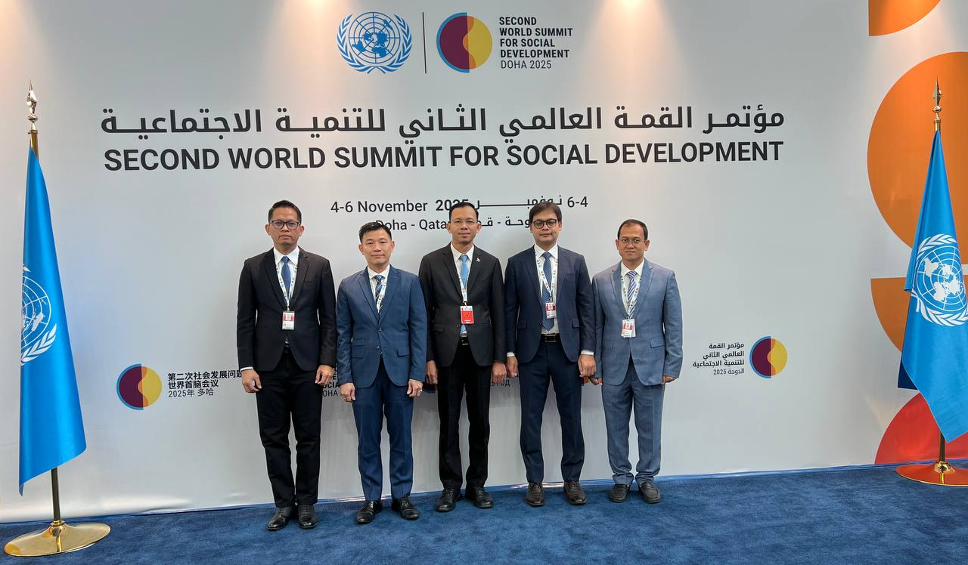
(Cambodian Delegation)

